Major Project on Fake News Detection

Submitted by

Adarsh Kumar Jha

Debabrata Bar

Raji Kumar Giri

Gulam Samdhani nijami

All the Outputs of our project are listed below :

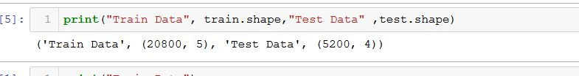

**Our Data Set Size**

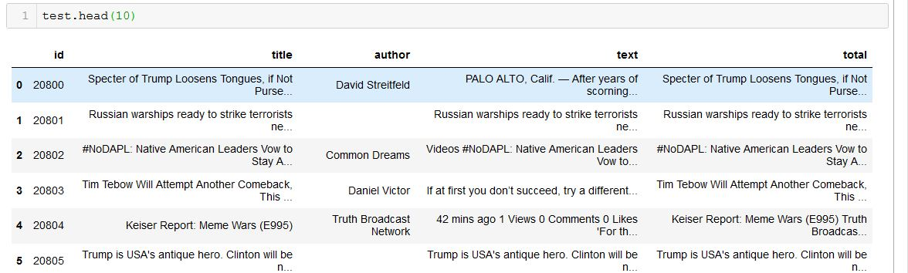

**Test Data**

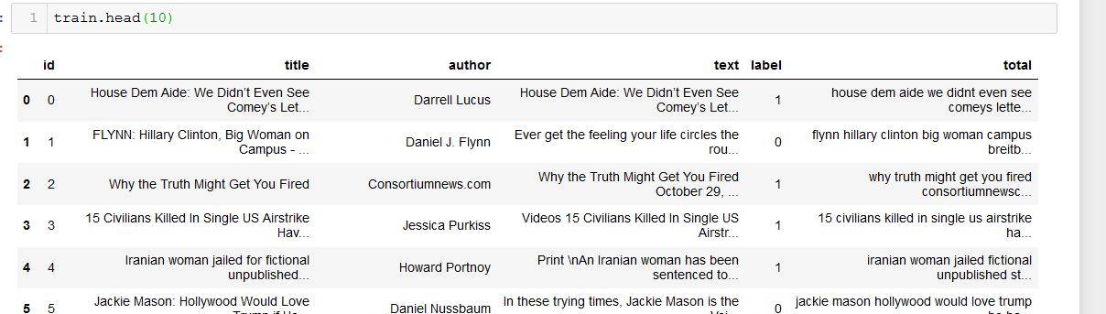

**Train Data**

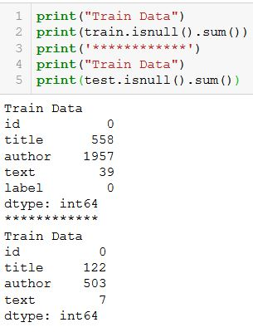

**Data Set Null Value Count**

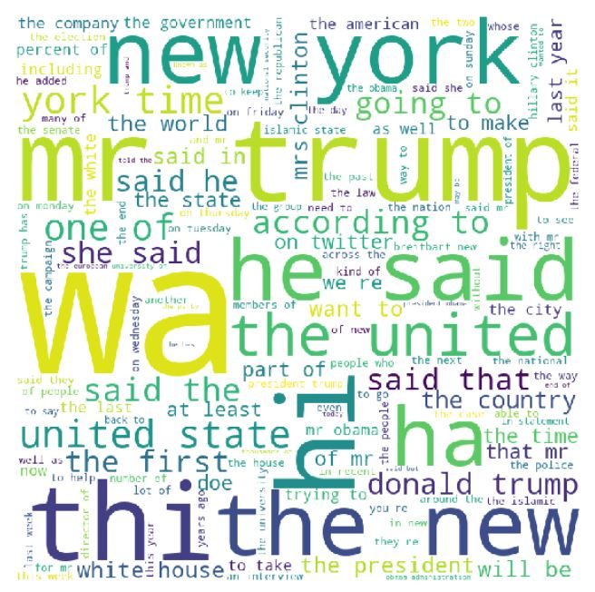

**Fake News Words Wordcloud**

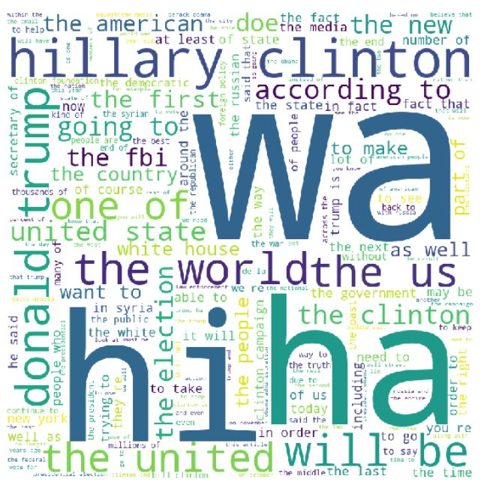

**Real News Wordcloud**

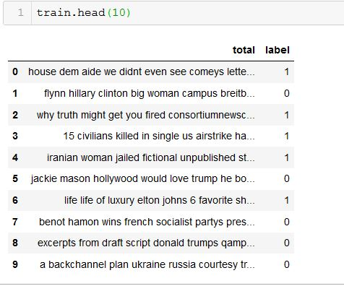

**Train Data after PrepProcessing**

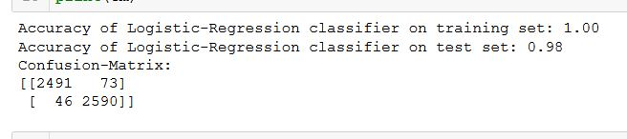

**Logistic Regression Confusion Matrix Array**

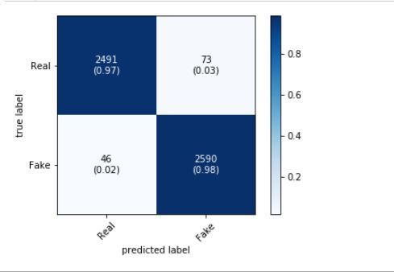

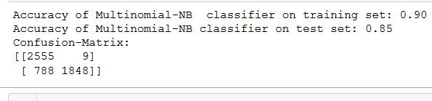**Logistic Regression Confusion Matrix Plot**

**Multinominal NB Confusion Matrix Array**

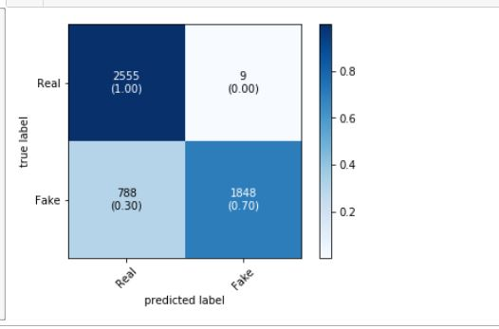

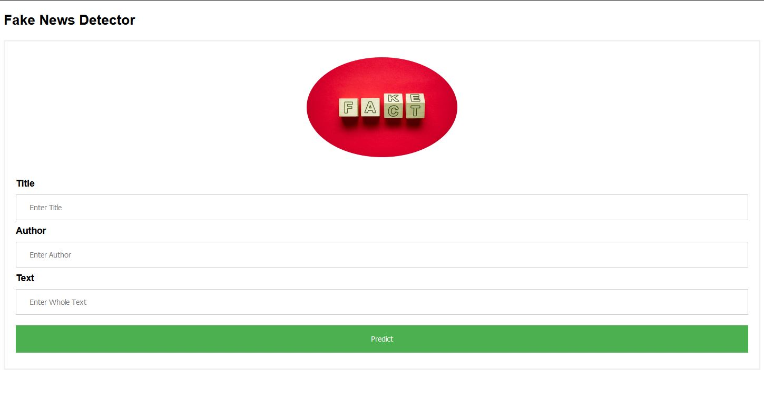**Multinominal NB Confusion Matrix Plot**

**Fake news Detector Web APP**

**Web Page Result**