This is a Functional Design Specification document template.
All italicized text is intended for instructional use and must be removed before the first publishing of the document.
Text indicated by brackets (for example, <text>) must be replaced by your project’s specific data.
No sections may be removed from this template and all existing section numbering must remain as is. Sections and subsections may be added as appended sub-paragraphs as long as the original numbering remains the same. Any sections that do not apply can be cleared of all text and the non-applicability indicated by “N/A”.
Before you begin to complete this document:
- Update the title, author and manager information of this document by going to the menu bar, and selecting File → Properties. In the Summary tab, complete the Title, Author, and Manager fields and click OK. Then, place the cursor in the title area of this page and press F9 on your keyboard. Note: Summarize the title in a few words so that readers will immediately know the subject covered by this document.
- Select File → Print Preview and complete the dialog boxes that appear. If the dialog boxes already display the correct information, simply click OK. All field codes in the document that are related to the dialog boxes will be automatically updated in the document.

Event Review

Functional Design Specification

Odyssey Financial Technologies
Case Postale 144  CH-1000 Lausanne 16  Switzerland | 2425 Matheson Blvd. East,  4th floor  Mississauga, ON L4W 5K4  Canada | Marine House  Meadlake Place, Thorpe Lea Road  Egham TW20 8HE  Surrey. U.K.

History
Date* | Action* | Name | Notes | Version
21/06/2010 | Created | OCE |  | 0.1
* Valid actions are Create, Modify, Review, and Approve

Reviewers
In addition to the organizations listed in the Sign-off section, representatives from the following departments must be invited to review and inspect this document.
- Business Analysts
- Project Management.

SIGN-oFF
Representatives from the following departments must be invited to sign-off this document.
- Product Management
- Testing

Copyright
© 2008 Odyssey Financial Technologies
All rights reserved. No part of this publication may be reproduced, stored in a retrieval system, or transmitted, in any form or by any means, electronic, mechanical, photocopying, recording, or otherwise, without the prior written permission of Odyssey Financial Technologies.
Odyssey and Triple'A are registered trademarks of Odyssey Group. All other trademarks referenced herein are the property of their respective owners.

Document summary
The purpose of this Functional Design Specification document is to provide functional design solutions for all requirements specified in the Requirements Definition document. This document is created during the Design stage of the Software Development Life Cycle (SDLC).

Project summary
Topic | Response | Notes
Program | Design Studio
Project | Design Studio for Triple’A+
Description
Sponsor(s) | Odyssey
Version | DS 5.0
Client | Error: Reference source not found
Audience | Services, implementation team

Overview
Many small enhancements have been asked after 1.40 user experiences.
This document summarizes all requirements related to the page designer event.

Requirements Description:
Only one requirement for page designer event can be found in 5.0 RD:
https://ozone.odyssey-group.com/alfresco/wcs/docasu/ui?nodeId=c7eaab72-998d-4afc-8ecc-c2e994d2cf47

FR29.1: Be able to extend the event designer to additional operators (example on date: Today(), Max, Min)

Other requirements are issues already existing in JIRA planned for the 5.0.List of requirements

List of requirements

Filter setting improvement
In the 1.40, user can only edit filter values.
DS provides no support to enter technical expression or function in the value.
A new UI is proposed to ease filter setting. The user chooses what the value content is between;
- Value (default): as of today,
- Function,
- Attribute
- Other dataset reference.

Example:
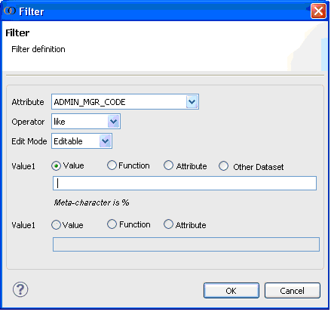

Functions presentation
In the 1.40, some functions are supported by the Framework:
- $CURRENT_MANAGER_CODE
- $CURRENT_MANAGER_ID
- $CURRENT_USER_CODE
- $CURRENT_USER_ID
- $CURRENT_DATA_PROFILE_ID
- $CURRENT_DATA_PROFILE_CODE
- $CURRENT_REPORT_PROFILE_ID
- $CURRENT_PRINTER_PROFILE_ID
- $TODAY
There is no support in DS for presenting existing list. This list is only available in the help. So, users copy/paste the function name from the documentation to the text field for filter value.

Additional functions to add in the 5.0(29.1)
Waiting for product management input.

UI for filter definition with functions (DS-3289)
The user selects the radio button: Function: 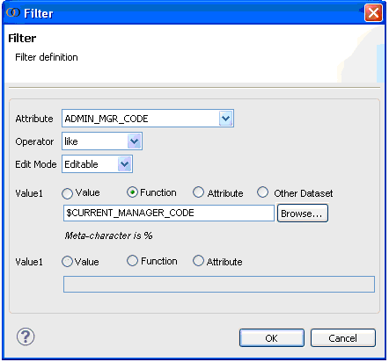
Clicking on the Browse button opens functions dialog box:
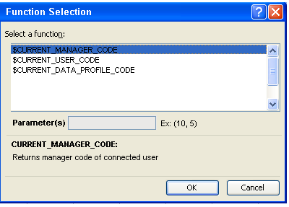

Functions are filtered by the attribute type.
List of functions split by type:
Types | Functions
String | - $CURRENT_MANAGER_CODE  - $CURRENT_USER_CODE  - $CURRENT_DATA_PROFILE_CODE
Date | - $TODAY
Integer | - $CURRENT_MANAGER_ID  - $CURRENT_USER_ID  - $CURRENT_DATA_PROFILE_ID  - $CURRENT_REPORT_PROFILE_ID  - $CURRENT_PRINTER_PROFILE_ID

Parameters:
If parameters apply on certain function, the text field becomes editable.
No parameter required for existing functions so far.

A description is displayed at the bottom of the box, explaining what returns the selected function.
Help to display in dialog box for functions:
Function name | Function description
$CURRENT_MANAGER_CODE | Returns manager code associated to the connected user
$CURRENT_MANAGER_ID | Returns manager identifier associated to the connected user
$CURRENT_USER_CODE | Returns the connected user code.
$CURRENT_USER_ID | Returns the connected user identifier.
$CURRENT_DATA_PROFILE_ID | Returns data profile identifier of the connected user.
$CURRENT_DATA_PROFILE_CODE | Returns data profile code of the connected user.
$CURRENT_REPORT_PROFILE_ID | Returns report profile identifier of the connected user.
$CURRENT_REPORT_PROFILE_CODE | Returns report profile code of the connected user.
$TODAY | Returns current date
Parameters are described as well if any.

Functions packaging
No configuration or specific package comes with these functions. So the list is hardcoded in DS. A new function added in Framework requires a sync DS delivery to be seen in the list. (Anyway, the user still have the value text field to enter new function).
The list of functions is just declared in a class package in a JAR:
public enum Function {
CURRENT_MANAGER_CODE, CURRENT_MANAGER_ID,CURRENT_USER_CODE,CURRENT_USER_ID,TODAY,CURRENT_DATA_PROFILE_ID,CURRENT_DATA_PROFILE_CODE, CURRENT_REPORT_PROFILE_ID,CURRENT_PRINTER_PROFILE_ID
}
The client cannot extend the list with custom functions.

Attributes
This possibility is chosen when the filter requires an attribute value.
For instance;
- in a table: hyperlink where the portfolio name (in hierarchy) or instrument code on current line has to be passed. The value is like the following:
- <udp:item column="_nodeDisplay"/>
- <udp:item column="INSTRUMENT_CODE"/>

- In a form: the portfolio or instrument code entered in the text field before launching a search. The value is like the following:
- valueOf(formSearch.portfolioDimPortfolio.code)
- valueOf(formSearch.instrumentDimInstrument.code)

Users with business profile are blocked when designing some events. Even for technical profiles it requires a deep knowledge of the Framework application. These expressions are too technical. A support is required in DS.
The user selects the radio button: Attribute:
Clicking on the Browse button opens functions dialog box
It displays the attributes composing the current module or fragment dataset.
If the event is set on widget within a table with hierarchy, the hierarchy node value is added in the list
Only one attribute can be selected,
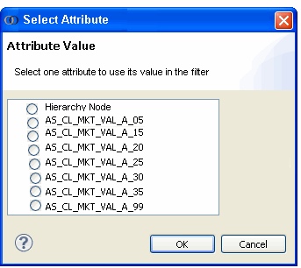

If the event is within a form (not a table), then the generated code is like:
- valueOf(form.[Attribute])
The association is added when fragment is dropped into final form. This already exists for attribute mapping in the search event setting.
If the event is within a table, then the generated code is like:
- <udp:item column="[Attribute]"/>
- <udp:item column="_nodeDisplay"/> if hierarchy node selected.
It can be directly generated from the original model.
Generated code is displayed in the text field but disable. The user knows the value has been taken into account.

Other dataset
The user can reference attribute of dataset different than the one referenced by the current the model.
After selecting radio button: Other dataset, a click on the Browse button opens functions dialog box:
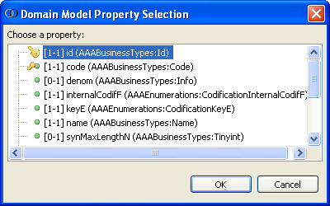
This can be found inn domain designer for mapping attributes.
Once selected, the generated code has the following structure:
@domain:dataset:attribute1.subAttribute2
Example: @AAADSDomain:DomainContext:portfolioDimPortfolio.code
Generated code is displayed in the text field but disable. The user knows the value has been taken into account.

Order for attribute mapping (DS-3399)
Today attribute mapping set in an event is the following:
The user selects an attribute in the event UI: for instance code and name.
When the fragment is dropped into a module, the generated code includes the association before the attribute and the attribute itself.:
for portfolio referenced in domain, the event parameters are:
name="Query.beanProperty1">portfolioDimPortfolio.code<
name="Query.beanProperty2">portfolioDimPortfolio.name<
For returning the value from the search result after selection, the user has to use the same parameter name: Query.beanProperty1 and Query.beanProperty2.
There is no possibility for the user to know which is the 1 and 2 unless looking at the generated XSP code of the event.
The mapping needs to be done from the event, is selection is single, when multiple, no mapping is required.
By exploring the search module model, the page designer looks into the search output module for an event of type on-click.
If this event has mapped attributes, these attributes are retrieved and exposed in the UI when the user sets “Attributes mapping” in the search calling event:
The label in the dialog box header lists attributes submitted by the search output event.
This indicates to the user what to map in the calling event. A rank is displayed beside the selected attribute. The first clicked attribute has the value (1) the second the (2) etc.
This gives the order of attributes for the mapping.
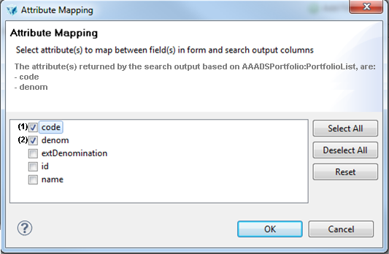

On the search output side, for the current example, we will have the on-click event with mapped attributes as following:
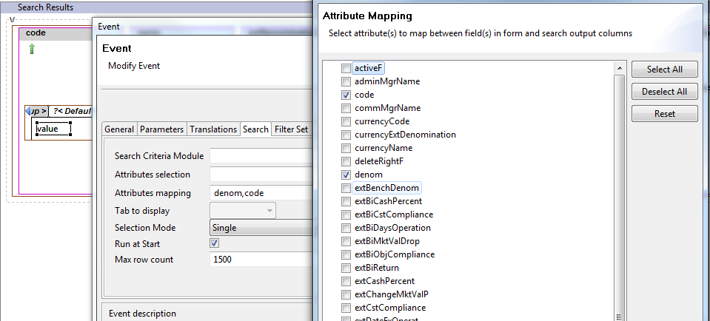
The parameters set manually on the event can be generated:
Query.beanValue1: <udp:item column="code"/>
Query.beanValue2: <udp:item column="denom "/>

Add tooltips on event properties
To be defined

Widget group default Value
When creating an event with a method = submit, the widget group ref is required.
Provide a default value = "form".
It's in line with the widget group ref set in the module.
Then all values are posted to the server.

