This is a Functional Design Specification document template.
All italicized text is intended for instructional use and must be removed before the first publishing of the document.
Text indicated by brackets (for example, <text>) must be replaced by your project’s specific data.
No sections may be removed from this template and all existing section numbering must remain as is. Sections and subsections may be added as appended sub-paragraphs as long as the original numbering remains the same. Any sections that do not apply can be cleared of all text and the non-applicability indicated by “N/A”.
Before you begin to complete this document:
- Update the title, author and manager information of this document by going to the menu bar, and selecting File → Properties. In the Summary tab, complete the Title, Author, and Manager fields and click OK. Then, place the cursor in the title area of this page and press F9 on your keyboard. Note: Summarize the title in a few words so that readers will immediately know the subject covered by this document.
- Select File → Print Preview and complete the dialog boxes that appear. If the dialog boxes already display the correct information, simply click OK. All field codes in the document that are related to the dialog boxes will be automatically updated in the document.

New property for CalDateField

Multi entries for decision state

Functional Design Specification

Odyssey Financial Technologies
Case Postale 144  CH-1000 Lausanne 16  Switzerland | 2425 Matheson Blvd. East,  4th floor  Mississauga, ON L4W 5K4  Canada | Marine House  Meadlake Place, Thorpe Lea Road  Egham TW20 8HE  Surrey. U.K.

History
Date* | Action* | Name | Notes | Version
09/7/2010 | Created | BJM |  | 0.1
* Valid actions are Create, Modify, Review, and Approve

Reviewers
In addition to the organizations listed in the Sign-off section, representatives from the following departments must be invited to review and inspect this document.
- Business Analysts
- Project Management.

SIGN-oFF
Representatives from the following departments must be invited to sign-off this document.
- Product Management
- Testing

Copyright
© 2008 Odyssey Financial Technologies
All rights reserved. No part of this publication may be reproduced, stored in a retrieval system, or transmitted, in any form or by any means, electronic, mechanical, photocopying, recording, or otherwise, without the prior written permission of Odyssey Financial Technologies.
Odyssey and Triple'A are registered trademarks of Odyssey Group. All other trademarks referenced herein are the property of their respective owners.

Document summary
The purpose of this Functional Design Specification document is to provide functional design solutions for all requirements specified in the Requirements Definition document. This document is created during the Design stage of the Software Development Life Cycle (SDLC).

Project summary
Topic | Response | Notes
Program | Design Studio
Project | Design Studio for Triple’A+
Description
Sponsor(s) | Odyssey
Version | DS 5.0
Client
Audience | Services, implementation team

Overview
Decision states support currently only one entry point (only one transition can lead to it ) . This leads to ineffective duplication of decision states which are basically the same . An example can be found on the valuation pageflow of the current OCS release (see below) : the UselessDecisionSate was added because it is not possible to point the transition execute from ValuationContext to DecisionSate .
As a result , it makes the pageflow hard to read and understand.
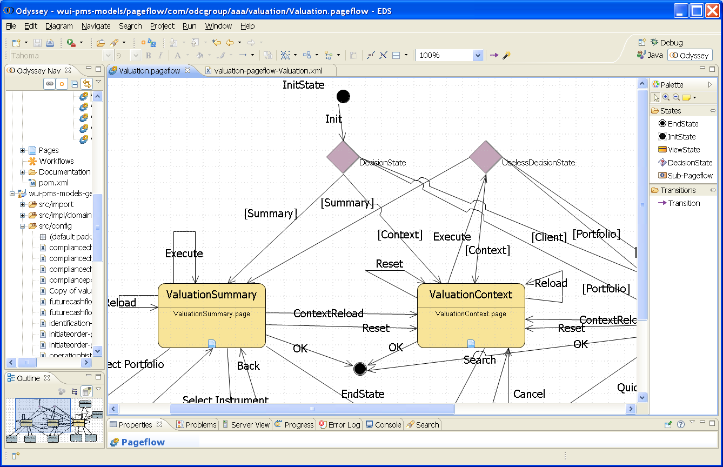

Requirements Description:

This improvement is based on the issue raised in JIRA DS-2846 .

List of requirements

Multi entries for decision state

DS should support multi entries decision state . There should be no limitations on the number of entries . An example can be found below for a decision state with 2 entries : transition 6 and transition 5 .
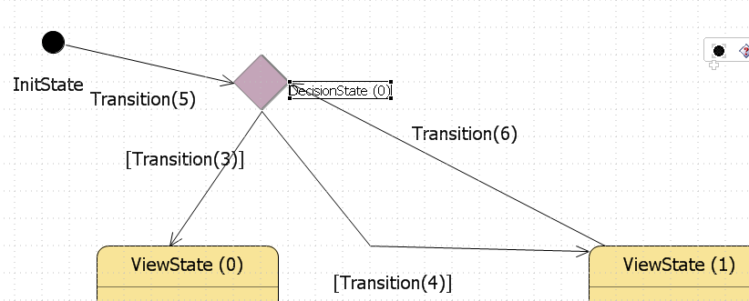
It is worth to note that the current version of the graphical editor allows at least to draw a second entry to the decision state . It doesn’t seem to have a limitation at this level . But as multi entries decision state is not supported , an error is displayed on the problem view :
Description Resource Path Location Type
Decision State<<DecisionState (0)>> must have exactly one incoming transition

Multi entries decision state should be defined as they are currently : mandatory properties remain unchanged .

For each new transition arriving at the decision state , it is possible to atomically generate the corresponding redirector based on the redirector already defined (simple replication) .

Generation

A decision state is currently implemented as a RedirectorService (process in charge of returning the integer which is given to the redirector) and a pageflow redirector . A redirector definition can be used as many times as needed within a pageflow , there is no limitation at this level .

For each transition arriving at a decision state , the same redirector and its corresponding service must be generated :
<wf:transition name="<transition name>" from-state="<state name>" to-redirector="true">
<any process associated to this transition>
<wf:process class-name="<redirector service>">
….
</wf:process>
<wf:redirector>
<redirector definition>
</wf:redirector>
</wf:transition>

Appendix – Current valuation pageflow and redirectors

By looking at the current valuation pageflow above , an by comparing the generated code for both redirectors (for UselessDecisionSate and DecisionSate ) , we can see that the code is basically the same . Two slight differences can be noticed, additional parameters for GetEntityBySearchProcess and an additional call to ExecuteWuiFinFunctionProcess , both additions are in the UselessRedirector . It is likely that these differences are linked to the duplication of the decision states , ideally there should not be any differences in that case .
