Installation of Git

Git Setup –

After installing the Git follow the below steps:

1. $ git config –global user.name “Deb”
2. $ git config –global user.email [debadattasatpathy@hotmail.com](mailto:debadattasatpathy@hotmail.com)
3. $ git config –list
4. Now create a folder for local Repo . Example F:/GitRepo
5. Right Click and select GitBash.
6. In the command prompt we can see check the path by $ pwd.
7. In the Gitbash, $ git init - Initializes an empty git repo and assigns .git

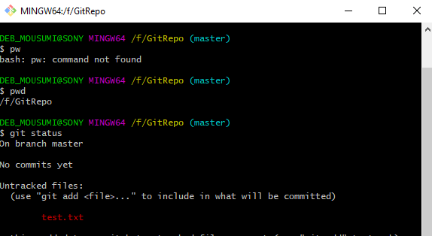

1. Now we can add file to our local repo.

For example

test.txt.

1. $ git status - to check the status of the file changes.
2. 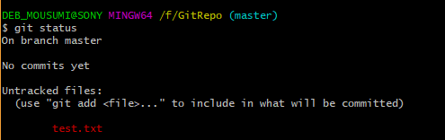
3. To add the file to local repo , we need to call below command

$ git add test.txt



1. Once the changes are done, we need to commit the changes.

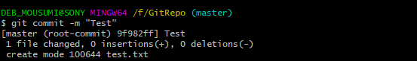

1. Check with git status command.



1. To remove the file from the git repo use the command

$ git rm test.txt

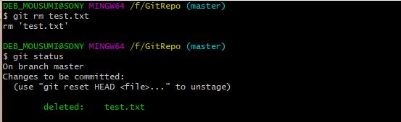

1. For force removal of the file from the repo, we will use git command –

$ git rm –f “File name”