**Software Requirements Specification**

for

Book-shop Automation Software(BAS)

Version 1.0

Debaditya Das

IIT KHARAGPUR

March 25, 2023

**Table of Contents**

**Table of Contents..........................................................................................................3**

**Revision History............................................................................................................2**

**1. Introduction............................................................................................................... 3**

1.1 Purpose................................................................................................................................. 3

1.2 Document Conventions ........................................................................................................ 3

1.3 Intended Audience and Reading Suggestions ..................................................................... 3

1.4 Product Scope ...................................................................................................................... 4

1.5 References ........................................................................................................................... 4

**2. Overall Description .................................................................................................. 5**

2.1 Product Perspective .............................................................................................................. 5

2.2 Product Functions ................................................................................................................. 6

2.3 User Classes and Characteristics ......................................................................................... 6

2.4 Operating Environment ......................................................................................................... 6

2.5 Design and Implementation Constraints ............................................................................... 7

2.6 User Documentation ............................................................................................................. 7

2.7 Assumptions and Dependencies .......................................................................................... 7

**3. External Interface Requirements ............................................................................ 8**

3.1 User Interfaces ..................................................................................................................... 8

3.2 Hardware Interfaces ............................................................................................................. 8

3.3 Software Interfaces .............................................................................................................. 8

3.4 Communications Interfaces .................................................................................................. 9

**4. System Features ...................................................................................................... 9**

4.1 System Feature 1 ................................................................................................................. 9

**5. Other Nonfunctional Requirements .......................................................................10**

5.1 Performance Requirements .................................................................................................10

5.2 Safety Requirements ............................................................................................................10

5.3 Security Requirements .........................................................................................................10

5.4 Software Quality Attributes ...................................................................................................11

5.5 Business Rules .....................................................................................................................11

**6. Other Requirements.................................................................................................12**

**Appendix A: Glossary .................................................................................................13**

**Appendix B: Analysis Model – UseCase Diagram ……….........................................14**

**Appendix C: Analysis Model – Class Diagram ………..….........................................15 Appendix D: To Be Determined List ..........................................................................16**

**Revision History**

|  |  |  |  |
| --- | --- | --- | --- |
| **Name** | **Date** | **Reason for Changes** | **Version** |
|  |  |  |  |

**1. Introduction**

**1.1 Purpose**

The purpose of this document is to present a detailed description of the Book-shop Automation Software. This document will explain the purpose and features of the system, the interfaces of the system, what the system will do, the constraints under which it must operate and how the system will react to external stimuli. This document is intended for both the stakeholders and the developers of the system.

**1.2 Document Conventions**

Document Templates: The SRS document will follow a specific template that includes the following sections: Introduction, System Overview, Functional Requirements, Non-Functional Requirements, User Interface Design, Use Cases, System Constraints, Assumptions, and Dependencies.

Writing Style and Tone: The document will be written in a formal tone, using technical terms and avoiding jargon or slang. The language used will be clear and concise, avoiding ambiguity or vagueness

**1.3 Intended Audience and Reading Suggestion**

The intended audience for the Software Requirements Specification (SRS) document for the online book store website includes the development team, project manager, and the client. The document should be written in a way that is easy to understand for technical and non-technical readers alike. Therefore, it is suggested that the document should include a glossary of technical terms used in the document, as well as explanations of any complex concepts or processes. The reading level of the document should be appropriate for a btech project, using clear and concise language to describe the system's functionality, user interface design, and technical requirements. Additionally, it is recommended that the document be reviewed by a technical writer or editor before final submission to ensure that it meets the required quality standards and is easy to read and understand for all intended audiences.

**1.4 Product Scope**

The online book store website will provide a convenient shopping experience for users, eliminating the need for them to physically visit a store. Users will be able to search for and purchase books, view book details and reviews, and manage their account information online. The website will also offer benefits to the owner, such as reduced crowd at the physical store location. The administrative portal will enable the owner to manage book listings, inventory, and orders with ease. The website will be accessible to users via a web browser and will be designed to be user-friendly and intuitive. The system will be optimized for desktop and mobile devices, with responsive design elements to ensure a seamless user experience across all devices. Additionally, the system will be scalable and easily maintainable, allowing for future updates and enhancements to be made as needed.

**1.5 References**

IEEE. IEEE Std 830-1998 IEEE Recommended Practice for Software Requirements Specifications. IEEE Computer Society, 1998.

The course link- <https://iitkgpacin-my.sharepoint.com/:f:/g/personal/lagnos_kgpian_iitkgp_ac_in/EmqXqcdIh-xFkTk84rekNmsBU7x0GjVvamMkcHIBcQEb4w?e=O9caWy>

**2. Overall Description**

**2.1 Product Perspective**

Book shop automation software is a type of software designed to automate various tasks and processes involved in the operation of a bookshop. From inventory management and sales tracking to customer management and analytics, the software provides a comprehensive solution for bookshops to manage their business more efficiently.

From a product perspective, book shop automation software offers a range of benefits, including:

Improved Efficiency: By automating various tasks such as inventory management and sales tracking, the software helps bookshops to save time and reduce the likelihood of errors by finding book in no time.

Increased Sales: The software enables bookshops to analyze sales data, identify trends, and optimize their inventory accordingly, which can lead to increased sales and profitability.

Enhanced Customer Experience: The software allows bookshops to manage customer information and preferences, enabling them to provide personalized recommendations and improve overall customer satisfaction.

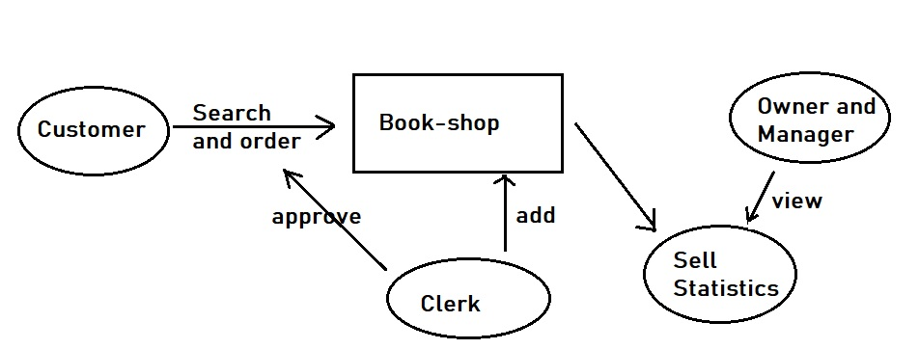

Book-shop Automation Software

**2.2 Product Functions**

Our product can do different functions to increase and to make easy the book shop business.

It helps customer to find books with their correct place in the shop and to add queries for needed books.

Employees of the shop can get an error-free method to keep account of different sells, and can fulfill customer queries.

This software helps to get track of most sold books, least sold books, and can calculate sell statistics containing various data containing inventory level threshold to increase business profit.

**2.3 User Classes and Characteristics**

Our product has different functionalities for different types of users. User can be of four types – Customer, Clerk, Manager, and Owner.

Customer search books and place an order. Also he/she can put a query to buy a book or increase number of any book. Customer can see his buy history.

Clerk can approve an order placed by customer and can update book-stock.

Manager can update book-stock, see sell statistics and get contact details of vendor/publishers for different books. He/she can also see queries made by customers.

Owner can see sell statistics, inventory threshold.

**2.4 Operating Environment**

Our software is a web-based system (application). Users can use it with computer/mobile with an internet connection (with any browser).

The operating environment for this web-based system includes the following components:

Web server: Used web server is Apache HTTP server

Database server: Database is MySQL

Operating system: The operating system we are using is Windows

Application server: Application server is IIS

**2.5 Design and Implementation Constraints**

Regulatory Policies: When it comes to implementing bookshop automation software, there are several regulatory policies that bookshops need to comply with, depending on their location. For example, it has to follow data protection according to the rule of that country.

Limitations: Our software has no money paying option for buying.

Language Requirements: BAS’s frontend is written in React JS and backend development done in Flask(Python)

Communication protocols: HTTP(Hyper text transfer protocol) which is secure for sending and receiving data is used as communication protocol

Security considerations: Encryption of passwords, stopping SQL injection, protection against virus.

Parallel operations: Users can use this website in parallel manner in different systems.

**2.6 User Documentation**

Introduction: This web app can be used by customer, clerk, manager and owner of book shop. This documentation helps all types of user to use this software.

Interfaces: The app’s home page contains login and then different users are redirected to their respective pages and do their functionalities. Long descriptions are given in section 3.1

Features: There are some advanced features of our app such that it can produce different visual-friendly sell stat to increase business. The query system for customer helps the shop to become up to date.

Troubleshooting: There may be some troubleshooting due to internet issues. Also customer may face time gap between ordering a book and its approval due huge queue in the clerk’s site.

**2.7 Assumptions and Dependencies**

Assumptions: Software is assuming that user has basic understanding of using web based systems. Customers know about name and author of book. Employees has basic idea to use a web app. Also database will work always properly.

Dependencies: Software requires stable internet connection to run. It is dependent on a specific version of Database management system.

**3. External Interface Requirements**

**3.1 User Interfaces**

The home page is login page. From there user can login to their respective portal. Newcomers can also register.

Customers can see 3 options. They are to search book(then order or put query), download current receipt, and see all previously bought books.

Clerk: They can see 2 options. Approve order of book and update book stock.

Manager: They have several options to see customer queries, update book stock, see sell stat and stockist’s list.

Owner: Can see different sell statistics.

Also there are key-board shortcuts like auto login on hitting Enter, up-down arrows to increase or decrease book number for ordering. Help and FAQ are in every page. There is no error message given manually, server may give their own message when error occur.

**3.2 Hardware Interfaces**

It is basically a web-based system. Database is stored in hardware. Cloud servers are used for different needs.

**3.3 Software Interfaces**

Our product(website) is built of different components. Here is the complete listing:

Frontend:

"http-proxy-middleware": "^2.0.6",

"react": "^18.2.0",

"react-dom": "^18.2.0",

"react-router-dom": "^6.9.0",

"react-scripts": "5.0.1",

"web-vitals": "^2.1.4"

Backend:

Python: ^3.10

Flask: ^2.2.3

Database:

SQLAlchemy: ^2.0.7

Flask-MySQLdb: ^1.0.1

Others:

Data is taken from user in frontend and goes to backend flask server using a ‘POST’ method. Then it is stored in database. In a reverse manner data is taken from database in backend and using ‘GET’ it is used in frontend. In the JSX files used in React app, ‘action’ is used to connect frontend and backend of the webapp. By usual way connecting between different react component is done.

**3.4 Communications Interfaces**

Communication standard used is HTTP. For running our website any web browser supports http(Chrome, opera, Firefox, edge) will suffice. Passwords are encrypted due to security issues.

**4. System Features**

**4.1 System Feature 1**

This website is designed for three types of users- 1)owner

      2)employee

      3)customer

4)Manager

The provided features are-

a)Four types of login interfaces are provided for four types of users.

b) The interface for customer is opened by default and it provides the following features-

The customer can do the following things-

1)View available and recommended books.

2)See his history of purchase.

3)Add books to cart.

4)Place an order for books.

5)Report if the book is not available or out of stock.

c)The website is integrated with a payment gateway which shows the amount of which the customer has ordered books and if the payment is done then the order gets placed successfully.

d)The administrative portal will enable the owner to manage book listings, inventory, and orders with ease. Owner will have full access to everything except the personal details of the customers. The passwords will be encrypted properly.

e)The database will store the purchase history of the customers and the statistics will be shared with the owner in order to scale up the profit.

**Functional Requirements:**

Discussed in section 3.3.

**5. Other Nonfunctional Requirements**

**5.1 Performance Requirements**

Response Time: It has a first response time for searching books and ordering them. Also it can generate sell stat in no time.

Scalability: It has a large database. It can handle millions of users and can millions of books. There is no issue for running this software in any book-shop.

Reporting: It can generate comprehensive reports on various metrics. It can improve business performance.

Compatibility: The software is compatible with different platforms like laptop, mobile phone, tablets etc.

**5.2 Safety Requirements**

Regarding safety requirements, software can perform without losing data. It has appropriate measures to place safeguard business data, inventory level and financial records. It has access control to such data to only authorized person.

**5.3 Security Requirements**

Here are some general security requirements for book shop automation software:

Authentication and authorization: The software should require users to authenticate themselves before accessing any sensitive data or functionality. This can be achieved through password authentication, two-factor authentication, biometric authentication, or other methods.

Encryption: The software uses encryption techniques to protect sensitive data like passwords

Access controls: The software enforce access controls to ensure that users only have access to the data and functionality that they need to perform their job functions. This can be achieved through role-based access control or other access control mechanisms.

**5.4 Software Quality Attributes**

Adaptability: It can independently monitor its behavior. With changing time its easy for it to adopt.

Availability: The software is available 24/7, with minimal downtime for maintenance or updates.

Correctness: The software can perform all functions accurately and without errors.

It is able to handle a variety of inputs and produce the expected outputs.

Flexibility: The software is able to adapt to changing business requirements and user needs. It is able to integrate with other software or systems as needed.

Robustness: The software is able to handle unexpected or invalid inputs without crashing or causing data loss. It has built-in security measures to protect against malicious attacks or unauthorized access.

Reliability: The software is able to perform consistently over time, without degradation in performance or functionality.

**5.5 Business Rules**

Customers can only search and buy books. Sell statistics is visible to only owner and manager. Book stock is available for all employees to update. Employee can also open accounts as customer to buy books.

**6. Other Requirements**

The use of the software program have to be guided by means of the rights an person is provided. No felony troubles have to be there with the use of the software. However, the equipment used right here have some precise licenses. The license phrases have to be observed to keep away from any criminal troubles in the future. A consumer guide will additionally help the software program so that customers can get the fine out of this software.

**Appendix A: Glossary**

• URL: - Uniform Resource Locator. It is the address of a given unique resource on the Web.

• SQL-Injection: - Structured Query Language-Injection. It is a common attack vector that uses malicious SQL code for backend database manipulation to access information that was not intended to be displayed.

• Third Party API’s:- Third Party Application Programming Interfaces. It allows you to access a third parties functionality or data to use on your site or application.

• HTTPS: - Hypertext Transfer Protocol Secure. It is used for secure communication over a computer network, and is widely used on the Internet.

• CORS: - Cross-Origin Resource Sharing. It is an Hypertext Transfer Protocol (HTTP)-header based mechanism that allows a server to indicate any other origins (domain, scheme, or port) than its own from which a browser should permit loading of resources.

• HTML: - Hypertext Markup Language. It’s a standard language to write in web browser

• TCP/IP:- Transmission Control Protocol/Internet Protocol, It is the conceptual model and set of communications protocols used in the Internet and similar computer networks.

• RDBMS: - Relational Database Management System. It is a Database Management System designed specifically for relational databases.

• JSX: - JSX stands for JavaScript XML. It allows to write HTML in React.

• CSS: - Cascading Style Sheets. It styles the webpage.

**Appendix B: Analysis Models – UseCase Diagram**

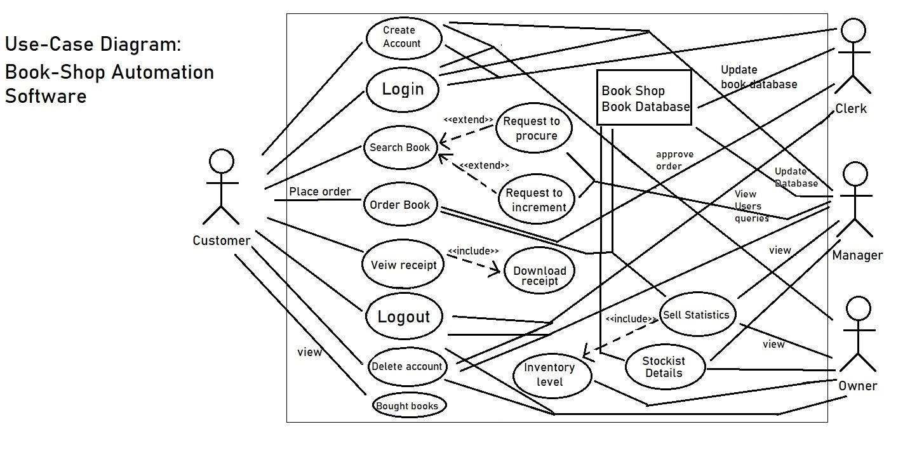

**Appendix C: Analysis Models – Class Diagram**

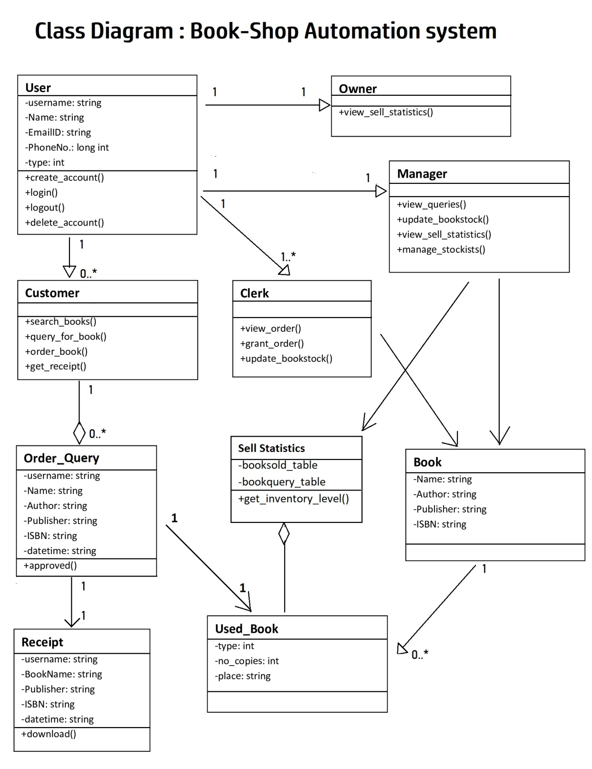

**Appendix D: To Be Determined List**

• The payment system is yet to be built. It will give a completeness of software.

• Business rules are completely decided yet.