PIZZA SALES SQL QUERIES:

A.KPI’S
1.Total Revenue:
SELECT SUM(total_price) AS total_revenue FROM pizza_sales;
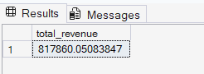
2.Average Order Value:
SELECT (SUM(total_price) / COUNT(DISTINCT order_id)) AS Average_order_value FROM pizza_sales;
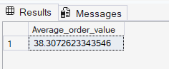
3.Total pizzas Sold:
SELECT SUM(quantity) AS total_pizzas_sold FROM pizza_sales;
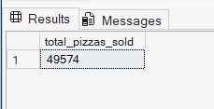
4.Total orders:
SELECT COUNT(DISTINCT order_id) AS totl_orders FROM pizza_sales;
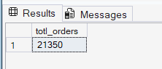
5.Average Pizza per order:
SELECT CAST(CAST(SUM(quantity) AS DECIMAL(10,2)) /
CAST(COUNT(DISTINCT order_id) AS DECIMAL(10,2)) AS DECIMAL(10,2))AS avg_pizza_per_odr FROM pizza_sales;
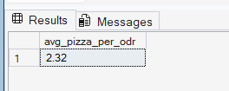

B. Daily Trend for Total Order:
SELECT DATENAME (DW, order_date) AS order_day, COUNT(DISTINCT order_id) AS total_order FROM pizza_sales GROUP BY DATENAME(DW, order_date);
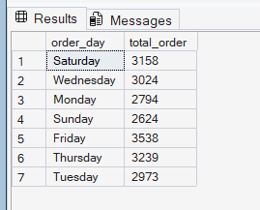
C. Monthly Trend For orders:
SELECT DATENAME(MONTH, order_date) AS monthly_trend, COUNT(DISTINCT order_id) AS total_orders FROM pizza_sales GROUP BY DATENAME(MONTH, order_date) ORDER BY total_orders DESC;
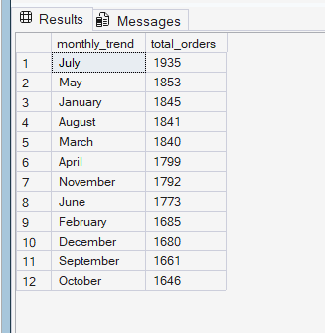

D. Percentage of Sales by Pizza Category:
SELECT pizza_category, CAST(SUM(total_price) AS DECIMAL(10,2)) AS total_sales,
CAST(SUM(total_price) * 100 /(SELECT SUM(total_price) FROM pizza_sales)AS DECIMAL(10,2)) AS PCT
FROM pizza_sales GROUP BY pizza_category;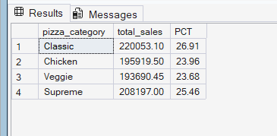
E. Percentage of Sales by pizza size:
SELECT pizza_size, CAST(SUM(total_price) AS DECIMAL(10,2)) AS total_sales,
CAST(SUM(total_price) * 100 /(SELECT SUM(total_price) FROM pizza_sales)AS DECIMAL(10,2)) AS PCT FROM pizza_sales
GROUP BY pizza_size;
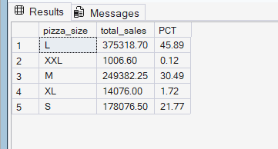
F. Total Pizza sold by pizza category:
SELECT pizza_category, SUM(quantity) AS pizza_sold FROM pizza_sales
WHERE MONTH(order_date) = 2
GROUP BY pizza_category
ORDER BY pizza_sold DESC ;

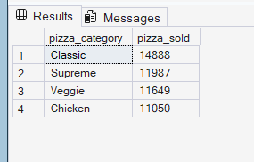
G. Top 5 pizzas sold by revenue:
SELECT TOP 5 pizza_name, CAST(SUM(total_price) AS DECIMAL(10,2)) AS totl_revenue FROM pizza_sales
GROUP BY pizza_name
ORDER BY totl_revenue DESC;
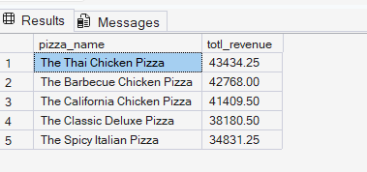
H. Bottom 5 pizzas sold by Revenue:
SELECT TOP 5 pizza_name, CAST(SUM(total_price) AS DECIMAL(10,2)) AS totl_revenue FROM pizza_sales
GROUP BY pizza_name
ORDER BY totl_revenue ASC;

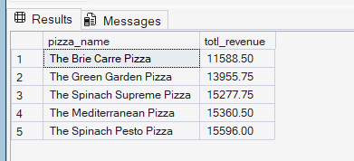

I. Top 5 pizzas sold By Quantity:
SELECT TOP 5 pizza_name, CAST(SUM(quantity) AS DECIMAL(10,2)) AS totl_quan FROM pizza_sales
GROUP BY pizza_name
ORDER BY totl_quan DESC;
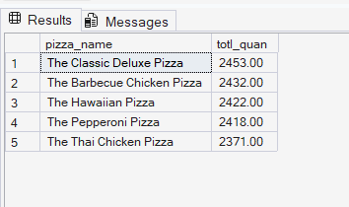
J. Bottom 5 pizzas sold by quantity:
SELECT TOP 5 pizza_name, CAST(SUM(quantity) AS DECIMAL(10,2)) AS totl_quan FROM pizza_sales
GROUP BY pizza_name
ORDER BY totl_quan ASC;
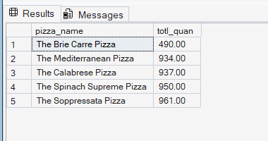
K. Top 5 pizzas sold by total orders :
SELECT TOP 5 pizza_name, COUNT(DISTINCT order_id) AS totl_quan FROM pizza_sales
GROUP BY pizza_name
ORDER BY totl_quan DESC;
SELECT TOP 5 pizza_name, COUNT(DISTINCT order_id) AS totl_orders FROM pizza_sales
GROUP BY pizza_name
ORDER BY totl_orders DESC;
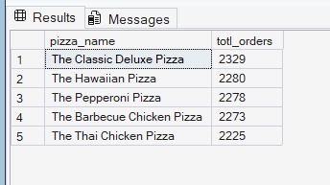
L. Bottom 5 pizzas sold by total orders:
SELECT TOP 5 pizza_name, COUNT(DISTINCT order_id) AS totl_orders FROM pizza_sales
GROUP BY pizza_name
ORDER BY totl_orders ASC;
