Deploying a Distributed Microservices Architecture on Virtual Machines Using VirtualBox

Introduction

Objective:

This project involves setting up multiple Windows 10 Virtual Machines (VMs) using VirtualBox, establishing network communication between them, and deploying a microservice-based application. The application consists of a RESTful API built with Node.js and a MongoDB database, hosted on separate VMs. The setup replicates a distributed system where services interact over a virtual network, providing practical experience in VM management, networking, and microservice deployment.

System Requirements:

  - Host System: Windows with sufficient RAM (8GB+ recommended) with a minimum hard disk space of 40 GB.
  - Virtual Machines: Windows 10 (two instances) iso file(any OS can be used, e.g – Ubuntu-Linux).
  - Software Requirements:
    - Oracle VirtualBox (for VM management)
    - VirtualBox Extension Pack (for enhanced networking)
    - Node.js (for building the API)
    - MongoDB (for database storage)
    - Git (optional for version control)
    - Postman (for API testing)
    - Windows PowerShell/Command Prompt (for command execution)

Virtual Machine Setup

Step 1: Install VirtualBox

- Download VirtualBox from VirtualBox Official Website and install it.

- Download and install the VirtualBox Extension Pack to enable additional networking features.

- Restart your computer if prompted after installation.

Step 2: Create Virtual Machines

- Open VirtualBox and click New to create a new VM.

- Enter a name for the VM (e.g., VM1-API for the API server, VM2-DB for the database server).

- Select Windows 10 (64-bit) as the operating system.

- Allocate at least 2GB RAM per VM (4GB recommended for better performance).

- Create a Virtual Hard Disk (at least 10GB, dynamically allocated).

- Install Windows 10 on the VM using an ISO file.

- Repeat the process for the second VM- Ubuntu.
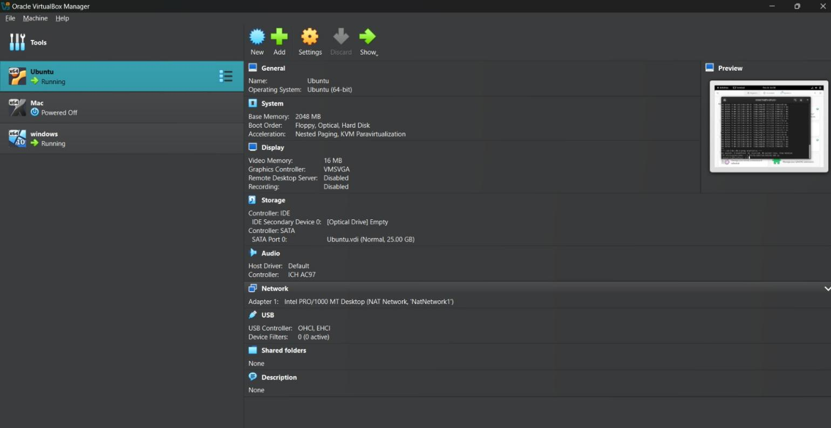

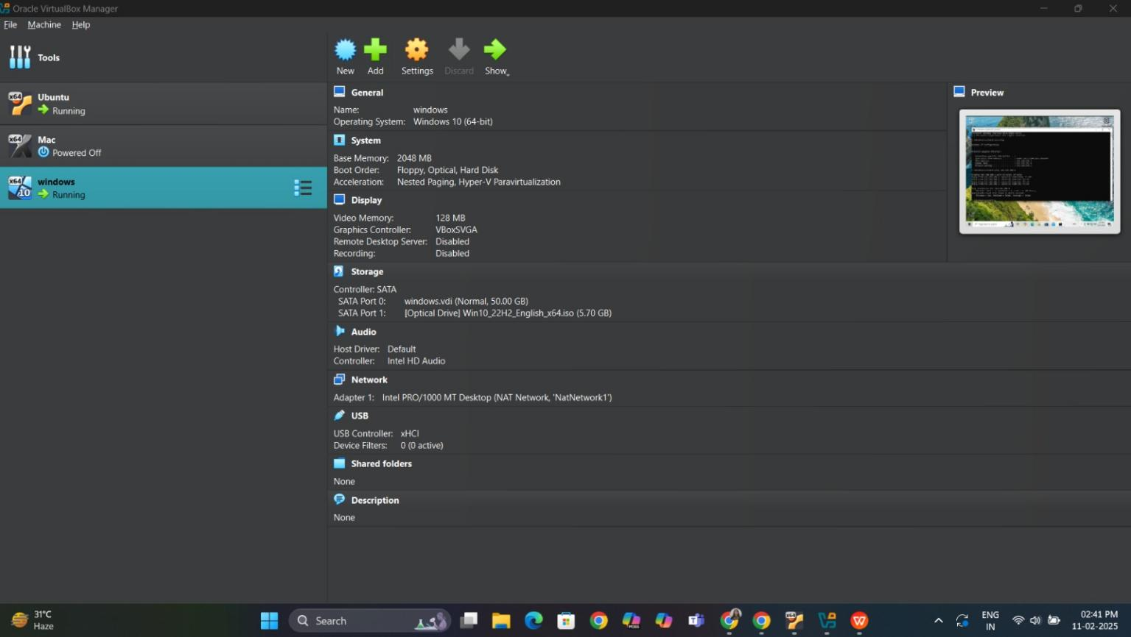
Figure 1: VM1 creation

Figure 2: VM2 creation

Step 3: Configure Network for VM Communication

- In VirtualBox, go to Settings → Network for each VM.

- Set to Nat network to enable communication between the VMs and set IP of 2 VMs..
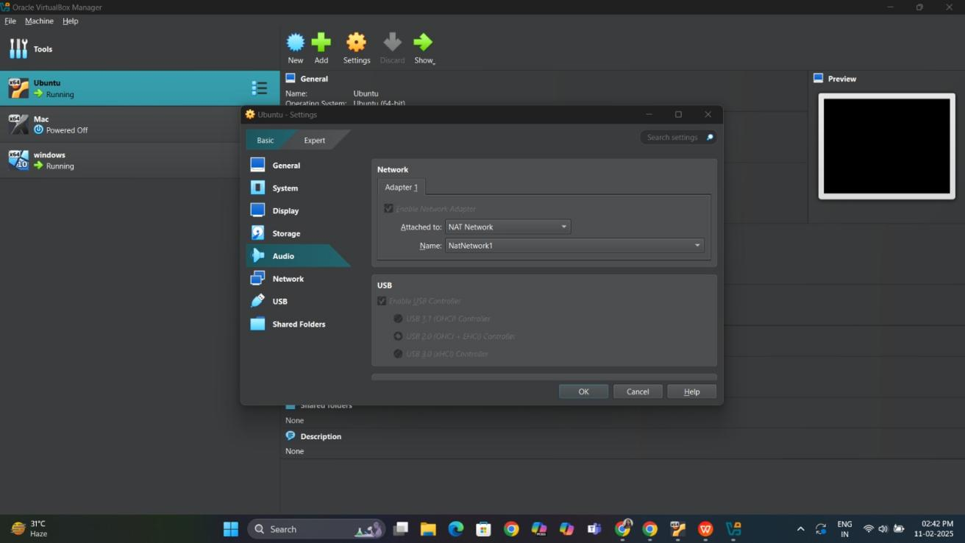

Figure 3: Network setting for each VM

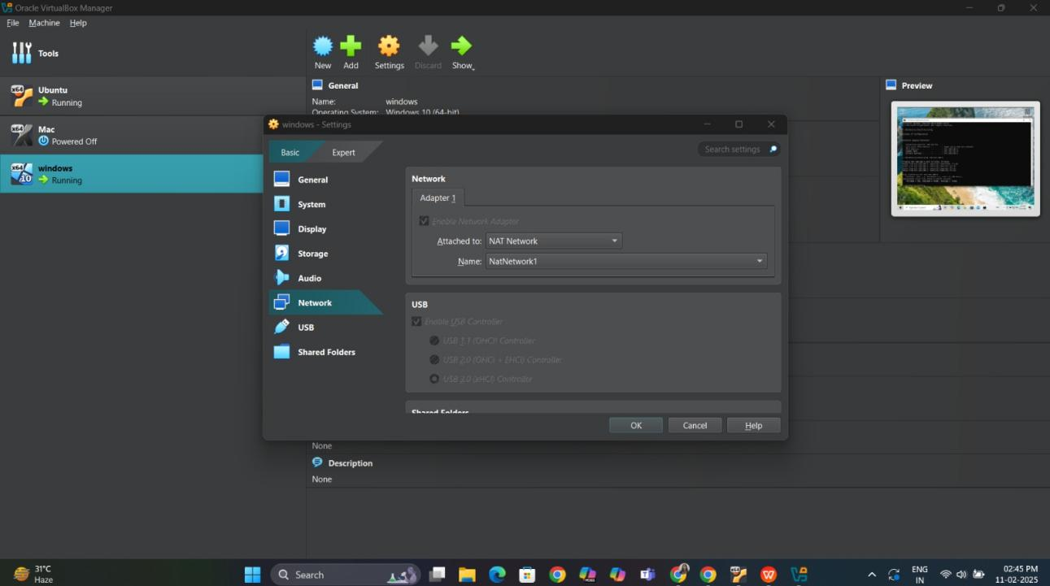
- Start both VMs and retrieve their IP addresses:

  - Open Command Prompt (CMD) in each VM and run:
ipconfig
  - Note down the IPv4 address (e.g., 192.168.100.4 for VM1, 192.168.100.5 for VM2).
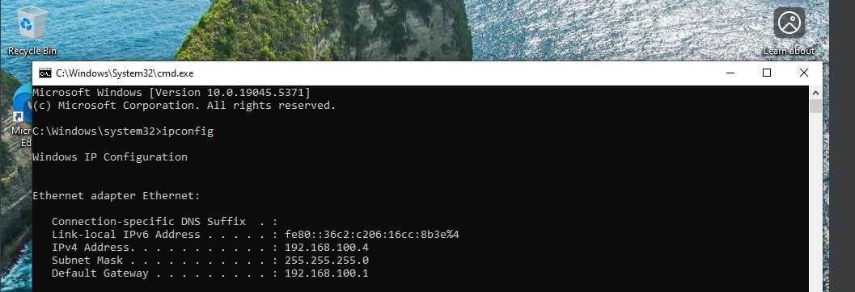

Figure 4: VM1's IPV4 address- ipconfig

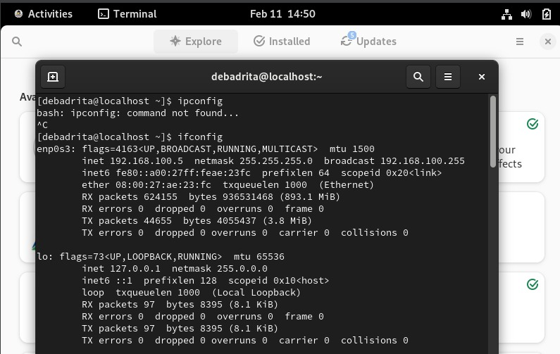

Figure 5: VM2's IPV4 address - command ifconfig

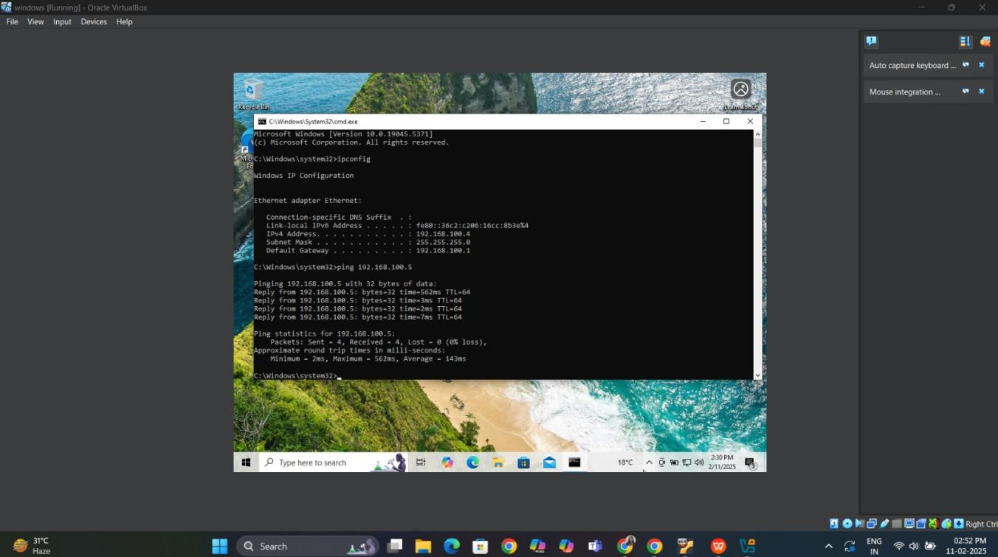
Figure 6: Connectivity test for VM2 from VM1

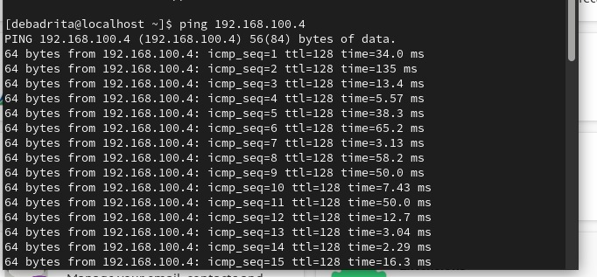
Figure 7: Connectivity test for VM1 from VM2

Setting Up the API Server (VM1 - Windows 10)

Step 4: Install Node.js

- Download and install Node.js from Node.js Official Website.
sudo apt update
sudo apt install -y nodejs npm

- Verify the installation by running:
node -v

npm -v

Step 5: Develop the Microservice
Open Command Prompt (CMD) and navigate to the project folder:
mkdir my-microservice
cd my-microservice
- Initialize a new Node.js project and install dependencies:
npm init -y
npm install --save-dev nodemon

- Create a new file index.js in the microservice folder:
touch index.js
nano index.js
const express = require('express');
const app = express();
const port = 3000;
app.get('/', (req, res) => {
res.send('Hello, this is a microservice!');
});

app.listen(port, () => {
console.log(`Microservice running on http://localhost:${port}`);
});

Run the Microservice:

node index.js

npx nodemon index.js

http://localhost:3000

Setting Up the Database Server (VM2 - Windows 10)

Step 6: Install MongoDB

- Download MongoDB Community Edition from MongoDB Official Website.

- Install MongoDB and ensure it runs as a Windows service.

- Start the MongoDB service:
net start MongoDB
- Allow remote connections:

  - Open C:\Program Files\MongoDB\Server\6.0\bin\mongod.cfg in Notepad.

  - Locate bindIp: 127.0.0.1 and change it to bindIp: 0.0.0.0.

  - Restart MongoDB:
net stop MongoDB

net start MongoDB

Testing the Microservice

Step 7: Verify API Connection
- From VM2, test the API by running:
curl http://192.168.100.4:3000
- Expected response:
Microservice Running

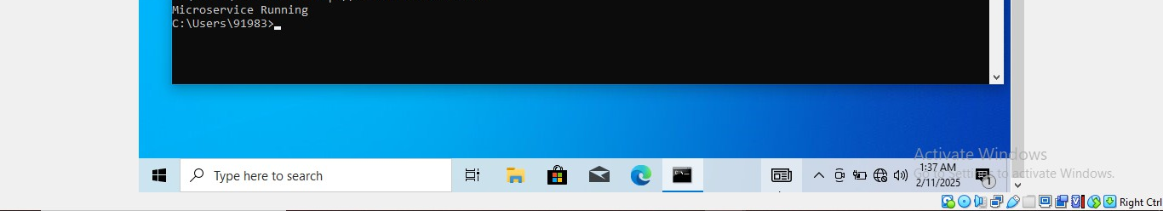

Figure 8: Connectivity test for API server using Microservice from VM2

- Verify MongoDB connection by checking the API logs:
Connected to MongoDB

API running on port 3000

- Alternatively, use Postman to send a GET request to:
http:// 192.168.100.4:3000

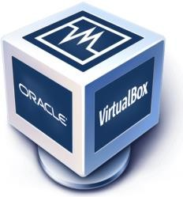
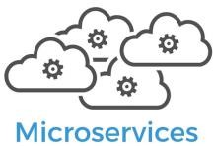

Architecture Diagram
VM1
Connected
through Internal
Network
API
Server
VM2
MongoDB
Node.js

- Source Code Repository

Github Repository Link

Recorded Video Demo

Deliverables

Included:

- Project Report (This Document)

- Architecture Diagram

- Source Code Repository

- Recorded Video Demo

Conclusion

This project successfully demonstrates the end-to-end process of setting up Virtual Machines, configuring network communication, and deploying a microservice-based application using Node.js and MongoDB. The configured environment replicates a real-world microservices architecture, allowing seamless interaction between services over a network. By implementing this setup, users gain hands-on experience with virtualization, networking, backend service deployment, and database management, making it an excellent foundation for learning distributed system design and deployment strategies.

