SUPPORTING INFORMATION

Large Seeds, Bats, and Tents: A Neotropical Dispersal Story
Debora Elías Díaz¹, Ricardo Sánchez-Calderón^{1,2}, Diego Salas-Solano², Miguel A. Martínez-Rodríguez³, Kate Good⁴, Silvia Alvarez-Clare⁴, Eduardo Venticinque⁵, Rodrigo A. Medellín⁶, Bernal Rodríguez-Herrera^{1,7}.

¹Graduate Studies System, School of Biology, University of Costa Rica, San Pedro de Montes de Oca 11501-2060, San José, Costa Rica.
²The School for Field Studies, Center for Amazon Studies (SFS), San Martín, Tarapoto 22201, Peru.
³Veragua Foundation, 70102, Limón, Costa Rica.
⁴Graduate Studies System, Western Campus (Sede de Occidente), University of Costa Rica, San Ramón, 20201, Alajuela, Costa Rica
⁵Department of Science and Conservation, The Morton Arboretum, IL, USA.
⁶Department of Ecology, Federal University of Rio Grande do Norte, 59078900 Lagoa Nova Natal, RN, Brazil.
⁷Department of Biodiversity Ecology, Institute of Ecology, National Autonomous University of Mexico, P.O. 70-275, C.P. 04510, México DF, México.
⁸Center for Research in Biodiversity and Tropical Ecology (CIBET in Spanish), University of Costa Rica, San Pedro de Montes de Oca 11501-2060, San José, Costa Rica.

¹Corresponding author; debaelias@gmail.com | debora.elias@ucr.ac.cr

Figure S1. Interactions between the most frequently dispersed plant families and tent-roosting bats. Band width on the plant side represents species richness within each family; on the bat side, it represents the number of plant species dispersed by each bat species. The color ring highlights the major angiosperm clades to which the plant families belong (scale: Magnolids “green”, Monocotyledon “yellow”, Rosids “orange”, Asterids “grey”). (Abbreviature of some families: Calophy: Calophyllaceae; Chryso: Chrysobalanaceae; Sapinda: Sapindaceae; Annona: Annonaceae). For bats, it indicates the species of tent-roosting bat involved in large-seeded dispersal. Subfamily Stenodermatinae (Artibeus jamaicensis, A. lituratus, Dermanura phaeotis, D. watsoni, D. tol: Dermanura tolteca; U. bil: Uroderma bilobatum; U. conv: U. convexum). Subfamily Rhinophyllinae (R. pum: Rhinophylla pumilio).
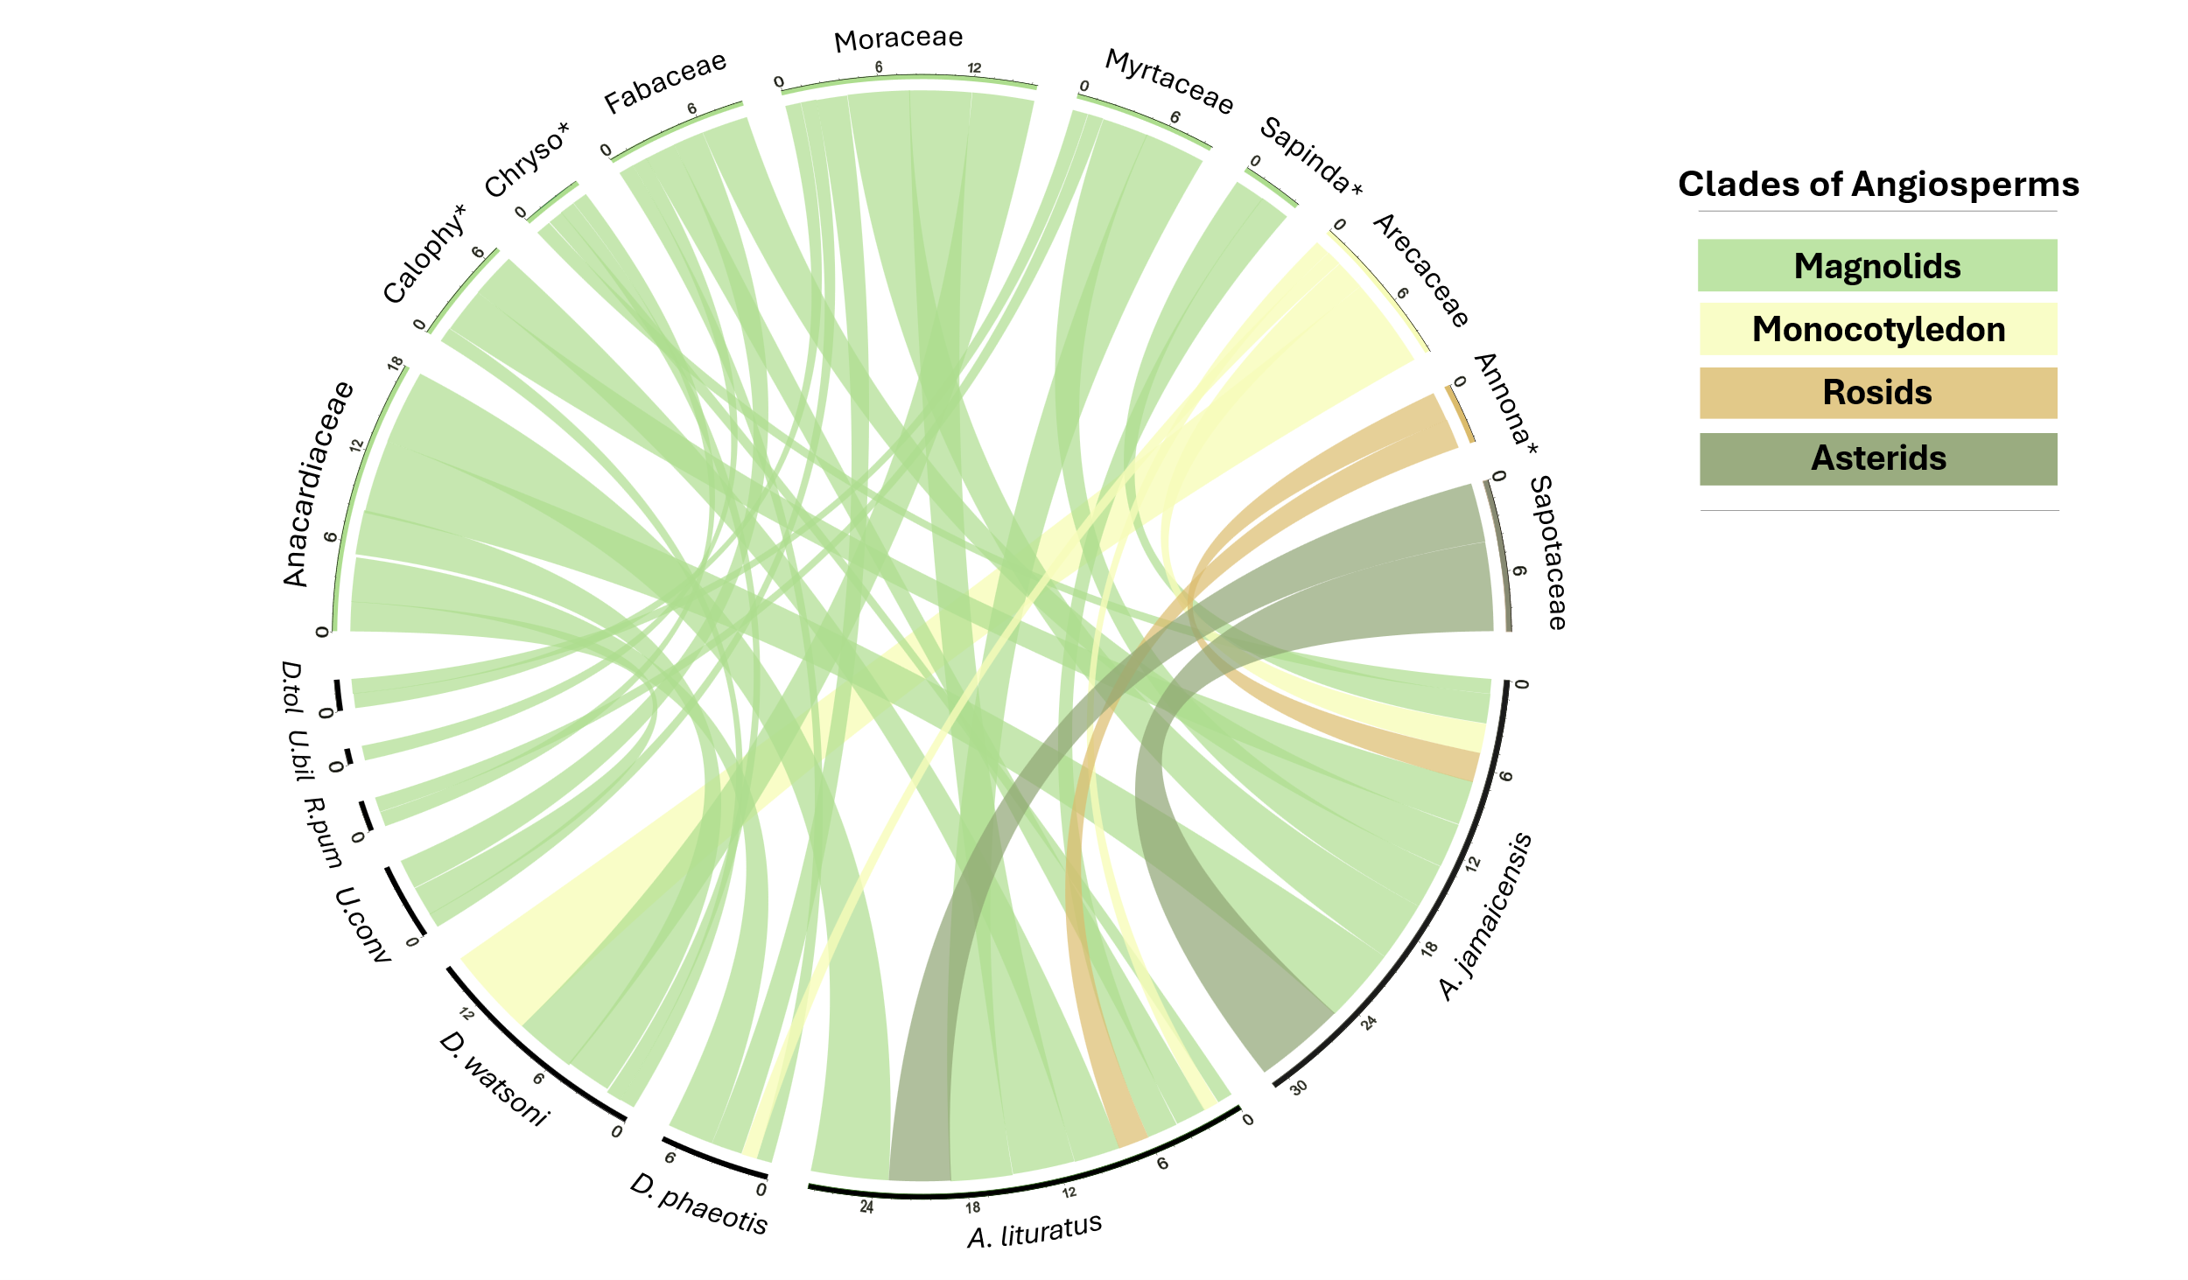

Table S3. Summary of evidence on fruit traits (mature color) of plant species dispersed by tent-roosting bats in the Neotropics. Trait information was obtained from the Tropicos database.
Table S4. Summary of evidence on fruit traits (shape) of plant species dispersed by tent-roosting bats in the Neotropics. Trait information was obtained from the Tropicos database.

Classification of fruit color | Number of species | % |  | Classification of fruit shape | Number of species | %
Yellow | 21 | 23.3 |  | Cylindrical | 2 | 2.0
Yellow - orange | 4 | 4.4 |  | Ellipsoidal - subglobose | 2 | 2.0
Yellow - brown | 3 | 3.3 |  | Ellipsoidal | 9 | 9.2
Orange | 5 | 5.6 |  | Ellipsoidal - globose | 7 | 7.1
Orange - red | 3 | 3.3 |  | Ellipsoidal - oblong | 2 | 2.0
Brown | 2 | 2.2 |  | Ellipsoidal - ovoid | 8 | 8.2
Brown - red | 1 | 1.1 |  | Globose | 28 | 28.6
Brown - green | 1 | 1.1 |  | Globose-oblong | 1 | 1.0
Gray - purple | 1 | 1.1 |  | Globose-ovoid | 3 | 3.1
Light brown | 2 | 2.2 |  | Oblate | 1 | 1.0
Light brown - yellow | 2 | 2.2 |  | Oblong | 4 | 4.1
Light brown - green | 1 | 1.1 |  | Obovoid | 4 | 4.1
Black | 11 | 12.2 |  | Ovoid | 13 | 13.3
Black - purple | 5 | 5.6 |  | Ovoid-globose | 4 | 4.1
Black – purple - red | 1 | 1.1 |  | Ovoid-oblong | 1 | 1.0
Purple | 3 | 3.3 |  | Pyriform | 2 | 2.0
Purple - blue | 1 | 1.1 |  | Reniform | 2 | 2.0
Purple - black | 1 | 1.1 |  | Subglobose | 5 | 5.2
Purple - red | 1 | 1.1 |  | Total species | 98 | 100.0
Red | 15 | 17.0
Red - yellow | 1 | 1.1
Red - orange | 1 | 1.1
Green | 4 | 4.4
Total species | 90 | 100.0

Table S5. Estimated parameters from the quantile regression analysis assessing the effect of forearm length (FA, mm) on fruit size (FL, mm) of fruits dispersed by tent-roosting bats. Includes coefficients, 95% confidence intervals (LC, UC), statistical significance, and pseudo-R² for quantiles 0.1, 0.15, 0.2, 0.5, 0.8, 0.85, and 0.9. Coefficient (FA: Forearm length).
Quantile | Coefficient (AB) | Lower LC | Upper UC | p-value | Pseudo-R²
0.10 | 0.1960 | 0.0899 | 0.2678 | 0.0388** | 0.0387
0.15 | 0.2156 | -0.0613 | 0.2762 | 0.0670 | 0.0131
0.20 | 0.0196 | -0.1486 | 0.2934 | 0.8811 | 0.0005
0.50 | 0.1372 | -0.0636 | 0.2638 | 0.1736 | 0.0069
0.80 | 0.4991 | -0.0401 | 0.9469 | 0.0531 | 0.0525
0.85 | 0.7415 | 0.2728 | 0.9291 | 0.0062** | 0.0781
0.90 | 0.6862 | -0.1056 | 1.0913 | 0.0440** | 0.0588
**: statistical significance.

Figure S2. Relationship between fruit size (length, mm) and forearm length (mm) in Neotropical tent-roosting bats was evaluated using quantile regression. A statistically significant positive relationship was detected at the lower quantile (A) and was markedly stronger in upper quantiles (C,D), indicating that forearm length influences dispersal capacity across the distribution of fruit sizes dispersed. Notably, as fruit size increases, dispersal becomes increasingly restricted to bats with larger forearms, highlighting body size as a key morphological trait underlying the transport of large fruits.
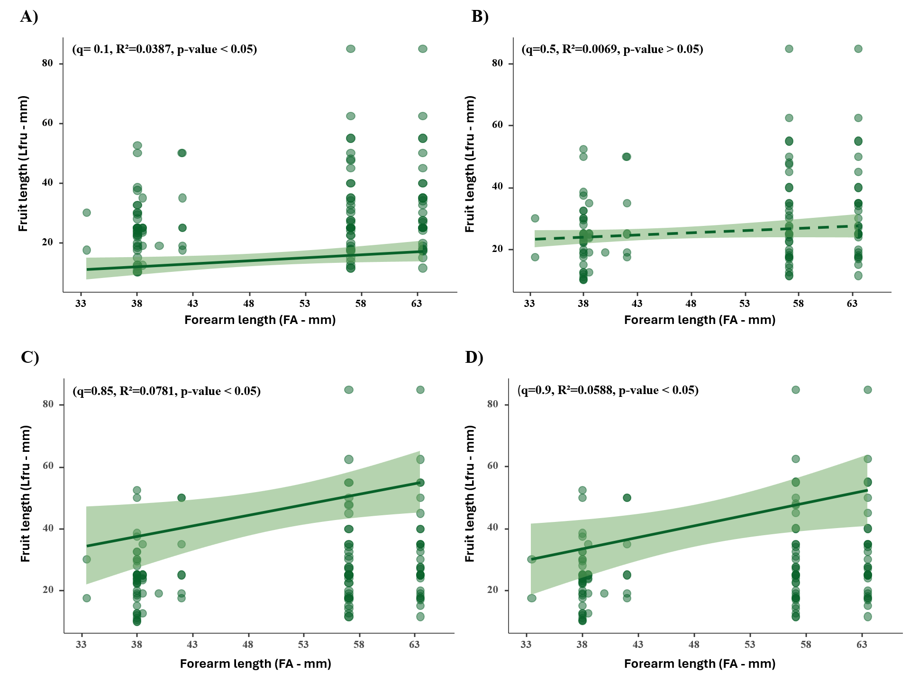

Table S6. List of large-seeded plants dispersed by tent-roosting bats in the Neotropics and their primary economic uses related to food, production, and construction that are relevant to humans. Abbreviations for tent-roosting bat species: (A: Artibeus) Artibeus lituratus; A. jamaicensis; (D: Dermanura) Dermanura phaeotis; D. tolteca; D. watsoni; (U: Uroderma) Uroderma convexum.
Plant species | Food - human | Food - animal | Medicine - human & veterinary | Poisons | Manufacturing chemicals | Other chemicals | Fuels | Construction or structural | Wearing apparel, accessories | Other household goods | Handicrafts, jewellery | Pets/display animals, horticulture | Research | Sport hunting/ specimen collecting | Establish ex-situ production | Fibre | Tent-roosting bast
Spondias mombin | Yes | Yes | Yes | -- | -- | -- | -- | Yes | -- | Yes | Yes | -- | -- | -- | -- | -- | A.lituratus, A.jamaicensis, A.phaeotis, A.watsoni, U.convexum.
Anacardium excelsum | Yes | -- | -- | -- | -- | -- | -- | Yes | -- | Yes | Yes | Yes | -- | -- | -- | Yes | A.lituratus, A.jamaicensis, A.phaeotis, A.watsoni
Anacardium occidentale | Yes | -- | Yes | -- | -- | -- | Yes | Yes | -- | -- | -- | -- | -- | -- | -- | -- | A.lituratus, A.jamaicensis
Iriartea deltoidea | ​ | ​ | -- | -- | -- | -- | -- | Yes | -- | -- | -- | -- | -- | -- | -- | -- | A.watsoni, A.phaeotis
Acrocomia aculeata | Yes | Yes | -- | -- | -- | -- | -- | -- | -- | -- | -- | -- | -- | -- | -- | -- | A.lituratus, A.jamaicensis
Socratea exorrhiza | -- | -- | -- | -- | -- | -- | -- | Yes | Yes | -- | Yes | -- | -- | -- | -- | -- | A.watsoni
Welfia regia | -- | -- | -- | -- | -- | -- | -- | Yes | -- | -- | -- | -- | -- | -- | -- | -- | A.watsoni
Socratea exorrhiza | -- | -- | -- | -- | -- | -- | -- | Yes | Yes | -- | Yes | -- | -- | -- | -- | -- | A.jamaicensis
Protium panamense | -- | -- | -- | -- | -- | -- | -- | Yes | -- | -- | -- | -- | -- | -- | -- | -- | A.watsoni
Calophyllum brasiliense | -- | -- | Yes | -- | -- | -- | -- | Yes | -- | -- | -- | -- | -- | -- | -- | -- | A.lituratus, A.jamaicensis, A.watsoni
Mammea americana | Yes | Yes | -- | -- | -- | -- | -- | -- | -- | -- | -- | -- | -- | -- | -- | -- | A.lituratus, A.jamaicensis
Symphonia globulifera | Yes | -- | -- | -- | -- | -- | -- | Yes | -- | -- | -- | Yes | -- | -- | -- | -- | A.watsoni
Terminalia catappa | Yes | -- | Yes | -- | -- | -- | -- | Yes | -- | Yes | -- | -- | -- | -- | -- | -- | A.lituratus, A.jamaicensis
Andira inermis | -- | -- | -- | -- | -- | -- | -- | Yes | -- | Yes | -- | -- | -- | -- | -- | -- | A.lituratus, A.jamaicensis, A.phaeotis, U.convexum
Humiriastrum diguense | -- | -- | -- | -- | -- | -- | -- | Yes | -- | -- | -- | -- | -- | -- | -- | -- | A.watsoni
Vitex cooperi | -- | -- | -- | -- | -- | -- | -- | Yes | -- | -- | -- | -- | -- | -- | -- | -- | A.watsoni
Brosimum alicastrum | -- | Yes | -- | -- | -- | -- | -- | Yes | -- | -- | -- | Yes | -- | -- | -- | -- | D.toltecus, A.jamaicensis, A.lituratus, A.watsoni, A.phaeotis, U.convexum
Poulsenia armata | Yes | -- | -- | -- | -- | -- | -- | Yes | -- | -- | -- | -- | -- | -- | -- | -- | A.lituratus, A.jamaicensis, A.phaeotis, A.watsoni
Muntingia calabura | Yes | -- | Yes | -- | -- | -- | Yes | Yes | -- | -- | -- | Yes | -- | -- | -- | Yes | A.jamaicensis
Virola sebifera | -- | -- | -- | -- | -- | -- | -- | -- | -- | -- | -- | -- | -- | -- | -- | -- | A.watsoni
Eugenia uniflora | Yes | -- | Yes | -- | -- | -- | -- | -- | -- | -- | -- | Yes | Yes | -- | Yes | -- | A.lituratus
Sapindus saponaria | -- | -- | -- | -- | -- | -- | -- | -- | Yes | Yes | -- | -- | -- | -- | -- | -- | A.lituratus, A.jamaicensis
Manilkara zapota | Yes | -- | -- | -- | -- | -- | Yes | Yes | -- | -- | -- | -- | -- | -- | -- | -- | A.lituratus, A.jamaicensis
Chrysophyllum cainito | Yes | -- | Yes | -- | -- | -- | -- | Yes | -- | Yes | -- | Yes | -- | -- | -- | Yes | A.lituratus, A.jamaicensis
Manilkara bidentata | -- | -- | Yes | -- | -- | Yes | -- | Yes | -- | -- | -- | -- | -- | -- | -- | -- | A.lituratus, A.jamaicensis
Simarouba amara | -- | -- | Yes | -- | -- | -- | -- | Yes | -- | Yes | Yes | -- | -- | -- | -- | -- | A.watsoni

