- Download Git:
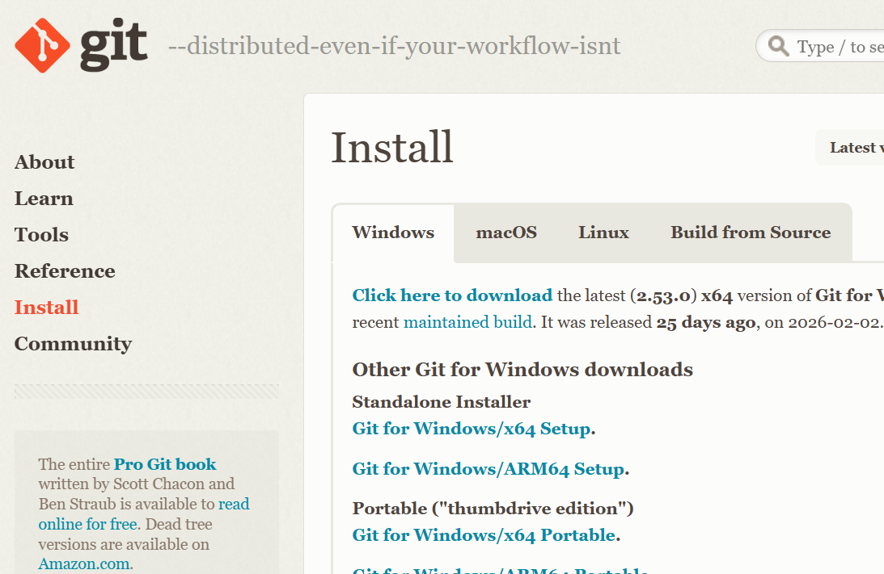

- Install Git:

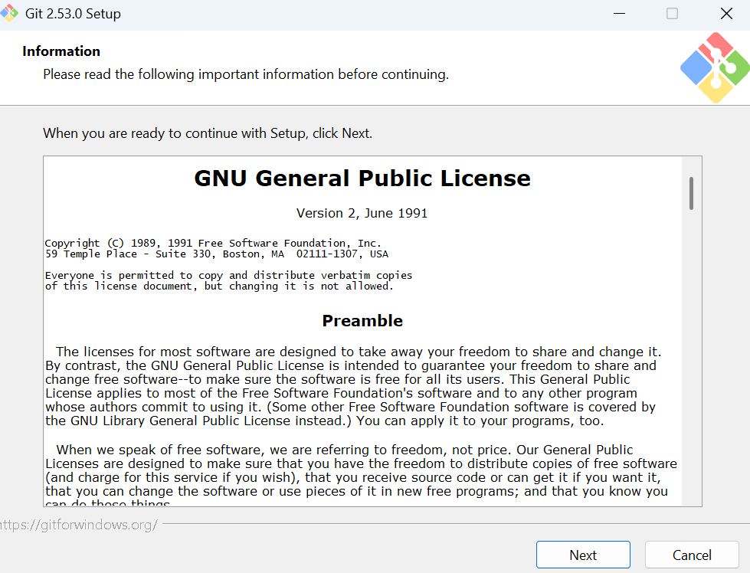

# Git version Check:

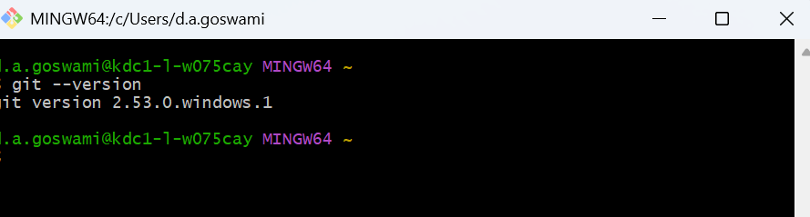
# Identity configuration: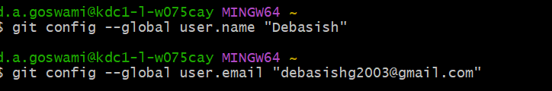

# Folder setup for Git:
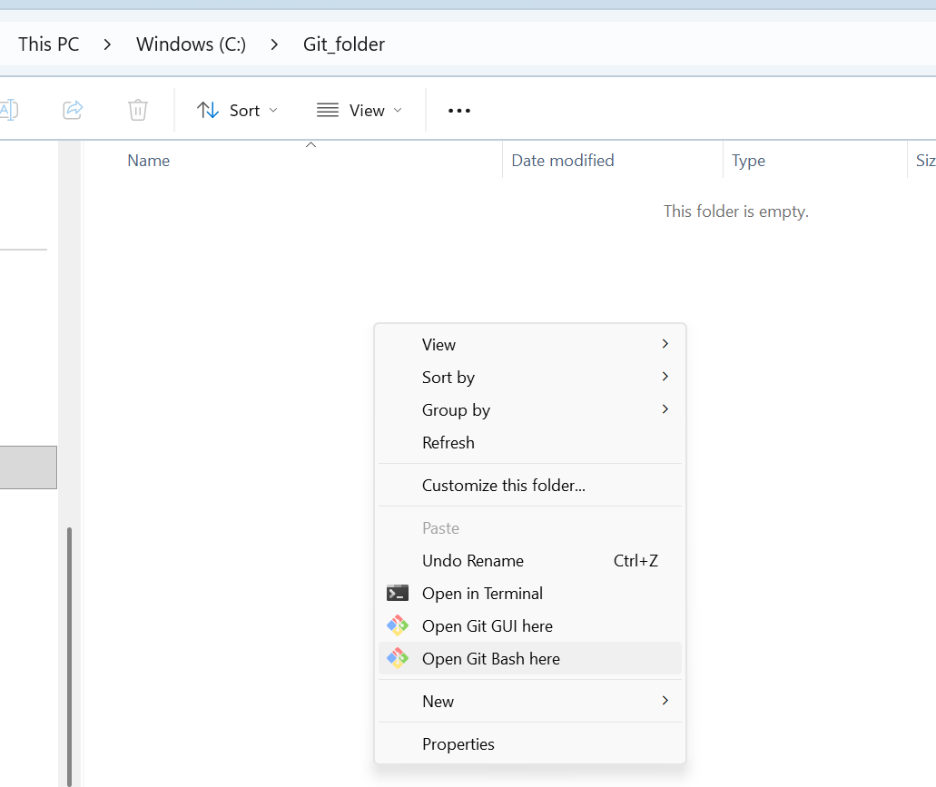

# Git init:
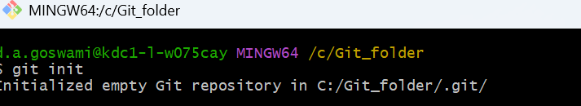
# ls -lart:
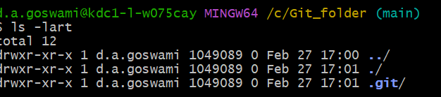

# Shifted to Visual studio code, If Git bash is not available as a terminal
