# **InsightsNet_CWB_CCC**

**img_1:**

In the img_1, you can see where my “InsightsNet_cwb_ccc” folder is located. You can keep your “InsightsNet_cwb_ccc” folder in any location. For me it is in “Desktop”.

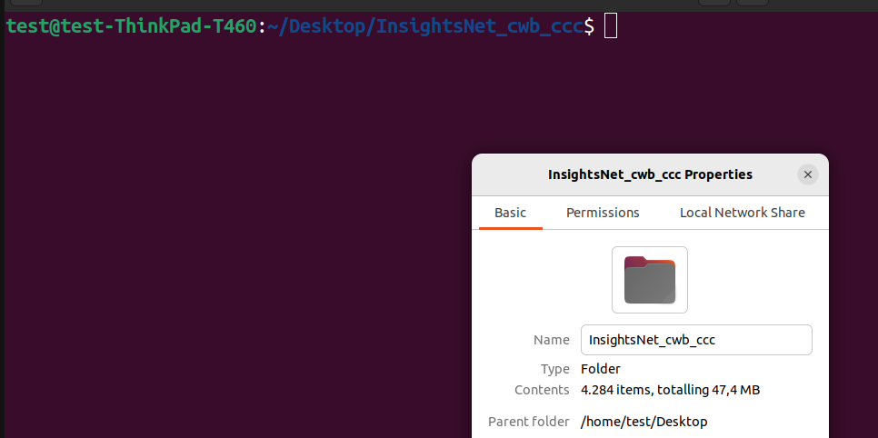

**Img_2:**

In the img_2, you can see all the files in “InsightsNet_cwb_ccc”.

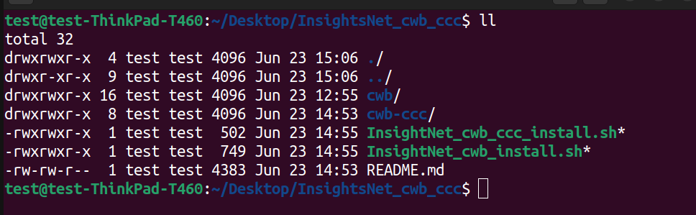

**Img_3:**

In the img_3, you can see the path of “InsightsNet_cwb_ccc”, where this folder is located. You need this path only for both shell scripts.

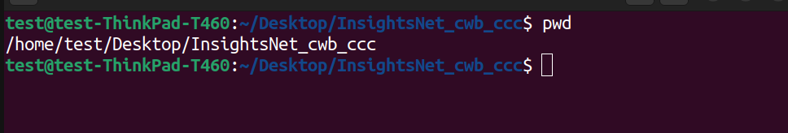

**Img_4:**

In the img_4, we are executing the “./InsightsNet_cwb_install.sh” file. And we are passing the path from the img_3.

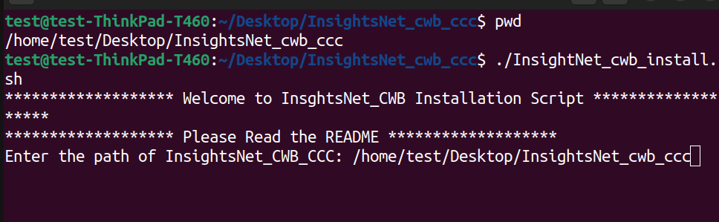

**Img_5:**

In the img_5, we are executing the “./InsightsNet_cwb_ccc_install.sh” file. And we are passing the path from the img_3.

