Write-back APIs and Endpoints

Looker write-back · Spoke 1 GKE · namespace writeback

Write-back APIs and endpoints
Two services to deploy for the write-back feature (option 3: Looker action secret + Looker group + Workload Identity). No extra API is needed to check group membership: Looker sends it with every click. For each: what it does, its identity, who may reach it, and every endpoint.

1. Service map
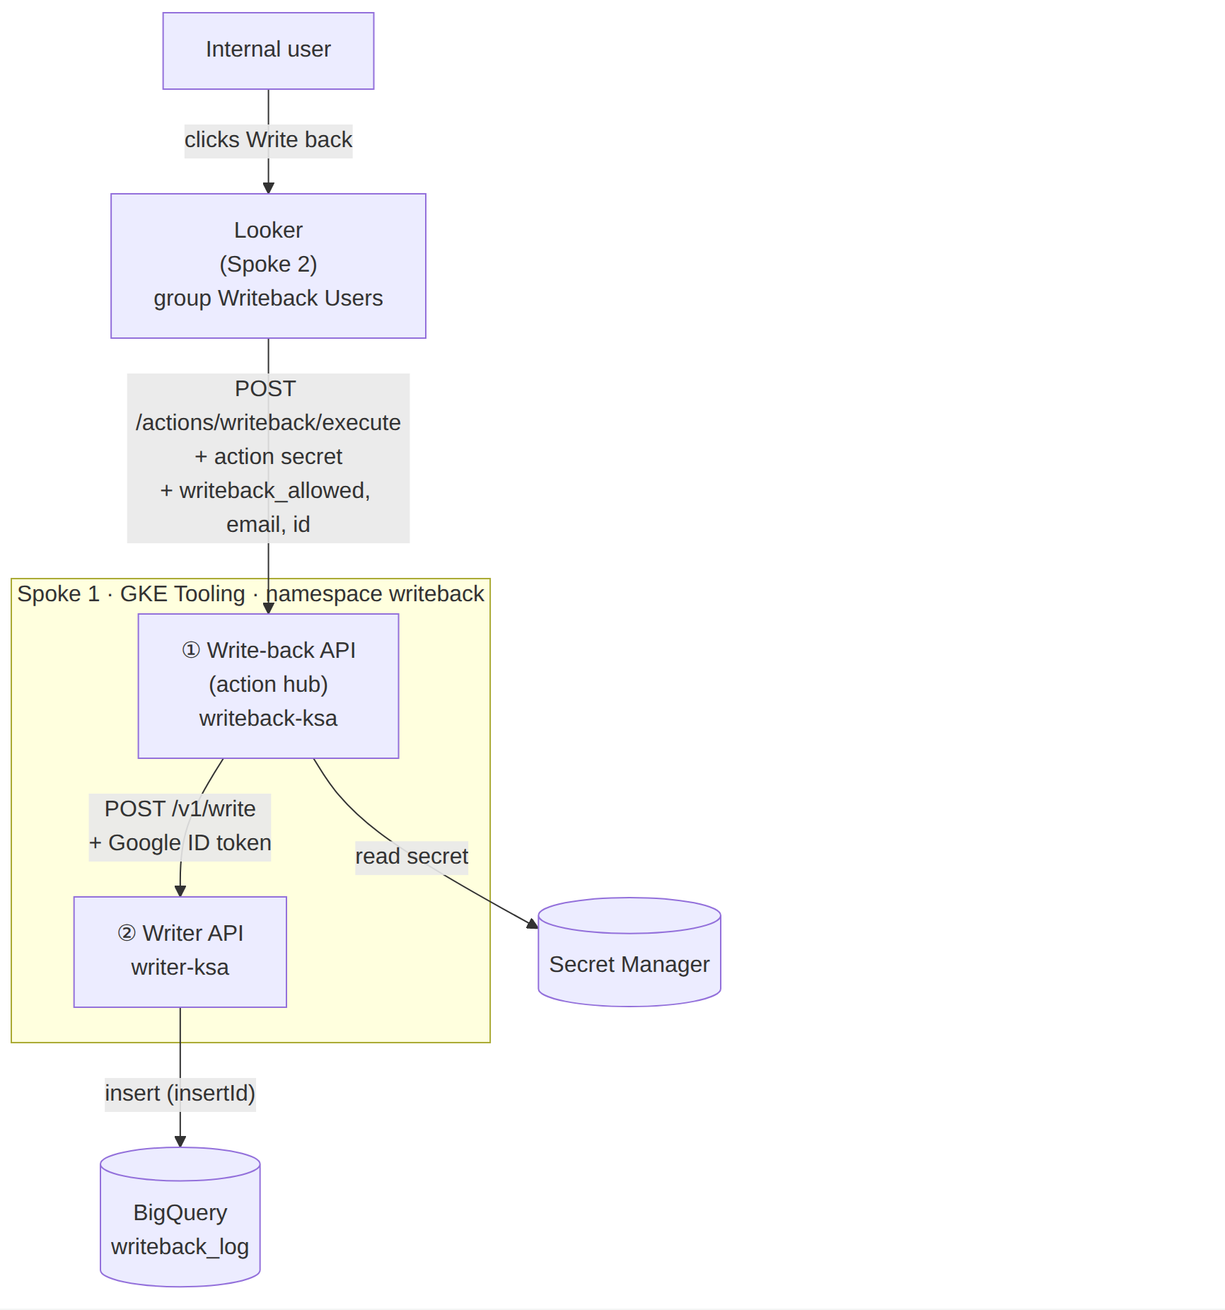

2. Summary
# | Service | Endpoints | Reachable from | Google identity | Can access
1 | Write-back API | POST /  POST /actions/writeback/form  POST /actions/writeback/execute  GET /healthz, /readyz | Looker only (internal LB + firewall) | writeback-api@ | looker-action-secret · Writer API
2 | Writer API | POST /v1/write  GET /healthz | Write-back API only (ClusterIP + NetworkPolicy) | writer@ | BigQuery writeback.writeback_log (insert)

3. Services

1. Write-back API Looker action hub · writeback
Receives Looker’s “Write back” calls, proves the caller is Looker, checks the user is in the Looker group “Writeback Users” (writeback_allowed = yes), validates the change and hands it to the Writer.
Deployment
writeback-api · 2 replicas · namespace writeback
Identity
KSA writeback-ksa → GSA writeback-api@: secretAccessor on looker-action-secret (nothing else)
Exposed
Internal LB https://writeback-api.internal; firewall allows only Looker’s range; TLS certificate from the internal CA, which Looker must trust
Calls
Secret Manager · Writer API
Authorisation
Looker group Writeback Users → user attribute writeback_allowed = yes, sent by Looker on every click
Secrets
looker-action-secret (same value as Looker › Admin › Actions › Authorization Token)

Endpoints
POST/
Returns the action list: “Write back”, supported on cells with tag writeback_key, and asks Looker to send the user attributes writeback_allowed, email and id as parameters.
Called by
Looker, when the action hub is added or refreshed
Auth
Authorization: Token token="<looker-action-secret>"
Success
200 {label, integrations[]}
Errors
401 wrong secret
POST/actions/writeback/form
Returns the input fields the user fills in (e.g. new value, comment).
Called by
Looker, before showing the action (only if a form is used)
Auth
Action secret
Success
200 form definition
Errors
401
POST/actions/writeback/execute
Steps 3–8: check secret, require writeback_allowed = yes, validate rows, set request_id, call Writer with the user’s email and id, audit, return result.
Called by
Looker’s server (never the browser), once per click when the user clicks “Write back” or submits the form
Auth
Action secret
Success
200 {"looker":{"success":true,"refresh_query":true}}
Errors
401 not Looker · 403 not in Writeback Users · 400 invalid change · 503 Writer/BigQuery down
GET/healthz · /readyz
Readiness checks the secret can be read.
Called by
GKE probes
Auth
none
Success
200
Errors
503

2. Writer API BigQuery writer · writeback
The only component that can write to BigQuery. Accepts calls only from the Write-back API’s service account.
Deployment
writer (Node.js) · 2 replicas · namespace writeback
Identity
KSA writer-ksa → GSA writer@: bigquery.dataEditor on writeback.writeback_log only
Exposed
ClusterIP only; NetworkPolicy allows only writeback-api pods
Calls
BigQuery (insert with insertId)

Endpoints
POST/v1/write
Verifies the Google ID token (audience https://writer.internal, caller = writeback-api@), then appends the row with insertId = request_id.
Called by
Write-back API only
Auth
Authorization: Bearer <Google ID token>
Success
200 {ok:true}
Errors
401 bad token · 403 wrong caller · 503 BigQuery error
GET/healthz
Liveness and readiness.
Called by
GKE probes
Auth
none
Success
200
Errors
503
json · /v1/write body
{ "request_id": "wb-7d1f…", "record_key": "STORE-0042|2026-11", "field": "forecast_value",
"new_value": "1310", "actor_email": "jane.doe@bank.example", "actor_id": "2381" }

4. Dependencies
Dependency | Used by | How it is reached | Permission
Looker action hub settings | Looker | Admin › Platform › Actions › Add Action Hub: URL https://writeback-api.internal + Authorization Token | Looker admin
Secret Manager · looker-action-secret | Write-back API | Google API, Workload Identity | secretAccessor on this secret for writeback-api@
Looker group Writeback Users + user attribute writeback_allowed | Looker → Write-back API | Admin › Users › Groups (manual members); attribute default no, group value yes; sent as an action parameter | Looker admin
BigQuery · writeback.writeback_log | Writer API | Google API, Workload Identity | bigquery.dataEditor on this table for writer@
Cloud Logging | both | stdout (structured JSON) | default

5. Deployment rules
Identity
writeback-ksa → writeback-api@ and writer-ksa → writer@ through Workload Identity. No key files.
Secret
Only looker-action-secret, read at run time from Secret Manager, cached 5 minutes. Never in YAML or images.
Network
Default-deny NetworkPolicy in writeback. Write-back API: internal LB, firewall allows Looker’s range only. Writer: from writeback-api pods only.
TLS
Serve writeback-api.internal with a certificate from your internal CA and add that CA to Looker’s trust store.
Probes
/healthz liveness, /readyz readiness. Cluster-internal only.
Logging
Structured JSON with request_id, user email and Looker id. Never log the action secret or tokens.
Runtime
2 replicas each, PodDisruptionBudget, non-root, read-only file system, resource limits.

