Looker Write-Back to BigQuery
Solution Architecture Document
Secure write-back from Looker dashboards to BigQuery using an Entra token exchanged for an ID&A JWT, verified by JWKS, then machine-to-machine service accounts
Item | Detail
Document | 01 Solution Architecture Document
Version | 0.1 — Draft for Architecture Council
Date | 6 October 2026
Prepared by | Solution Architecture
Status | For review
Related | looker-writeback-oauth2-entra-v4.drawio · 02 Security & Threat Assessment · 03 End-to-End Steps · 04 API & Endpoint Specification

Contents
1. Executive summary
2. Scope
3. Business context and requirements
4. Architecture overview
5. Components
6. Runtime flow (summary)
7. Identity and trust model
8. Architecture decisions
9. Non-functional requirements
10. Deployment and network
11. Operations
12. Risks, assumptions and open decisions
13. Approval

1. Executive summary
Business users need to correct or enrich values directly from Looker dashboards (“write-back”) and see the change reflected immediately. This document describes how a write-back click in Looker reaches BigQuery securely, using the bank’s identity services (Microsoft Entra ID and ID&A) and Google Cloud service accounts, without user passwords, static API keys or long-lived tokens on the wire.
Decision requested: approve the target design in section 6 and the open decisions in section 12.
- Every write is authenticated twice: the caller (Action Hub) proves itself with an ID&A-issued JWT obtained by exchanging an Entra token through Apigee; the Write-back API verifies that JWT against ID&A’s public keys (JWKS).
- Every write is authorised for the user: the user’s Entra identity is checked live (Microsoft Graph) for membership of the write-back group, fail-closed.
- Everything after verification is machine-to-machine: the Write-back API calls the Writer with a Google ID token, and the Writer writes to BigQuery as its own service account through Workload Identity — no keys, no user tokens.
- ID&A is reached only through the Apigee internal proxy, in line with the bank’s integration standard.

2. Scope
In scope | Out of scope
Write-back action on Looker dashboards for internal (Entra) users  Action Hub, Write-back API, Writer API on GKE  Token exchange Entra → ID&A via Apigee; JWKS verification  BigQuery write table and current-state view  Audit, monitoring, secrets, network controls | External partner access (covered by the partner dashboard design)  Bulk/batch data loads  Changes to Looker SAML sign-in  Data model changes beyond the write-back table

3. Business context and requirements
ID | Requirement | How the design meets it
FR-1 | Authorised users can change a value from a Looker dashboard | Looker action “Write back” on tagged fields; Action Hub → Write-back API → Writer → BigQuery
FR-2 | The dashboard shows the new value after saving | Writer appends to writeback_log; current_state view returns latest value; Looker refreshes the query
FR-3 | Each change is traceable to a person | entra_oid and email carried with every write; stored in each row and in Cloud Logging
SR-1 | Service calls must carry an ID&A-issued token | Action Hub exchanges an Entra token for an ID&A JWT via Apigee
SR-2 | Tokens must be verified before data is touched | Write-back API verifies the JWT (signature via JWKS, issuer, audience, expiry, scope)
SR-3 | No static credentials for Google access | Workload Identity for all pods; no service-account keys
SR-4 | Least privilege | Writer can only insert into one table; each service reads only its own secret
SR-5 | ID&A reached only via Apigee | Token exchange and JWKS both go through lloyds-auth-int

4. Architecture overview
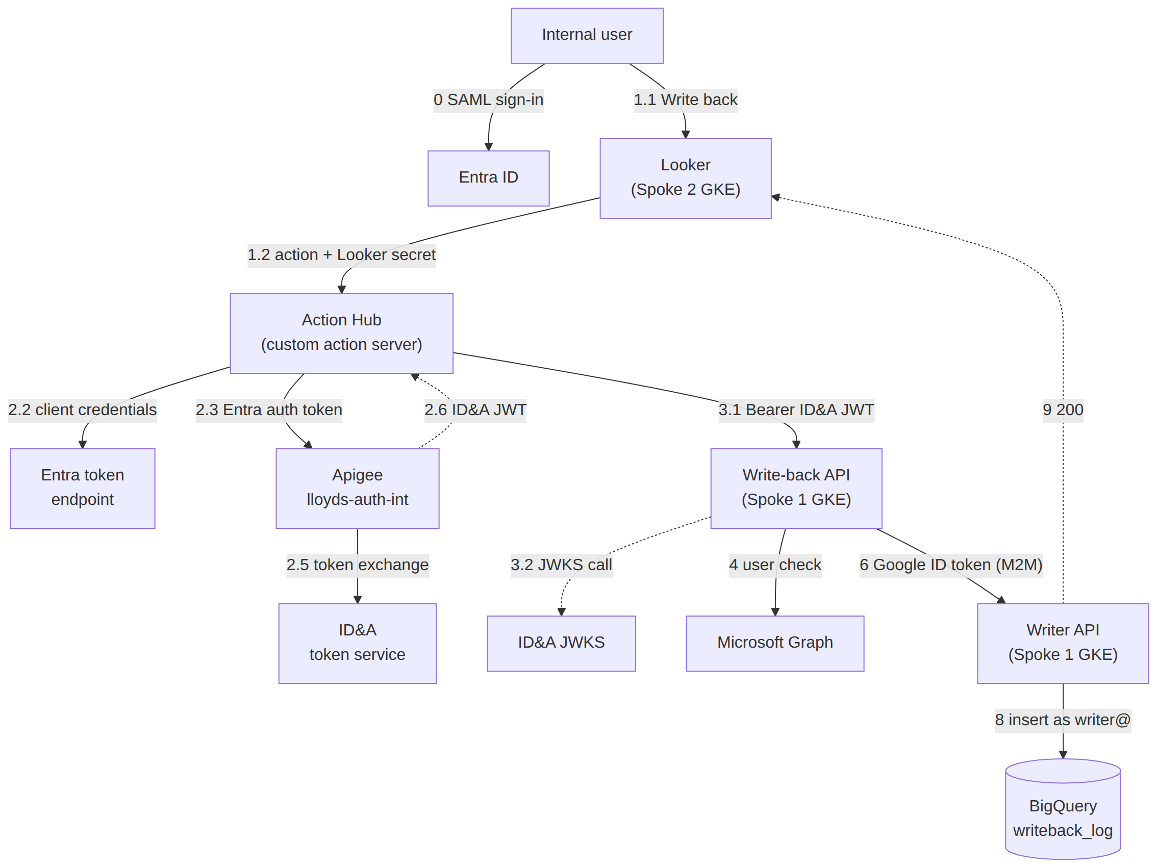
Figure 1 — Logical architecture (full detail in looker-writeback-oauth2-entra-v4.drawio)
The diagram file contains every sub-step as numbered boxes (0.1 – 10). The numbering is used consistently across all four documents.

5. Components
Component | Location | Responsibility | Identity
Looker | Spoke 2 · GKE | Dashboards; SAML sign-in with Entra; fires the write-back action from its server | Looker action secret (shared with Action Hub)
Action Hub (custom action server) | Looker project · GKE | Receives Looker action calls; verifies the Looker secret; gets the Entra auth token; exchanges it for an ID&A JWT via Apigee; calls the Write-back API | KSA action-hub-ksa → GSA action-hub@; Entra app (federated credential)
Microsoft Entra ID | Microsoft cloud | SAML sign-in for users; issues the Action Hub’s app token (client credentials); Graph for user checks | —
Apigee X · lloyds-auth-int | Apigee internal | Verifies the Entra token; calls ID&A token exchange; exposes ID&A JWKS | Apigee proxy
ID&A token service | Bank identity platform | Issues the Apigee-approved JWT (aud = writeback-api, scope = writeback.write) | ID&A signing keys
Write-back API | Spoke 1 · GKE · ns writeback | Verifies the JWT via JWKS; checks the user (Graph); validates the change; calls the Writer | KSA writeback-ksa → GSA writeback-api@
Writer API (Node.js) | Spoke 1 · GKE · ns writeback | Verifies the caller (Google ID token); writes to BigQuery | KSA writer-ksa → GSA writer@
BigQuery | Data project | writeback_log (append-only) and current_state / authorised views | —
Secret Manager | GCP | LOOKER_SECRET, GRAPH_CLIENT_SECRET | —
Cloud Logging / Monitoring | GCP | Audit trail and alerting | —

6. Runtime flow (summary)
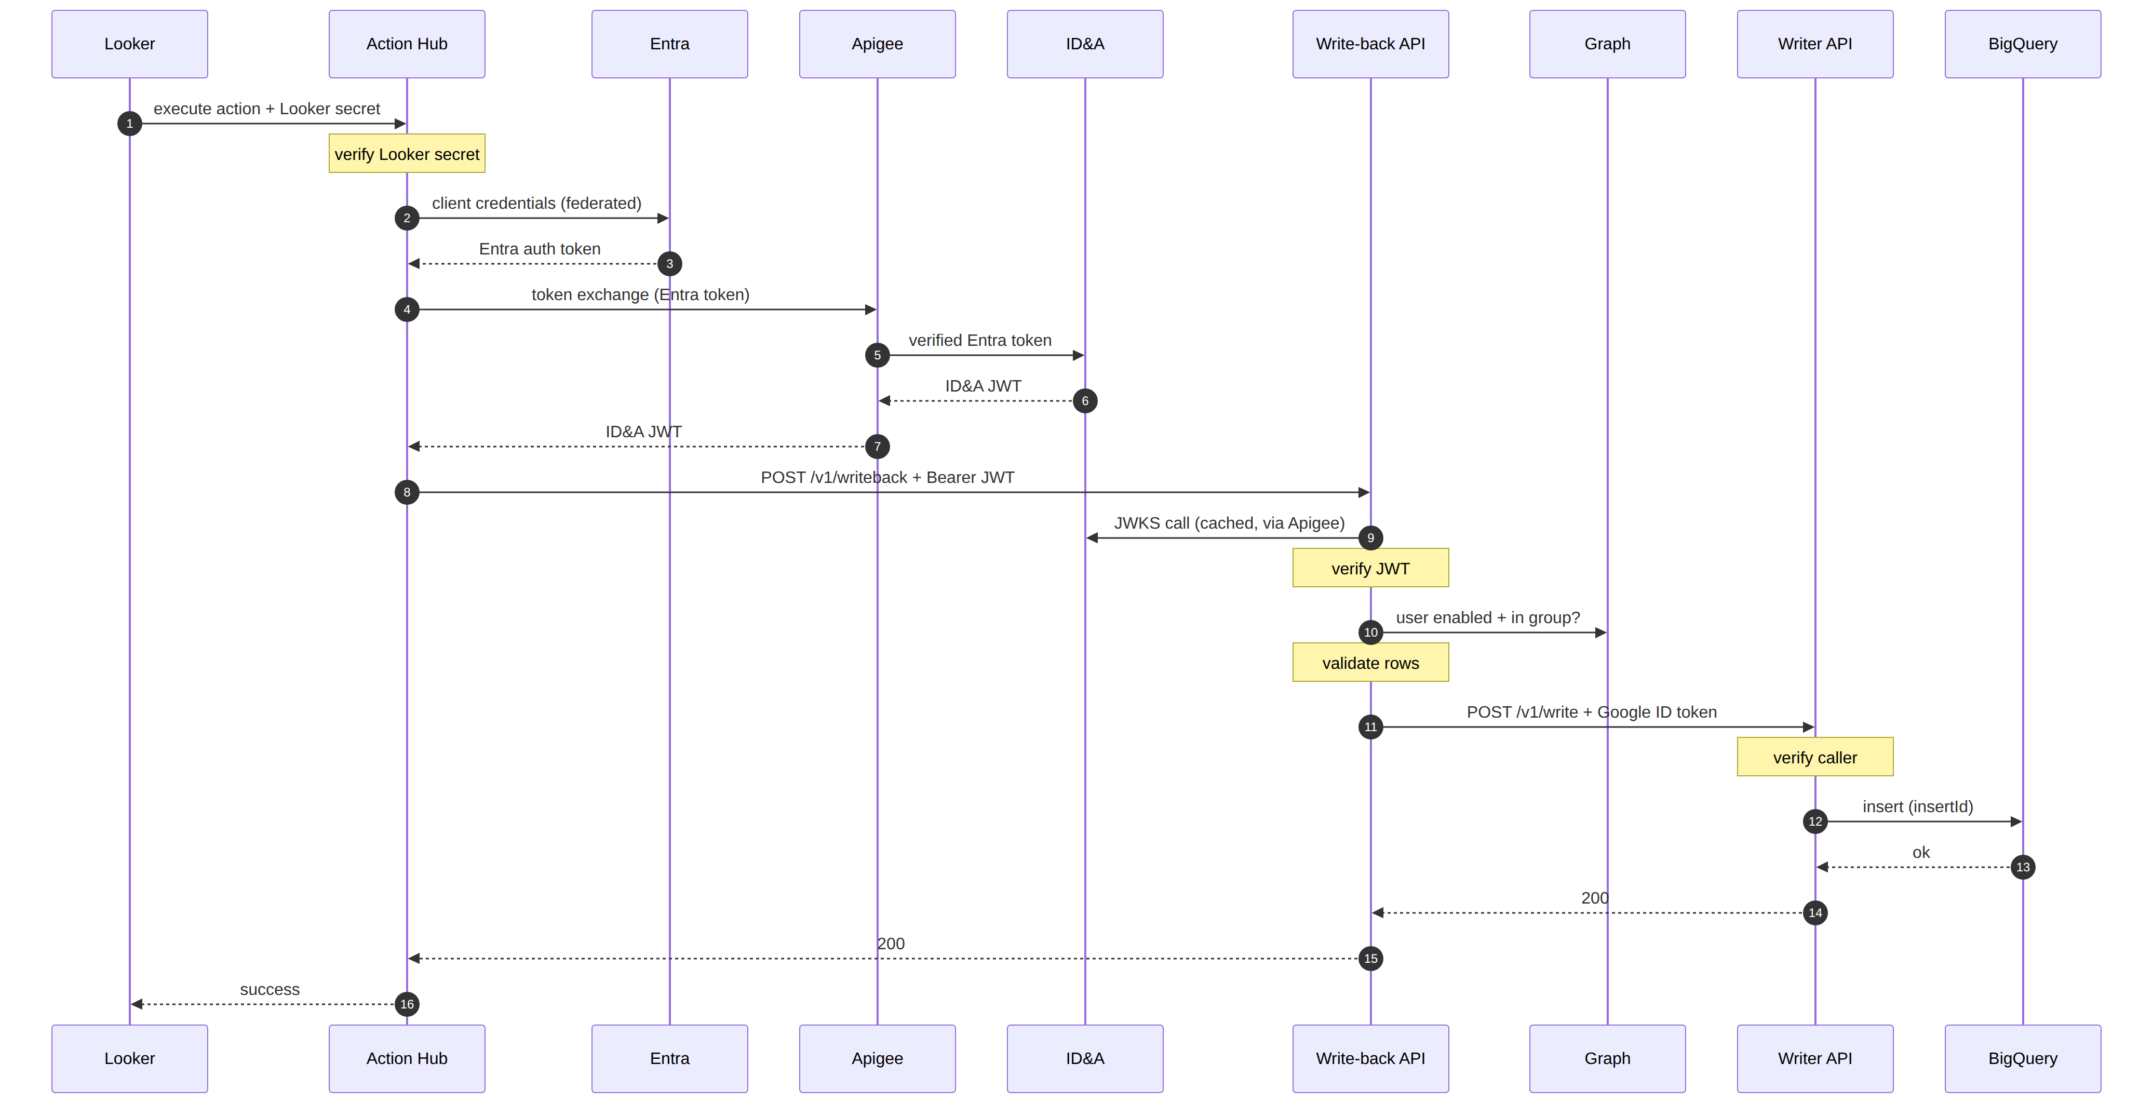
Figure 2 — Sequence of one write-back click
Stage | Steps | What happens
Sign-in | 0.1 – 0.3 | User signs in to Looker with Entra (SAML, MFA). Looker holds entra_oid and groups as user attributes.
Click | 1.1 – 1.3 | User clicks “Write back”. Looker’s server sends the action to the Action Hub with the Looker secret, entra_oid and the rows.
Token exchange | 2.1 – 2.7 | Action Hub verifies the Looker secret, gets an Entra auth token (client credentials, federated, no secret), sends it to ID&A via Apigee; Apigee verifies it; ID&A issues a JWT; Action Hub caches it.
Verify | 3.1 – 3.4 | Action Hub calls the Write-back API with Bearer ID&A JWT. The API fetches ID&A public keys (JWKS call, cached) and verifies signature, issuer, audience, expiry, scope. Invalid → 401.
Authorise user | 4 (4a – 4c) | Write-back API checks via Microsoft Graph that entra_oid is enabled and in BQ-Writeback. Cached 5 min, fail-closed → 403.
Validate | 5 | Schema, allowed columns, ranges, row limits; request_id set as idempotency key.
Machine-to-machine | 6 – 8 | Write-back API calls the Writer with a Google ID token (writeback-api@). Writer verifies the caller and inserts into BigQuery as writer@ (insertId = request_id).
Result | 9 – 10 | 200 returned to Looker (“success”); the dashboard refreshes from current_state.

7. Identity and trust model

7.1 Identities
Identity | Type | Used for | Granted
Internal user | Entra user | Signs in to Looker; identity carried as entra_oid | Member of BQ-Writeback (write permission)
Looker → Action Hub | Shared action secret | Proves the caller is Looker | Configured in Looker › Admin › Actions
looker-writeback-action-hub | Entra app registration | Client-credentials token for the token exchange | Federated credential trusting action-hub@ (no client secret)
action-hub@ | Google service account | Action Hub pods | secretAccessor on LOOKER_SECRET
writeback-api@ | Google service account | Write-back API pods; caller identity to Writer | secretAccessor on GRAPH_CLIENT_SECRET
writer@ | Google service account | Writer pods; BigQuery writes | bigquery.dataEditor on writeback.writeback_log only
writeback-graph-reader | Entra app registration | Graph user checks | User.Read.All, GroupMember.Read.All (application)

7.2 Tokens
Token | Issued by | Audience | Lifetime | Where it travels
Looker action secret | Configured | Action Hub | Rotated quarterly | Looker → Action Hub header
Entra auth token | Entra ID | ID&A token-exchange app | ≈ 60 min | Action Hub → Apigee (only)
ID&A JWT | ID&A (via Apigee) | writeback-api | ≈ 15 min, cached by Action Hub | Action Hub → Write-back API
Google ID token | Google (metadata server) | https://writer.internal | ≈ 60 min | Write-back API → Writer
Google access token | Google (metadata server) | Google APIs | ≈ 60 min | Pods → Secret Manager / BigQuery

8. Architecture decisions

ADR-01 Service authentication for write-back
Option | Description | Assessment
A (previous v3) | Write-back API obtains an ID&A token with client credentials (client secret in Secret Manager); Apigee write proxy verifies it | Static client secret to manage; extra Apigee hop on every write
B | Looker action secret + Workload Identity only, no ID&A | Simplest, but does not meet SR-1 (ID&A-issued token on service calls)
C (chosen) | Action Hub exchanges an Entra app token for an ID&A JWT via Apigee; Write-back API verifies it via JWKS; downstream M2M on service accounts | Meets SR-1/SR-2/SR-5; no static ID&A secret; verification local and fast; short-lived token
D | User’s own Entra token from the browser (Looker extension) | Requires rebuilding write-back as an extension; not justified for internal users
Decision: Option C. Rationale: satisfies the bank’s requirement for ID&A-issued tokens through Apigee, removes the ID&A client secret, keeps the write path to one network hop after verification.

ADR-02 User authorisation
Current design: live Microsoft Graph check of entra_oid against the Entra group BQ-Writeback (cached 5 minutes, fail-closed). Alternative under consideration: manual Looker group “Writeback Users” setting a hidden user attribute writeback_allowed = yes, sent by Looker with each click (removes Graph and its client secret). See open decision OD-1.

ADR-03 Machine-to-machine after verification
Once the JWT is verified, no user or ID&A token is forwarded. The Writer trusts only Google ID tokens minted for writeback-api@ and writes as writer@. This limits blast radius: a stolen ID&A JWT cannot reach BigQuery directly.

9. Non-functional requirements
Area | Target | Design measure
Latency | p95 < 2 s per click | ID&A JWT cached (≈15 min); JWKS cached (10 min); Graph answer cached (5 min)
Availability | Aligned with Looker (99.9%) | 2+ replicas per service; PodDisruptionBudgets; regional GKE
Resilience | No duplicate rows on retry | request_id as BigQuery insertId; idempotent APIs
Dependency failure | Fail closed | ID&A / Apigee / Graph unavailable → write refused with clear message; no bypass
Scalability | ≥ 20 writes/s | Stateless services; HPA on CPU
Auditability | Who, what, when for every write | actor in each row; structured audit logs with request_id, JWT sub, outcome
Data residency | UK/EU | europe-west2 for GKE, Secret Manager, BigQuery

10. Deployment and network
- Action Hub and Looker run in the Looker project (Spoke 2); Write-back API and Writer run in Spoke 1 GKE, namespace writeback.
- Write-back API is exposed only through an internal load balancer (writeback-api.internal); the firewall admits only the Action Hub’s egress range; TLS with the internal CA.
- Writer is ClusterIP only; NetworkPolicy allows only Write-back API pods.
- Apigee internal proxy lloyds-auth-int reached privately (PSC); ID&A never called directly.
- Spoke-to-spoke traffic transits the HUB (HA VPN, Cloud Router); private DNS for internal names.

11. Operations
Activity | Approach
Secret rotation | LOOKER_SECRET quarterly (dual-accept window); GRAPH_CLIENT_SECRET per bank policy; no ID&A secret exists
Key rotation | ID&A rotates signing keys; Write-back API refreshes JWKS on unknown kid
Monitoring | Alerts: 401/403 spikes, token-exchange failures, Writer 5xx, latency SLO
Access management | Add/remove writers via Entra group BQ-Writeback
Support | Trace any write by request_id across Action Hub, Write-back API, Writer logs

12. Risks, assumptions and open decisions

12.1 Risks
ID | Risk | Impact | Mitigation
R-1 | ID&A or Apigee unavailable | Writes refused | JWT cached ≈15 min; alerting; clear user message
R-2 | Entra federated credential (Google issuer) not permitted by tenant policy | Token exchange cannot start | Fallback: Entra client certificate in Secret Manager
R-3 | Graph throttling or outage | Writes refused (fail-closed) | 5-minute cache; or adopt Looker-group option (OD-1)
R-4 | Looker action secret leaked | Unauthorised calls to Action Hub | Network allow-list; rotation; still requires ID&A JWT and Graph check downstream
R-5 | JWT replay within its lifetime | Repeat calls | Short TTL; audience-bound; internal network only; idempotent writes

12.2 Assumptions
- ID&A supports token exchange for Entra-issued tokens and publishes a JWKS endpoint via Apigee.
- Looker runs on GKE and can reach the Action Hub privately.
- Users already sign in to Looker through Entra SAML.

12.3 Open decisions
ID | Decision | Options | Owner
OD-1 | User authorisation source | Microsoft Graph (current) or manual Looker group with writeback_allowed | Data platform + IAM
OD-2 | ID&A token-exchange contract | RFC 8693 shape assumed; confirm endpoint, claims, TTL | ID&A team
OD-3 | Action Hub hosting | Looker project (Spoke 2) or Spoke 1 tooling cluster | Platform
OD-4 | JWT lifetime | 15 min proposed | Security

13. Approval
Role | Name | Decision | Date
Architecture Council chair
Security architecture
Data platform owner
IAM / ID&A owner

