BIaaS – Minimum Viable Design
Minimum Viable Design (MVD-1) – Looker External Design
Secure, reusable external-facing Looker capability: partner dashboard access (signed embedding, ID&A, Apigee, Tenant Registry) and dashboard write-back to BigQuery
Item | Detail
Document | BIaaS – Minimum Viable Design (MVD-1) – Looker Ext. Design
Version | 0.1 – Draft for architecture review
Date | 6 October 2026
Platform | BIaaS (Business Intelligence as a Service) on Google Cloud
Initial use case | GEM Analytics – Looker reports embedded in a third-party portal
Prepared by | Solution Architecture
Architecture significance | SIGNIFICANT – group-level architecture review required
Status | For review

Contents
Section 1 – Design Overview and Strategic Alignment
Section 2 – Solution Design
Section 3 – Additional Design Detail
Section 4 – Design Time Considerations
Section 5 – Design Quality

Section 1 – Design Overview and Strategic Alignment
MANDATORY – Section Guidance

1.1 The Need / Problem / Opportunity
Several business areas have emerging requirements to share analytics and reporting with external parties who cannot access LBG’s internal BI platforms. The initial use case is GEM Analytics, who need to embed Looker reports within a portal accessed by third parties. However, this requirement is expected to grow across multiple business domains.
Today, BIaaS primarily provides internally facing Looker capabilities, and there is no approved, reusable architecture for securely delivering Looker content to external audiences. This creates a risk of duplicated solutions, inconsistent security controls, longer delivery times, and increased operational overhead as new use cases emerge.
LBG currently has established external reporting solutions for Power BI, Tableau, and other legacy BI technologies. As Tableau and other non-strategic BI platforms are decommissioned and Looker becomes the strategic analytics platform, an equivalent external-facing capability is required to support existing and future external analytics use cases.
There is an opportunity to establish a standardised external-facing Looker capability that enables business areas to securely embed and share analytics with third parties. The solution should provide a reusable architecture, security model, operational framework, and onboarding process that can be adopted by future use cases beyond GEM Analytics, reducing delivery effort, avoiding bespoke implementations, and accelerating external analytics adoption across the organisation.

Proposed solution in one paragraph
External partner users sign in to the partner WebApp with ID&A credentials. When they open a dashboard, the WebApp calls a Looker API in the Spoke 1 Tooling GKE cluster with the ID&A JWT. The API validates the user with ID&A through the Apigee internal proxy, reads the partner’s tenant, Looker groups and folders from a Tenant Registry in Cloud SQL, and asks Looker to create a single-use signed embed URL. The browser opens the URL in an iframe; Looker places the user in the tenant’s groups (which decide which dashboards) and sets user attributes (which decide which rows, via LookML access filters on BigQuery). Separately, authorised internal users can write back values from a dashboard: Looker calls an Action Hub, which exchanges an Entra auth token for an ID&A JWT through Apigee, calls the Write-back API (JWT verified via JWKS), and the write continues machine-to-machine under service accounts into BigQuery.

1.2 Problems to be solved
# | Problem | How this design addresses it
P1 | External parties, such as Lloyds Bank channel partners, need secure access to specific internal dashboards. | Signed embedding; access chain partner → tenant group → Looker folder → dashboards held in the Tenant Registry. No direct user-to-dashboard grants.
P2 | External users currently on Tableau or SAP will require equivalent access when dashboards migrate to Looker. | Reusable onboarding (tenant, groups, folders, users) – a migrated dashboard is published into the tenant folder; no new build per use case.
P3 | Dashboards must be accessible through both mobile and web applications with a consistent experience. | Looker is embedded in an iframe in the partner WebApp / mobile web view; the same signed-URL API serves both channels.
P4 | External users belong to different domains; identity mapping and federation are needed between their organisation, Google Cloud and Looker. | ID&A is the single external identity provider (OSIS). The partner id (JWT sub) maps to Looker via external_user_id = partner_id::tenant_id. Looker never holds external passwords.
P5 | Access must protect data security, privacy and integrity. | Tenant isolation by folder permissions + LookML access_filter on tenant_id / business_group; fail-closed checks; TLS everywhere; private networking.
P6 | External user activity must be monitored, logged and auditable. | Audit events from every API (partner_id, tenant_id, dashboard_id, outcome, correlation id), ID&A and Looker activity logs into Cloud Logging, BigQuery log sink.
P7 | Role-based access control so each party sees only what its contract allows. | role_capabilities table (permissions/models per role), max_role ceiling per user, tenant and business-group groups.
P8 | Onboarding, approval, periodic review and offboarding must be documented. | Registry-driven onboarding with change reference; status flags for offboarding; nightly reconciliation; quarterly recertification (Section 2.10).
P9 | SSO, MFA, domain allow-listing and session timeout policies must be agreed. | ID&A login (MFA per ID&A policy); Looker embedded-domain allowlist; Looker session 3600 s; signed URL single-use, minutes validity.
P10 | Licensing, cost impact and support responsibilities for external Looker users must be clarified. | Embed-user licensing captured as cost risk; support model in Section 2.10; FinOps table Section 2.7.
P11 | Legal, compliance and data-sharing obligations must be reviewed before exposing dashboards. | Data-sharing agreement is an onboarding pre-requisite (tenant cannot be activated without DSA reference).

Performance
Authentication cost is paid once per login, not per dashboard tile. JWTs are verified locally with cached JWKS keys (sub-millisecond), registry reads are cached for 60 seconds, and dashboard switches within a session do not call GKE at all. Query performance is governed by Looker caching, BigQuery partitioning/clustering on tenant_id, and aggregate awareness for heavy dashboards.

Cost Risk
- Looker embed-user licensing for external users (per-user or capacity based) – volume to be confirmed with GEM Analytics and Google account team.
- BigQuery query cost driven by external usage – mitigated by Looker caching, PDTs/aggregate tables, per-tenant cost attribution through the log sink, and BigQuery reservations or quotas.
- Apigee call volume and GKE / Cloud SQL run cost are small and shared with the existing BIaaS platform.

Operational Risks
- Dependency on ID&A, Apigee and Looker availability on the login path (mitigated by caching, retries, health checks and clear degraded-mode messages).
- Drift between Looker folder permissions and the Tenant Registry (mitigated by nightly reconciliation job and alerts).
- Manual onboarding errors (mitigated by a scripted onboarding job, change reference on every grant, and audit triggers).

Platform Consistency
The design reuses existing LBG patterns: HUB-and-spoke networking with HA VPN and Cloud Router, Apigee as the only route to ID&A, GKE with Workload Identity, Secret Manager, Cloud Logging and the standard GCP 2.0 IDP environments (INT, PRE, PRD). No new technology is introduced; the capability is offered as a reusable BIaaS service rather than a GEM-specific build.
MANDATORY – Section Guidance

1.3 Requirements

Functional requirements
ID | Requirement | Priority
FR-01 | External partner users can open authorised Looker dashboards embedded in the partner portal (web and mobile). | Must
FR-02 | A partner sees only dashboards of its own tenant folder(s) and only rows for its tenant / business group. | Must
FR-03 | Partner users can switch between authorised dashboards in the same session without re-authenticating. | Must
FR-04 | Onboarding creates tenant, Looker group, folder and user mapping through a controlled, auditable process. | Must
FR-05 | Access can be changed or removed per user, per business group or per tenant. | Must
FR-06 | Authorised internal users can write back a value from a dashboard to BigQuery and see it after refresh. | Should (MVD scope)
FR-07 | Every access and write-back is attributable to a user and traceable end to end with a correlation id. | Must

Non-functional requirements
Area | Requirement | How the design meets it
NFR baseline | Define the end-to-end NFR baseline for secure external Looker access, covering performance, availability, security, observability, disaster recovery, high availability, compliance, supportability, scalability and operational ownership. | This table is the baseline; targets marked TBC are confirmed in performance and resilience testing (Section 4).
Performance | ID&A authentication should add no more than 5 ms overhead per request under normal operating conditions. Support at least 1,000 concurrent external-user requests, with gateway RPS, authentication RPS, dashboard query latency and Looker embed load-time targets confirmed through performance testing. | Per-request auth is local JWT verification with cached JWKS (< 1 ms). The ID&A call via Apigee happens once per login. GKE HPA, Apigee quotas and Looker node sizing are tested at 1,000 concurrent users (target: signed URL < 1.5 s p95, first dashboard render < 5 s p95 – TBC).
Accessibility / Usability | External users must access authorised dashboards from approved mobile and web applications, while internal developer and operations access remains available from approved corporate laptops and GCP 2.0 IDP environments across INT, PRE and PRD. The experience should be responsive, browser-compatible and usable without direct GCP console access. | Embedded Looker in the partner portal (responsive dashboards, mobile web view). No GCP console access for partners. Internal access via corporate devices and IDP pipelines in each environment.
Availability | Define availability targets for each dependency in the access path – External Load Balancer, Apigee external proxy, ID&A APIs, GKE regional services, Apigee internal proxy, Looker and network components – and document degraded-mode behaviour, failover expectations and dependency SLAs so the external service target is measurable. | Target 99.5% (business hours) for MVD, 99.9% candidate for scale-out. Dependency SLAs listed in Section 2.10. Degraded mode: if ID&A/Apigee is unavailable, new logins fail with a friendly message; open Looker sessions continue until expiry.
Security | Tokens should have a maximum TTL of 1 hour, use HSM-backed signing where applicable, avoid client secrets in external-facing clients, and support leaver access revocation within 1 hour. Access must enforce SSO, MFA where required, domain allow-listing, least-privilege RBAC, row-level security, tenant isolation and protection against cross-partner data exposure. | ID&A JWT ≤ 1 h (write-back JWT ≈ 15 min); Looker session 3600 s; signed URL single-use, minutes. No secrets in the browser or WebApp; Workload Identity for all pods. Leaver: registry status → disabled blocks new URLs immediately, session ends ≤ 1 h (or immediately by disabling the Looker user). RBAC via groups/roles, RLS via access_filter, tenant isolation via folders.
Observability & audit | All authentication and authorisation decisions must be logged with client ID, user or subject identifier, endpoint, outcome, latency, correlation ID and failure reason. Looker activity logs for external users should be captured, retained, monitored and linked to platform telemetry. | Structured audit events from Looker API, Partner Details API, Embed URL API, Action Hub, Write-back API and Writer with x_request_id; Apigee analytics; Looker System Activity exported; Cloud Logging → BigQuery log sink for audit, SLA and charge-back.
Disaster recovery | Define recovery targets for Looker, gateway services, identity integrations, configuration and deployment artefacts, including an initial RTO under 12 hours for Looker restore. Confirm backup region/zone approach, restore testing cadence, backup scope and runbook ownership. | Looker RTO < 12 h, RPO 24 h (Looker internal DB backup); GKE workloads redeployed from CI/CD (RTO < 4 h); Cloud SQL automated backups + PITR (RPO ≤ 15 min); BigQuery time travel / snapshots. Restore test every 6 months.
High availability | Confirm whether regional or zonal replication is required for gateway, identity, network and Looker components. Define active-active or active-passive design, single points of failure, health checks, automated failover and monitoring. | Regional GKE (3 zones), ≥ 2 replicas + PDBs per API; Cloud SQL HA (regional); HA VPN (99.99%); Apigee managed multi-zone; Looker active-passive within region (MVD). Single region europe-west2 for MVD.
Scalability and capacity | Establish capacity assumptions for partner count, named and concurrent users, dashboard usage, API traffic, Looker query concurrency, cache behaviour and growth. | MVD assumption: 20 partners, 2,000 named, 1,000 concurrent, 5 dashboard opens/user/hour. Stateless APIs scale horizontally; Looker query concurrency and BigQuery slots sized in performance test.
Compliance and data governance | Ensure external data exposure is governed by approved data-sharing agreements, regulatory obligations, retention rules, audit requirements and documented ownership for sensitive datasets. | Tenant activation requires DSA reference and data owner approval; only curated partner_analytics model exposed; data stays in UK region; log retention per LBG policy.
Supportability and operations | Define support model, incident ownership, escalation paths, runbooks, alert thresholds, access request workflow, periodic recertification and onboarding/offboarding responsibilities. | BIaaS platform team owns run; ID&A and Apigee teams own their services; runbooks for onboarding, offboarding, secret rotation and incident triage; quarterly access recertification from the registry.

1.4 Architecture Alignment

Significance
Architecture Significance | Assessment
Significance level | ☒ SIGNIFICANT (likely to require group level architecture review)
Introduces new technology | ☐ No – Looker, GKE, Apigee, ID&A, Cloud SQL, BigQuery are existing approved services
Extends technology scope beyond original intention | ☒ Yes – Looker extended from internal-only to external audiences (signed embedding) and to write-back
Creates or modifies critical dependencies across enterprise domains or platforms | ☒ Yes – new runtime dependency on ID&A and Apigee for external Looker access; Entra/ID&A token exchange for write-back
Requires group governance or architectural review | ☒ Yes
May trigger changes to architectural principles or standards | ☐ No – follows existing external-access, hub-and-spoke and secrets standards

Alignment to principles
Principle / standard | Alignment
Strategic BI platform (Looker) | Replaces external Tableau / Power BI reporting with Looker; reusable for any business domain.
Zero trust | Every hop authenticated (JWT, signed URL, Google ID tokens, Workload Identity); no implicit trust from network location.
ID&A via Apigee only | All ID&A calls (validation, token exchange, JWKS) go through the Apigee internal proxy.
No static credentials | Workload Identity for GCP, IAM DB auth for Cloud SQL, federated Entra credential; residual secrets held only in Secret Manager.
Hub-and-spoke network | Spoke 1 ↔ Spoke 2 traffic always transits the HUB; PSC for WebApp and Apigee.
Reuse before build | One set of APIs and one registry serves all tenants and use cases.

Section 2 – Solution Design

2.1 Solution overview
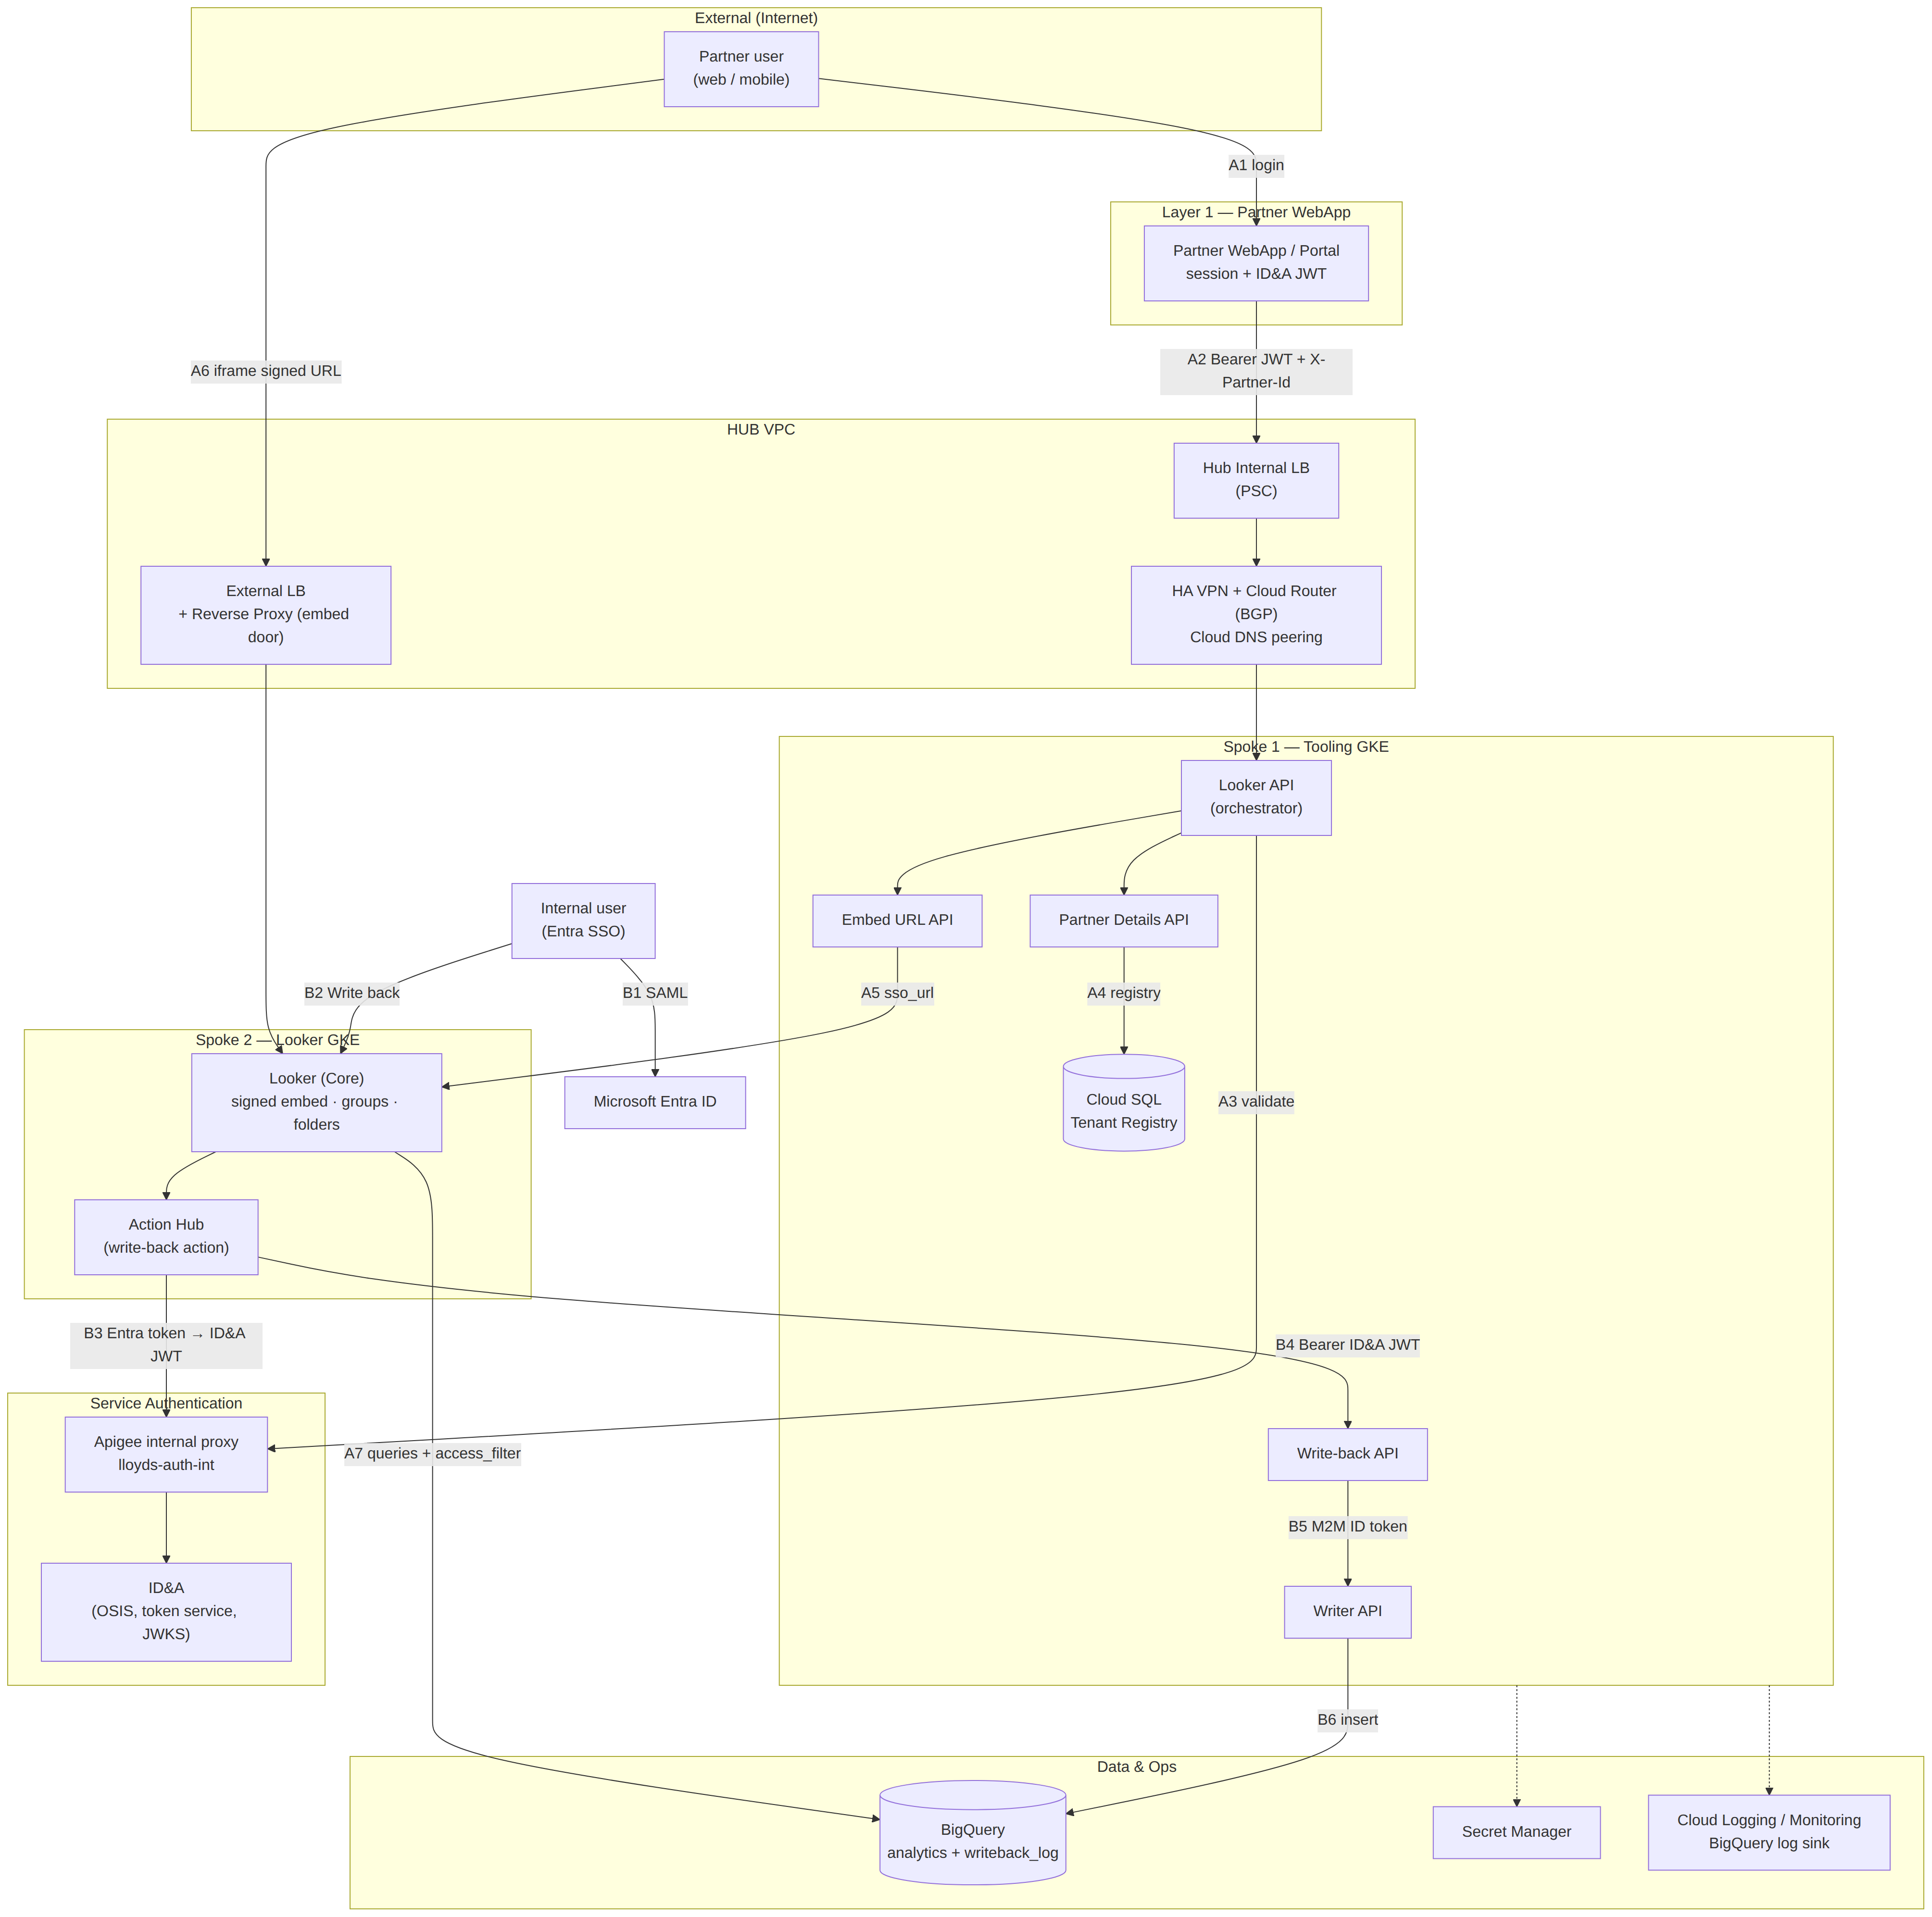
Figure 1 – Solution context: partner dashboard access (A) and internal write-back (B)
Component | Location | Responsibility
Partner WebApp / portal | Layer 1 (consumer) | Login with ID&A, holds session and JWT, hosts the Looker iframe and dashboard menu
Looker API (orchestrator) | Spoke 1 Tooling GKE | Validates the user with ID&A via Apigee, verifies JWT (JWKS), selects landing dashboard, returns signed URL
Partner Details API | Spoke 1 Tooling GKE | Reads Tenant Registry; lists dashboards in the tenant folders (looker-ro)
Embed URL API | Spoke 1 Tooling GKE | Creates the signed embed URL (looker-embed) for an allowed dashboard only
Tenant Registry | Cloud SQL PostgreSQL, Spoke 1 | Partners, tenants, Looker groups, folders, roles, audit; private IP, IAM auth
Looker (Core) | Spoke 2 GKE | Signed embedding, embed users, groups, folders, access filters, dashboards
Reverse Proxy + External LB | HUB | Public embed host for the browser; internal API door to Looker
Apigee internal proxy + ID&A | Service authentication | Token validation, Entra → ID&A JWT exchange, JWKS
Action Hub | Spoke 2 GKE (looker-actions) | Receives the Looker write-back action, obtains ID&A JWT, calls Write-back API
Write-back API / Writer API | Spoke 1 GKE (writeback) | JWT verification, user authorisation, validation; M2M insert into BigQuery
BigQuery | Data | Analytics datasets (tenant-tagged) and writeback_log

2.2 Partner dashboard access flow
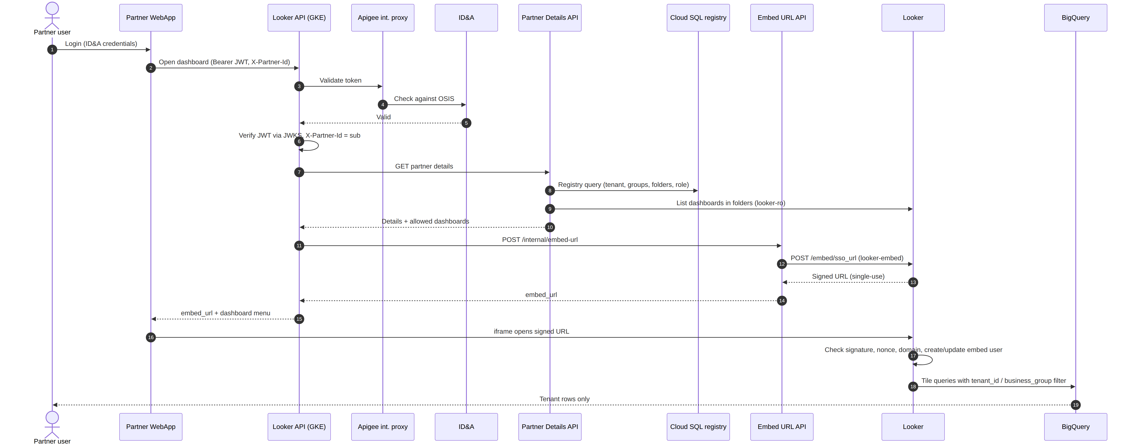
Figure 2 – Partner access sequence
Stage | What happens | Control
A – Login | User signs in to the WebApp; ID&A issues the JWT (sub = partner id e.g. PRT-ACME-0071). | ID&A credentials / MFA
B – Call Looker API | WebApp → PSC → HUB ILB → HA VPN → Spoke 1 Looker API with Authorization: Bearer JWT and X-Partner-Id. No tenant is ever sent by the caller. | Private connectivity
C – Validate with ID&A | Looker API → Apigee internal proxy (lloyds-auth-int) → ID&A checks the token against OSIS. | Invalid → stop
5.1 Verify caller | JWT verified with ID&A JWKS (cached 5 min): signature, expiry, issuer, audience; X-Partner-Id must equal sub. | 401 / 403
5.2–5.3 Registry | Partner Details API reads partner_users ⋈ tenants ⋈ partner_groups ⋈ tenant_groups ⋈ group_folders via Cloud SQL Auth Proxy (IAM, private IP, 60 s cache). | Unknown / disabled / suspended → 403
5.4 Allowed dashboards | Lists dashboards in the tenant folders through the Reverse Proxy API door (looker-ro service user). | None → 403
5.6–5.10 Signed URL | Embed URL API re-checks the dashboard is allowed and calls POST /api/4.0/embed/sso_url with external_user_id = partner_id::tenant_id, group_ids, user_attributes {tenant_id, business_group}, permissions, models, session_length 3600. | Never logged or stored
6 – Open dashboard | Browser opens the signed URL in the iframe via External LB → Reverse Proxy → HUB → Looker. Looker checks signature, nonce, time and embed domain, creates/updates the embed user, sets groups and attributes. | Single use; domain allowlist
6 – Query | Every tile query gets WHERE tenant_id = … AND business_group = … (LookML access_filter) on BigQuery. | Row-level security
Switch dashboard | WebApp changes iframe.src to another embed path; Looker reuses the session and checks folder permission. No GKE call. | Folder permission
Access chain: partner_users → partner_groups → tenant_groups → group_folders → Looker folder → dashboards. group_ids decide which dashboards; user_attributes decide which rows. The check is done twice: by the API before signing and by Looker on every open.

2.3 Dashboard write-back flow
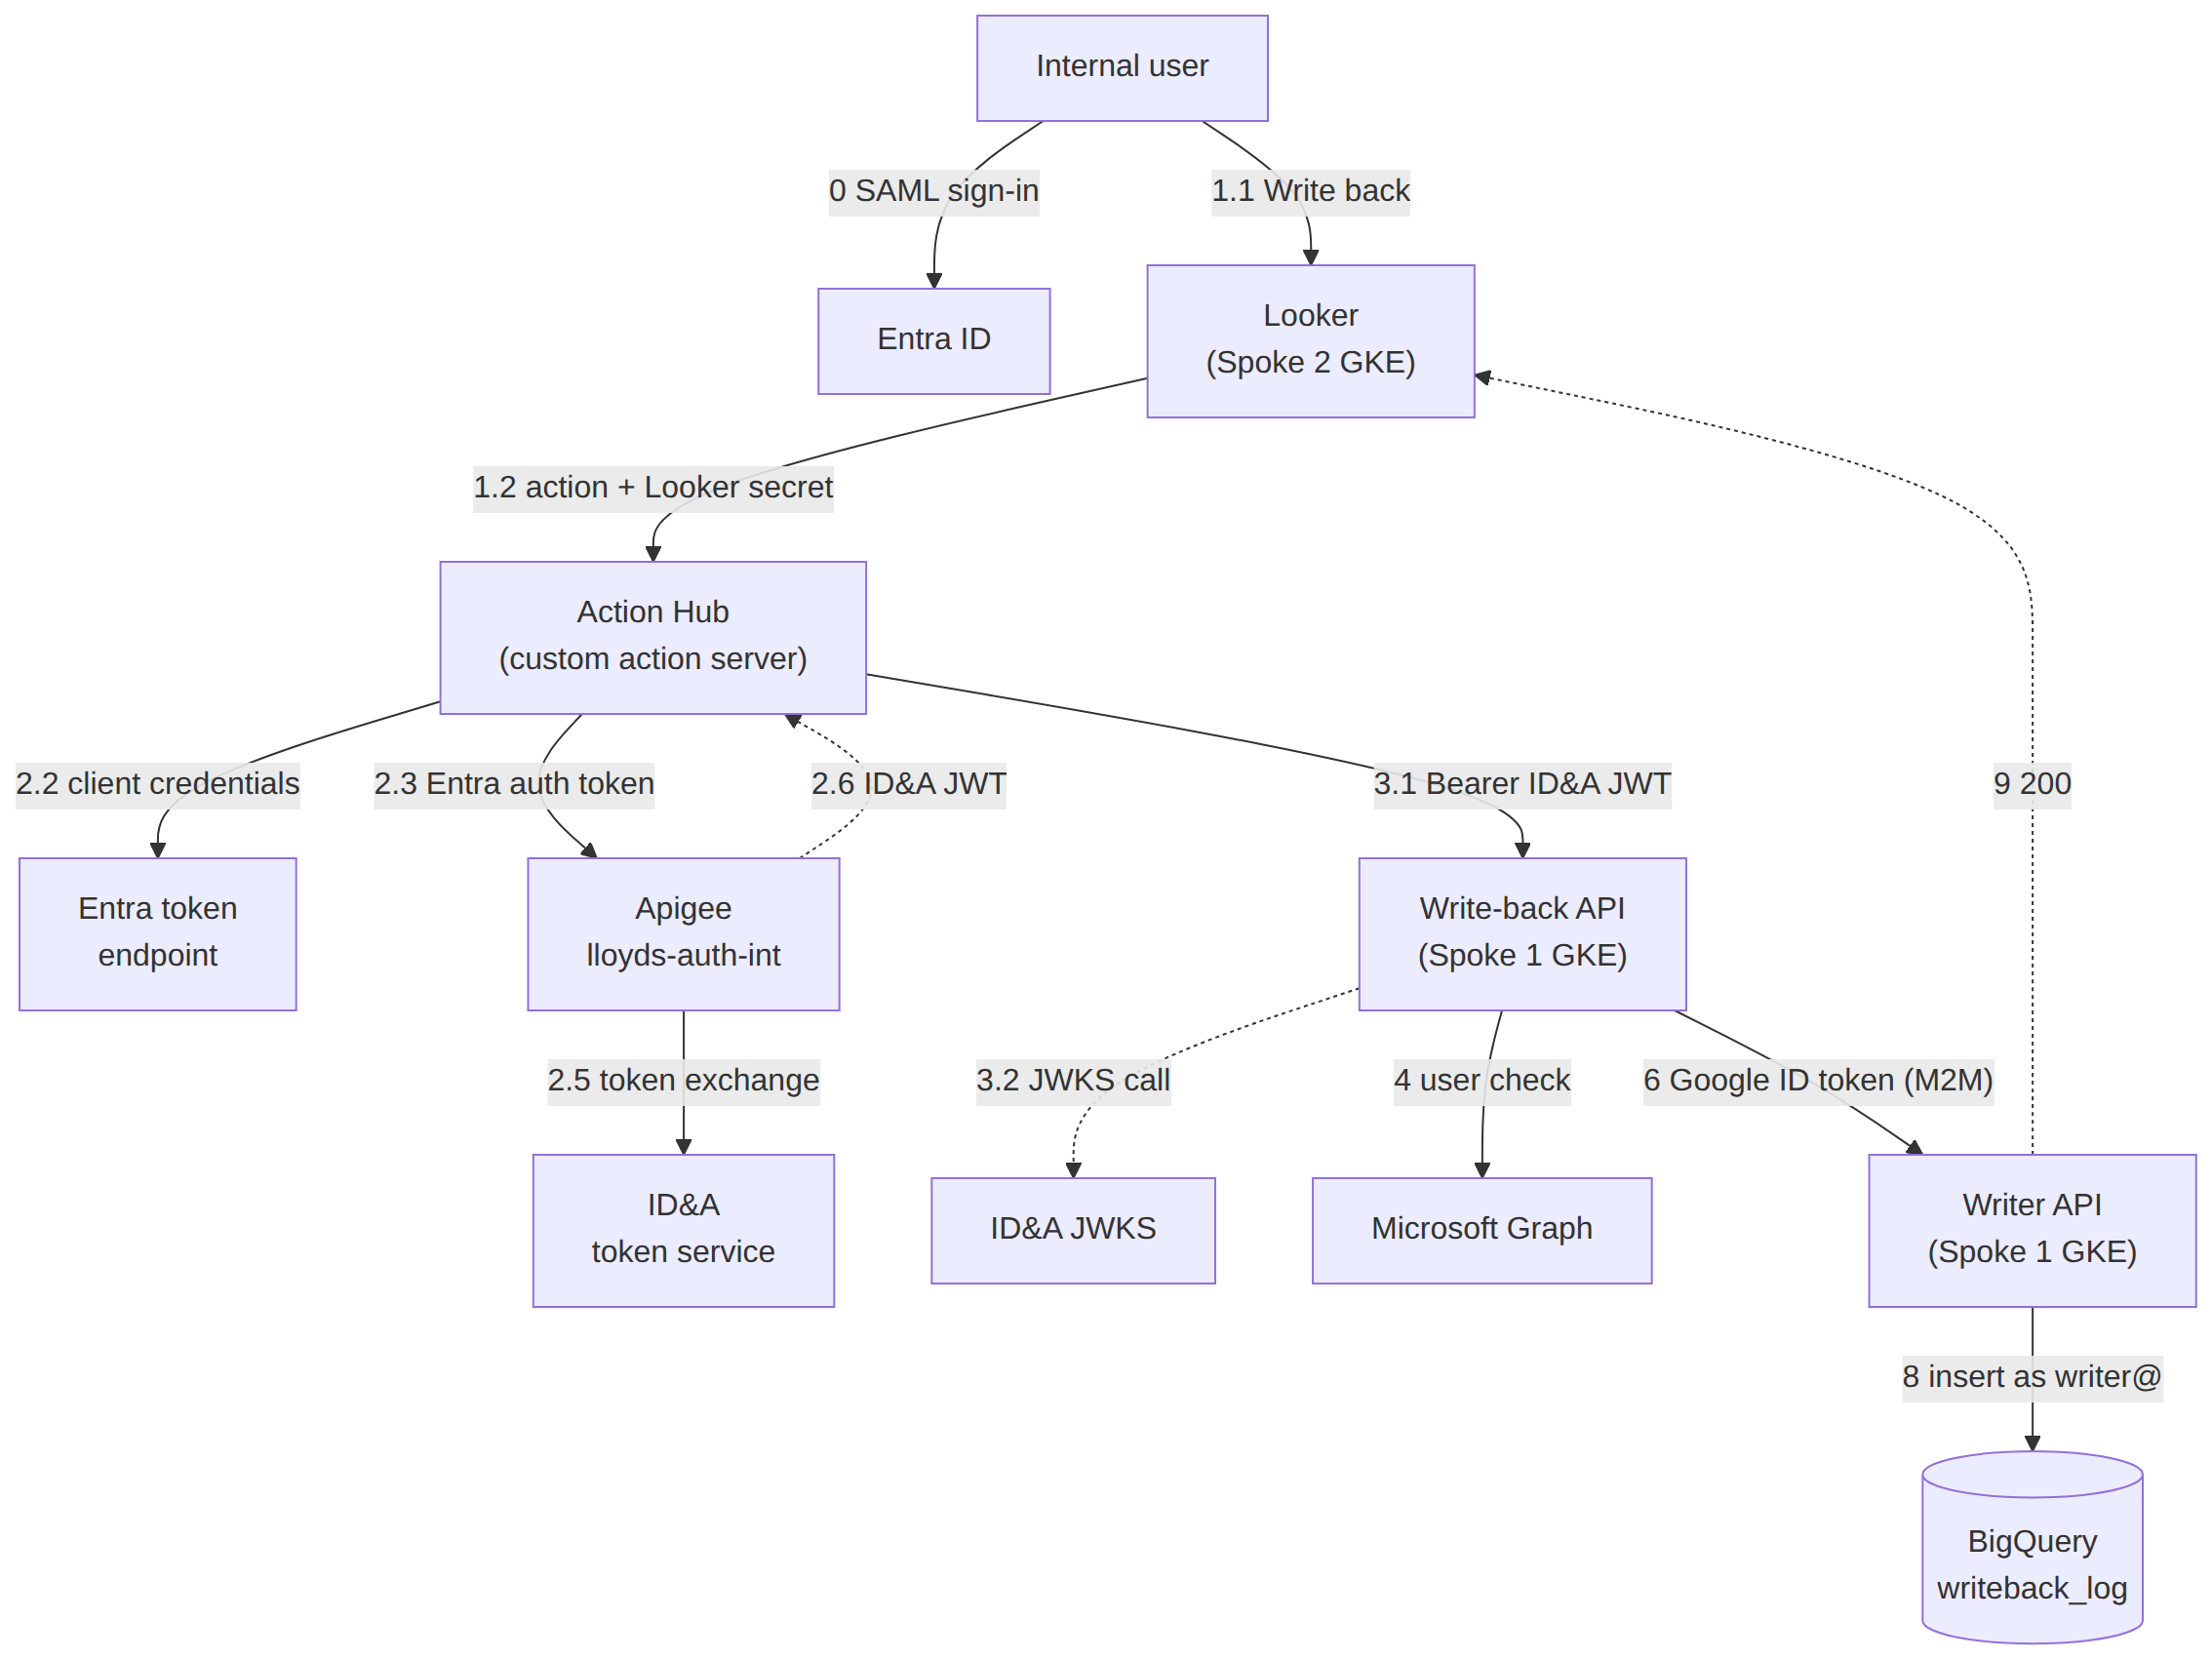
Figure 3 – Write-back architecture (matches looker-writeback-oauth2-entra-v4.drawio)
Step | What happens
0.1–0.3 | Internal user signs in to Looker with Entra SAML; Looker stores user attribute entra_oid.
1.1–1.3 | User clicks Write back; Looker server calls the Action Hub with the Looker action secret, entra_oid, email and rows.
2.1 | Action Hub verifies the Looker action secret (constant-time).
2.2 | Action Hub obtains an Entra auth token by client credentials using a federated credential (its Google service account) – no client secret.
2.3–2.6 | Action Hub calls ID&A via the Apigee proxy (lloyds-auth-int /v1/token-exchange) passing the Entra auth token; Apigee verifies it, ID&A returns an Apigee-approved JWT (aud = writeback-api, scope = writeback.write, ≈15 min).
2.7 | Action Hub caches the JWT until shortly before expiry.
3.1–3.4 | Action Hub calls POST /v1/writeback with Bearer ID&A JWT; Write-back API makes a JWKS call (lloyds-auth-int /v1/jwks, cached 10 min) and verifies signature, issuer, audience, expiry, scope. Invalid → 401.
4 | User authorisation of entra_oid (account enabled and member of BQ-Writeback; fail-closed → 403). See OD-1.
5 | Payload validated; request_id assigned as idempotency key.
6–8 | Machine-to-machine: Write-back API calls the Writer with a Google ID token as writeback-api@; Writer verifies caller and inserts into BigQuery writeback_log as writer@ (Workload Identity), insertId = request_id.
9–10 | 200 back to Looker; dashboard refreshes and shows the new value via the current_state view.

2.4 Data design
Store | Object | Purpose
Cloud SQL (tenancy) | tenants | Partner company, status (active / suspended / offboarded), home dashboard
Cloud SQL (tenancy) | tenant_groups | Looker group per tenant / business group (one group belongs to one tenant)
Cloud SQL (tenancy) | group_folders | Looker group → Looker folder (View); reconciled nightly with Looker
Cloud SQL (tenancy) | role_capabilities | Role → Looker permissions and models; role rank for ceiling rule
Cloud SQL (tenancy) | partner_users | partner_id (= JWT sub), tenant, status, max_role, business_groups, generated looker_external_user_id = partner_id::tenant_id
Cloud SQL (tenancy) | partner_groups | User ↔ group membership with validity dates and change reference
Cloud SQL (tenancy) | registry_audit | Append-only change history written by triggers
BigQuery | Analytics datasets | Every row carries tenant_id and business_group (or joins account_access)
BigQuery | writeback.writeback_log / current_state | Append-only write-back records (request_id, record_key, field, new_value, actor_oid, actor_email, written_at) and latest-value view
BigQuery | Log sink dataset | Audit and usage logs for charge-back and analytics

2.5 Identity and access design
Identity | Type | Used for
Partner user (PRT-…) | ID&A identity (OSIS) | WebApp login; JWT sub; Looker embed user via external_user_id
Internal user | Entra ID (SAML to Looker) | Looker internal access and write-back; entra_oid attribute
looker-ro / looker-embed | Looker API service users (client id/secret in Secret Manager) | List folder dashboards / create signed URLs
partner-details@, onboarding@ | GSA + IAM DB users | Read (data_api) / write (onboarding) Tenant Registry
action-hub@ | GSA via Workload Identity; federated to Entra app looker-writeback-action-hub | Entra auth token → ID&A JWT
writeback-api@, writer@ | GSA via Workload Identity | M2M call to Writer; insert into writeback_log
Token / secret | Issuer | Lifetime | Validated by
Partner JWT | ID&A | ≤ 1 h | ID&A via Apigee + Looker API (JWKS)
Signed embed URL | Looker (embed secret) | Single use, minutes | Looker (signature, nonce, time, domain)
Looker embed session | Looker | 3600 s | Looker
Looker action secret | Secret Manager | Rotated per policy | Action Hub
Entra auth token (app) | Entra ID | ≈ 60 min | Apigee / ID&A
ID&A write-back JWT | ID&A via Apigee | ≈ 15 min | Write-back API (JWKS)
Google ID / access tokens | Google (Workload Identity) | ≤ 1 h | Writer / GCP APIs

2.6 Technology / Infrastructure Design

Overview
Service | Purpose | Configuration
Google Looker | Looker image deployed in GKE | Spoke 2 GKE; signed embedding enabled; embedded domain allowlist = partner portal; partner_analytics model with access_filter; user attributes tenant_id, business_group, entra_oid; Action Hub registered for write-back
Google Apigee (internal and external proxy) | Connection established via internal and external proxies | External proxy for partner-facing APIs; internal proxy lloyds-auth-int for ID&A validation, token exchange and JWKS; PSC endpoints; quotas and spike arrest
Cloud Logging | Centralised observability layer | Structured JSON audit events with x_request_id; log-based metrics and alerts; retention bucket per policy
Google Kubernetes Engine | Looker deployment, UX deployment, Write-back API deployment | Regional clusters, Workload Identity, NetworkPolicy; ≥ 2 replicas, HPA, PDBs; namespaces per table below
BigQuery | Log sink to enable charge back and analytics | Plus analytics datasets (tenant-tagged) and writeback dataset; partitioned and clustered by tenant_id
Cloud SQL (Database) | Maintain mapping among external partner, internal Looker id, tenant id and dashboard id | PostgreSQL, private IP only, regional HA, IAM DB authentication, Cloud SQL Auth Proxy sidecar, automated backups + PITR
Secret Manager | Hold the remaining secrets | looker-ro / looker-embed API3 keys, Looker action secret, Graph client secret; accessed via Workload Identity
Network (HUB, HA VPN, Cloud Router, Cloud DNS, PSC, External LB) | Private connectivity and public embed entry | Hub-and-spoke with BGP; DNS peering for *.internal; Cloud Armor on External LB
Cloud Monitoring | Alerting and SLO tracking | Uptime checks, SLO burn alerts, dashboards per API

Infrastructure Impacts
Env | Instance Type | Looker Static IP | Looker Direct connect link | GKE Namespace
INT | Internal | TBC (Network team) | TBC | looker-int, looker-actions
PRE | Internal | TBC | TBC | looker-pre, looker-actions
PRD | Internal | TBC | TBC | looker-prd, looker-actions
INT | External | TBC | TBC | looker-ext-int, partner-api, writeback
PRE | External | TBC | TBC | looker-ext-pre, partner-api, writeback
PRD | External | TBC | TBC | looker-ext-prd, partner-api, writeback
Static IPs and direct-connect links are allocated by the Network team at build. Namespace names are proposals: partner-api hosts Looker API, Partner Details API and Embed URL API; writeback hosts Write-back API and Writer; looker-actions hosts the Action Hub.
MANDATORY (Public Cloud) – Section Guidance

2.7 FinOps Considerations
Consideration | Met? (Y/N) | Details
Use of Cloud provider calculators or LBG version of the calculators | Y (draft) | Incremental estimate: 3 small GKE deployments (≈ 6 pods), Cloud SQL HA db-custom-2-7680, Secret Manager, Apigee calls on existing org. Looker embed-user licensing and BigQuery query cost are the main drivers – to be finalised with GEM volumes.
Resources rightsized | Y | APIs start at 250m CPU / 256 Mi; Cloud SQL 2 vCPU; reviewed after performance test.
Auto-scaling in place where applicable | Y | GKE HPA on CPU / RPS; Cluster Autoscaler; Looker node pool scaling.
Appropriate Storage used | Y | Cloud SQL SSD for registry (small); BigQuery for analytics and logs.
Storage lifecycle policy in place | Y | Log bucket and BigQuery log-sink table expiry per retention policy; writeback_log retained per data owner.
Storage tiering in place | Y | BigQuery long-term storage pricing applies automatically to unchanged partitions.
Tagging/Labelling in place | Y | Labels: app=biaas-looker-ext, env, cost-centre, tenant (where possible) on all resources.
Power scheduling policies in place | Y (non-PRD) | INT scaled down out of hours; PRE on demand; PRD always on.
Quotas and Limits set appropriately | Y | Apigee quotas per client; BigQuery custom quotas per project; HPA max replicas.
Latest version of resources used | Y | GKE release channel Regular; PostgreSQL 15+; supported Looker release.
Logging set at appropriate levels | Y | INFO in PRD with structured audit events; DEBUG disabled; no tokens or signed URLs logged.
IF REQUIRED – Section Guidance

2.8 Sustainability
Uses shared, managed services in an existing low-carbon region where possible; serverless/autoscaled components and out-of-hours scale-down in non-production; Looker caching and aggregate tables reduce repeated BigQuery scans.
MANDATORY – Section Guidance

2.9 Controls By Design
Question | Answer | Details / Rationale
What was the outcome of the assessment of controls in the design? Include how many existing controls require enhancement, how many new controls need to be introduced, and how many existing controls need to be closed or replaced. | Existing enhanced: 3  New: 6  Closed / replaced: 0 | Enhanced: Looker access management (extended to external users), Apigee access policy (new proxies/quotas), logging & monitoring (new audit events).  New: tenant isolation (folders + access_filter), signed-URL issuance control, registry change audit, nightly permission reconciliation, write-back authorisation (JWT + user check), quarterly external recertification.
Have all new or enhanced controls been designed to be automated or semi-automated? | Yes | Automated: JWT/JWKS checks, registry fail-closed checks, signed URL validation, access filters, audit triggers, reconciliation job, alerts. Semi-automated: onboarding job (approval by change ticket) and quarterly recertification report generated from the registry.
Have regular reviews been established with the Business Area throughout the cycle of the change, to ensure controls are designed collaboratively with optimisation in mind? | Yes | Fortnightly design reviews with GEM Analytics, BIaaS platform, ID&A, Apigee and Security; outcomes recorded in Section 5.
Confirm how you have captured the controls that relate to the change (existing / new / no longer required). | Control list | Captured in the Security & Threat Assessment control checklist and to be entered in the Control Register; links in Section 3.
IF REQUIRED – Section Guidance

2.10 Operating Considerations

Availability
Dependency | Target / SLA | Degraded mode
External LB + Reverse Proxy | 99.99% (GCP LB) | Embed host unavailable → portal shows maintenance message
Apigee (external / internal) | 99.9%+ | New logins and write-backs fail; open sessions continue
ID&A APIs | Per ID&A SLA | Same as Apigee; JWKS cached 5–10 min
GKE regional APIs | 99.95% (regional control plane) | Multi-zone replicas; PDBs
Cloud SQL registry (HA) | 99.95% | 60 s cache bridges failover (~60 s)
Looker | Platform target 99.5% | No dashboards; RTO < 12 h for full restore
BigQuery | 99.99% | Tiles fail; retry

Capacity & Scalability
MVD sizing: 20 partners, 2,000 named users, 1,000 concurrent. Signed-URL path ≈ 5 calls per login; at a 10-minute login burst of 1,000 users this is < 10 RPS per API. Stateless APIs scale with HPA; Looker concurrency and BigQuery slots are the constraining factors and are confirmed by load test. Registry growth is negligible (thousands of rows).

Performance
- Login to first dashboard: target < 5 s p95 (TBC in test).
- Per-request auth overhead: < 5 ms (local JWT verification, cached keys).
- Dashboard switch: no backend call; Looker render only.
- Write-back: < 2 s p95 end to end (JWT cached).

Monitoring and Alerting
Signal | Threshold | Action
4xx / 5xx rate per API | 5xx > 2% for 5 min; 401/403 spike > 3× baseline | Page BIaaS on-call; security review for auth spikes
Latency p95 | Signed URL > 2 s for 10 min | Investigate Looker / Apigee
ID&A / Apigee errors | > 1% failures | Escalate to ID&A / Apigee teams
Registry reconciliation | Any difference | Ticket to BIaaS ops
Cloud SQL / GKE health | Failover, pod restarts, CPU > 80% | Auto-heal; notify
Write-back failures | > 0 in 15 min (403/5xx) | Notify product owner

Disaster Recovery
Primary region europe-west2. Looker: restore from backup (internal DB + configuration) to the standby environment, RTO < 12 h, RPO 24 h. APIs: redeploy from CI/CD artefacts and GitOps manifests (RTO < 4 h). Cloud SQL: cross-region backup and PITR (RPO ≤ 15 min). BigQuery: dataset snapshots / time travel. Secrets: Secret Manager replication policy. Runbook owner: BIaaS platform; restore test every 6 months.

Resilience
Resilience by Design principle / outcome | Description | How the solution adheres to the principle
Confidentiality | Ensure data classified correctly and processed with correct protection and access. | Data classified Confidential; tenant isolation (folders + access_filter); TLS on all hops; private IP; least-privilege IAM.
Integrity | Ensure checks in place to assure the accuracy and consistency of all data. | Signed JWTs and URLs; server-side validation; idempotent write-back (insertId); append-only logs; registry FKs prevent cross-tenant mapping.
Monitoring and Alerting | Monitoring required for all IBS components and data and for key components and services in other workloads. | Cloud Monitoring SLOs and alerts for every component in the path (see table above).
Automation and Simplification | Ensure services automated wherever possible and include an alternative means of service provision. | IaC (Terraform) and CI/CD; scripted onboarding; fallback: existing reporting extracts until Tableau decommission.
Availability and Currency | Ensure systems have no single points of failure and are recoverable within defined impact tolerances. | Multi-zone GKE, Cloud SQL HA, HA VPN, managed Apigee; RTO/RPO defined; supported versions via release channels.
Supply Chain Management | All IBS components and data with third-party dependencies must map their network of dependencies and ensure third-party services are managed within impact tolerances. | Third parties: Google Cloud (Looker, GKE, BigQuery, Cloud SQL, Apigee), Microsoft (Entra ID). Covered by existing LBG supplier agreements.
Identifiable and Locatable | Components and data must be identifiable through a unique identifier, mapped and stored within LBG systems (ServiceNow). | All components registered as CIs in ServiceNow under the BIaaS service; resources labelled.
Testable and Measurable | Functional and non-functional testing completed before implementing changes; IBS subject to regular recovery testing. | Functional, security (ST-1..7), performance (1,000 users) and DR tests in PRE before PRD; DR test every 6 months.
Governance | All appropriate LBG governance must be followed in design and operation. | Architecture review (this MVD), security review, CAB for releases, data-sharing approvals per tenant.
Interconnection / Interdependency | Interdependencies of all service components must be understood. | Dependency map in Figure 1 and availability table; FMEA below.
Incident Response and Recovery | Incident response and recovery plans must be in place to restore any service. | Runbooks for login failure, ID&A outage, Looker restore, secret compromise (rotate + revoke), tenant suspension.
Performance and Capacity Management | An adequate capacity plan including a suitable support model with the correct resources and skill sets must be in place. | Capacity assumptions above; quarterly capacity review; BIaaS platform team skilled in Looker/GKE.

Failure Mode & Effects Analysis (FMEA)
Failure mode | Effect | Detection | Mitigation | Sev
ID&A / Apigee unavailable | No new logins / write-backs | Apigee errors alert | Retry, cached JWKS, friendly message; open sessions unaffected | High
Cloud SQL failover | Brief registry unavailability | Health check | HA instance, 60 s cache | Low
Wrong group/folder mapping | Partner sees another tenant’s dashboard list | Reconciliation job, audit | FK constraints, access_filter still limits rows, change approval | High
Missing tenant_id on data | Rows hidden or exposed | Data quality checks | No default user attribute (no value = no rows); DQ tests | High
Embed secret compromise | Forged sessions | Looker audit anomalies | Rotate embed secret; domain allowlist; short URLs | High
Looker outage | No dashboards | Uptime check | Restore runbook, RTO < 12 h | Medium
Write-back duplicate / partial | Wrong value shown | request_id logs | insertId idempotency, append-only + view | Low

Deployment Approach
- Infrastructure via Terraform through GCP 2.0 IDP pipelines; application images built and scanned in CI, deployed by GitOps to GKE.
- Promotion INT → PRE → PRD with automated tests and CAB approval for PRD.
- Blue/green or rolling updates with readiness probes; feature flag for write-back.
- Phased rollout: GEM Analytics pilot tenant first, then further partners.

Environments
Environment | Purpose | Data
INT | Integration and functional testing | Synthetic / masked
PRE | Performance, security, DR and UAT | Masked production-like
PRD | Live partner and internal use | Production

Third Parties
Google Cloud (Looker, GKE, BigQuery, Cloud SQL, Apigee, Secret Manager, Logging) and Microsoft (Entra ID). External partner organisations consume the service under data-sharing agreements; they host no LBG components.

Stressed Exit Approach
Dashboards are LookML/content-as-code in Git; data remains in BigQuery; the registry is standard PostgreSQL; APIs are containerised and portable. In a stressed exit from Looker, partner data can be served by an alternative BI tool reading the same BigQuery datasets with the same tenant mapping; partners can be suspended centrally through the registry within minutes.

Section 3 – Additional Design Detail
IF REQUIRED – Section Guidance

3.1 Links to other information
Reference | Link
Partner access architecture (HUB / spokes, Stage 5 expanded) | partner-dashboard-flow-v5-spacious-stage5-expanded-v3.drawio
Looker API to dashboard (Stage 5–6) | partner-dashboard-stage5-6-looker-api-to-dashboard.drawio
GKE to Cloud SQL Tenant Registry | gke-to-cloudsql-registry.drawio
Tenant Registry schema | tenant_registry_schema.sql
Partner access end-to-end steps | partner-dashboard-end-to-end-steps-v3.txt
Partner folder access and signed URL guide | partner-folder-access.html · signed-url-signature.html
GKE API catalogue | gke-api-catalogue.html
Write-back architecture | looker-writeback-oauth2-entra-v4.drawio
Write-back Solution Architecture Document | 01-Writeback-Solution-Architecture-Document.docx
Write-back Security & Threat Assessment | 02-Writeback-Security-Threat-Assessment.docx
Write-back End-to-End Steps | 03-Writeback-End-to-End-Steps.docx
Write-back API & Endpoint Specification | 04-Writeback-API-Endpoint-Specification.docx
CODA / Control Register | TBC – to be linked on Confluence

3.2 Low Level Designs – Design Space
Hierarchy of design artefacts below this MVD:
- LLD-01 Network: HUB/spoke routing, PSC, DNS peering, External LB and Reverse Proxy
- LLD-02 Identity: ID&A / Apigee integration, JWT and JWKS, Entra federation for write-back
- LLD-03 Tenant Registry: schema, roles, onboarding and reconciliation jobs
- LLD-04 Looker: signed embedding, groups/folders, user attributes, access filters, Action Hub
- LLD-05 APIs: Looker API, Partner Details API, Embed URL API, Write-back API, Writer (OpenAPI specs)
- LLD-06 Observability and operations: logging schema, alerts, runbooks

Section 4 – Design Time Considerations
IF REQUIRED – Section Guidance
Action | Type | Comments | Status (Open / Closed)
OD-1 Write-back user authorisation: Entra group via Microsoft Graph or Looker group / user attribute | Decision | Looker-group option removes the Graph client secret and a dependency | Open
OD-2 Confirm ID&A token-exchange contract (Entra → ID&A JWT), claims and JWKS path | Dependency | ID&A / Apigee teams | Open
OD-3 Action Hub hosting (Spoke 2 looker-actions namespace vs Spoke 1) | Decision | Proposed: Spoke 2 next to Looker | Open
OD-4 Write-back JWT lifetime (15 min proposed, max 1 h) | Decision | Within 1 h token NFR | Open
Fix external_user_id format partner_id::tenant_id before go-live | Decision | Changing it later creates new Looker users | Closed (agreed)
Looker embed-user licensing volumes and cost | Risk | Google account team / GEM Analytics | Open
Performance test at 1,000 concurrent users; confirm 5 ms auth overhead | Action | PRE environment | Open
Data-sharing agreement for GEM Analytics partners | Dependency | Legal / Data owner | Open
Static IP and direct-connect allocation per environment | Action | Network team | Open
Assumption: all partner datasets carry tenant_id and business_group | Assumption | Data engineering to confirm | Open
Partner MFA policy enforced by ID&A | Assumption | ID&A to confirm | Open

Section 5 – Design Quality
IF REQUIRED – Section Guidance

5.1 Additional Governance
Forum | Date | Link to minutes / Outcome
BIaaS design authority | TBC | Planned
Security architecture review | TBC | Planned – input: Security & Threat Assessment
Group architecture review (SIGNIFICANT) | TBC | Planned – this MVD
Data governance / data-sharing approval | TBC | Planned per tenant

5.2 Design Quality Checks
Requirement | Met By Design
Design checklist reviewed against this design | Y
Functional and Non Functional Requirements are clearly understood and the design demonstrates how these requirements are effectively supported | Y
The capacity needs of this design are understood and catered for | Y (to be confirmed by performance test)
The resilience implications of this design are well understood and have been appropriately addressed | Y
This design does not introduce any currency related risks | Y
Secure Design has been considered during this design | Y

5.3 Attachments
- Figure 1 – Solution context
- Figure 2 – Partner access sequence
- Figure 3 – Write-back architecture
- Supporting documents listed in Section 3.1

