Lab Report: Basic Linux System Commands

1. Creating and Renaming Files and Directories
Task: Create a directory structure, create a text file, and rename it.

Operation | System Command
Create directory | mkdir test_dir
Create empty file | touch test_dir/example.txt
Rename file | mv test_dir/example.txt test_dir/renamed_example.txt

Explanation:

- mkdir test_dir: Creates a new folder named "test_dir" in the current location.
- touch test_dir/example.txt: Generates an empty text file inside the newly created directory.
- mv: Used for moving files, in this case, to rename "example.txt" to "renamed_example.txt".

Screenshot:
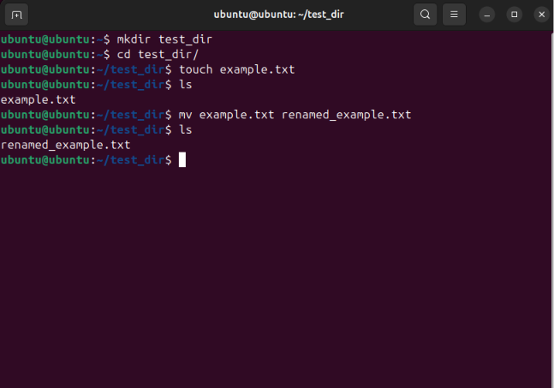

2. Viewing File Contents
Task: Display data from the system file /etc/passwd using various tools.

a) Display full contents
- Command: cat /etc/passwd
- Description: The cat command outputs the entire file content directly to the terminal.

b) Display the first 5 lines
- Command: head -n 5 /etc/passwd
- Description: The head tool with the -n 5 flag limits the result to the first five lines of the file.

c) Display the last 5 lines
- Command: tail -n 5 /etc/passwd
- Description: The tail tool with the -n 5 flag retrieves and displays the last five lines of the file.

Screenshot:
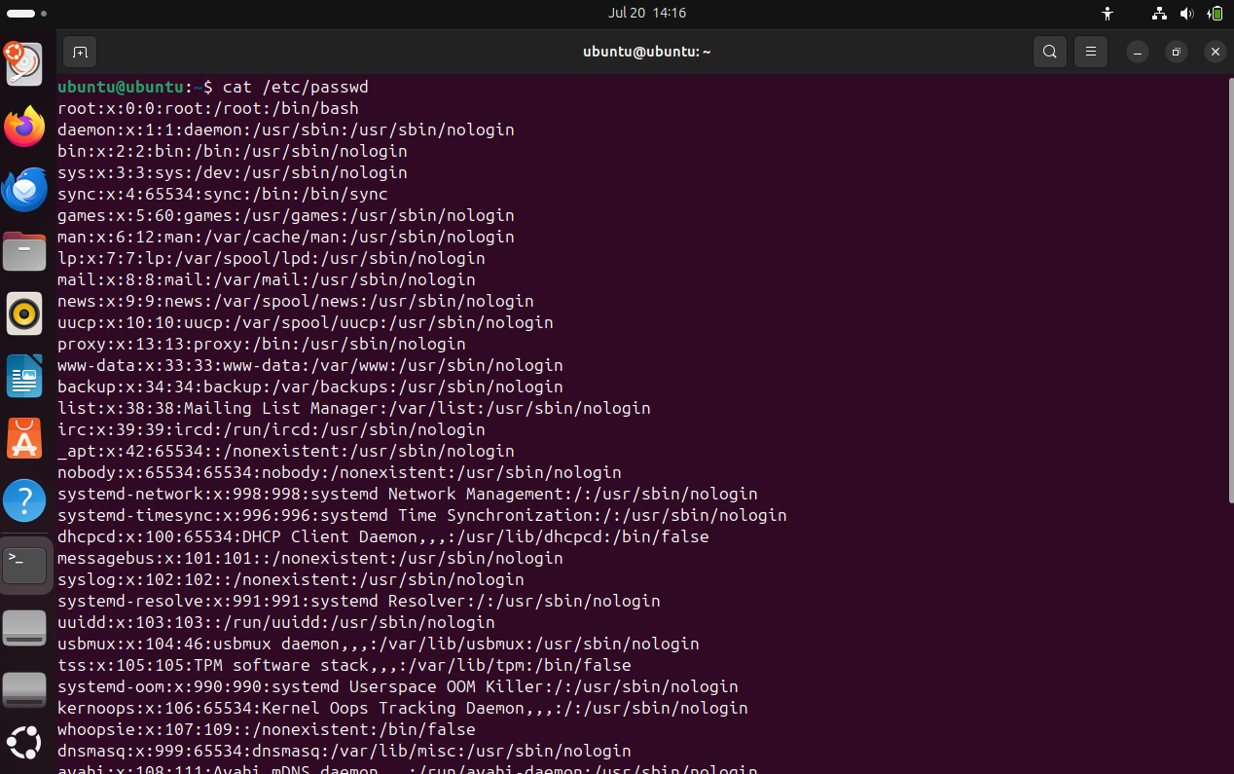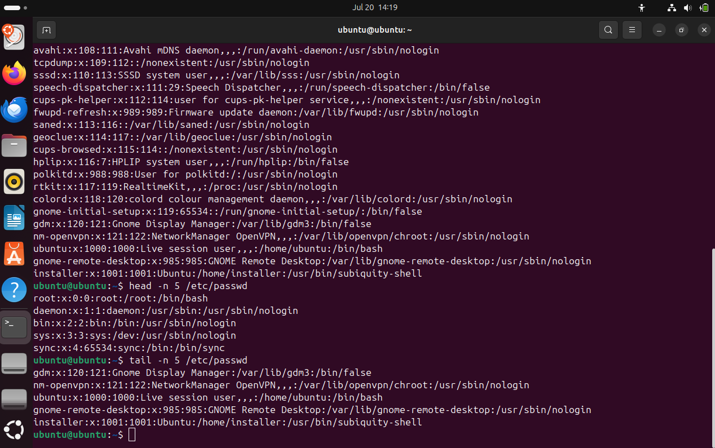

3. Searching for Text Patterns
Task: Find all entries containing the phrase "root" in the user configuration file.

- Command: grep "root" /etc/passwd
- Explanation: The grep command searches the specified file and filters lines that match the provided text pattern.

Screenshot:
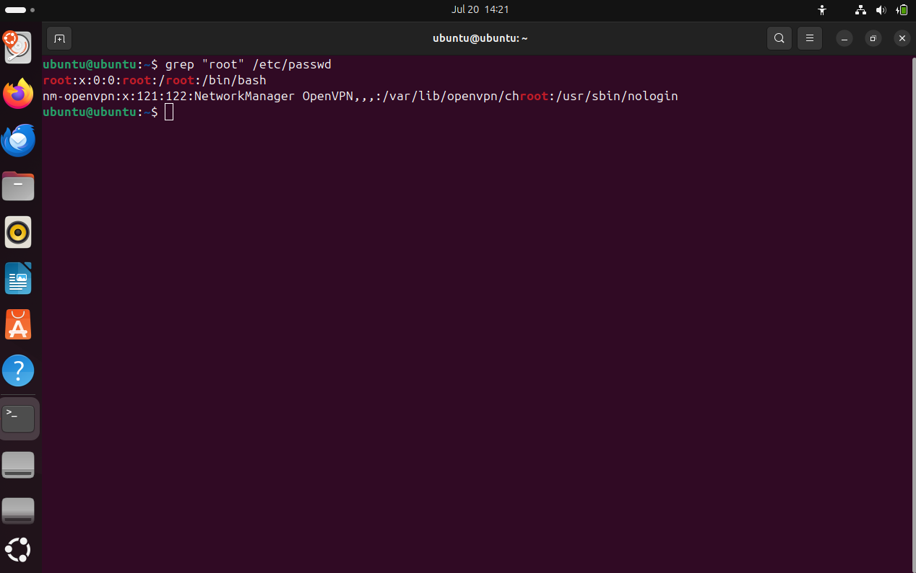

4. Data Archiving and Compression
Task: Compress a directory to ZIP format and extract it.

Stage | Command
Compression | zip -r test_dir.zip test_dir
Create target | mkdir unzipped_dir
Unzip | unzip test_dir.zip -d unzipped_dir

Explanation:

- The -r option in the zip command ensures recursive addition of all subdirectories and files.
- The -d flag in the unzip command allows you to specify the target directory for the extracted data.

Screenshot:
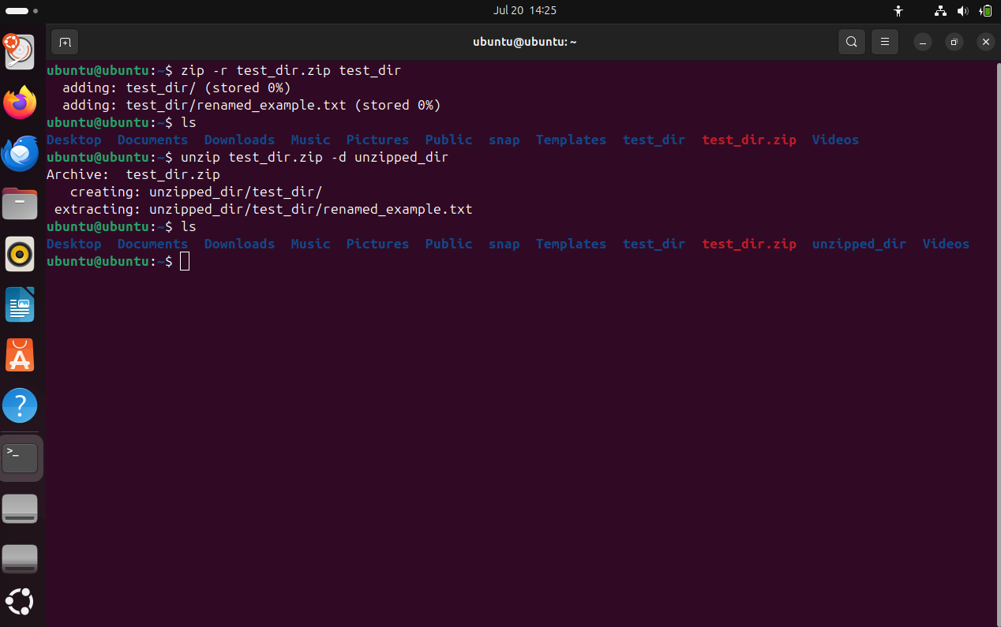

5. Downloading Files from the Network
Task: Download a remote file using the HTTP/HTTPS protocol.

- Command: wget https://www.w3.org/TR/PNG/iso_8859-1.txt
- Explanation: The wget tool downloads the resource from the specified URL and saves it in the current working directory.

Screenshot:
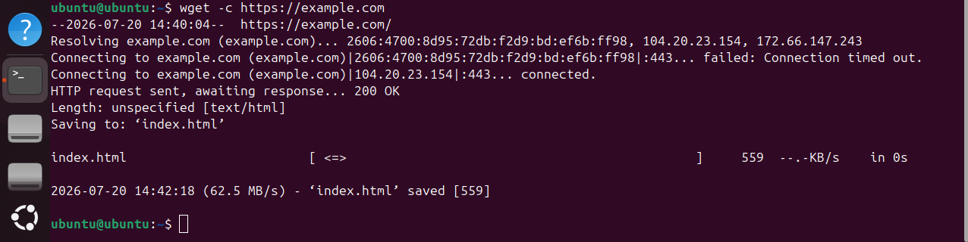

6. Managing Permissions
Task: Create a file with restricted access rights (read-only).

- Commands:
  - touch secure.txt
  - chmod 444 secure.txt
- Explanation: Mode 444 grants read permissions to the owner, group, and other users, while blocking the ability to edit or execute the file.

Screenshot:
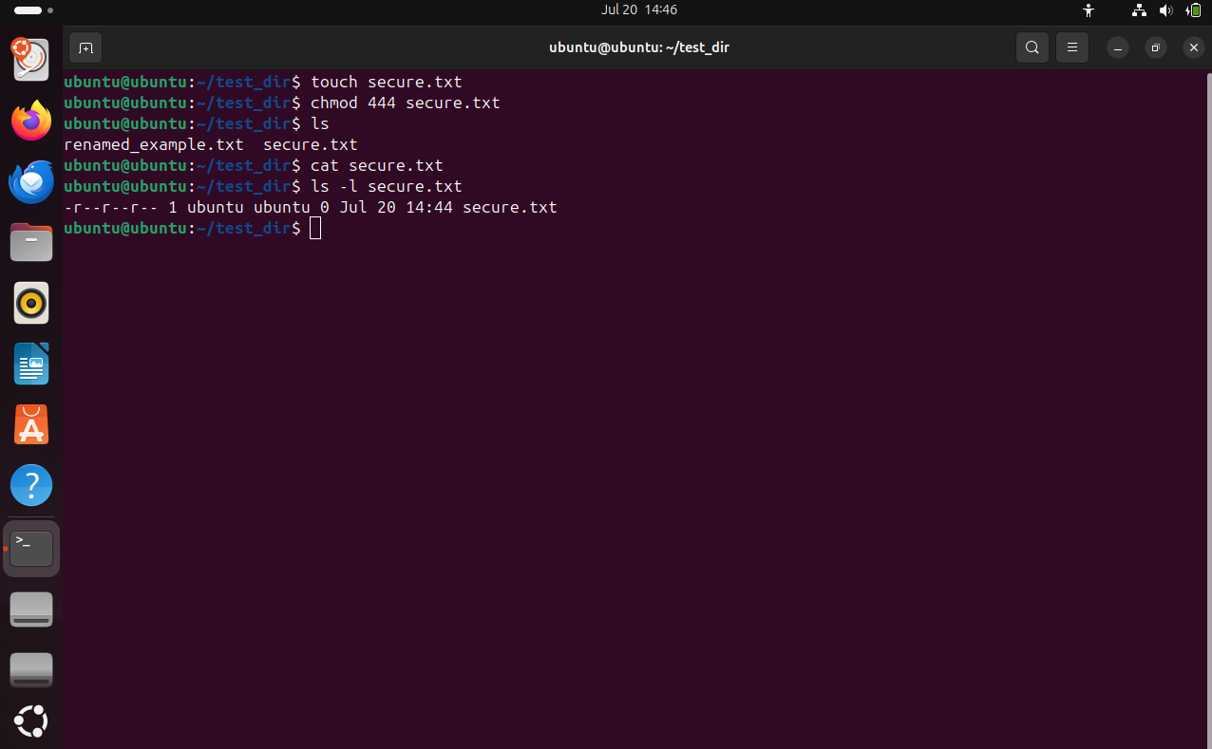

7. Working with Environment Variables
Task: Define a new environment variable and verify its value.

- Commands:
  - export MY_VAR="Hello, Linux!"
  - echo $MY_VAR
- Explanation: export declares a variable available to child processes of the shell, and echo displays its current value stored in memory.

Screenshot:
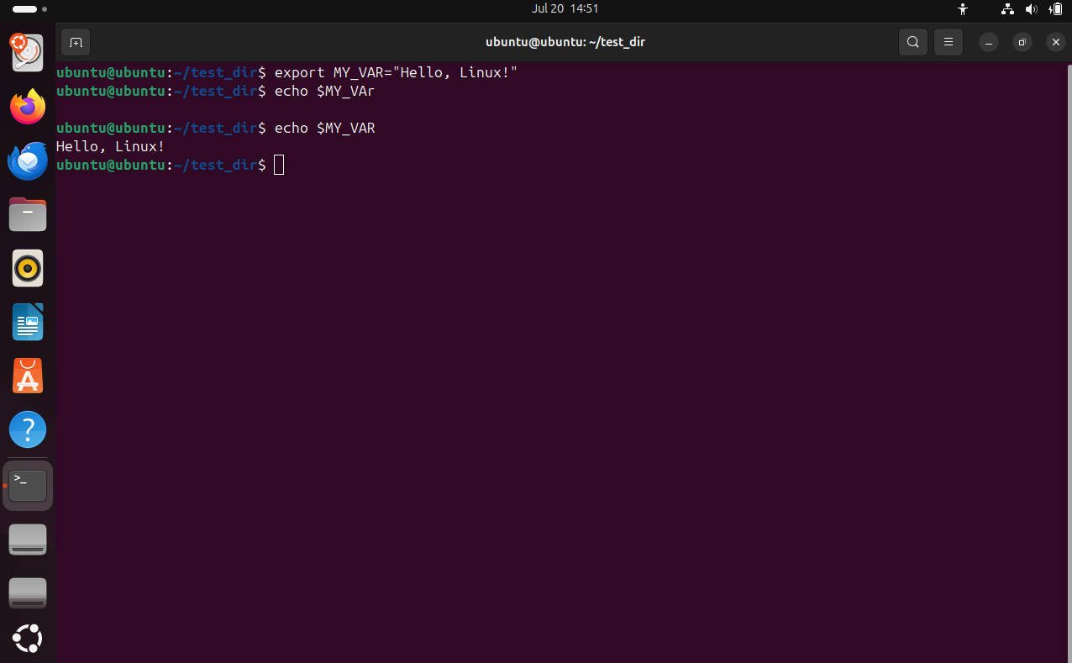

GitHub Repository
- Repository Name: linux-command-assignment
- Link: https://github.com/deanjansen32/linux-command-assignment

Summary
During this assignment, knowledge of basic Linux system administration was reinforced. Practice was conducted on file system operations, text stream filtering techniques, archive management, and configuring permissions and shell variables. These skills form the foundation for effective work in server and development environments.

