INFOSYS SPRINGBOARD VIRTUAL INTERNSHIP 7.0
Workflow Report On
AI-Assisted Threat Detection Dashboard Using AWS Cloud and Machine Learning

Submitted in Partial Fulfillment of the Requirements
for the
Infosys Springboard Internship 7.0

Submitted By

Name: DEBANJAN GHOSH

Team: A (GROUP 2)

ARCHITECTURE DESCRIPTION
The proposed system follows a serverless AWS architecture to provide automated threat detection and visualization. Security logs are uploaded through the dashboard and stored in Amazon S3. An S3 event automatically invokes AWS Lambda, which preprocesses the log data and loads the trained Random Forest model to classify threats. The prediction results and calculated risk scores are stored in Amazon DynamoDB. If a critical threat is detected, Amazon SNS immediately sends an email notification to the administrator. Finally, the dashboard retrieves data from DynamoDB and displays real-time security analytics, including threat summaries, risk scores, attack timelines, and downloadable reports.

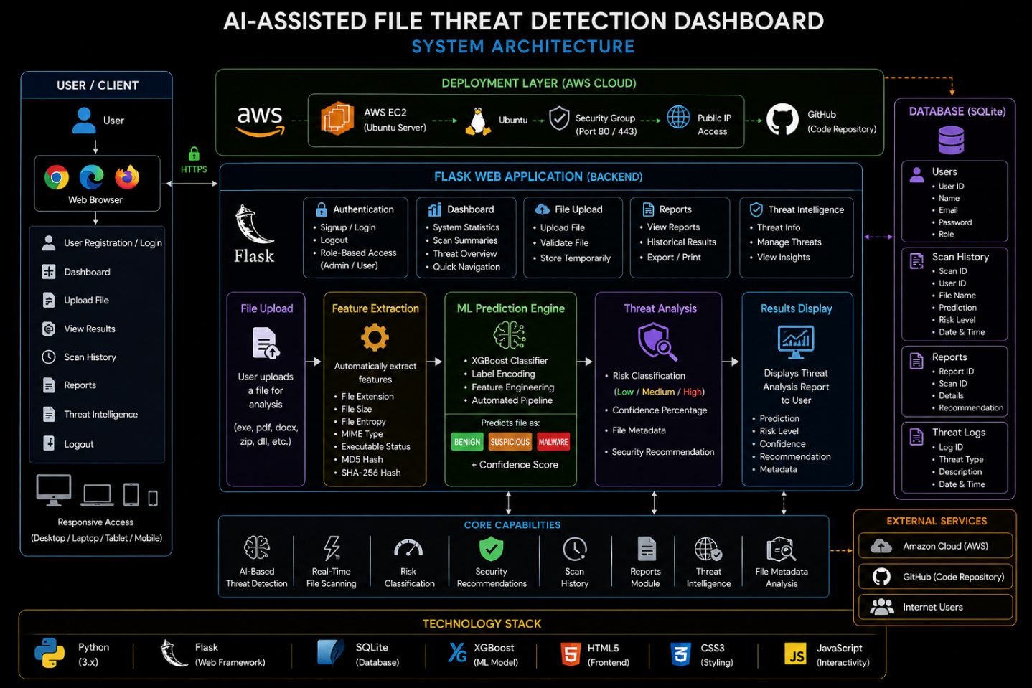

AI-ASSISTED THREAT DETECTION DASHBOARD
WORKFLOW

DEVELOPMENT (VS Code)

Dataset
│
▼
Data Preprocessing
│
▼
Train ML Algorithm
(Random Forest / SVM / etc.)
│
▼
Evaluate Model
│
▼
Save Model (threat_model.pkl)
│
▼
Deploy Project to AWS EC2

AWS EC2 (Deployment)

User
│
▼
Browser
│
▼
Flask Web Server
│
▼
Load Saved Model (.pkl)
│
▼
User Uploads File
│
▼
Threat Prediction
│
▼
SQLite Database
│
▼
Dashboard

AI-Assisted Threat Detection Dashboard Workflow
- Dataset Collection
  - Collect network traffic, URLs, files, or security log datasets required for training the machine learning model.
- Data Preprocessing
  - Clean the dataset, remove missing values, extract important features, and prepare the data for training.
- Machine Learning Model Training (VS Code)
  - Train the machine learning algorithm (e.g., Random Forest, SVM, XGBoost) using Python in Visual Studio Code.
  - Evaluate the model and save the best-performing model as a .pkl file.
- Application Deployment on AWS EC2
  - Deploy the Flask web application along with the pre-trained ML model on an AWS EC2 Ubuntu instance.
  - Configure the server to host the application for user access.
- User Authentication
  - Users access the application through a web browser and log in using secure authentication.
- Threat Data Submission
  - Users upload suspicious files, URLs, or security logs for analysis through the web interface.
- Threat Analysis
  - The Flask application loads the saved ML model and performs feature extraction on the uploaded data.
  - The model analyzes the input and predicts whether it represents a security threat.
- Risk Assessment
  - The system generates a threat classification and corresponding risk score based on the prediction.
- Data Storage
  - Prediction results, scan history, and user information are stored securely in the SQLite database.
- Dashboard Visualization
  - The dashboard displays threat analytics, risk scores, scan history, reports, and other security insights in real time.
- Report Generation
  - Users can review the results, monitor detected threats, and download reports for future analysis and decision-making.

Core Features
1. Secure User Authentication
- User Registration (Signup)
- User Login
- Logout
- Password authentication
- Role-based access (Admin/User)

2. Dashboard
- Interactive security dashboard
- Overall system statistics
- Scan summaries
- Threat overview
- Quick navigation to all modules

3. AI-Based File Threat Detection
- Upload files for security analysis
- Automatic feature extraction
- Machine Learning–based classification
- Predicts whether a file is:
  - Benign
  - Suspicious
  - Malware
- Confidence score for each prediction

4. Intelligent Feature Extraction
Automatically extracts:
- File Extension
- File Size
- File Entropy
- MIME Type
- Executable Status
No manual input is required.

5. Threat Analysis Report
Displays:
- Prediction
- Risk Level
- Confidence Percentage
- File Metadata
- Security Recommendation

6. Risk Classification
Classifies uploaded files into:
- Low Risk
- Medium Risk
- High Risk

7. Security Recommendations
Provides recommendations such as:
- Safe to open
- Scan with antivirus
- Delete immediately
- Avoid execution

8. Scan History
Stores every scan including:
- File Name
- Prediction
- Risk Level
- Scan Date & Time
- Metadata

9. SQLite Database
Stores:
- User Accounts
- Scan History
- Reports
- Threat Logs

10. File Metadata Analysis
Generates:
- MD5 Hash
- SHA-256 Hash
- File Size
- Extension
- Entropy

11. Machine Learning Engine
Uses:
- XGBoost Classifier
- Label Encoding
- Feature Engineering
- Automated Prediction Pipeline

12. Dataset-Based Learning
Model trained on a professional dataset containing:
- Benign Files
- Suspicious Files
- Malware Files
13. Professional User Interface
Includes:
- Responsive Dashboard
- Sidebar Navigation
- Animated Background
- Upload Interface
- Result Cards
- History Page

14. Real-Time File Scanning
Workflow:
Upload File
↓
Feature Extraction
↓
Machine Learning Prediction
↓
Threat Analysis
↓
Risk Report

15. AWS Cloud Deployment
Application deployed on:
- AWS EC2
- Ubuntu Server
- GitHub Integration
- Public IP access

16. GitHub Version Control
Supports:
- Source code management
- Commit history
- Push/Pull updates
- Easy deployment updates

17. Threat Intelligence Module
Provides a dedicated section for viewing and managing threat-related information as part of the application interface.

18. Reports Module
Allows users to:
- View scan results
- Access historical reports
- Review previous analyses

19. Responsive Web Application
Accessible from:
- Desktop
- Laptop
- Tablet
- Mobile browsers

20. Lightweight Architecture
Uses:
- Flask (Backend)
- SQLite (Database)
- HTML/CSS/JavaScript (Frontend)
- Python (Machine Learning)
- XGBoost (Prediction Model)

