**Python**

Python is a simple, general purpose, high level, and object-oriented programming language. Python is an interpreted scripting language also. Guido Van Rossum is known as the founder of Python programming.

Python is a cross-platform programming language, which means that it can run on multiple platforms like Windows, mac OS, Linux, and has even been ported to the Java and .NET virtual machines. It is free and open-source.

Even though most of today's Linux and Mac have Python pre-installed in it, the version might be out-of-date. So, it is always a good idea to install the most current version.

**What is Python?**

Python is a general purpose, dynamic, high-level, and interpreted programming language. It supports Object Oriented programming approach to develop applications. It is simple and easy to learn and provides lots of high-level data structures.

We don't need to use data types to declare variable because it is dynamically typed so we can write a=10 to assign an integer value in an integer variable.

**History of Python Programming Language:**

Python was invented by Guido van Rossum in 1991 at CWI in Netherland. The idea of Python programming language has taken from the ABC programming language or we can say that ABC is a predecessor of Python language.

There is also a fact behind the choosing name Python. Guido van Rossum was a fan of the popular BBC comedy show of that time, "Monty Python's Flying Circus". So he decided to pick the name Python for his newly created programming language.

**Why learn Python?**

Python provides many useful features to the programmer. These features make it most popular and widely used language. We have listed below few-essential feature of Python.

* Easy to use and Learn Expressive Language
* Interpreted Language
* Object-Oriented Language
* Open Source Language
* Extensible
* Learn Standard Library
* GUI Programming Support
* Integrated
* Embeddable
* Dynamic Memory Allocation
* Wide Range of Libraries and Frameworks

**Where is Python used?**

Python is a general-purpose, popular programming language and it is used in almost every technical field. The various areas of Python use are given below.

* Data Science
* Date Mining
* Desktop Applications
* Console-based Applications
* Mobile Applications
* Software Development
* Artificial Intelligence
* Web Applications
* Enterprise Applications
* 3D CAD Applications
* Machine Learning
* Computer Vision or Image Processing Applications.
* Speech Recognitions

**Python popular Frameworks and Libraries**

Python has wide range of libraries and frameworks widely used in various fields such as machine learning, artificial intelligence, web applications, etc. We define some popular frameworks and libraries of Python as follows.

* Web development (Server-side) - Django Flask, Pyramid, CherryPy
* GUIs based applications - Tk, PyGTK, PyQt, PyJs, etc.
* Machine Learning - TensorFlow, PyTorch, Scikit-learn, Matplotlib, Scipy, etc.
* Mathematics - Numpy, Pandas, etc.

**The Easiest Way to Run Python**

The easiest way to run Python is by using Thonny IDE.

The Thonny IDE comes with the latest version of Python bundled in it. So you don't have to install Python separately.

Follow the following steps to run Python on your computer.

1. Download [Thonny IDE](https://thonny.org/).
2. Run the installer to install Thonny on your computer.
3. Go to: File > New. Then save the file with .py extension. For example, hello.py, example.py, etc.  
   You can give any name to the file. However, the file name should end with .py
4. Write Python code in the file and save it.
5. Then Go to Run > Run current script or simply click F5 to run it.

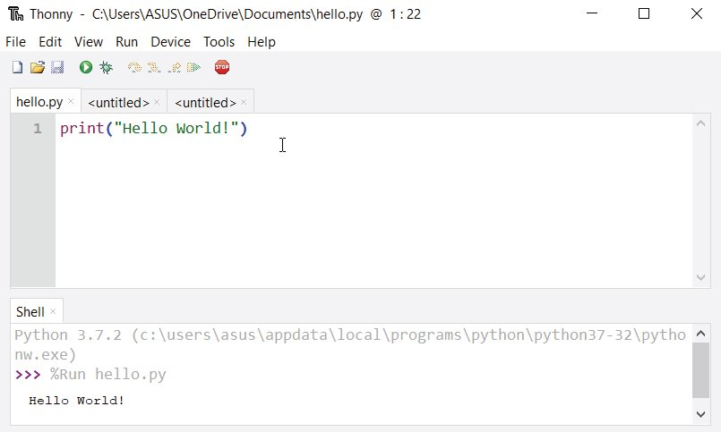

**Install Python Separately**

If you don't want to use Thonny, here's how you can install and run Python on your computer.

1. Download the [latest version of Python](https://www.python.org/downloads/).
2. Run the installer file and follow the steps to install Python  
   During the install process, check Add Python to environment variables. This will add Python to environment variables, and you can run Python from any part of the computer.  
     
   Also, you can choose the path where Python is installed.

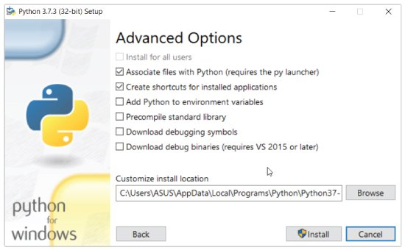

Once you finish the installation process, you can run Python.

**1. Run Python in Immediate mode**

Once Python is installed, typing python in the command line will invoke the interpreter in immediate mode. We can directly type in Python code, and press Enter to get the output.

Try typing in 1 + 1 and press enter. We get 2 as the output. This prompt can be used as a calculator. To exit this mode, type quit() and press enter.

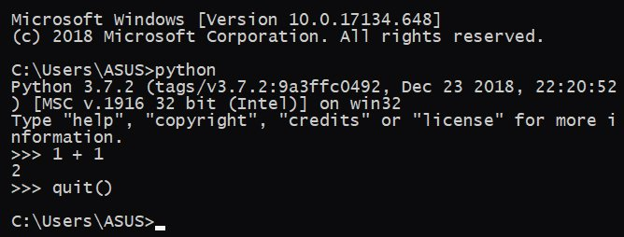

Running Python on the Command Line

**2. Run Python in the Integrated Development Environment (IDE)**

We can use any text editing software to write a Python script file.

We just need to save it with the .py extension. But using an IDE can make our life a lot easier. IDE is a piece of software that provides useful features like code hinting, syntax highlighting and checking, file explorers, etc. to the programmer for application development.

By the way, when you install Python, an IDE named **IDLE** is also installed. You can use it to run Python on your computer. It's a decent IDE for beginners.

When you open IDLE, an interactive Python Shell is opened.

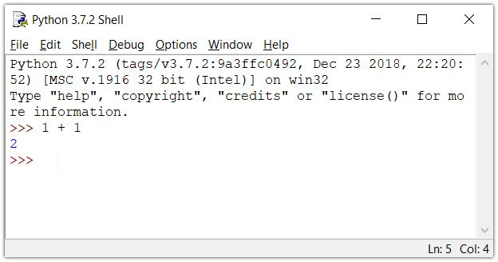

Now you can create a new file and save it with .py extension. For example, hello.py

Write Python code in the file and save it. To run the file, go to Run > Run Module or simply click F5.

