A Project Report
On

Design Of MIMO Antennas
BY
Debanshu Ghosh
2023A3PS0332H

Under the supervision of
Sourav Nandi

SUBMITTED IN FULFILLMENT OF THE REQUIREMENTS OF
EEE F376: DESIGN PROJECT



BIRLA INSTITUTE OF TECHNOLOGY AND SCIENCE PILANI
HYDERABAD CAMPUS
(November 2025)

ACKNOWLEDGMENT

I want to say that I am an extremely grateful person who received priceless knowledge and assistance during this project thanks to Mr. Sourav Nandi. His professional recommendations and regular guidance were very helpful in helping me to proceed with my research on the design of MIMO antennas. I am also thankful to the Department of Electrical and Electronics Engineering at the Birla Institute of Technology and Science, Pilani -Hyderabad Campus, to have availed the necessary resources and a vibrant environment that would be favorable to the implementation of this project.

BIRLA INSTITUTE OF TECHNOLOGY AND SCIENCE PILANI,
HYDERABAD CAMPUS

Certificate

This is to certify that the project report entitled “Design Of MIMO Antennas” submitted by Debanshu Ghosh (ID No. 2023A3PS0332H) in fulfillment of the requirements of the course EEE F76, Design Project Course, embodies the work done by him under my supervision and guidance.

Date: 27/11/2025 Sourav Nandi
BITS- Pilani, Hyderabad Campus

ABSTRACT

The aim of the project is on the design, simulation and analysis of Multiple-Input Multiple-Output (MIMO) antennas in modern wireless communication systems. MIMO technology increases capacity, reliability and spectral efficiency of the system using multiple transmitting and receiving antennas.
Here, microstrip patch antennas are optimised and designed with full-wave electromagnetic simulation. The parameters of the different antennas considered to evaluate performance include: return loss (S11), mutual coupling (S21), radiation pattern, gain etc. To achieve low coupling and stable radiation, design methods to enhance the isolation between the elements of the antenna are investigated: through optimising the elements separation, substrate characteristics, and metasurface methods. The findings show that in the proper impedance match and space arrangement, compact MIMO antenna systems can be used effectively with less mutual coupling and this makes compact antenna ideal in next generation wireless and radar systems.

Contents

Design Of MIMO Antennas 1
ACKNOWLEDGMENT 2
Certificate 3
ABSTRACT 4
Introduction 6
Literature Survey 7
Design and Simulated Performance of the Microstrip Patch Antenna 10
Design and Simulated Performance of the Dual-Element Microstrip Patch Array 11
Design and Simulated Performance of a Metasurface Unit Cell 13
Effective Parameter Retrieval of a Metasurface Unit Cell 15
Conclusion 18
References 19

Introduction

The growing need of the high-speed and dependable wireless communication has triggered the development of the improved antenna technologies. One of such, Multiple-Input Multiple-Output (MIMO) systems is one of the foundations of the contemporary wireless standards due to the ability to enhance the data throughput, connectivity reliability, and spectral efficiency without requiring extra bandwidth or power. The proposed project is dedicated to designing and analyzing microstrip patch antennas to be used in MIMO. The task includes studying the antenna theory, researching the literature already existing, and modeling patch designs to test the parameters of return loss (S11), mutual coupling (S21), and the radiation properties. The aim is to have efficient radiation, low reflection and good isolation among the antenna elements which are most important in determining the performance of MIMO systems in modern communication set ups.

Literature Survey

The current report holds an extensive overview of the basic concepts in antenna theory, starting with simple single-element designs, and moving on to more complex multi- antenna designs, with special focus on printed antenna designs that are small-sized. The survey was first of wide isolation schemes, then a detailed discussion of the specific papers on parasitic elements, neutralization fences, defected ground structures (DGS) / electromagnetic band-gap (EBG) structures, and, later on, the sophisticated metasurface-based decoupling schemes.

- Design Procedure and Results of Microstrip Patch Antenna.
The construction process theory of a small rectangular patch antenna microstrip on a substrate would traditionally involve the calculation of geometrical sizes depending upon the desired resonant frequency, substrate dielectric constant and substrate thickness.
- Parameters of Design: When calculating the first length and width of the patch, approximate transmission-line model equations are used including Equation (5.1) and Equation (5.4) in Alsaker (2011).
- Substrate Effect: A substrate of higher dielectric constant significantly lowers the physical size of a patch, which in turn allows easy miniaturisation; a feature that is essential in miniaturisation of receivers (like GPS units or satellite television terminals).
- Feeding and Matching: This is a necessary process in which the location of the optimal feed-point is determined as (x, y) to obtain the desired input impedance and maximise the power transfer. It may frequently be necessary to make an iterative correction to the original calculation, as is the case with GPS antennas.
- Array Application: To achieve higher performance, e.g., higher received power, directivity, which is desirable in a satellite communication system, one can use an array of multiple patch antennas of microstrip type (two-element arrays or four-element arrays). The next challenge is that of designing a corporate feed network and equivalent lines which maintain system impedance.

- Detailed Investigation of the Key MIMO Performance Measures

Characterisation of MIMO antenna systems requires use of reliable metrics by taking into consideration the interaction between closely spaced elements and the surrounding environment.

A. Correlation Coefficient (CC) or Envelope Correlation Coefficient (ECC)
The ECC refers to the independence of the radiation channels, which is needed for achieving the theoretical channel capacity gains of MIMO. A value below 0.3 is often considered acceptable for 4G wireless systems.
- Calculation Method: To make an accurate calculation, the three dimensional patterns of the radiated fields of the antenna elements (Equation(2) in Sharabi(2013)) should be integrated to rightfully capture pattern coupling..
- Common Misuse: It is often mistaken as calculating ECC only based on S -parameters (e.g., Equation (4) in Sharabi (2017)). It can only be used with lossless antennas in an isotropic environment, and not with realistic lossy printed antennas, which will show false good correlation in cases where there is a lot of overlap of the fields.
- Isolation vs. Correlation: Port isolation (large ) attempts to isolate ports, therefore, improving efficiency. Field correlation aims at decoupling the spatial fields, and as such enhances capacity. Isolating an antenna does not imply that they will be lowly correlated, unless the antenna patterns are spatially isolated (e.g. by orthogonal polarisation or beam tilting).

B. Total Active Reflection Coefficient (TARC)
TARC is a better evaluation of total impedance bandwidth and efficiency of a MIMO system than single-port reflection coefficients. It is the square root of the reflected total power over all ports to square root of incident total power over all ports.
- TARC naturally measures mutual coupling and phase difference among input signals, hence provides a complete measure of the operational bandwidth of the system with abroad range of excitation conditions.

- Comparative Literature Survey: Microstrip Antennas and MIMO Systems

Comparing the design of the antenna technology of Microstrip Patch Antenna Arrays with the basics of the sophisticated MIMO theories and issues as mentioned in the two articles by Sharabi.

Feature | Microstrip Patch Antennas (Alsager, 2011) | MIMO Antenna Systems (Sharawi, 2013 & 2017)
Primary Goal | To Achieve resonance, directional patterns, high gain and impedance matching. | Maximizes Channel Capacity by utilizing savailable space and increasing the number of antennas.
Key Antenna Type | Rectangular and circular patch designs. | Monopoles that are printed, PIFAs, F-shaped, and dielectric resonator antenna (DRA) antennas.
Critical Metric | Measures power delivered to the antenna, ensures good impedance matching to the source. | Measures channel isolation/independence; directly impacts channel capacity.
Isolation/Coupling | The concern is minimized feed-point reflected power | Usually faces high mutual coupling, especially at lower frequency bands in closely packed elements, degrades performance
Design Trade-offs | High dielectric constant reduces size but may affect efficiency and bandwidth. | Antenna miniaturization negatively affects efficiency and operating bandwidth.

- Various Isolation Techniques for MIMO Antennas
The isolation methods may be divided into the external and internal decoupling methods:
- External Decoupling Techniques refer to the inclusion of new structures or alterations that aimes at opposing the mutual coupling. These include:
- Neutralization Lines: The neutralisation Lines are proposed to be used between the coupled antennas with the lines of certain length and width to provide an additional path to be mutually coupled and then cancelled. The radiated near-field of the coupled antennas is also perturbed by them. This technique has been useful with different types of antennas, such as narrowband mobile-phone antennas, wideband antennas, and ultra-wideband antennas. (Kaur et al., 2024; Liu et al., 2018).
- Parasitic Decoupling Elements: These may include monopoles, PIFAs, and mushroom-like structures that are strategically that’re located between driven antenna elements, which improves port isolation (Liu et al., 2018). These are parasitic elements that can also contain scatterers or radiative patches, which are supposed to scatter or redirect the coupling energy (Tang et⁻ al., 2017). Attention to the design is required to make sure that these aspects do not violate the original antenna radiation pattern or ruin the impedance-matching performance (Liu et al., 2018).
- Defected Ground Structures These involved etching slots or patterns on the ground plane to restrain ground current coupling and provides isolated operating conditions (Kaur et al., 2024). By optimizing the parameters of the DGS, such as the dimensions of the rings, the resonant frequency can be controlled to cover the operating band of the antenna (Wang et al., 2013).
- EBG structures that consist of elements periodically arranged are used to inhibit surface-wave coupling (Tang et al., 2017). Exemplary designs include mushroom-like, F-shaped and uniplanar compact EBGs (Tang et al., 2017). Such designs add an outlaw propagation band thus reducing mutual coupling of antenna elements. In the case of antenna decoupling with EBGs, elements are always required to be spaced adequately to fit the required number of EBG cells (Liu et al., 2018; Wei et al., 2023).

- Internal Decoupling Techniques focus on the inherent properties of the antenna array:
- Space Diversity involving the optimum spatial allocation and separation between elements in order to reduce interference (Kaur et al., 2024).
- Polarization Diversity This utilizes orthogonally polarized antennas (e.g., horizontal and vertical) to limit signal crosstalk and increase isolation.

- Metasurface-based Isolation Techniques
Metasurfaces have emerged as a The isolation method based on metasurface has become one of the available technologies to enhance isolation in small MIMO antenna systems because it has distinct electromagnetic characteristics and the ability to control the propagation of waves. A number of studies have explored the use of metasurface in decoupling.
An example is incorporating a metamaterial array in the middle of symmetrically spaced radiators through which the isolation has improved by a factor of -39 dB at 28 GHz and 38 GHz (Kaur et al., 2024). Other methods are to place a metasurface superstrate over coupled antenna elements. Periodic circular split-ring resonator elements on top of two-element patch antennas are a part of one design (Wang et al., 2020). It is a negative-permeability medium that suppresses mutual coupling to generate an enhancement of isolation of up to about -8dB to -20dB over operating band 5.58-6.0GHz and matches performance at the same time (Wang et al., 2020). The progress highlights that metasurfaces are an effective method in overcoming mutual coupling in MIMO antenna design to help create smaller, more efficient, and high-performance wireless communication systems.

Design and Simulated Performance of the Microstrip Patch Antenna
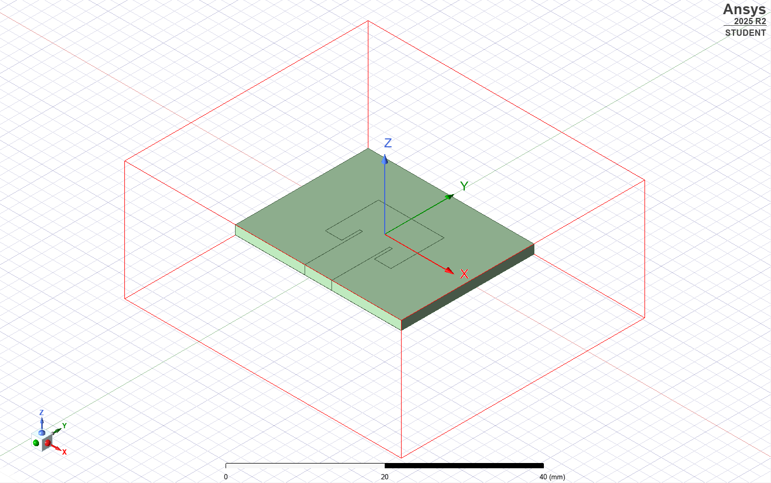
The latter is a single-element patch antenna in microstrip, optimized to work at 100 GHz in the high-frequency (8 to 12 GHz) spectrum, and based on the benefits of planar, low-profile technology. The radiating element with a modified rectangular shape with specific physical dimensions is a rectangular patch with a length of 9.64mm and a width of 11.86mm. The antenna is deposited on a dielectric substrate of thickness 1.588 1.588mm. The patch surface has u-shaped slots that are used to optimize the complex impedance and the resonant frequency of the element. The patch is linked to power through a direct inset feed mechanism in which the feed line is connected to the radiating patch at a special inset depth of 3.26 0.5 mm - which is a sensitive factor to obtain a critical 50 ohm match of the impedance..
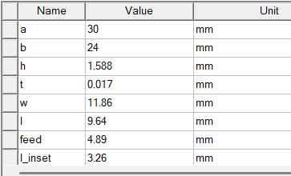
- Impedance Matching and S-Parameter Performance
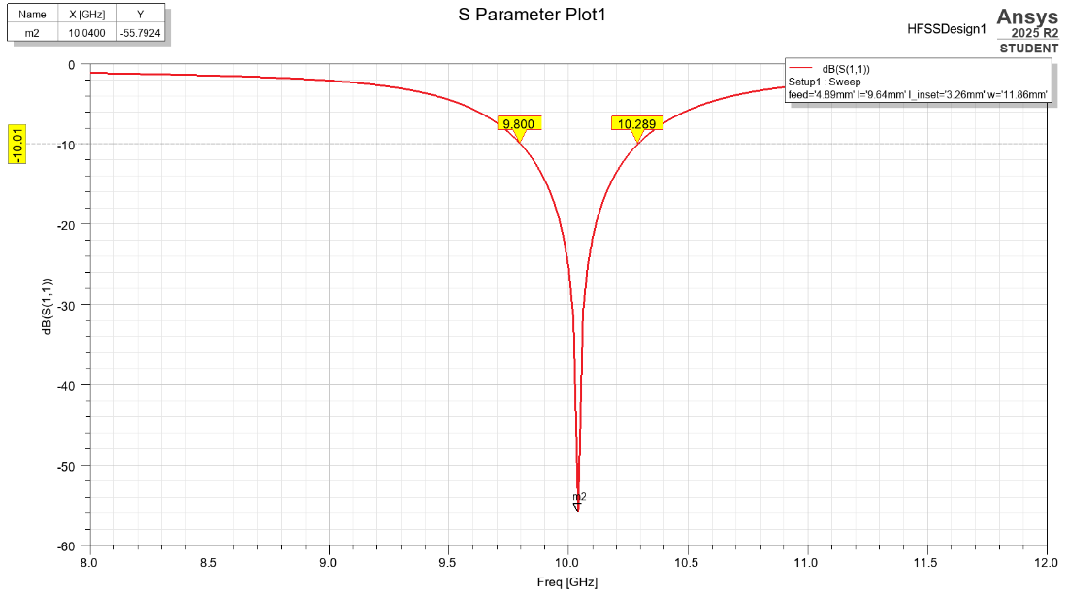
The reflection coefficient (S11) simulation results show an extraordinary amount of numerical accuracy of a high-quality-factor design. The antenna is adjusted to resonate at 10.040 0Hz, with the minimum (return loss) of -55.792 0D. This extreme match means that insignificant proportion of the incident power is reflected back to source. The system gives a usable operational bandwidth defined by standard value of S11 -10 dB to 9.800 -10.289 GHz which gives an approximate band width of 489 megahertz and a fractional band width of 4.8%.
The theory of far-field simulation proves that the antenna is an effective radiator that can be used in the directional mode. The element is of conventional broadside radiation pattern and the primary beam is perpendicular to the planar surface of the antenna. This trend is necessary in high-gain systems like fixed radar or satellite communication. The antenna has attained an actual peak gain of 7.70 dBi that proves effective change of input power to radiated energy. Two-dimensional polar plot analysis has verified that the angular distribution of radiated power is heavily concentrated around the desired co-polar component, which proves the ability of the design to create a focused, linearly polarized beam with high directivity.
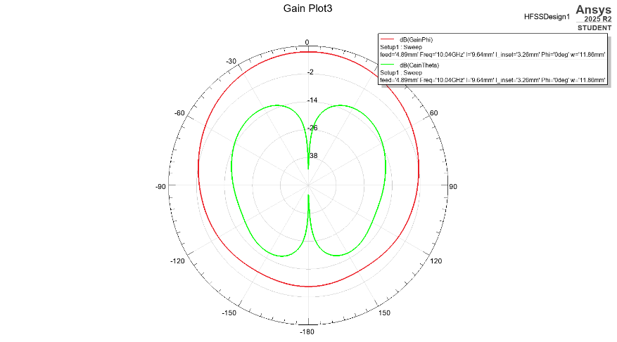
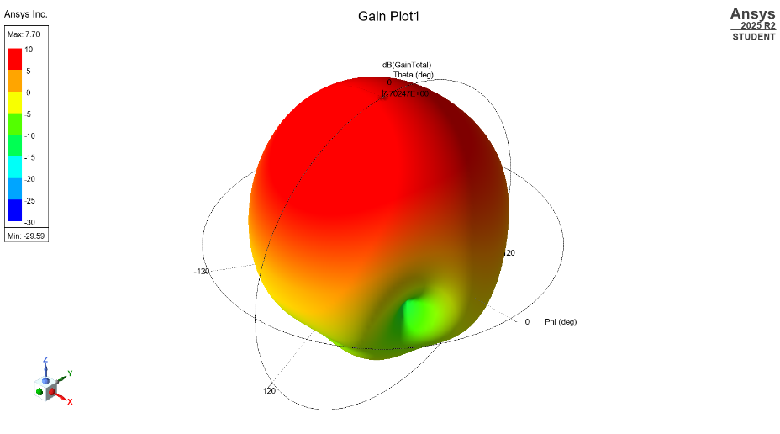

Design and Simulated Performance of the Dual-Element Microstrip Patch Array
This paper discusses the properties of a dual-element array of microstrip patches (MPA) antenna to be used in the 10 GHz range. The array is made up of two rectangular patch self-symmetrical individual elements with the same dimensions but altered and placed on a single dielectric substrate. The patches have internal U-shaped slots, a circuit element that is routinely utilized to tune resonant frequency precisely and input impedance optimally, this is especially important when tuning at high frequency. The antenna elements are inset fed to the feed network, and are optimized to a 50 ohms interface, and are plotted on a substrate of 1.588 mm thickness.
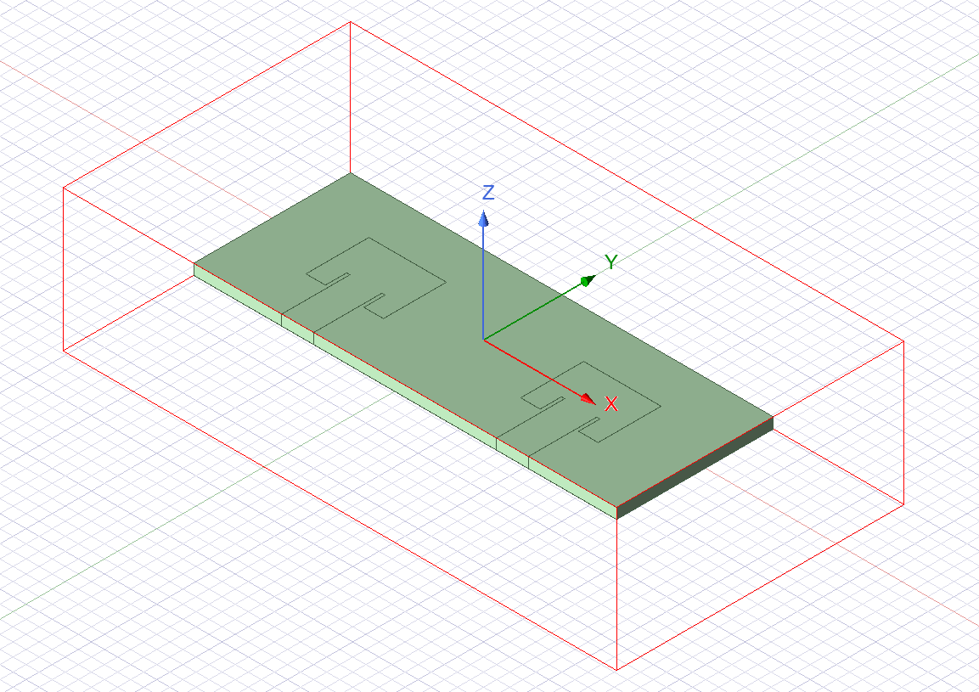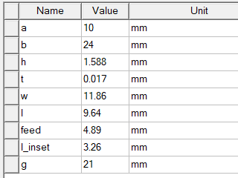

- Impedance Matching Performance (S₁₁)
The reflection coefficient (S11) is used to determine the impedance performance of the array elements and is used to measure the efficiency of power delivery to the antenna. The dual-element array with an inset depth of 3.26mm, patch length of 9.64mm and inter-patch distance of 21mm has simulated results of a resonant frequency of 10.040GHz. The return loss at this frequency is -39.415dB which represents a very good match and thus a very small portion of incident power is bounced back to the source and thus, high power transfer efficiency is assured. Its bandwidth of operation spans around 460MHz (9.803 to 10.286 GHz).
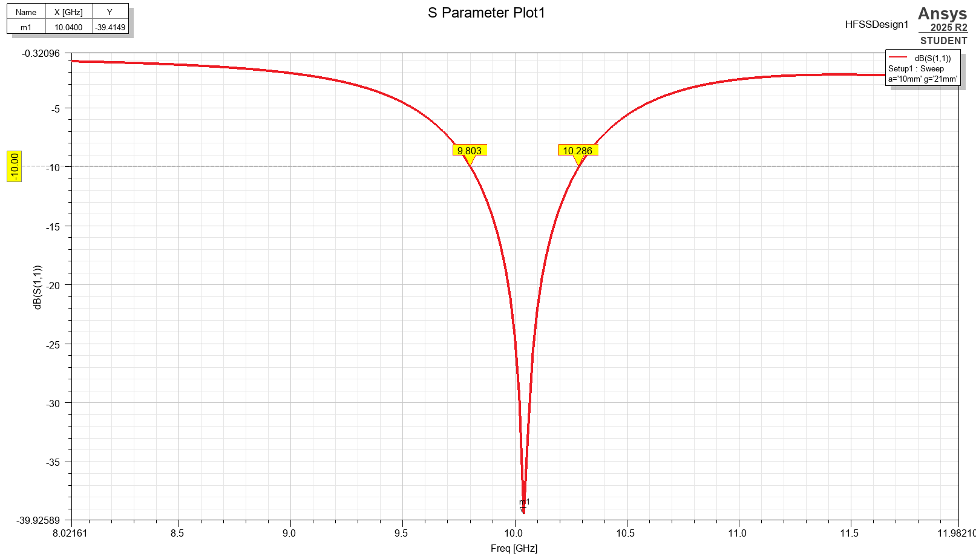
- Inter-Port Isolation Performance
Variation of S₂₁ with Gap (g)
1. Observation from the Plot
The higher the separation g compared to 2mm, the lower the coupled point represented by S21 curve, that is, the more negative the S21 values (refer to figure 2). At small sizes (25 mm -5 mm) the coupling is high, with S21 values of about -20 -30 dB. Once the gap has increased to about 10 -13 mm, the attenuation dip becomes much more pronounced, with a value of -50 -70 dB. Increasing the distance beyond 18mm the curves will approach saturation, again marginal improvements in isolation but the resonant dip will be close to 10.8-11GHZ.
2. Physical Explanation
- The coupling is due to electromagnetic interaction between the two patch antennas and is mainly through fringing and surface waves.
- Small values of g are sufficiently close enough to allow high near patch interactions hence high energy leakage to the other patch, and thus high coupling (S21 is not so negative).
- This interaction decreases with an increase in g, thus decreasing mutual coupling and making S21 more negative.
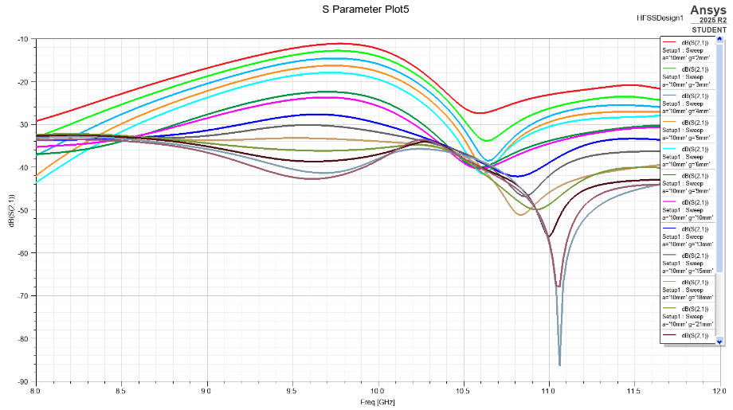
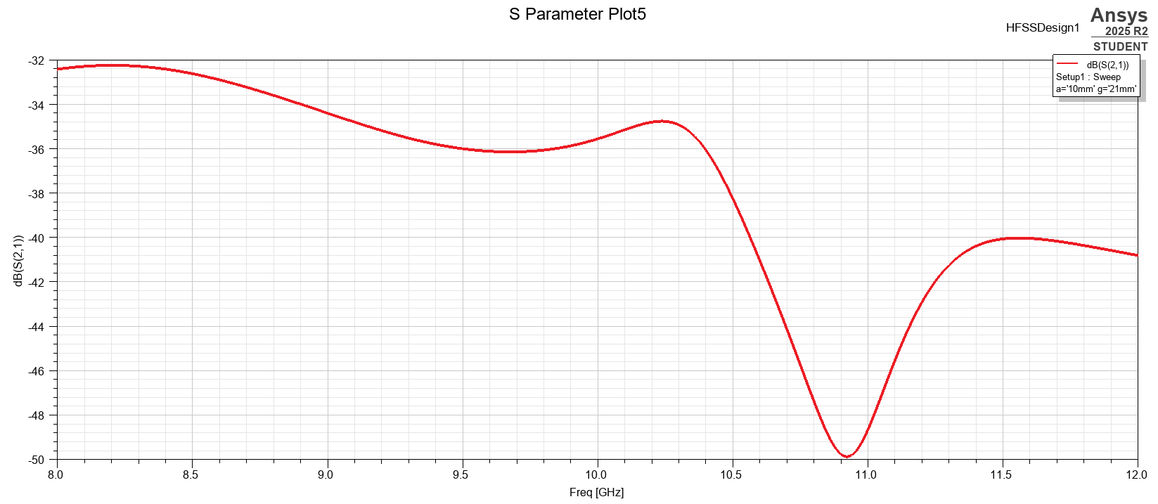

Design and Simulated Performance of a Metasurface Unit Cell
The metasurfaces (MS) are planar periodical electrically thin structures and are used in the management of electromagnetic waves. Their common uses are in suppression of mutual coupling, increased bandwidth as well as radiation patterns of small arrays of antennas. A toothed ring unit cell with four symmetric arms and a square form was developed and modeled in ANSYS HFSS in this study with Floquet ports and periodic boundary conditions. The geometry and simulation setup is guided by the metasurface structure indicated by Xin Wei. (J. Phys.D: Applied Physics, 2024).
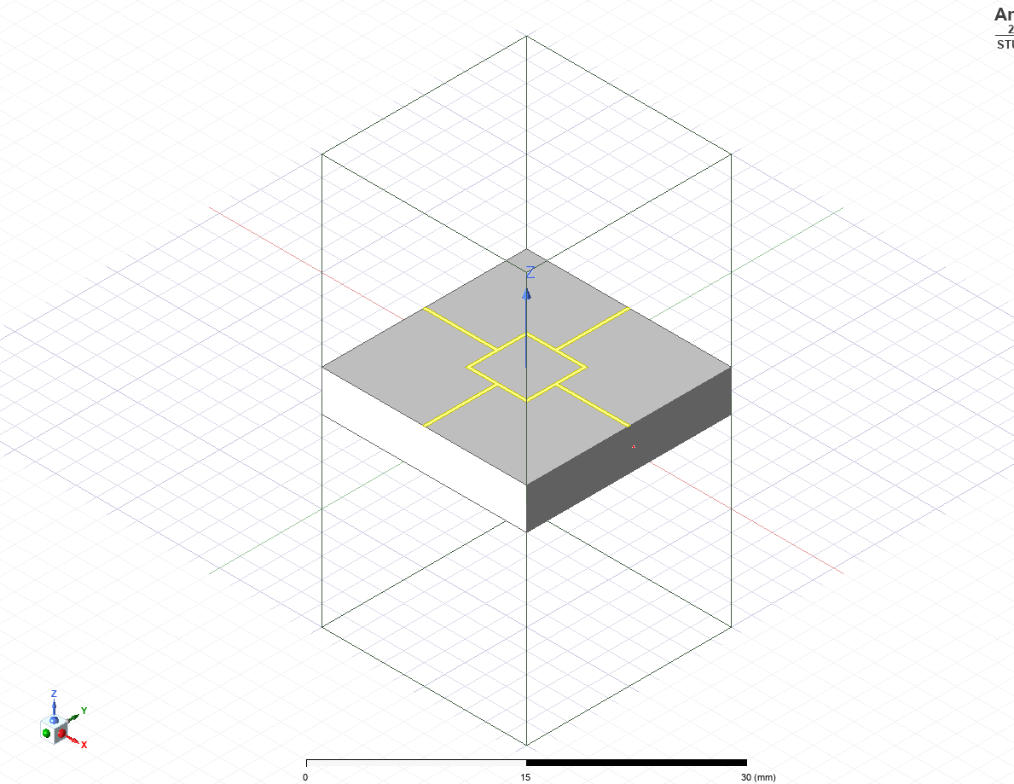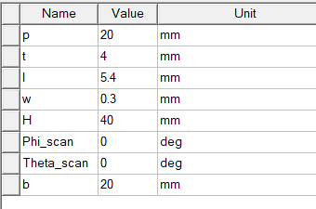
Boundary Conditions
- Master/Slave boundaries on the side faces ensures periodicity.
- Floquet ports were located at the +z and the -z face to excite all TE/TM modes.
- The air box is surrounded by a radiation boundary condition.
This arrangement is similar to the one in the reference article (page 3), in which Floquet ports are used to extract the unit-cell
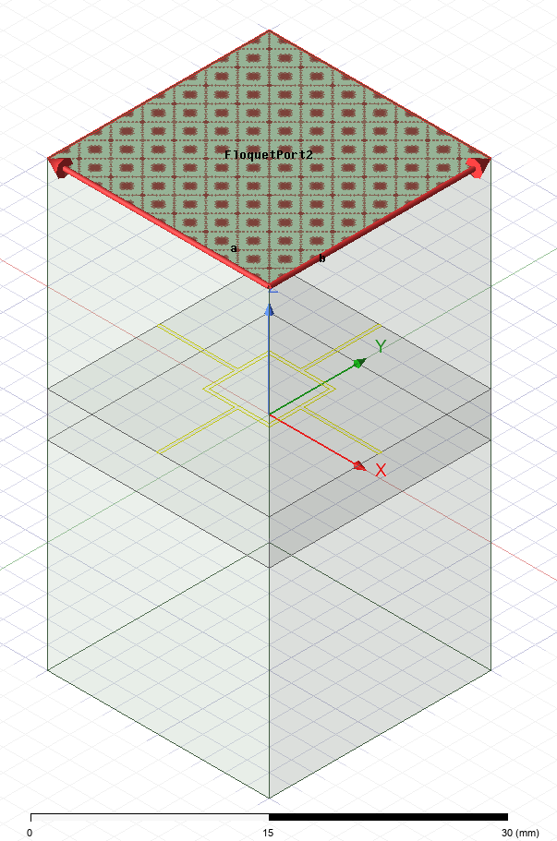
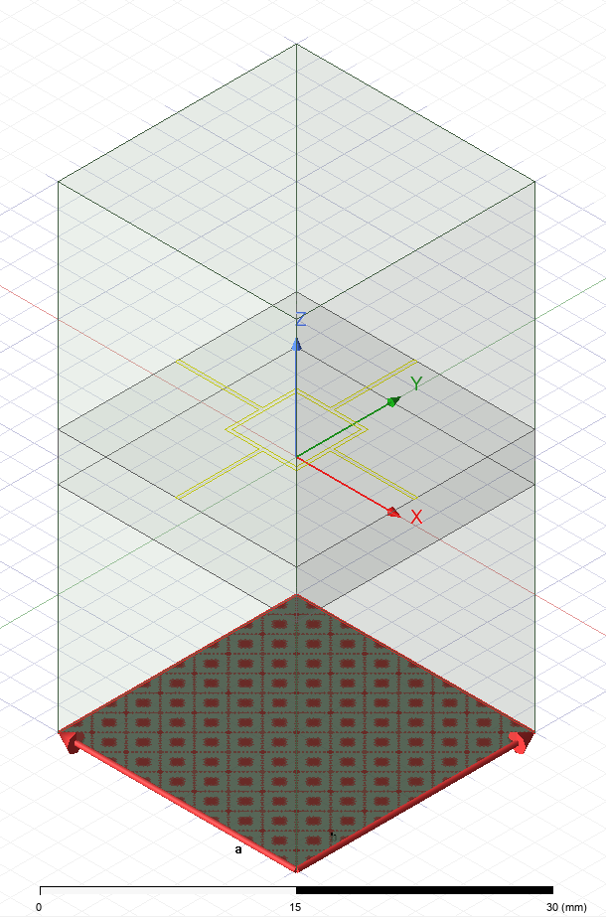
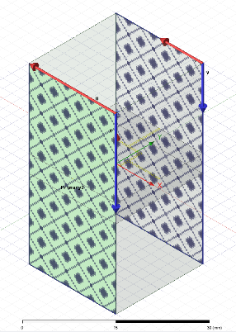
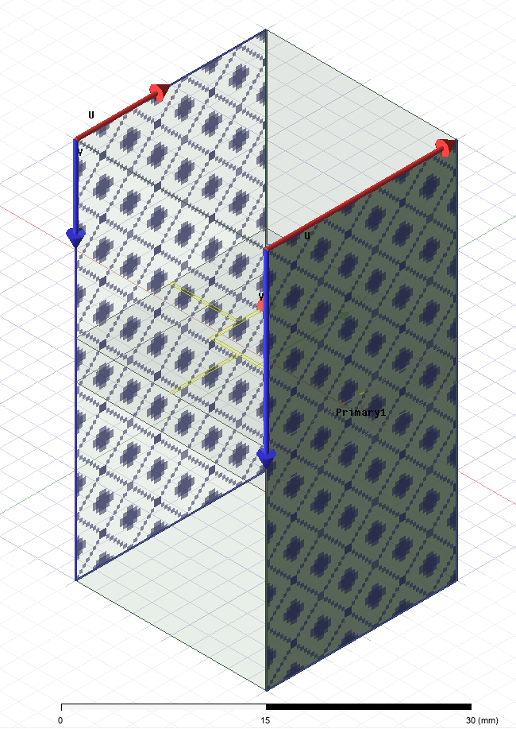

S-Parameter Behaviour
- S11 Resonance Near 5.15 GHz
As the strip width w is increased, the resonance moves to high frequencies.
- S21 Shows Weak Transmission (High Reflection)
The unit cell has a very high electric resonance, which behaves like a partially reflective surface, which is an excellent property of metasurface superstrates.
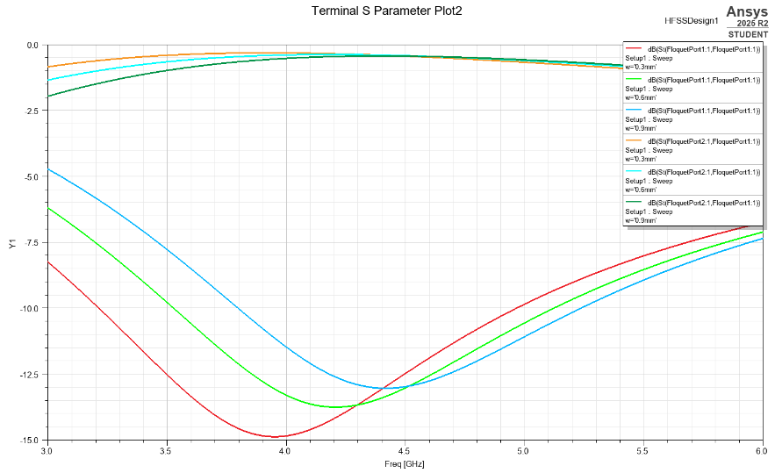
The plot with w = 0.3, 0.6, 0.9 mm shows:
- Larger w leads to higher resonant frequency
- Narrow strips results in deeper S11 dip
- Wider strips gives shallower resonance
This matches published metamaterial behaviour.
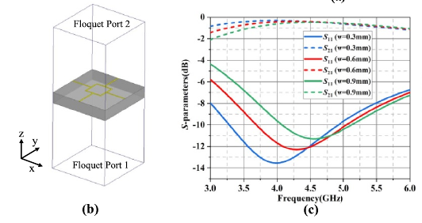

Effective Parameter Retrieval of a Metasurface Unit Cell
The study by Wei et al. (2024) proposed a square-ring-based metasurface designed to provide reduction in wideband mutual-coupling and enhance bandwidth in compact H-plane patch arrays. Their study demonstrates that the space-wave coupling can be significantly reduced by using an effective permittivity of such a unit cell, between 2.8 and (roughly) 4.15 GHz, which is effective and considered a key factor in suppression surface-wave coupling.
The unit cell has been replicated in this project, modeled in ANSYS HFSS, with Floquet ports, and the S -parameter data was extracted to CSV. To calculate the effective permittivity \epsilon eff and the permeability mu eff as a function of frequency, the standard NicolsonRossWeir (NRW)/Chen retrieval method was used. The material parameters were then compared with the behaviour that was reported in the reference study.
Preprocessing
The simulation was additionally exported to a CSV file containing the S -parameters. One can see a sample data set below:
Column 1: Frequency (GHz)
Column 2: S11 (dB) = dB(St(FloquetPort1:1,FloquetPort1:1))
Column 3: S21 (dB) = dB(St(FloquetPort2:1,FloquetPort1:1))

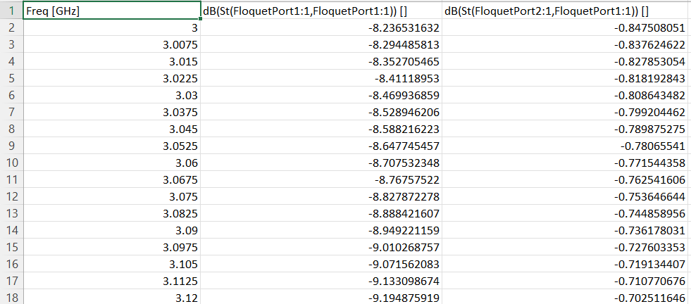
- Effective Parameter Retrieval Method
The retrieval method used is based on the well-established formulation given in the reference paper which relies on solving for:
Refractive index $n=\frac{1}{kd}{cos⁡}^{-1}[\frac{1-S_{11}^{2}+S_{21}^{2}}{2S_{21}}]$
Wave impedance $z=\sqrt{\frac{(1+S_{11})^{2}-S_{21}^{2}}{(1-S_{11})^{2}-S_{21}^{2}}}$
$$Effective Permittivity ε=\frac{n}{z}$$
$$Effective Permeability μ=nz$$
where:
- free-space wavenumber k = $=\frac{2πf}{c_{0}}$
- thickness of the unit cell d = 4mm
- speed of light in free space $c_{0}=299 792 458\text{ m/s}$
MATLAB Computation and Results
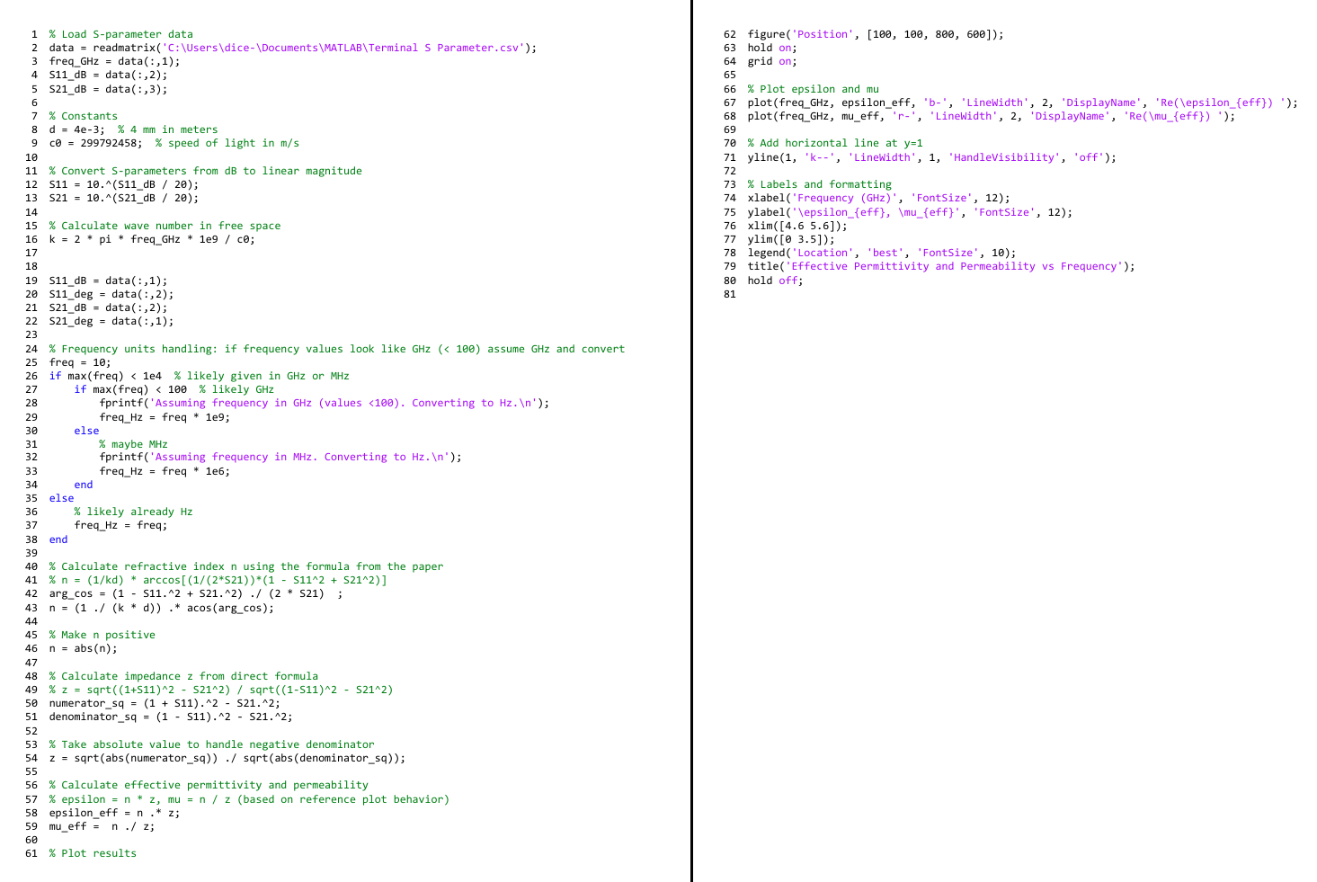
The CSV was then exported and MATLAB was applied to calculate n, z, and ef and muef over the range 4.6-5.6 GHz, the range where retrieval is physically significant.

Effective Permittivity (ε_{eff})
- It rises with frequency about in a linear manner; at 4.6GHz it is roughly 1.9 and rises to about 3.0 at 5.6GHz.
- This tendency is coincidental with that of the case of w = 0.3 mm and where the eff is approximately 2.5 at 5.15 GHz.
- The findings support the dispersion properties of the metasurface.
Effective Permeability (μeff)
Therefore, the effective permeability of a substance is the equivalent of the product of the product permeability and the weighting factor:
- In this case, 1 equals 0.57 and 0.07, so the product of the two values is 0.2144.
- The permeability stays near to the values of the effective permeability are still near to the value of 1.0-1.1 across the band, which proves that the structure is largely acting like an electric resonator as opposed to a magnetic resonator, as has been explained in the literature.
- This small positive trend (approximately 1) is not surprising and is in agreement with the weak magnetic response given in the reference.
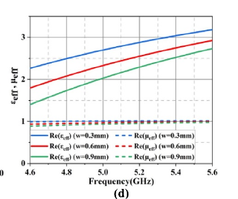
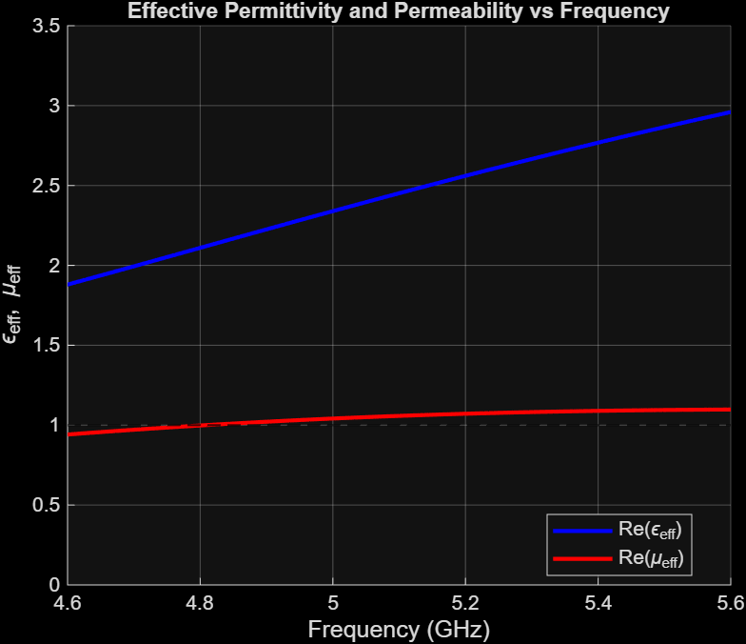

Conclusion
The current paper illustrates an overall process of designing and analysing MIMO antenna systems with a high performance single microstrip patch antenna as the initial starting point. The optimized 10 GHz element has a high realized gain, stable broadside radiation and good impedance matching which makes it a viable building block in multi antenna design. The dependence of mutual coupling on the inter-elements separation is explained by the dual-element array analysis and S21 is significantly enhanced by the increase in the gap between the elements. These results highlight the significance of configuration space in the attainment of sufficient isolation- an important necessity in small MIMO systems. To reduce further on the coupling, a metasurface unit cell was developed and effective electromagnetic parameters obtained by NRW/Chen method.
The resulting trends of both the effective infertility and the effective permittivity, i.e. the trends of both the HFSS model and the MATLAB processing agree with published behaviour thus confirming the HFSS model and the MATLAB processing. In general, patch design and array optimisation combined with metasurface engineering may contribute significantly to the improvement of MIMO antennas and offer a solid base to fabrication and experimental validation in the future.

References
- Antenna theory: analysis and design / Constantine A. Balanis, third edition, Hoboken, NJ: Wiley, 2005, ISBN 047166782X
- Sharawi, M. S., "Current Misuses and Future Prospects for Printed Multiple-Input, Multiple-Output Antenna Systems," IEEE Antennas and Propagation Magazine, vol. 59, no. 2, pp. 162-170, April 2017.
- Sharawi, M. S., "Printed Multi-Band MIMOAntenna Systems and Their Performance Metrics," IEEE Antennas and Propagation Magazine, vol. 55, no. 5, pp. 218-232, October 2013.
- Alsager, A. F., "Design and Analysis of Microstrip Patch Antenna Arrays," Master Thesis No. 1/2011, School of Engineering, Högskolan i Borås, Sweden, January 2011.
- Tang et al., 2017 Tang, M.-C., Chen, Z., Wang, H., & Yu, Y.. Mutual Coupling Reduction Using Meta-Structures for Wideband, Dual-Polarized, and High-Density Patch Arrays.
- Wang et al., 2013 Wang, F.-W., Liang, R., Gong, S., & Li, R.. Employing DGS structures in dual-band antennas for mimo applications with high port isolation.
- Liu et al., 2018 Liu, F., Guo, J., Zhao, L., & Li, L.. A Meta-Surface Decoupling Method for Two Linear Polarized Antenna Array in Sub-6 GHz Base Station Applications.
- Kaur et al., 2024 Kaur, P., Malhotra, S., & Sharma, M.. A Review of Isolation Techniques for 5G MIMO Antennas.
- Wei et al., 2023 Wei, X., Wang, G., Wang, Y., & Li, H.. Metasurface-based bandwidth and isolation enhancement for compact H-plane coupled antennas.
- D. R. Smith,* D. C. Vier, Th. Koschny and C. M. Soukoulis..Electromagnetic parameter retrieval from inhomogeneous metamaterials

