**Ho Ramamoorthy Deadlock Detection Algorithm Implementation**:

**Output :**

1. **No deadlock :**

|  |  |  |  |
| --- | --- | --- | --- |
| Site id | Process id | Hold resource id | Requesting resource id |
| S1 | P1 | R1, R2 | R3 |
| S1 | P2 | R3,R4 | --- |
| S2 | P3 | --- | R4,R3,R2 |
| S2 | P4 | R5 | R2 |

R1 R2 R3 R4 R5

P1 1 1 -1 0 0

P2 0 0 1 1 0

P3 0 -1 -1 -1 0

P4 0 -1 0 0 1

(-1 : request & 1 : allocated)

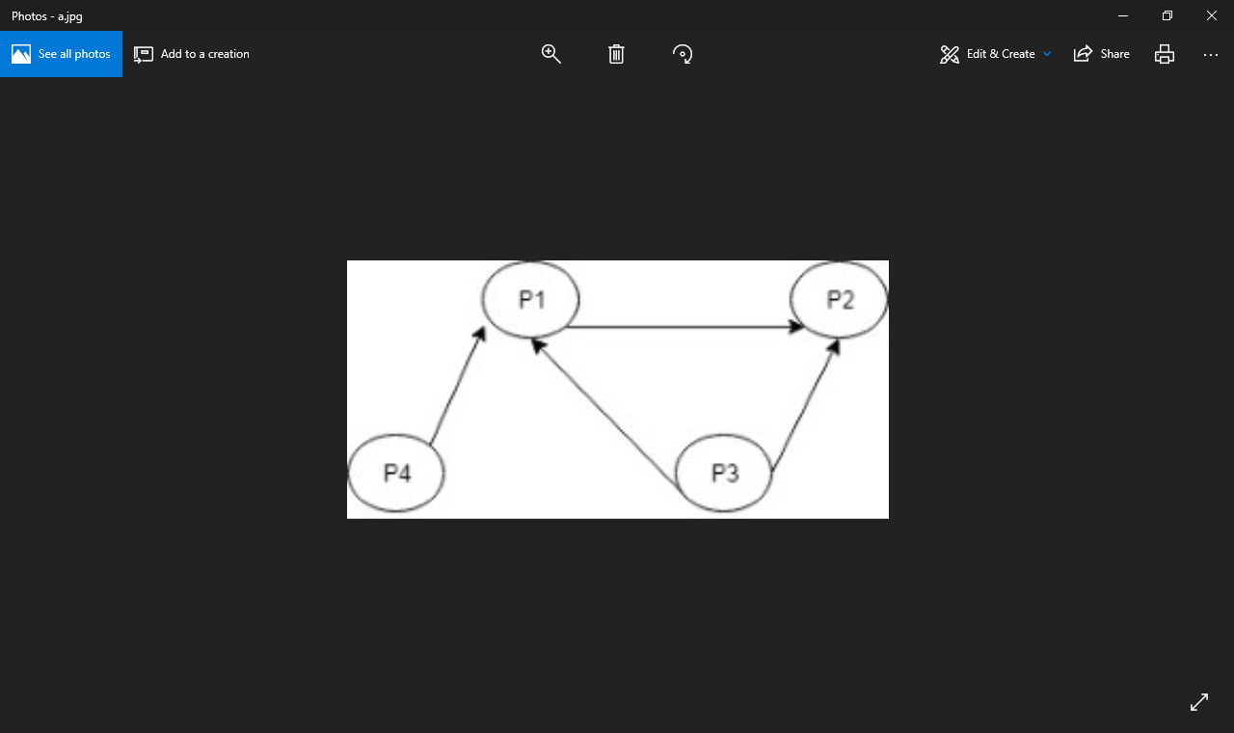

(No cycle)

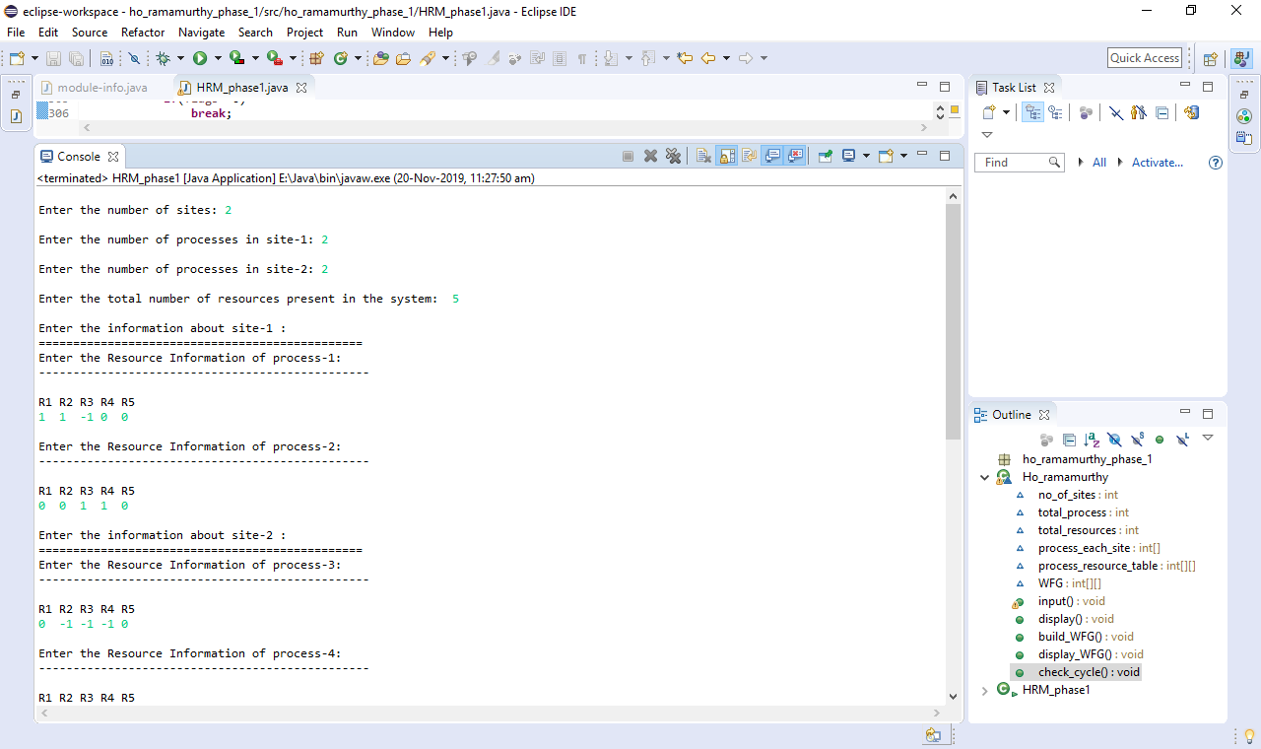

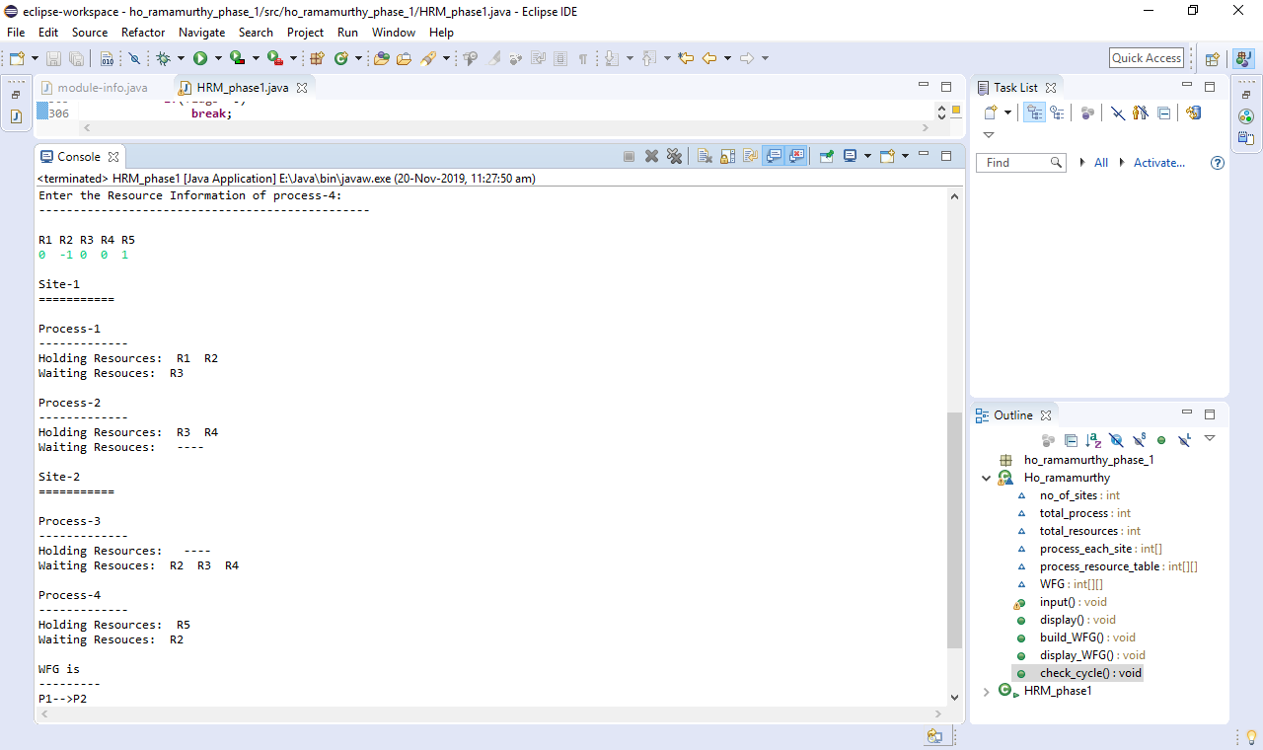

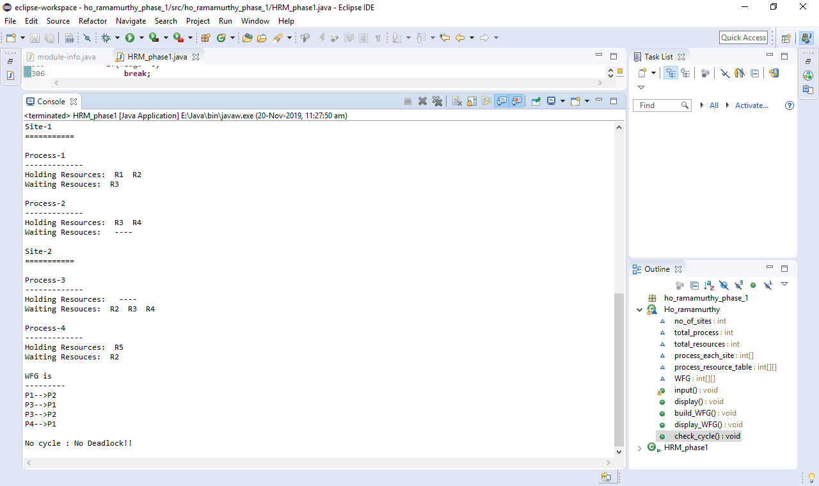

1. **Deadlock :**

|  |  |  |  |
| --- | --- | --- | --- |
| Site id | Process id | Hold resource id | Requesting resource id |
| S1 | P1 | R1, R2 | R3 |
| S1 | P2 | R3,R4 | R5 |
| S2 | P3 | --- | R4,R3,R2 |
| S2 | P4 | R5 | R2 |

R1 R2 R3 R4 R5

P1 1 1 -1 0 0

P2 0 0 1 1 -1

P3 0 -1 -1 -1 0

P4 0 -1 0 0 1

(-1 : request & 1 : allocated)

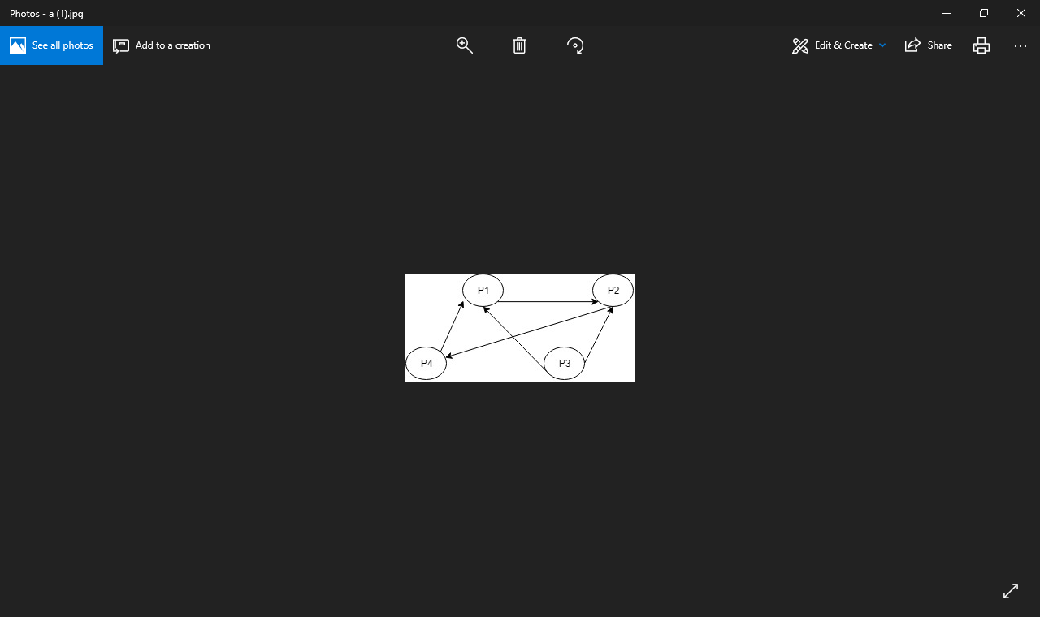

**Output :**

