- Setup your machine with Git Configuration

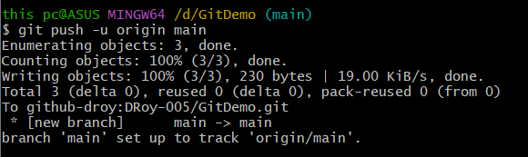

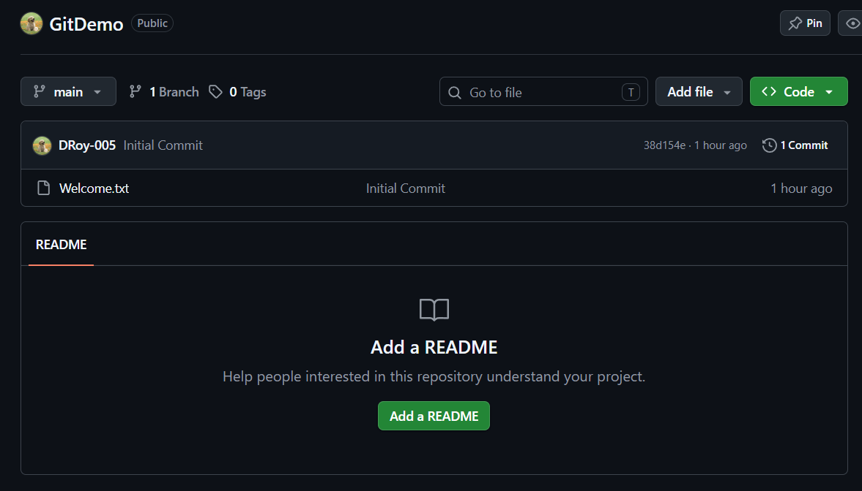

- Create a “.log” file and a log folder in the working directory of Git. Update the .gitignore file in such a way that on committing, these files (.log extensions and log folders) are ignored.

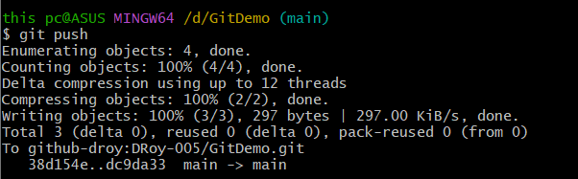

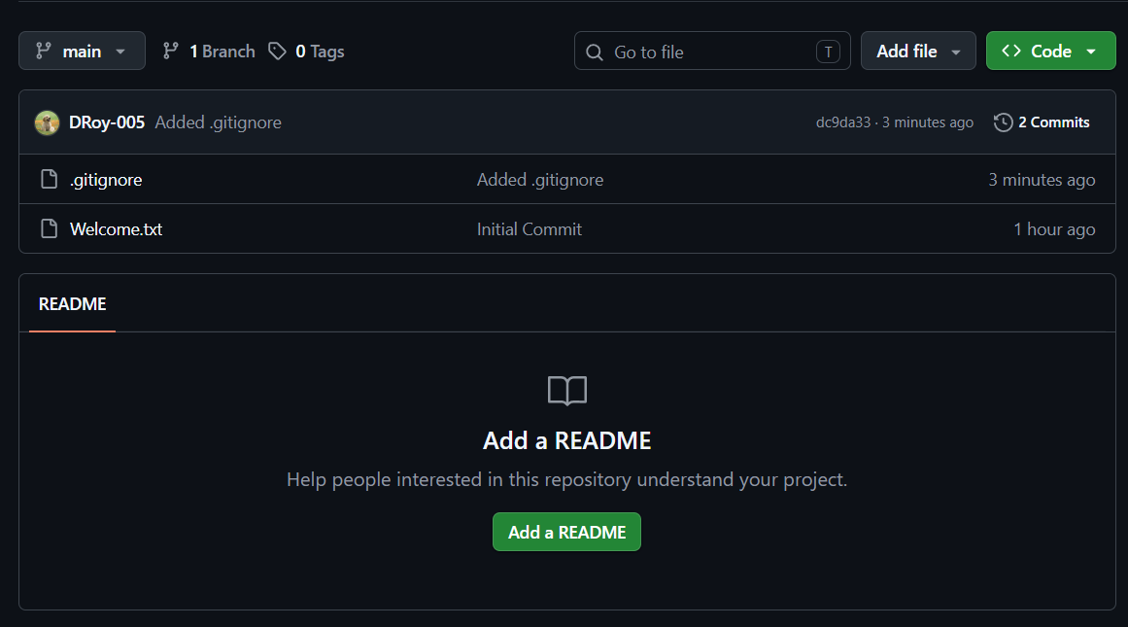

- Branching and merging

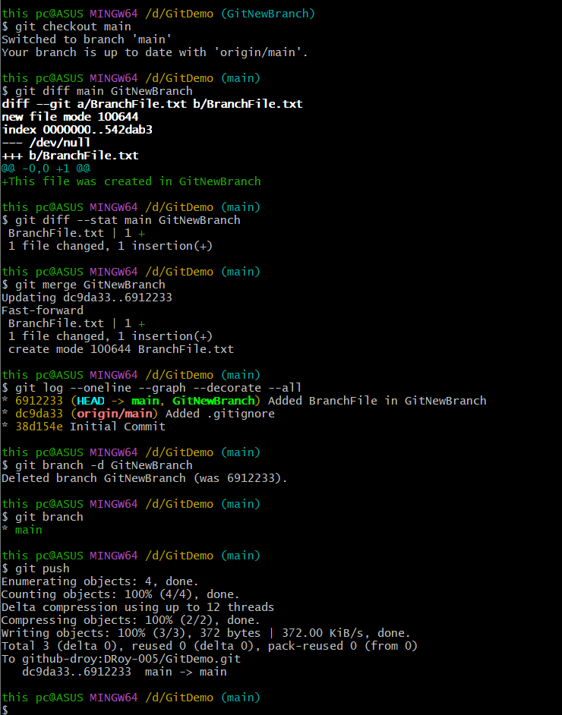
- Git Merge Conflict Resolution

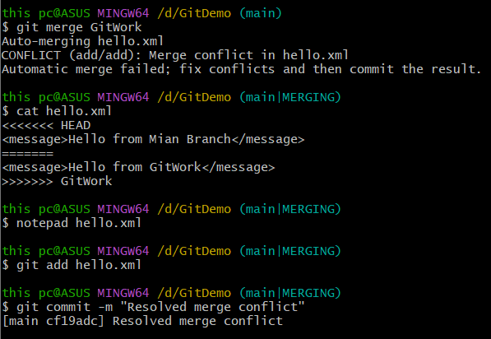

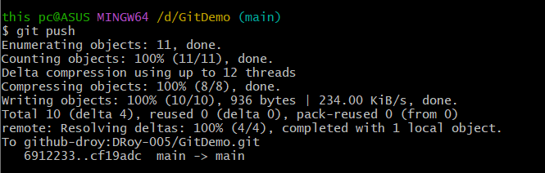

- Final Cleanup and Push

