1.ReactJS-HOL
Create a new React Application with the name “myfirstreact”, Run the application to print “welcome to the first session of React” as heading of that page.

App.js

function App() {
return (
<h1>Welcome the first session of React</h1>
);
}

export default App;

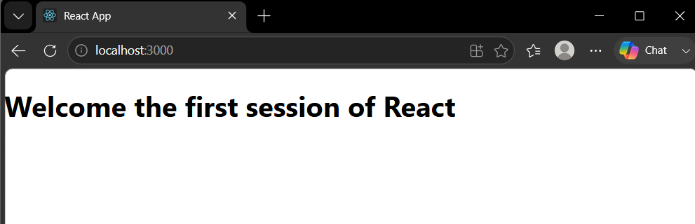

2.ReactJS-HOL

Home.js

function Home() {
return (
<div>
<h1>Welcome to the Home Page of Student Management Portal</h1>
</div>
);
}

export default Home;

About.js

function About() {
return (
<div>
<h1>About Student Management Portal</h1>
</div>
);
}

export default About;

Contact.js

function Contact() {
return (
<div>
<h1>Contact us</h1>
</div>
);
}

export default Contact;

App.js

import Home from "./Components/Home";
import About from "./Components/About";
import Contact from "./Components/Contact";

function App() {
return (
<div>
<Home />
<About />
<Contact />
</div>
);
}

export default App;

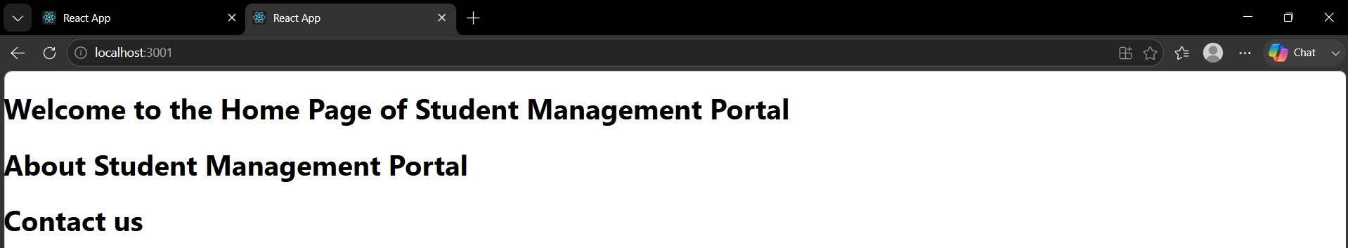

3.ReactJS-HOL

Student.js

import React from "react";
import "./Styles.css";

function Student() {
const name = "John";
const score = 80;
const school = "ABC School";

return (
<div className="student">
<h1>Student Details</h1>

<div className="details">
<p><strong>Name:</strong> {name}</p>
<p><strong>Score:</strong> {score}</p>
<p><strong>School:</strong> {school}</p>
</div>
</div>
);
}

export default Student;

Styles.css

.student {
text-align: center;
}

h1 {
color: red;
}

.details {
color: brown;
font-size: 20px;
}

strong {
color: darkmagenta;
}

p {
font-style: italic;
}

App.js

import Student from "./Student";

function App() {
return (
<div>
<Student />
</div>
);
}

export default App;

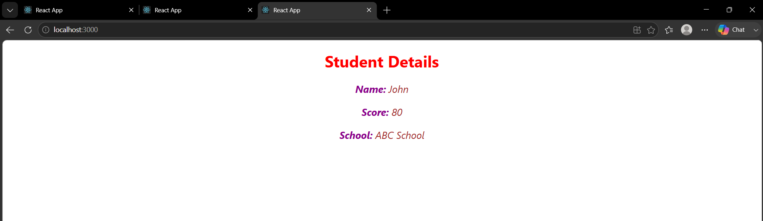

4.ReactJS-HOL

Post.js

class Post {
constructor(id, title, body) {
this.id = id;
this.title = title;
this.body = body;
}
}

export default Post;

Posts.js
import React from "react";
import Post from "./Post";

class Posts extends React.Component {

constructor(props) {
super(props);

this.state = {
posts: [],
hasError: false
};
}

loadPosts() {
fetch("https://jsonplaceholder.typicode.com/posts")
.then(response => response.json())
.then(data => {

let postList = data.map(
item => new Post(item.id, item.title, item.body)
);

this.setState({
posts: postList
});

})
.catch(error => {
console.log(error);
});
}

componentDidMount() {
this.loadPosts();
}

componentDidCatch(error, info) {
alert("An error occurred.");
console.log(error);
console.log(info);
}

render() {

return (
<div>

<h1>Posts</h1>

{
this.state.posts.map(post => (

<div key={post.id}>

<h3>{post.title}</h3>

<p>{post.body}</p>

<hr />

</div>

))
}

</div>
);
}
}

export default Posts;
App.js

import Posts from "./Posts";

function App() {

return (
<div>
<Posts />
</div>
);

}

export default App;

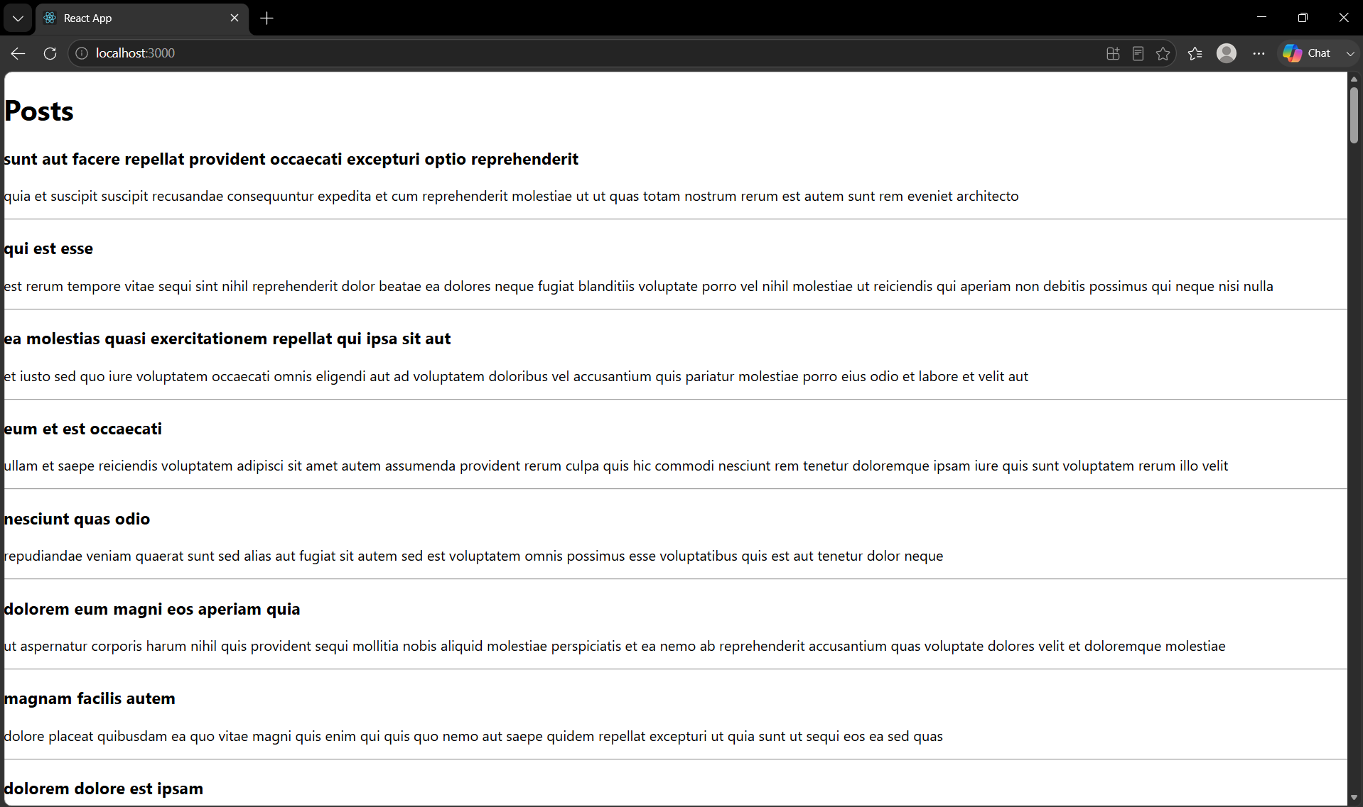

5.ReactJS-HOL

CohortDetails.module.css

.box {
width: 300px;
display: inline-block;
border: 1px solid gray;
border-radius: 10px;
margin: 20px;
padding: 15px;
}

dt {
font-weight: bold;
}

dd {
margin-left: 0;
margin-bottom: 10px;
}

CohortDetails.js

import styles from "./CohortDetails.module.css";

function CohortDetails(props) {

const statusStyle = {
color: props.status === "Ongoing" ? "green" : "blue",
fontWeight: "bold"
};

return (
<div className={styles.box}>

<h2>{props.name}</h2>

<dl>

<dt>Started On</dt>
<dd>{props.startedOn}</dd>

<dt>Current Status</dt>
<dd style={statusStyle}>{props.status}</dd>

<dt>Coach</dt>
<dd>{props.coach}</dd>

<dt>Trainer</dt>
<dd>{props.trainer}</dd>

</dl>

</div>
);
}

export default CohortDetails;

App.js

import CohortDetails from "./CohortDetails";

function App() {

return (

<div>

<h1>Cohorts Details</h1>

<CohortDetails
name="INTADMDF11"
startedOn="22-Feb-2022"
status="Scheduled"
coach="Rakesh"
trainer="Anil"
/>

<CohortDetails
name="ADMJUL24"
startedOn="10-Jul-2024"
status="Ongoing"
coach="Priya"
trainer="Kiran"
/>

<CohortDetails
name="CDBAPR25"
startedOn="01-Apr-2025"
status="Ongoing"
coach="Rahul"
trainer="Sneha"
/>

</div>

);
}

export default App;

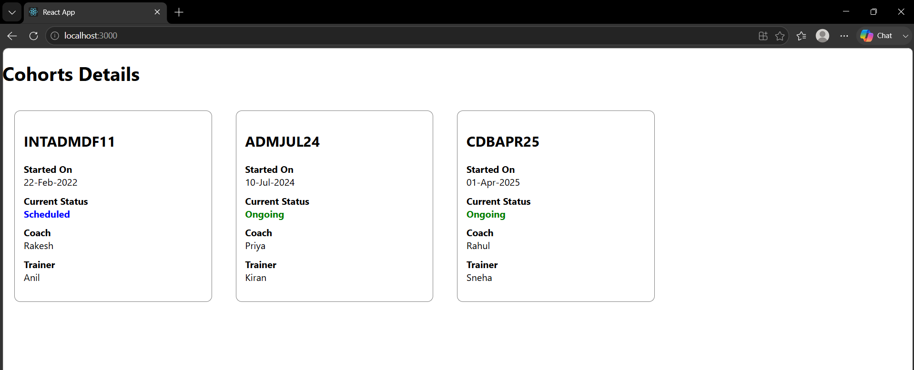

9.ReactJS-HOL

ListOfPlayers.js

import React from "react";

function ListOfPlayers(props) {

return (
<ul>
{
props.players.map((item, index) => (
<li key={index}>
Mr. {item.name} <span>{item.score}</span>
</li>
))
}
</ul>
);
}

export default ListOfPlayers;

ScoreBelow70.js

import React from "react";

function ScoreBelow70(props) {

const players70 = props.players.filter(
player => player.score <= 70
);

return (
<ul>
{
players70.map((item, index) => (
<li key={index}>
Mr. {item.name} {item.score}
</li>
))
}
</ul>
);
}

export default ScoreBelow70;

IndianPlayers.js

import React from "react";

export function OddPlayers([first, , third, , fifth]) {

return (
<ul>
<li>First : {first}</li>
<li>Third : {third}</li>
<li>Fifth : {fifth}</li>
</ul>
);
}

export function EvenPlayers([, second, , fourth, , sixth]) {

return (
<ul>
<li>Second : {second}</li>
<li>Fourth : {fourth}</li>
<li>Sixth : {sixth}</li>
</ul>
);
}

const T20Players = [
"First Player",
"Second Player",
"Third Player"
];

const RanjiPlayers = [
"Fourth Player",
"Fifth Player",
"Sixth Player"
];

export const IndianPlayers = [
...T20Players,
...RanjiPlayers
];

export function ListofIndianPlayers(props) {

return (
<ul>
{
props.IndianPlayers.map((player, index) => (
<li key={index}>
Mr. {player}
</li>
))
}
</ul>
);
}

App.js

import ListOfPlayers from "./ListOfPlayers";
import ScoreBelow70 from "./ScoreBelow70";

import {
OddPlayers,
EvenPlayers,
IndianPlayers,
ListofIndianPlayers
} from "./IndianPlayers";

function App() {

const players = [

{ name: "Jack", score: 50 },
{ name: "Michael", score: 70 },
{ name: "John", score: 40 },
{ name: "Ann", score: 61 },
{ name: "Elizabeth", score: 61 },
{ name: "Sachin", score: 95 },
{ name: "Dhoni", score: 80 },
{ name: "Virat", score: 90 },
{ name: "Jadeja", score: 64 },
{ name: "Raina", score: 75 },
{ name: "Rohit", score: 80 }

];

const IndianTeam = [
"Sachin",
"Dhoni",
"Virat",
"Rohit",
"Yuvraj",
"Raina"
];

const flag = true;

if (flag === true) {

return (

<div>

<h1>List of Players</h1>

<ListOfPlayers players={players} />

<hr />

<h1>List of Players having Scores Less than 70</h1>

<ScoreBelow70 players={players} />

</div>

);

}

return (

<div>

<h1>Odd Players</h1>

{OddPlayers(IndianTeam)}

<hr />

<h1>Even Players</h1>

{EvenPlayers(IndianTeam)}

<hr />

<h1>List of Indian Players Merged</h1>

<ListofIndianPlayers IndianPlayers={IndianPlayers} />

</div>

);

}

export default App;

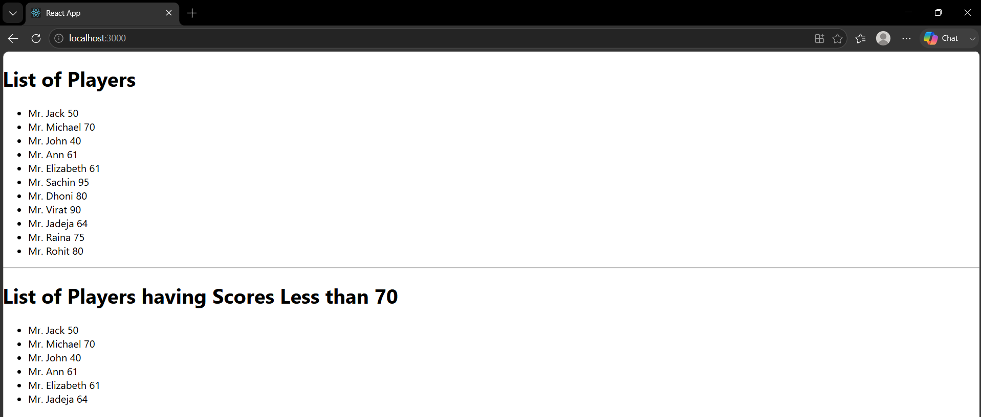

10.ReactJS-HOL

App.js

import office from "./images/office.jpeg";

function App() {

const heading = "Office Space , at Affordable Range";

const officeDetails = {
Name: "DBS",
Rent: 50000,
Address: "Chennai"
};

let colors;

if (officeDetails.Rent <= 60000) {
colors = { color: "red" };
} else {
colors = { color: "green" };
}

return (
<div style={{ margin: "20px" }}>

<h1>{heading}</h1>

<img
src={office}
alt="Office Space"
width="250"
height="200"
/>

<h2>Name: {officeDetails.Name}</h2>

<h3 style={colors}>
Rent: Rs. {officeDetails.Rent}
</h3>

<h3>
Address: {officeDetails.Address}
</h3>

</div>
);
}

export default App;

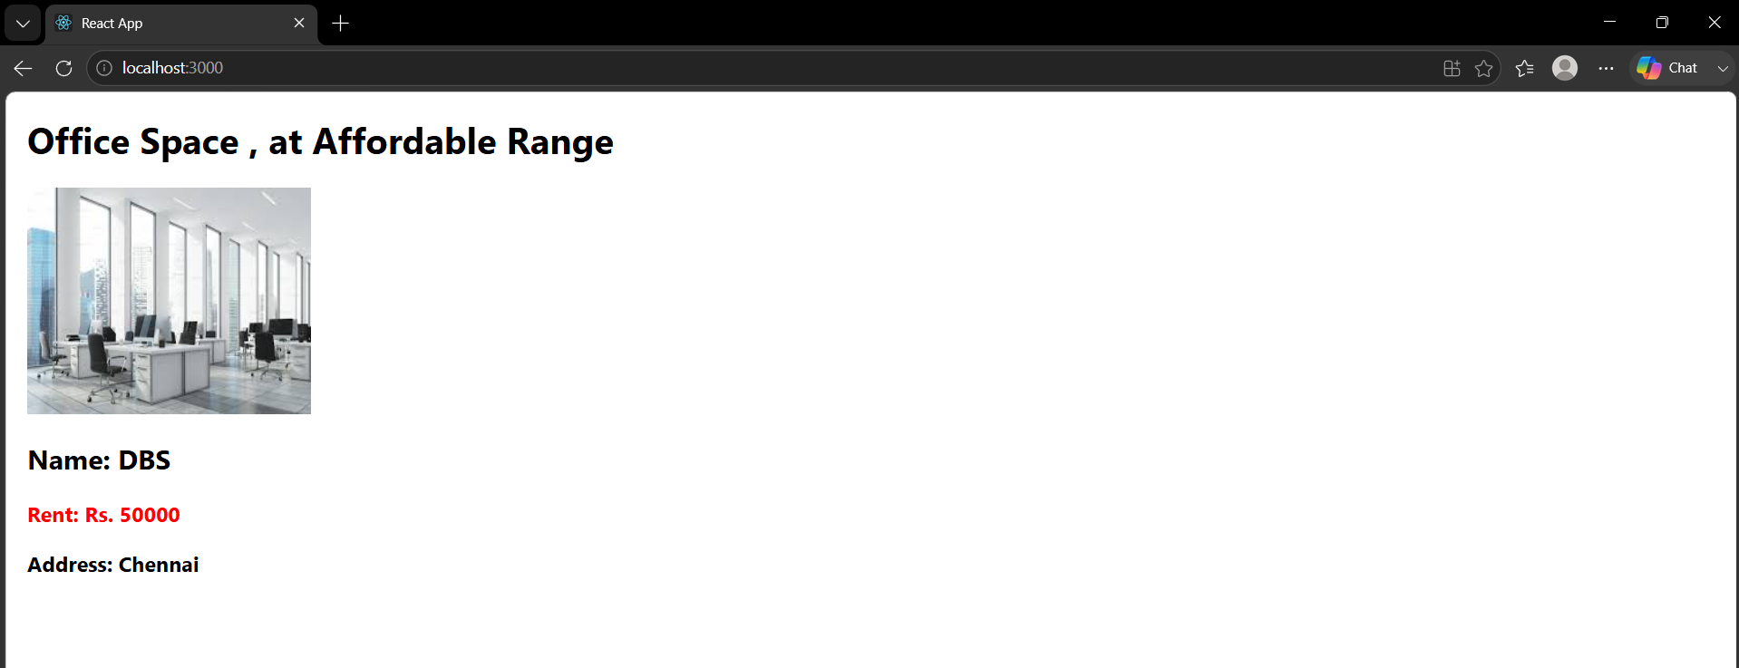

11.ReactJS-HOL

CurrencyConverter.js

import React, { useState } from "react";

function CurrencyConverter() {

const [rupees, setRupees] = useState("");
const [currency, setCurrency] = useState("");

function handleSubmit(e) {

e.preventDefault();

const euro = Number(rupees) * 80;

alert("Converting to Euro Amount is " + euro);
}

return (

<div>

<h1 style={{ color: "green" }}>Currency Convertor!!!</h1>

<form onSubmit={handleSubmit}>

<table>

<tbody>

<tr>

<td>Amount:</td>

<td>

<input
type="number"
value={rupees}
onChange={(e) => setRupees(e.target.value)}
/>

</td>

</tr>

<tr>

<td>Currency:</td>

<td>

<input
type="text"
value={currency}
onChange={(e) => setCurrency(e.target.value)}
/>

</td>

</tr>

<tr>

<td></td>

<td>

<button type="submit">
Submit
</button>

</td>

</tr>

</tbody>

</table>

</form>

</div>

);
}

export default CurrencyConverter;

App.js

import { useState } from "react";
import CurrencyConverter from "./CurrencyConverter";

function App() {

const [count, setCount] = useState(0);

function increment() {

setCount(count + 1);

sayHello();

}

function decrement() {

setCount(count - 1);

}

function sayHello() {

alert("Hello! Member!");

}

function sayWelcome(message) {

alert(message);

}

function handleClick() {

alert("I was clicked");

}

return (

<div style={{ margin: "20px" }}>

<h3>{count}</h3>

<button onClick={increment}>
Increment
</button>

<br /><br />

<button onClick={decrement}>
Decrement
</button>

<br /><br />

<button onClick={() => sayWelcome("Welcome")}>
Say Welcome
</button>

<br /><br />

<button onClick={handleClick}>
Click on me
</button>

<br /><br />

<CurrencyConverter />

</div>

);

}

export default App;

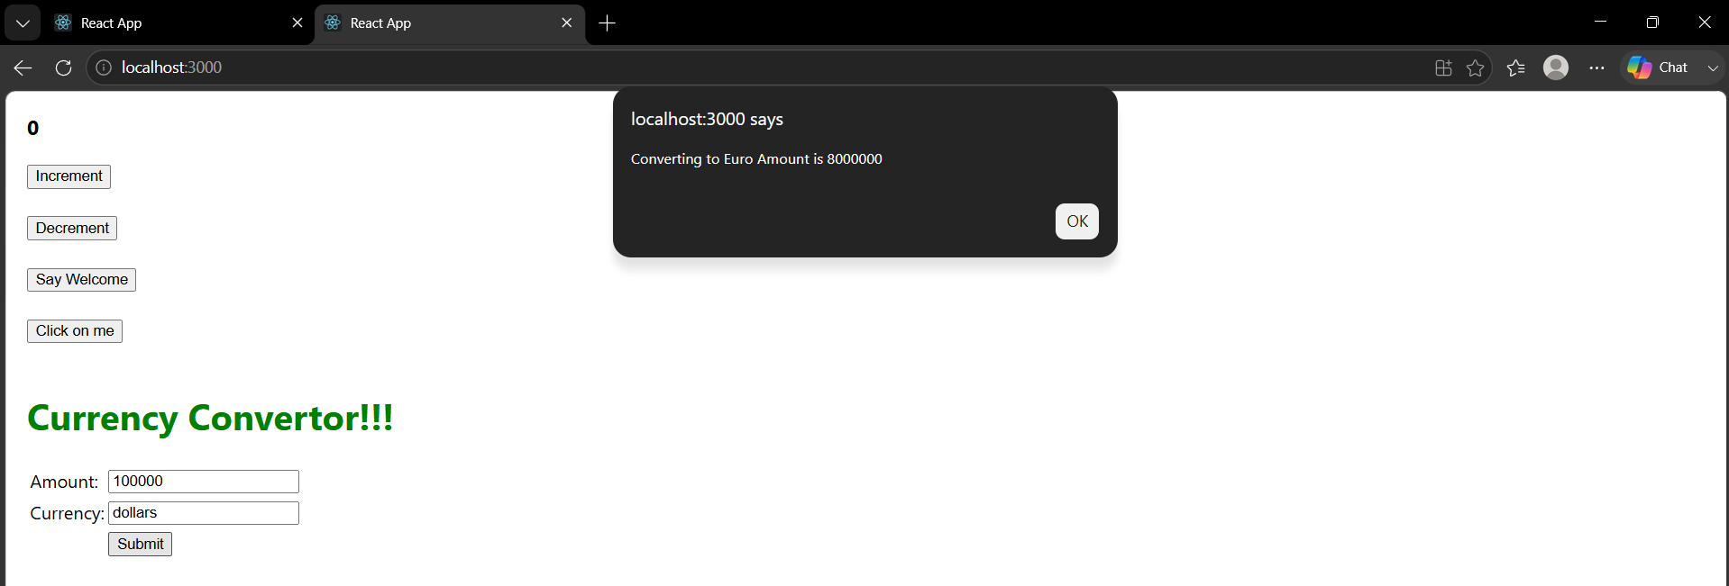

12.ReactJS-HOL

LoginButton.js

function LoginButton(props) {
return (
<button onClick={props.onClick}>
Login
</button>
);
}

export default LoginButton;

LogoutButton.js

function LogoutButton(props) {
return (
<button onClick={props.onClick}>
Logout
</button>
);
}

export default LogoutButton;

Greeting.js

import LoginButton from "./LoginButton";
import LogoutButton from "./LogoutButton";

function Greeting(props) {

if (props.isLoggedIn) {
return (
<div>
<h2>Welcome back</h2>
<LogoutButton onClick={props.onLogoutClick} />
</div>
);
}

return (
<div>
<h2>Please sign up.</h2>
<LoginButton onClick={props.onLoginClick} />
</div>
);
}

export default Greeting;

App.js

import { useState } from "react";
import Greeting from "./Greeting";

function App() {

const [isLoggedIn, setIsLoggedIn] = useState(false);

function handleLogin() {
setIsLoggedIn(true);
}

function handleLogout() {
setIsLoggedIn(false);
}

return (
<div style={{ margin: "40px" }}>
<Greeting
isLoggedIn={isLoggedIn}
onLoginClick={handleLogin}
onLogoutClick={handleLogout}
/>
</div>
);
}

export default App;

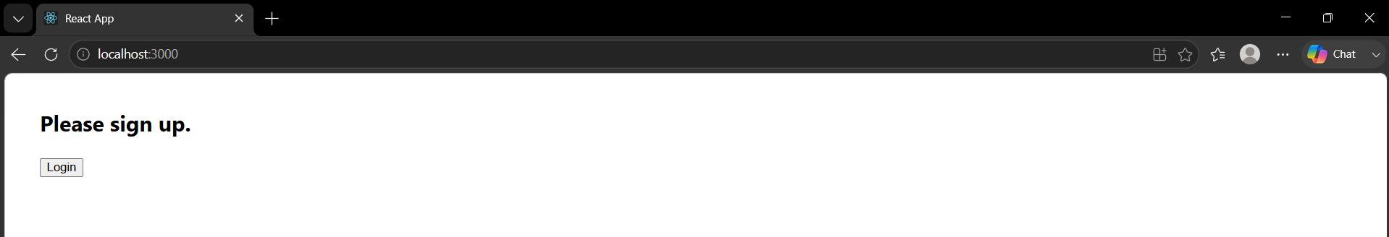

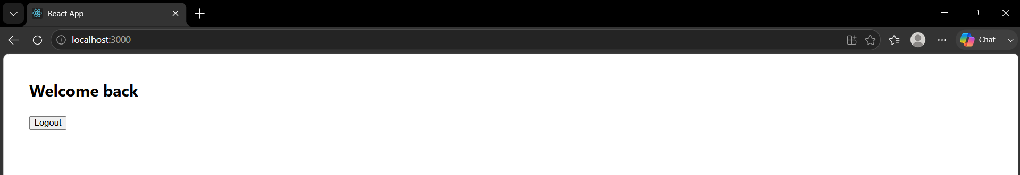

13.ReactJS-HOL

Books.js

export const books = [
{
id: 101,
bname: "Master React",
price: 670
},
{
id: 102,
bname: "Deep Dive into Angular 11",
price: 800
},
{
id: 103,
bname: "Mongo Essentials",
price: 450
}
];

Blogs.js

export const blogs = [
{
id: 1,
title: "React Learning",
author: "Stephen Raj"
},
{
id: 2,
title: "Installation",
author: "Schneider"
}
];

Courses.js

export const courses = [
{
id: 1,
cname: "Angular",
date: "4/5/2021"
},
{
id: 2,
cname: "React",
date: "6/3/2021"
}
];

BookDetails.js

import { books } from "./Books";

function BookDetails() {

return (
<ul>
{books.map((book) => (
<div key={book.id}>
<h3>{book.bname}</h3>
<h4>{book.price}</h4>
</div>
))}
</ul>
);
}

export default BookDetails;

BlogDetails.js

import { blogs } from "./Blogs";

function BlogDetails() {

return (
<ul>
{blogs.map((blog) => (
<div key={blog.id}>
<h3>{blog.title}</h3>
<h4>{blog.author}</h4>
</div>
))}
</ul>
);
}

export default BlogDetails;

CourseDetails.js

import { courses } from "./Courses";

function CourseDetails() {

return (
<ul>
{courses.map((course) => (
<div key={course.id}>
<h3>{course.cname}</h3>
<h4>{course.date}</h4>
</div>
))}
</ul>
);
}

export default CourseDetails;

App.js

import "./App.css";

import BookDetails from "./BookDetails";
import BlogDetails from "./BlogDetails";
import CourseDetails from "./CourseDetails";

function App() {

return (

<div className="container">

<div className="column">
<h2>Course Details</h2>
<CourseDetails />
</div>

<div className="column">
<h2>Book Details</h2>
<BookDetails />
</div>

<div className="column">
<h2>Blog Details</h2>
<BlogDetails />
</div>

</div>

);

}

export default App;

App.js

.container {
display: flex;
justify-content: space-around;
margin-top: 40px;
}

.column {
border-left: 3px solid green;
padding-left: 20px;
width: 250px;
}

h2 {
text-align: center;
}

ul {
list-style: none;
padding: 0;
}

h3 {
margin-bottom: 5px;
}

h4 {
margin-top: 0;
font-weight: normal;
}

