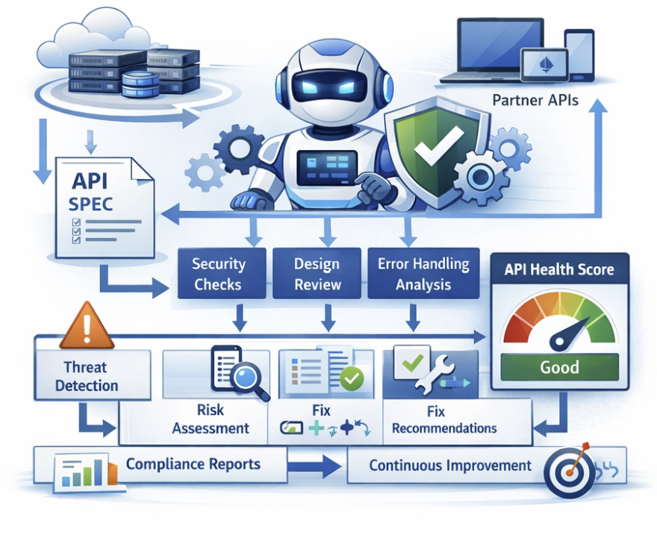
SpecSentinel
Agentic AI API Health, Compliance & Governance Bot

IBM Hackathon Submission
Date: February 25, 2026
Table of Contents
1. Project Title 3
2. Problem Statement 3
3. Short Version 3
4. Solution MVP Scope 4
4.1. Overview 4
4.2. Input Scope 4
4.3. Core Functional Capabilities 4
4.3.1. Autonomous Planning 4
4.3.2. Spec Analysis Engine 4
a. Security Checks 5
b. API Design & Structure 5
c. Error Handling 5
d. Documentation Quality 5
e. Governance & Lifecycle 5
4.3.3. Threat Classification 5
4.3.4. API Health Score Engine 6
4.3.5. Actionable Fix Recommendations 6
4.3.6. Benchmark Alignment & Improvement Guidance 7
4.4. Output Deliverables 7
4.5. Agentic AI Demonstration 8
4.6. Out of Scope (Future Roadmap) 8
4.7. MVP Success Criteria 8
5. Business Value, Impact & Agentic AI Differentiation 9
5.1. Architectural Governance at Scale 9
5.2. Shift-Left Validation and Reduced Architectural Drift 9
5.3. Standardized Contract and Error Modeling 9
5.4. Quantifiable API Maturity 9
5.5. Why This Is Agentic AI 9
5.6. Business Enablement Through Technical Discipline 9

Project Title
SpecSentinel: Agentic AI API Health, Compliance & Governance Bot

Problem Statement
Modern enterprises expose hundreds of APIs, but API specifications (OpenAPI/Swagger) often:
- Lack defined security schemes (OAuth2, JWT, scopes)
- Miss critical response codes (401, 403, 429)
- Have inconsistent error models
- Do not follow REST maturity principles
- Fail to align with international standards (e.g., OpenAPI best practices, OWASP API Security Top 10, ISO-aligned governance frameworks)
- Degrade over time without continuous monitoring
Manual reviews are:
- Slow
- Inconsistent
- Hard to scale
- Dependent on individual expertise
As API ecosystems grow, organizations need continuous, intelligent, automated governance — not just static linting.

Short Version
SpecSentinel is an Agentic AI bot that autonomously evaluates OpenAPI specifications for security, compliance, and design maturity. It generates an API health score, categorizes threats (Critical/High/Medium/Low), and provides fix-ready mitigation plans aligned to international standards such as OpenAPI best practices and OWASP API Security principles. Unlike static linters, SpecSentinel follows a Plan–Analyze–Act–Verify loop, re-evaluating improvements and tracking API maturity over time. The bot serves as a continuous API governance agent, enabling enterprises to scale secure API development, reduce manual reviews, and implement measurable API quality improvements across their ecosystem.

Solution MVP Scope

Overview
The MVP of SpecSentinel – Agentic AI API Health Bot will deliver an autonomous bot that analyzes uploaded OpenAPI 3.x specifications and generates a structured API Health Report. The MVP focuses on automated threat detection, severity classification (Critical/High/Medium/Low), health scoring, actionable remediation guidance, and benchmarking against international API standards.
The core objective is to demonstrate an Agentic AI loop:
Plan → Analyze → Categorize → Recommend → Score → Improve
  - Input Scope
The MVP will support:
- OpenAPI 3.x specifications (YAML or JSON)
- Manual upload via:
  - Simple Web UI, or
  - CLI-based bot interface
The system will parse and resolve references within the specification before analysis.
  - Core Functional Capabilities

    - Autonomous Planning
Upon receiving a specification, the bot:
- Detects the OpenAPI version.
- Identifies applicable international benchmarks, such as:
  - OpenAPI 3.x best practices
  - OWASP API Security Top 10
  - REST design guidelines
- Selects validation categories dynamically:
  - Security
  - Design & Structure
  - Documentation Quality
  - Error Handling
  - Governance & Versioning
This dynamic rule selection demonstrates agentic planning rather than static linting.
    - Spec Analysis Engine
The MVP will evaluate the API specification across the following dimensions:
  - Security Checks
- Presence of authentication schemes (OAuth2, API Key, JWT)
- Missing 401/403 responses
- Inconsistent security definitions
- Absence of rate limiting indicators
- Basic detection of sensitive schema exposure patterns
  - API Design & Structure
- Missing versioning strategy
- Improper HTTP method usage
- Inconsistent naming conventions
- Missing operationId
- Absence of pagination in collection endpoints
  - Error Handling
- Missing standardized error response model
- Inconsistent response structure
- No defined reusable error schema component
  - Documentation Quality
- Missing endpoint summaries or descriptions
- Missing request/response examples
- Untagged endpoints
- Poor schema-level documentation
  - Governance & Lifecycle
- Lack of deprecation metadata
- Missing lifecycle indicators
- No standard metadata alignment
    - Threat Classification
Each issue detected will be:
- Categorized as:
  - Critical
  - High
  - Medium
  - Low
- Mapped to a risk domain:
  - Security Risk
  - Design Risk
  - Operational Risk
  - Governance Risk
Severity will be determined using a weighted risk model aligned to industry security and compliance practices.
    - API Health Score Engine
The MVP will compute an overall API Health Score (0–100), based on weighted categories:
- Security – 35%
- Design Consistency – 20%
- Error Handling – 15%
- Documentation Quality – 15%
- Governance & Maturity – 15%
The report will include:
- Overall score
- Category-wise score breakdown
- Maturity band:
  - Poor (0–40)
  - Moderate (41–70)
  - Good (71–85)
  - Excellent (86–100)
This provides measurable API quality benchmarking.
    - Actionable Fix Recommendations
For each detected issue, the bot will provide:
- Issue description
- Risk explanation (why it matters)
- Recommended fix
- Basic mitigation plan
- Example YAML/JSON snippet (where applicable)
Example:
Issue: Missing 401/403 responses
Risk: Unauthorized access handling is undocumented, increasing security exposure
Fix: Add standardized 401 and 403 responses referencing a common error schema
Plan:
- Define reusable error component
- Reference it in secured endpoints
- Re-run validation
This demonstrates reasoning and action capability, not just rule reporting.
    - Benchmark Alignment & Improvement Guidance
The MVP will benchmark API maturity against:
- OpenAPI specification best practices
- OWASP API Security Top 10 alignment
- REST maturity standards
The final report will include:
- Compliance percentage per benchmark
- Identified improvement gaps
- Prioritized roadmap for maturity improvement
This enables periodic reassessment and continuous improvement.
  - Output Deliverables
The bot will generate a structured API Health Report containing:
- Overall Health Score
- Category-wise scoring breakdown
- Threat list with severity classification
- Risk explanations
- Fix-ready mitigation steps
- Improvement roadmap
Output format:
- On-screen report (Web or CLI)
- Structured JSON export (optional)

  - Agentic AI Demonstration
To clearly demonstrate agentic behavior, the MVP will:
- Explain which standards were selected and why
- Justify severity classifications
- Provide reasoning for each mitigation
- Show projected score improvement after fixes
This showcases a closed-loop autonomous governance model rather than static validation.
  - Out of Scope (Future Roadmap)
The following are excluded from MVP:
- Automated PR creation
- CI/CD integration
- Multi-agent distributed architecture
- Runtime traffic monitoring
- API gateway integration
- Policy-as-code dashboard
- Advanced ML model training
These will be proposed as future enhancements.
  - MVP Success Criteria
The MVP will be successful if it:
- Accepts a real OpenAPI spec
- Produces a structured health score
- Classifies threats accurately
- Generates actionable mitigation steps
- Aligns findings with international standards
- Demonstrates an agentic reasoning loop

Business Value, Impact & Agentic AI Differentiation
SpecSentinel delivers architectural governance at scale by embedding intelligent, standards-driven validation directly into the API design lifecycle. As enterprises expand microservices, partner integrations, and cloud-native platforms, maintaining consistent API security, design discipline, and compliance becomes increasingly complex. SpecSentinel addresses this challenge through autonomous, agentic governance.

Architectural Governance at Scale
Enterprise architects define API standards, but enforcing them across distributed teams is difficult and manual reviews do not scale. SpecSentinel translates architectural policies and international standards into machine-evaluable controls, ensuring consistent security models, versioning strategies, naming conventions, and error contracts.

Shift-Left Validation and Reduced Architectural Drift
By analyzing OpenAPI specifications before deployment, SpecSentinel identifies structural and security gaps early, reducing rework and preventing fragile contracts from reaching production.

Standardized Contract and Error Modeling
SpecSentinel enforces reusable components, standardized response models, and consistent documentation patterns, improving backward compatibility and integration predictability.

Quantifiable API Maturity
The API Health Score provides a measurable architectural KPI across security, governance, design, and documentation categories, enabling structured modernization programs.

Why This Is Agentic AI
SpecSentinel operates through a Plan–Analyze–Act–Verify loop: dynamically selecting standards, evaluating risks, generating fix-ready remediation guidance, and recalculating projected maturity improvements. This closed-loop behavior demonstrates autonomous reasoning and structured action generation.

Business Enablement Through Technical Discipline
Strong architectural governance enables business agility. Secure and standardized APIs reduce integration failures, accelerate onboarding, and minimize production risk. By combining governance intelligence with agentic automation, SpecSentinel transforms API compliance into a scalable, measurable, and continuously improving capability.

