### 1.When a user wants to set a goal, he will get goal options based on his current body weight and whether he wants to lose or gain or maintain weight:

Below are the exampls where two different users gets different daily calorie intake limits based on their body weights:

1. For User 10014:

SELECT GoalID,GoalLevel,GoalType,DailyCalorieLimit,WeeklyWeightGainOrLoss

FROM goals

where USERID = '10014' AND EndWeightLimit>

(SELECT StartingWeight FRom user where UserId='10014')

AND StartWeightLimit<(SELECT StartingWeight FROM user where UserId='10014')

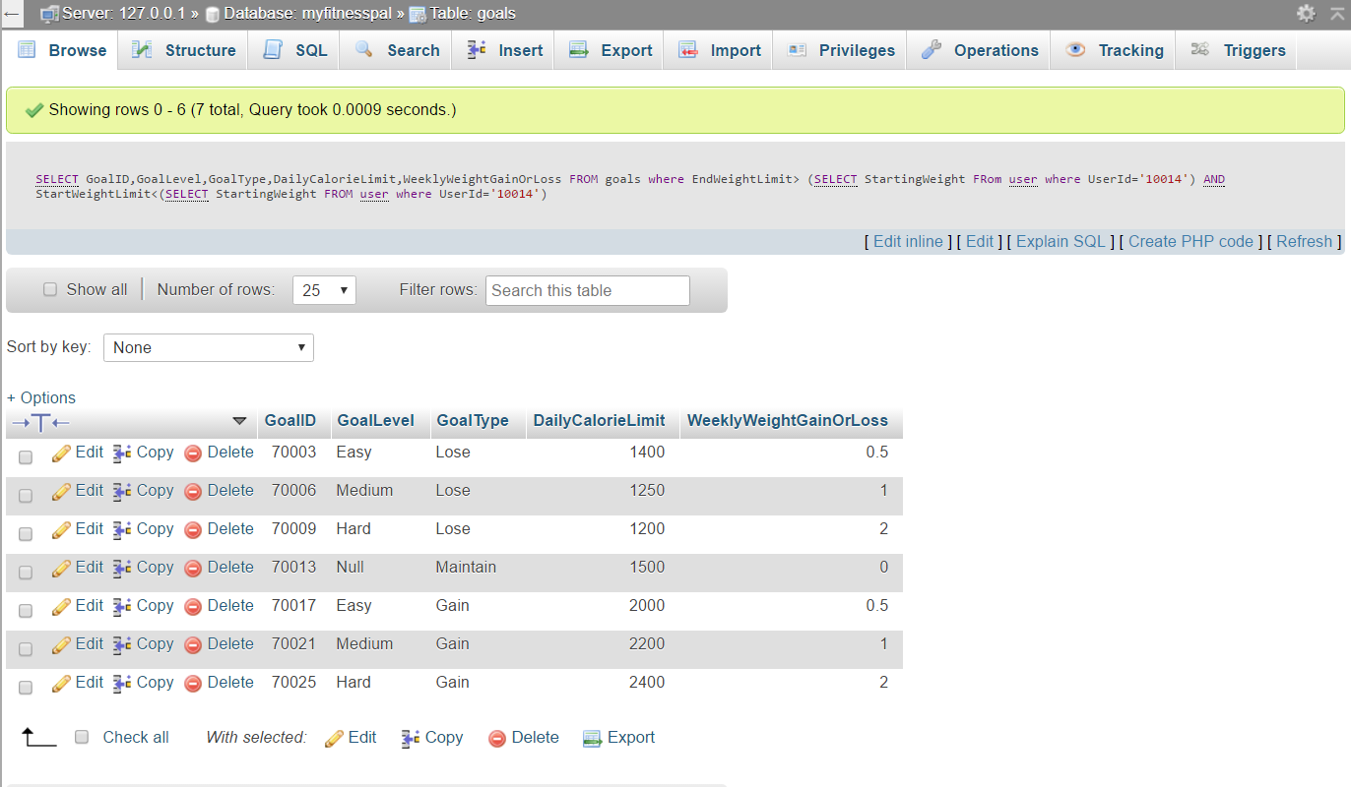

1. For User 10002:

SELECT GoalLevel,GoalType,DailyCalorieLimit,WeeklyWeightGainOrLoss

FROM goals

where EndWeightLimit>

(SELECT StartingWeight FRom user where UserId='10002')

AND StartWeightLimit<(SELECT StartingWeight FROM user where UserId='10002')

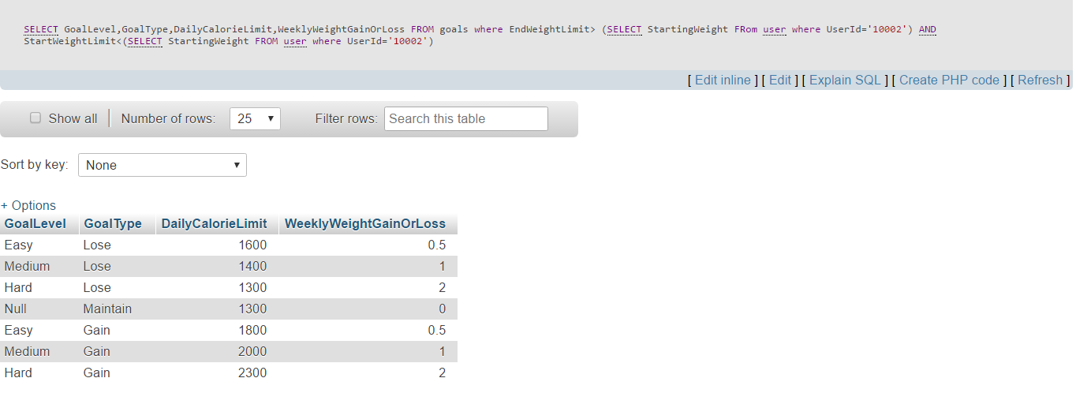

### 2. How long should it take the users to reach their goals? [Only the users who wants to lose or gain weight]

SELECT user.UserID,

((user.StartingWeight-GoalLog.Goal_Weight)/Goals.WeeklyWeightGainOrLoss)

AS WeeksNeededToReachGoal

FROM user,goals,GoalLog

WHERE user.UserId = GoalLog.UserId

AND goals.GoalID=GoalLog.GoalID

AND goals.GoalType <> 'Maintain'

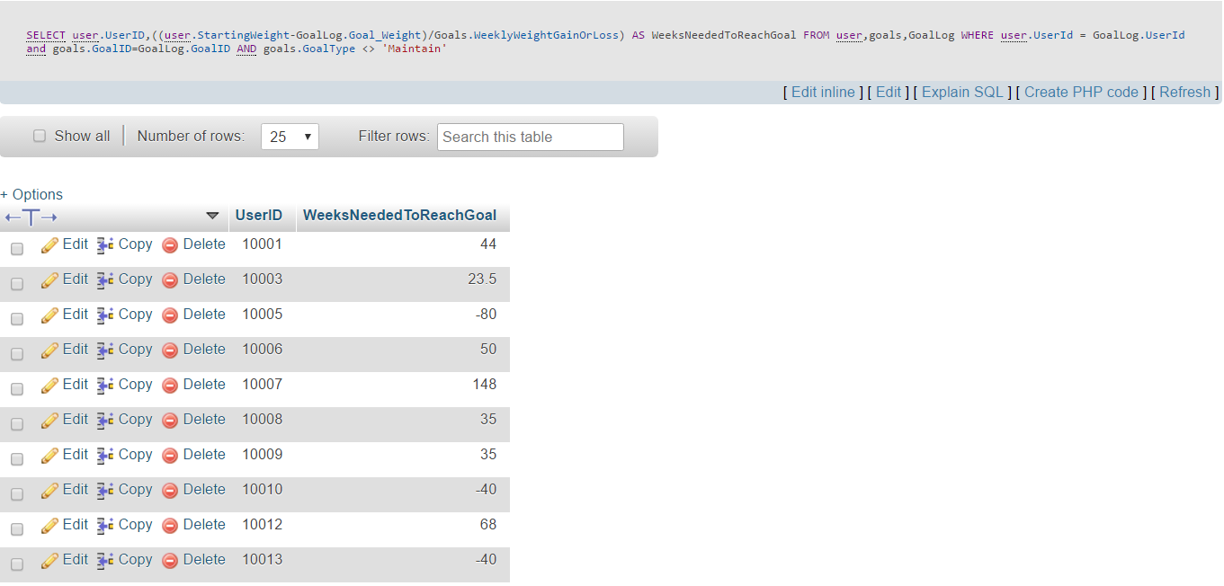

### 3. Calories consumed by users per day, from their food log:

Select USER.USERID,FOODLOG.FoodLogDATE,

SUM(FOOD.FoodCalories*foodlog.NoOfServing) AS TOTAL_CALORIES_CONSUMED

FROM USER,FOODLOG,FOOD

WHERE USER.USERID=FOODLOG.USERID AND

FOOD.FOODID=FOODLOG.FOODID

GROUP BY USER.USERID,FOODLOG.FoodLogDate

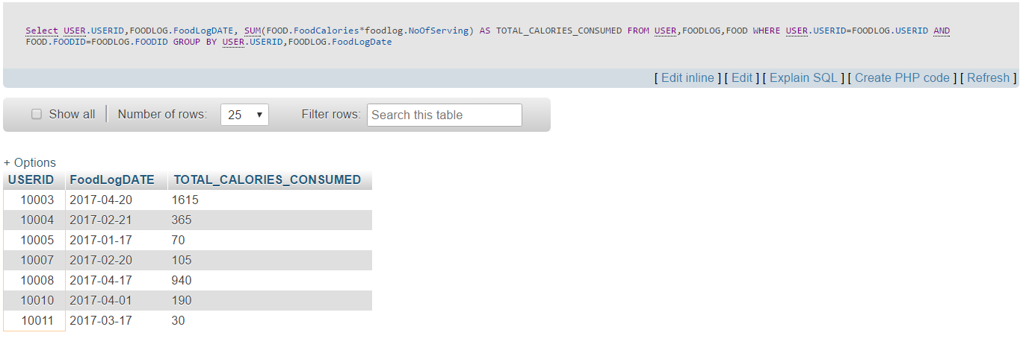

### Calorie consumed by users per day per meal:

Select USER.USERID,FOODLOG.FoodLogDATE,foodlog.TypeOfMeal,

SUM(FOOD.FoodCalories*foodlog.NoOfServing) AS TOTAL_CALORIES_CONSUMED

FROM USER,FOODLOG,FOOD

WHERE USER.USERID=FOODLOG.USERID AND

FOOD.FOODID=FOODLOG.FOODID

GROUP BY USER.USERID,FOODLOG.FoodLogDATE,foodlog.TypeOfMeal

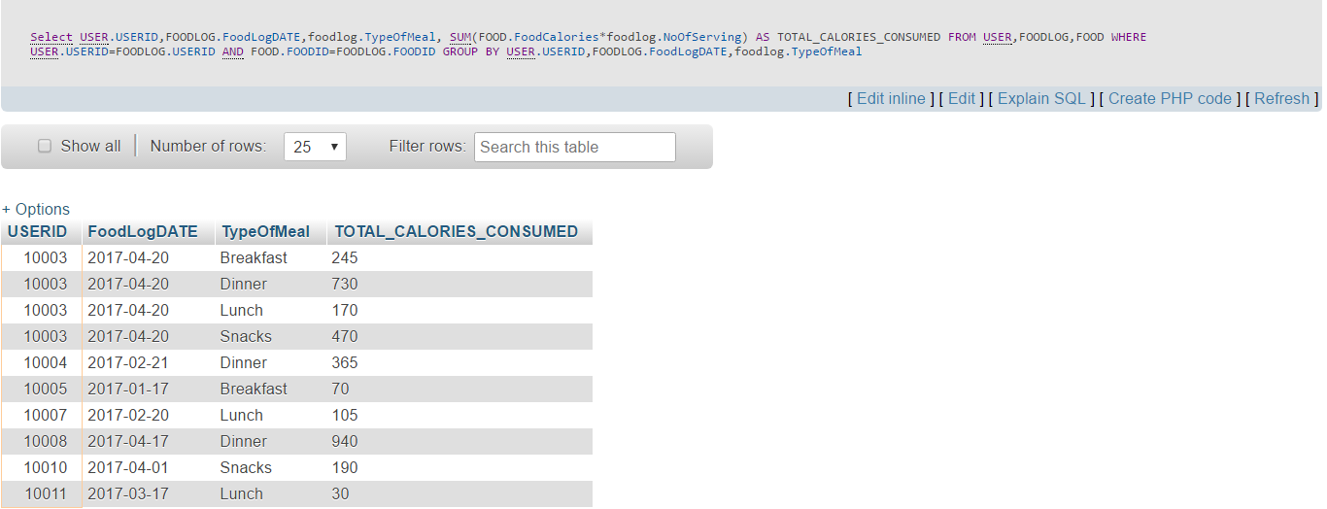

### 4. Total calorie burnt by per user per day per exercise:

SELECT userID, exerciselog.ExLogDate, exercise.ExerciseDesc,

SUM(exerciselog.Duration*EXERCISE.CalBurnedPerMin) AS TotalCalorie

From Exerciselog join exercise

on exerciselog.ExerciseID=exercise.ExerciseID

GROUP BY userid, ExLogDATE, exerciselogID

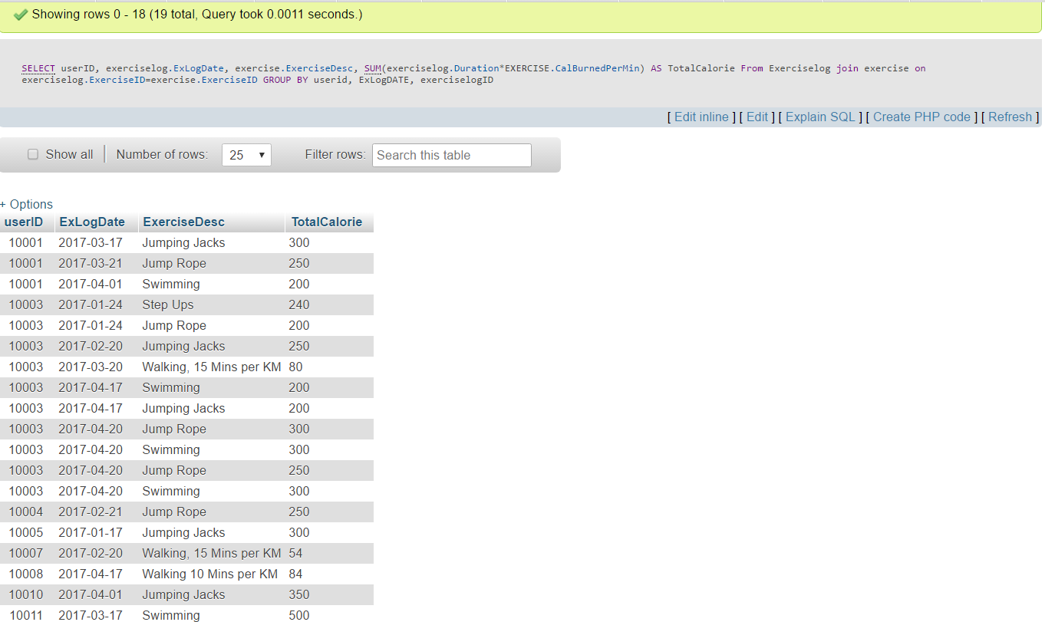

### Total calorie burnt by per user per day:

SELECT userID, exerciselog.ExLogDate,

SUM(exerciselog.Duration*EXERCISE.CalBurnedPerMin) AS Total

From Exerciselog join exercise

on exerciselog.ExerciseID=exercise.ExerciseID

GROUP BY userid, ExLogDATE

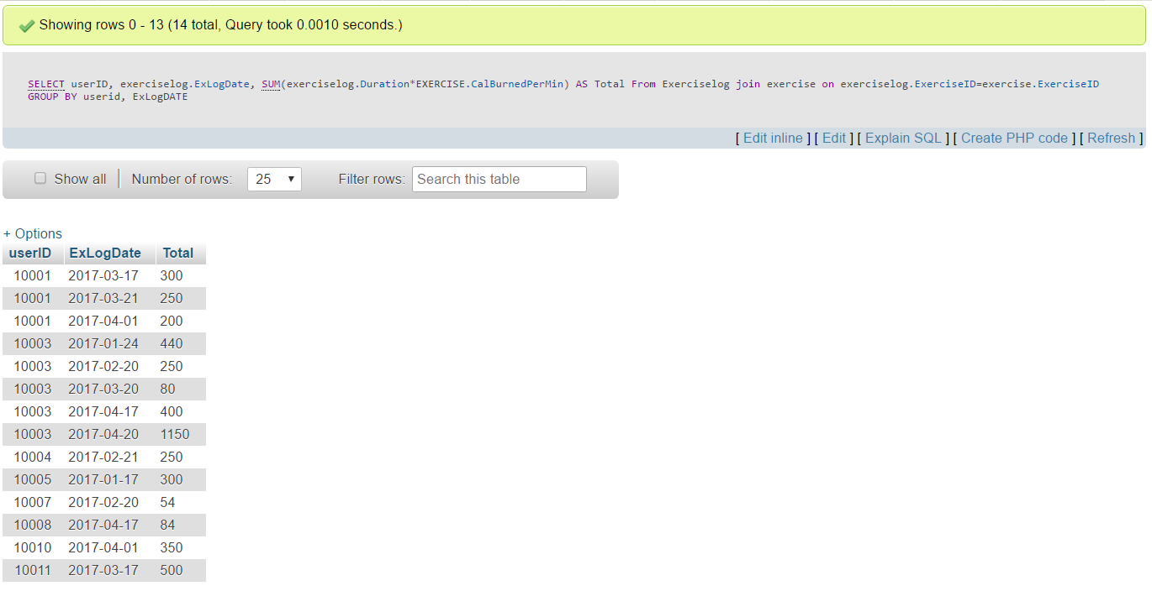

### 5. How much any user has paid for trainers till now?

Select User_Trainer.USERID,SUM(trainer.PricePerCustomer) AS TotalAmountPaid

FROM User_Trainer,trainer

WHERE USER_trainer.TrainerID = trainer.trainerID

Group By user_trainer.userID

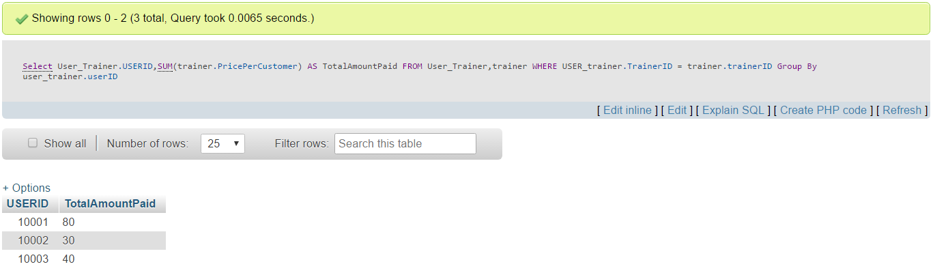

### 6. Average daily water consumption per user:

SELECT w.UserID, AVG(DailyTotal) AS AvgDailyCups

FROM

( SELECT UserID, DATE, SUM(NoOfCups) AS DailyTotal

FROM waterlog

GROUP BY waterlog.DATE, UserID

) w

GROUP BY w.UserID

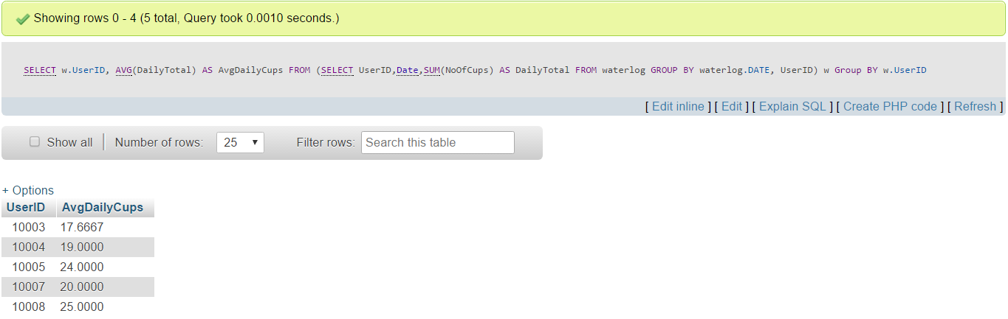

7. The weight journey of any user, i.e. how much weight a user has lost or gained till date, since he/she has joined the app [Users who never logged their weight after joining, the weight loss value will show as ‘0’ for them]:

SELECT u.UserID, u.StartingWeight, gl.Goal_Weight,

wl.LatestWeightLogDate,wl.Weight AS LatestWeight,

COALESCE((u.StartingWeight-wl.Weight),0) AS WeightLoss

FROM User AS u INNER JOIN goallog AS gl ON u.userID = gl.UserID LEFT JOIN

(select UserID, Weight, max(weightLogDate) as LatestWeightLogDate

from weightlog

group by UserID) wl

ON wl.UserID = u.UserID

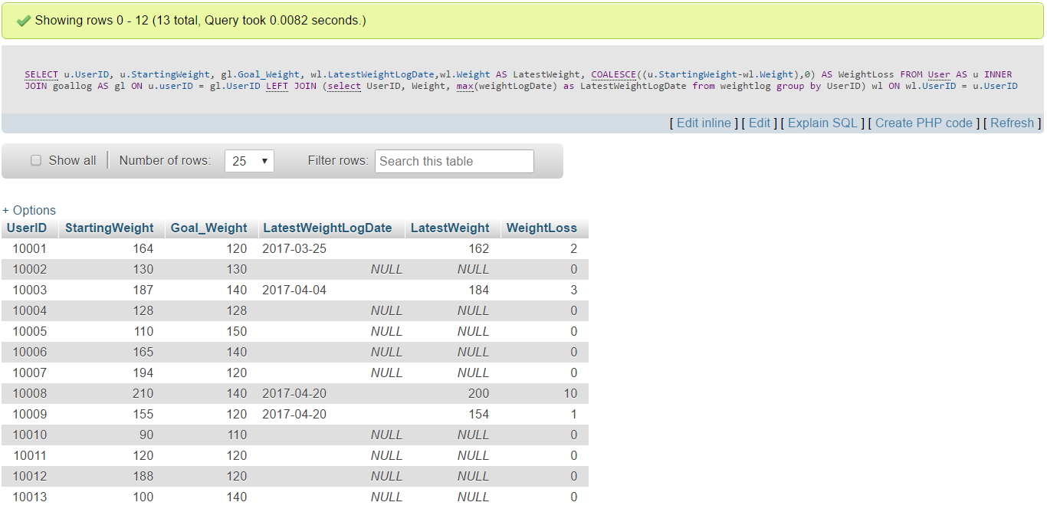

8. Challange:

SELECT w1.UserID,w1.Weight AS StartWeight,w2.Weight AS EndWeight FROM

(select UserID, Weight, MIN(weightLogDate)

from weightlog WHERE WeightLogDate

BETWEEN "2017-03-16" AND "2017-04-04"

group by UserID) w1

INNER JOIN

(select UserID, Weight, MAX(weightLogDate)

from weightlog WHERE WeightLogDate

BETWEEN "2017-03-16" AND "2017-04-04"

group by UserID) w2

ON w1.USERID = w2.USERID

8. Daily nutrients consumed by any user:

Select USER.USERID,FOODLOG.FoodLogDATE,

SUM(FOOD.Carbs*foodlog.NoOfServing) AS TOTAL_CARBS_CONSUMED,

SUM(FOOD.FAT*foodlog.NoOfServing) AS TOTAL_FAT_CONSUMED,

SUM(FOOD.Protein*foodlog.NoOfServing) AS TOTAL_Protein_CONSUMED

FROM USER,FOODLOG,FOOD

WHERE USER.USERID=FOODLOG.USERID AND

FOOD.FOODID=FOODLOG.FOODID

GROUP BY USER.USERID,FOODLOG.FoodLogDate

