1. **Familiar with Git commands like git init, git status, git add, git commit, git push, and git pull.**

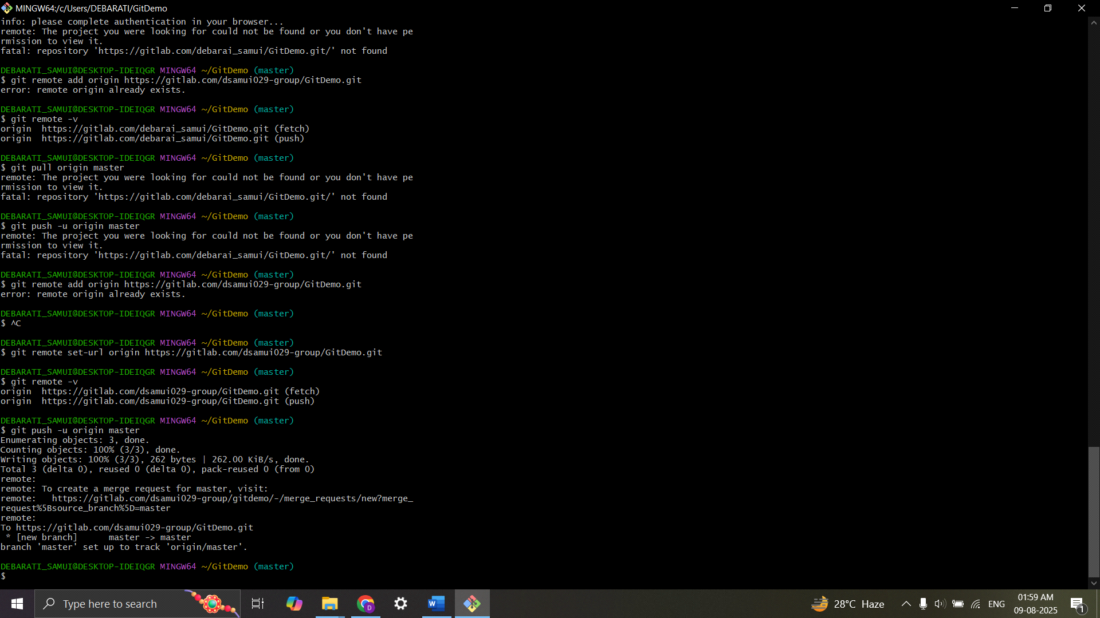

1. **Implement git ignore command to ignore unwanted files and folders**

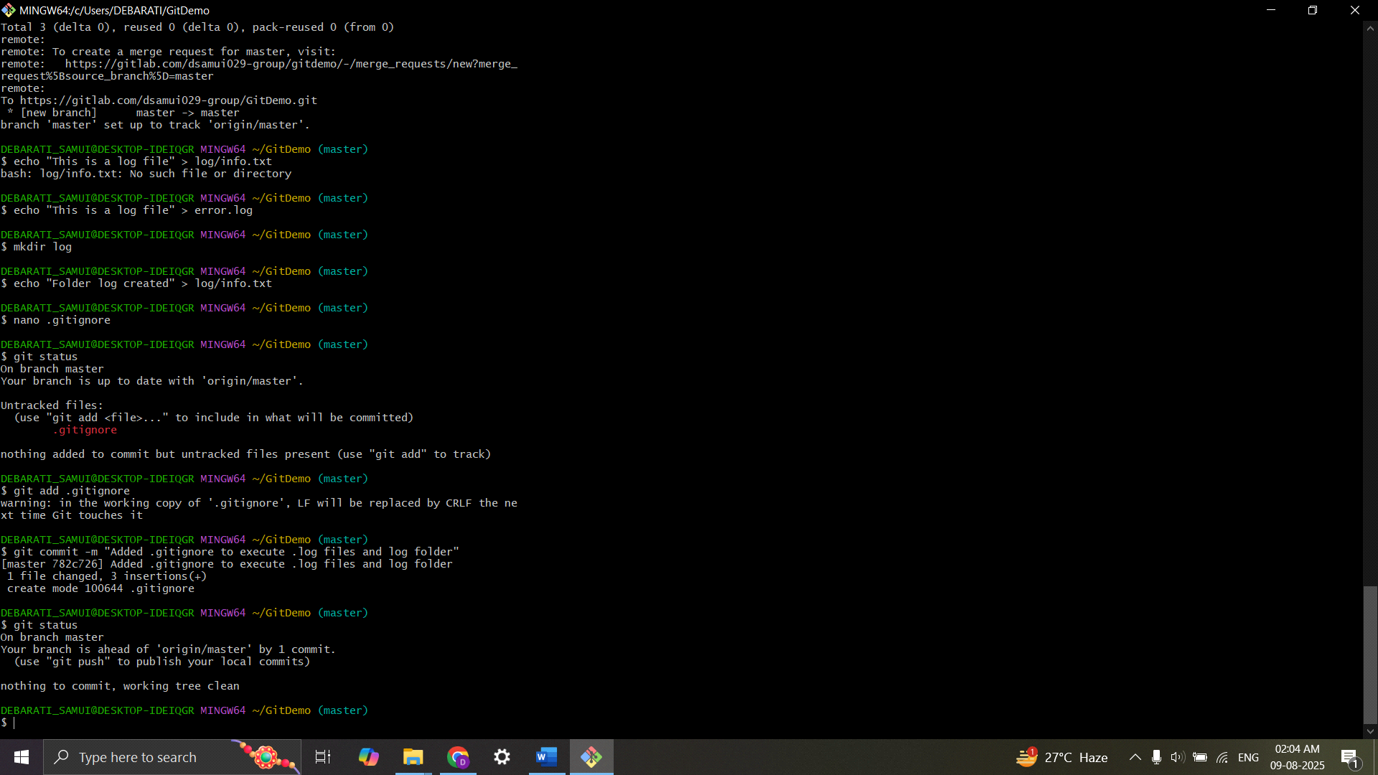

1. **Construct a branch, do some changes in the branch, and merge it with master (or trunk)**

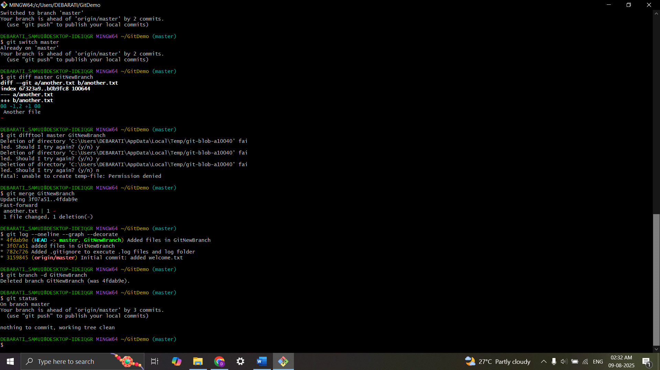

1. **Implement conflict resolution when multiple users are updating the trunk (or master) in such a way that it results into a conflict with the branch’s modification.**

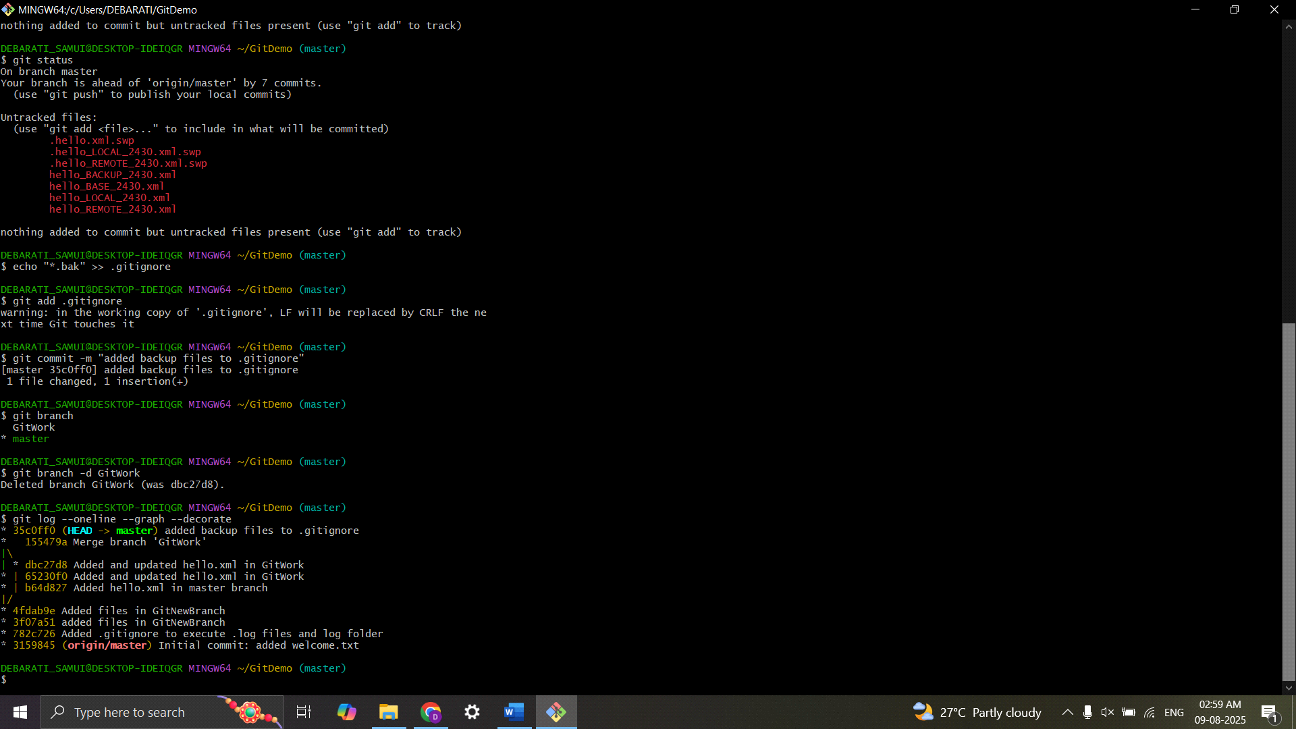

1. **Execute steps involving clean up and push back to remote Git.**

