implementation of lan and man
PROJECT BASED LEARNING
Abstract
This mini project demonstrates the design and simulation of a Local Area Network (LAN) and its extension into a Metropolitan Area Network (MAN) using Cisco Packet Tracer. Multiple LANs are created using switches to connect end devices such as PCs, and routers are configured to link these LANs over serial connections, forming a MAN. The project focuses on implementing proper IP addressing, subnetting, and routing to enable communication between different subnets and geographical areas. Through this simulation, the working principles of LAN and MAN are understood, including packet forwarding, routing, and data exchange between interconnected networks. The results confirm successful communication between LANs, validating the effectiveness of routing in a metro-scale network environment.

TITLE PAGE

MINI PROJECT 1: Implementation of LAN and MAN
DEPARTMENT: Computer Science and Engineering – CS & DS
PROGRAMME [SECTION]: B.Tech.(CSE)-DS [C]
COURSE NAME [CODE]: Computer Networks Lab [PCC-CSD592]
SUBMITTED BY: (team members listed according to codes)
NAME | CODE
Somnath Bhunia | BWU/BTD/23/132
Ankur Nandi | BWU/BTD/23/137
Arnab Khanra | BWU/BTD/23/138
Babai Purkait | BWU/BTD/23/140
Bohnisikha Das | BWU/BTD/23/151
Debarati Das | BWU/BTD/23/307

GUIDED BY:
Mr. Jitesh Prasad Khatick and Subhadip Kowar,
Assistant Professor, Dept. of CSE (CS & DS)

ACKNOWLEDGEMENT

We sincerely express our gratitude to our project guides, Mr. Jitesh Prasad Khatick and Mr. Subhadip Kowar, Assistant Professors, Department of Computer Science and Engineering (CS & DS), Brainware University, for their valuable guidance and encouragement throughout the course of this mini project.
We would also like to thank the Department of CSE (CS & DS), Brainware University, for providing the necessary resources and academic support that helped us understand the concepts required for this work.

TABLE OF CONTENTS

- Title page
- Acknowledgment
- Table of Contents
- Objective
- Problem Statement
- Tools Used
- Scope
- Theoretical Background
- Network Design
- Implementation Steps
- Results
- Discussion
- Conclusion
- References

Objective:

To understand and implement the basic structure of LAN and simulate a MAN environment using network simulation tools, analyzing their characteristics, performance, and applications.

Problem statement:

Develop and simulate a LAN (Local Area Network) connecting multiple PCs through switches and extend it to a MAN (Metropolitan Area Network) using routers and serial links. The goal is to establish communication between LANs located in different subnets or geographical areas.

Tools used:

- Cisco Packet Tracer
- Personal computer (PC)
- Switches
- Routers
- Command Line Interface (CLI)

Scope:

Included:
- Designing and simulating a Local Area Network (LAN) using switches and PCs.
- Extending multiple LANs into a Metropolitan Area Network (MAN) using routers and serial links.
- Configuring IP addressing and subnetting for efficient communication between networks.
- Implementing static routing to enable data exchange between geographically separated LANs.
- Testing and verifying end-to-end connectivity using ping and simulation tools in Cisco Packet Tracer.
Excluded:
- Wireless and WAN (Internet) connectivity.
- Dynamic routing protocols such as RIP, OSPF, or EIGRP.
- Security configurations like ACLs, VLANs, or firewalls.
- Real hardware implementation; the project is limited to simulation-based design.

Theoretical Background

Local Area Network (LAN):
A LAN is a network limited to a small geographic area such as a room, building, or campus. It enables high-speed
communication and resource sharing among computers.
● Devices: PCs, Switches, Routers, Access Points
● Technologies: Ethernet, Wi-Fi
● Common Protocols: TCP/IP, DHCP, DNS
Metropolitan Area Network (MAN):
A MAN spans a city or a large campus, connecting multiple LANs. It is larger than a LAN but smaller than a Wide
Area Network (WAN).
● Devices: Routers, Modems, Switches, Fiber links
● Technologies: Fiber optics, Metro Ethernet, DSL
● Use cases: Inter-campus universities, bank branches in a city, city-wide ISPs

Network Design:

The network design connects two Local Area Networks (LANs) through routers using a serial link, forming a Metropolitan Area Network (MAN). Each LAN is built using switches and PCs, and the routers act as gateways for inter-network communication.
Description:
- LAN 1: Two PCs connected to a switch, linked to Router0.
- LAN 2: Two PCs connected to another switch, linked to Router1.
- Router0 and Router1 are interconnected through a serial link (Serial 0/1/0) to form the MAN.
Figure 1: Implementation of LAN and MAN Network Topology
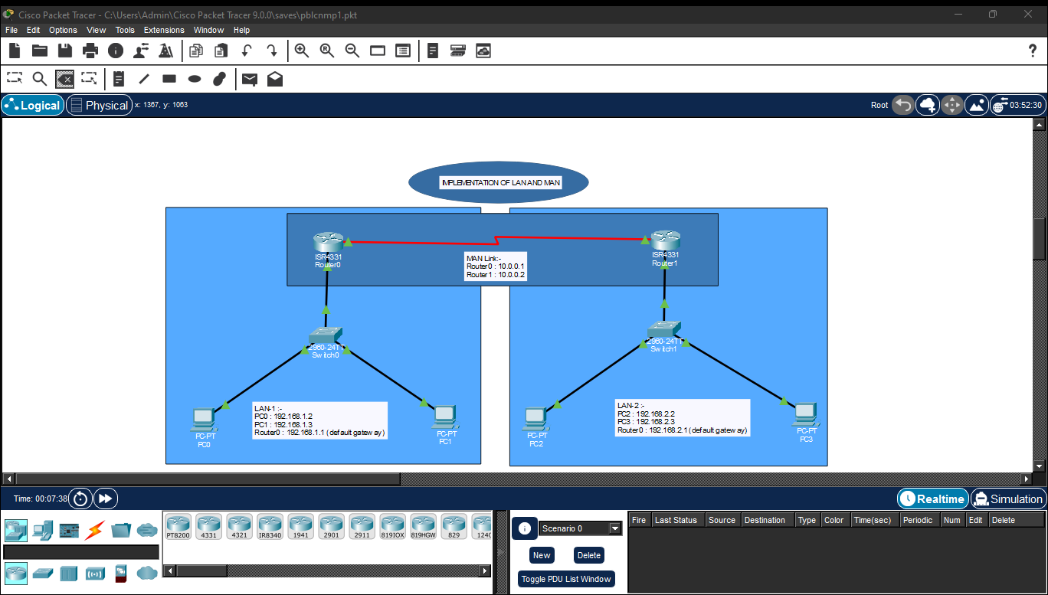
IP Addressing Table
Network | Device | IP Address | Default Gateway
LAN 1 | PC0 | 192.168.1.2 | 192.168.1.1
 | PC1 | 192.168.1.3 | 192.168.1.1
 | Router0 (Gig0/0/0) | 192.168.1.1 | —
LAN 2 | PC2 | 192.168.2.2 | 192.168.2.1
 | PC3 | 192.168.2.3 | 192.168.2.1
 | Router1 (Gig0/0/0) | 192.168.2.1 | —
MAN Link | Router0 (Serial 0/1/0) | 10.0.0.1 | —
 | Router1 (Serial 0/1/0) | 10.0.0.2 | —

Implementation Steps

Step 1: Device Selection and Placement
- Open Cisco Packet Tracer.
- Place the following devices on the workspace:
  - 2 Routers (Model: Cisco 4331)
  - 2 Switches (Model: 2960-24TT)
  - 4 PCs (2 for each LAN)
- Arrange them as shown in the network topology diagram.

Step 2: Connect the Devices
- Connect each PC to its respective switch using Copper Straight-Through cables.
- Connect each switch to its router (Gig0/0 interface) using a Copper Straight-Through cable.
- Connect Router0 (Serial 0/1/0) to Router1 (Serial 0/1/0) using a Serial DCE cable.

Step 3: Assign IP Addresses to PCs
- Configure IP addresses and default gateways as per the IP Addressing Table:
Device | IP Address | Subnet Mask | Default Gateway
PC0 | 192.168.1.2 | 255.255.255.0 | 192.168.1.1
PC1 | 192.168.1.3 | 255.255.255.0 | 192.168.1.1
PC2 | 192.168.2.2 | 255.255.255.0 | 192.168.2.1
PC3 | 192.168.2.3 | 255.255.255.0 | 192.168.2.1

Step 4: Configure Router Interfaces
🔹 Router0 Configuration:
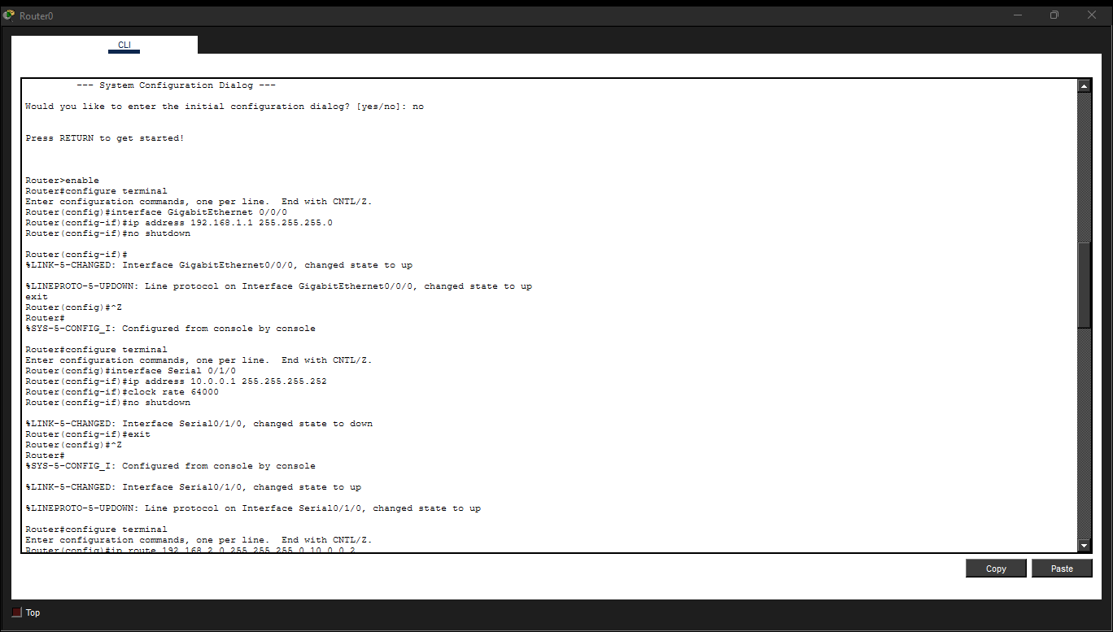
🔹 Router1 Configuration:
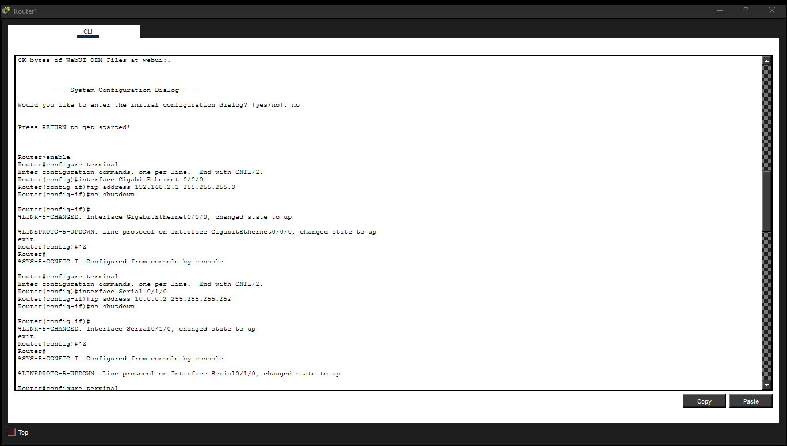

Step 5: Configure Static Routing
🔹 Router0 Configuration:
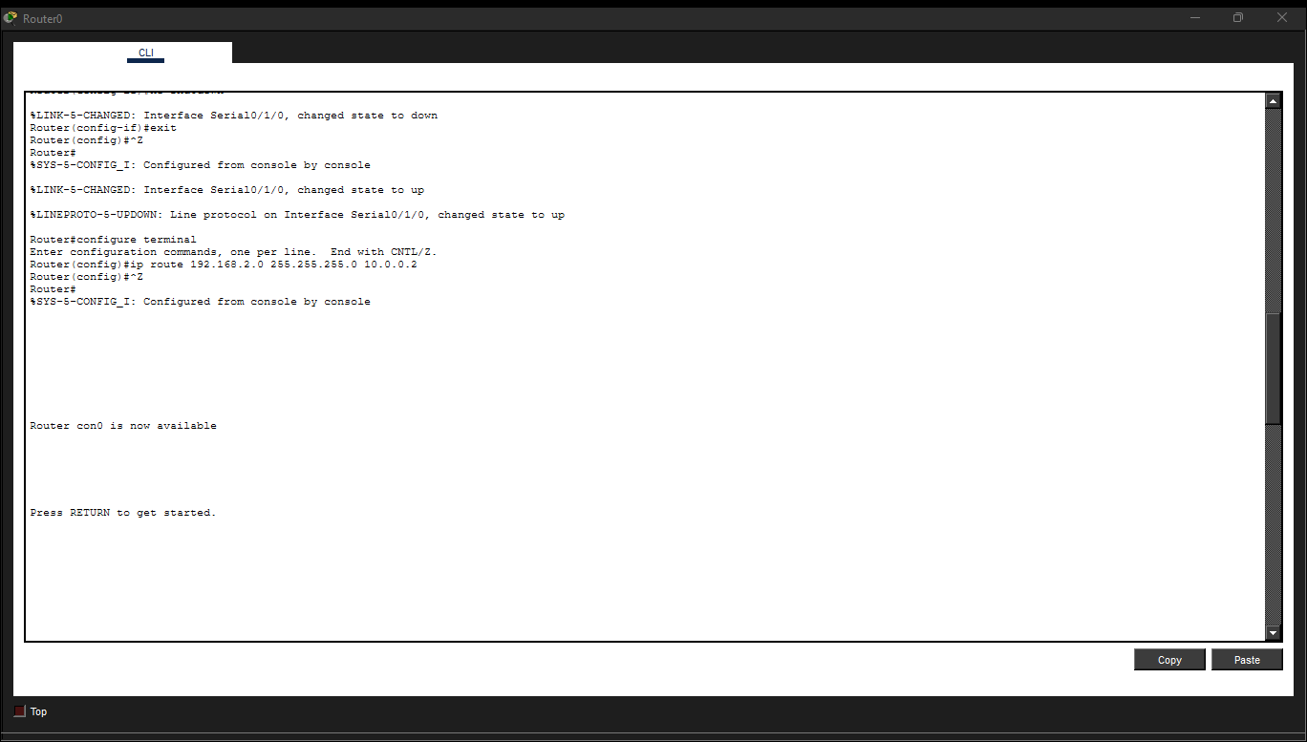
🔹 Router1 Configuration:
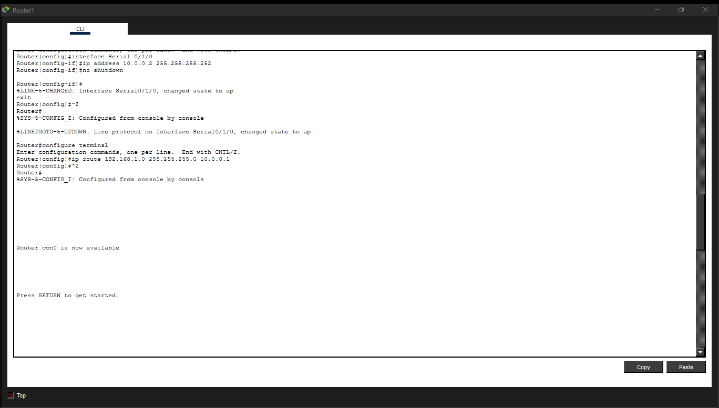
This enables both routers to communicate between LAN1 and LAN2.

Step 6: Verify Connectivity
- Use the Command Prompt on each PC and type:
ping <destination IP>
- Example: From PC0, ping 192.168.2.2 (PC2).
- If configuration is correct, the ping should be successful.

Results

The network simulation of LAN and MAN was successfully implemented in Cisco Packet Tracer. After assigning IP addresses, configuring routers, and setting up static routes, communication between devices in different LANs was verified using the ping command.
Verification Results:
- Inter-LAN communication: Successful through routers connected via serial links.

  - PC0 → PC2 (192.168.1.2 → 192.168.2.2): Ping Successful
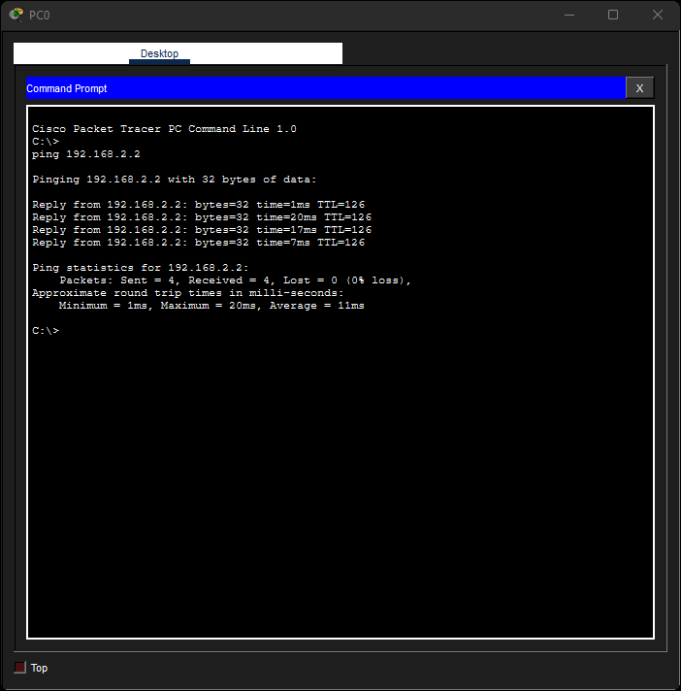

  - PC1 → PC3 (192.168.1.3 → 192.168.2.3): Ping Successful
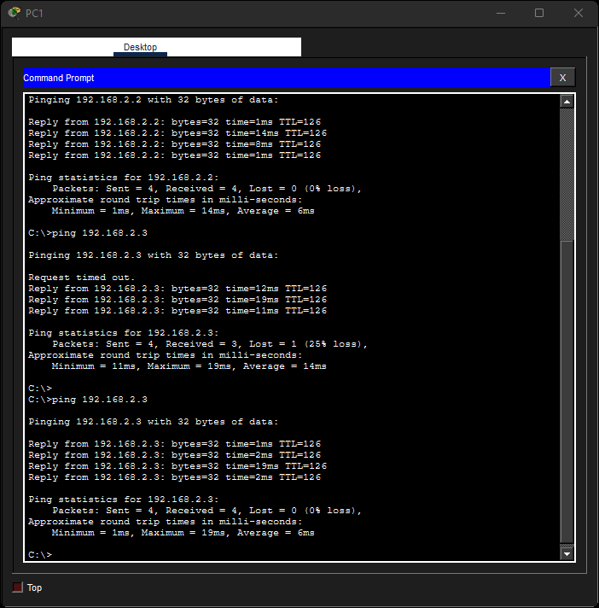

- PCs within the same LAN: Successful communication through the switch.
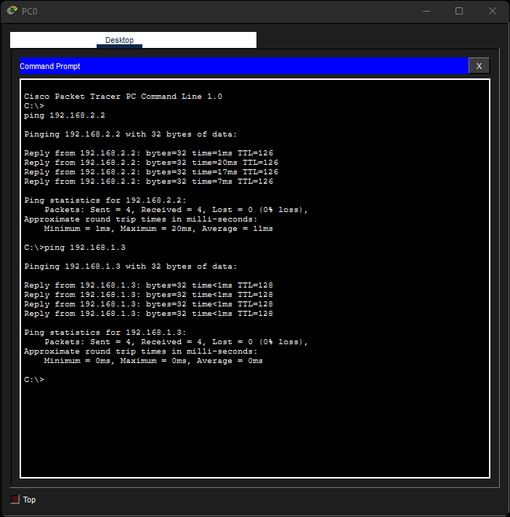

These results confirm that both LANs are successfully interconnected through the MAN link using routers, and data transfer between geographically separated networks works correctly.

Discussion

- The LAN and MAN simulation was successfully implemented in Cisco Packet Tracer using switches, routers, and PCs.
- Within each LAN, switches allowed PCs to communicate directly, using internal MAC address learning to forward frames efficiently.
- Between LANs, routers with static routes enabled communication over serial connections, forming the Metropolitan Area Network (MAN).
- The ping tests confirmed that data transfer between devices in different subnets was successful, proving correct routing and addressing.
- Basic troubleshooting was performed to ensure connectivity — such as checking cable types, enabling interfaces with the no shutdown command, and verifying route configurations.
- The project helped understand practical networking concepts like IP addressing, subnetting, router configuration, and static routing for interconnecting multiple LANs.
- Overall, this simulation demonstrated how local networks can be interconnected to form larger regional networks, providing a foundation for real-world network design.

Conclusion

The mini project successfully demonstrated the implementation of a Local Area Network (LAN) and its extension into a Metropolitan Area Network (MAN) using Cisco Packet Tracer. By connecting multiple LANs through routers and configuring static routes, seamless communication between different subnets was achieved.

The experiment reinforced key networking concepts such as IP addressing, subnetting, static routing, and serial communication between routers. It also provided practical experience in designing scalable network topologies and verifying data transfer across interconnected networks.

Through this simulation, we gained a clear understanding of how LANs can be efficiently linked to form larger metropolitan networks — a crucial step toward building real-world enterprise and city-wide communication infrastructures.

References

- Department of Computer Science and Engineering (CS & DS), Brainware University — for providing academic guidance and learning resources.
- Cisco Packet Tracer — for network simulation and implementation.
- ChatGPT (OpenAI) — for structured guidance and documentation assistance during project preparation.

