MonkMode
AI-Powered Personal Growth Platform
FULL STACK  React • Express • MongoDB | SECURE  Clerk auth • user isolation • Arcjet rate limits | DATA-DRIVEN  Analytics • weekly reports • AI guidance
Project Summary
MonkMode is a full-stack web application that brings daily productivity, wellness, and reflection into one focused workspace. Users track journals, tasks, habits, goals, workouts, and nutrition; explore cross-module analysis; and chat with Ming for personalized AI guidance and weekly feedback.
Motivation
I started MonkMode because, as a student, I struggled to stay consistent and focus on one task for long. I wanted to build a practical tool that helps people practice discipline each day and see their progress over time.
PURPOSE  Help students and self-improvement focused users build focus, self-control, and consistent daily habits. | PRODUCT APPROACH  Bring reflection, planning, habit and goal tracking, fitness, analytics, and Ming AI guidance together in one dashboard, with a read-only demo for exploration.
What Makes MonkMode Different
MonkMode brings journaling, tasks, habits, goals, fitness, and reflection into one workspace, then connects that activity to cross-module analytics, weekly feedback, and Ming AI guidance. Its read-only demo lets people explore the product without an account, while sample changes are never saved.
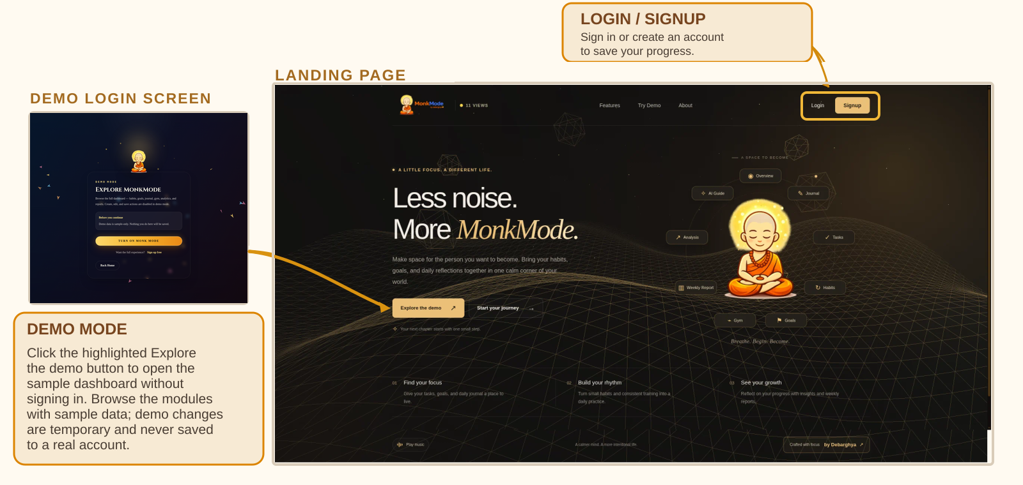
CORE FEATURES  Daily productivity — Journals, tasks, habits, and goals  Wellness — Workouts, nutrition, measurements, and progress photos  Analytics & AI — Cross-module insights, weekly reports, and Ming AI  Security & automation — Clerk auth, read-only demo, weekly reports, and Arcjet API protection. Smart Reminders with Nodemailer/node-cron are planned. | TECH STACK  Frontend — React + Vite  Backend — Node.js + Express  Database — MongoDB + Mongoose  Services — Clerk, Groq, Arcjet; Nodemailer and node-cron (planned)
Architecture & Application Flow
MonkMode follows a three-tier architecture. The React client attaches a Clerk session token to requests. Express verifies the request, applies business rules and rate limits, then reads or writes records owned by the authenticated user.
CLIENT  React + Vite  React Router • Axios  Clerk session | → | APPLICATION API  Express controllers  Validation • rate limits  Business logic | → | DATA & AI  MongoDB / Mongoose  Groq AI • Arcjet
AUTHENTICATION & DATA ISOLATION  Protected routes use Clerk. The backend maps identity to a MongoDB user, and user-owned records are scoped by userId. | SAFE DEMO MODE  Bundled sample data enables product exploration while persistent API writes remain blocked.
DATA INTEGRITY  Indexes and unique constraints support fast date-based views and prevent duplicate daily records. | RESILIENT REQUEST HANDLING  Arcjet rate limits AI and write-heavy actions, with a local in-memory fallback.
Application lifecycle: sign in or demo → select a module → record activity → review trends → receive weekly guidance.
Application Screens
From daily actions to long-term growth: capture activity, review patterns, and use weekly guidance to decide what to improve next.
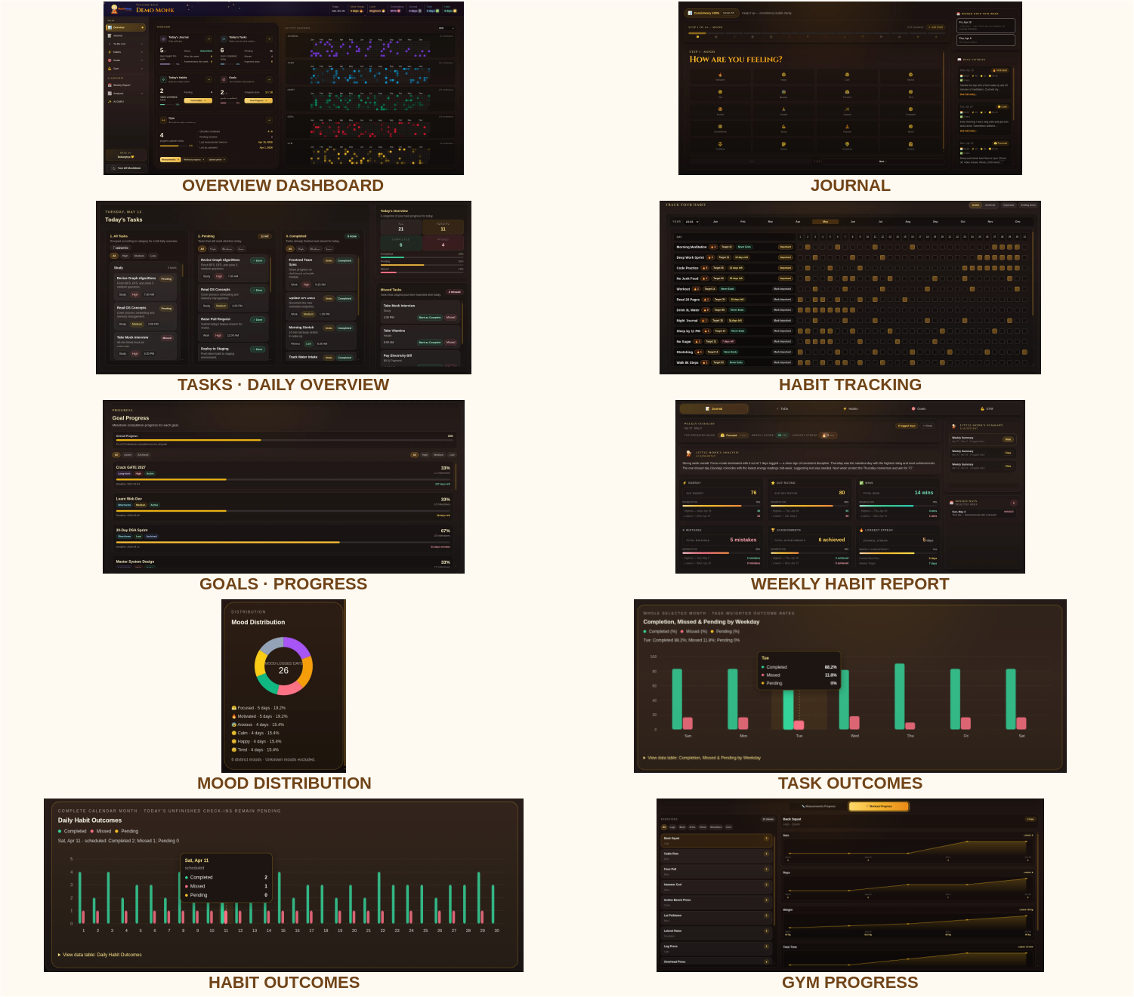
Core Capabilities
DAILY EXECUTION  Journal, To-Do, and Habits transform daily actions into visible streaks, heatmaps, and consistency scores. | GOALS & FITNESS  Goals, workouts, nutrition, measurements, and progress photos support long-term development.
ANALYTICS & REPORTS  Analysis views reveal patterns across sleep, mood, energy, task outcomes, habits, and training volume. | AI GUIDANCE  Ming provides contextual guidance from available user activity and supports cached weekly summaries.
Engineering Considerations  • Security: Clerk token verification, configurable CORS, schema validation, user-scoped data, and rate limits.  • Performance: lazy-loaded routes, indexed MongoDB queries, parallel data loading, and cached AI summaries.  • Maintainability: feature-oriented frontend folders and server separation across routes, controllers, models, middleware, and utilities.  • Quality: ESLint, backend regression tests, production builds, and explicit database environment separation. | 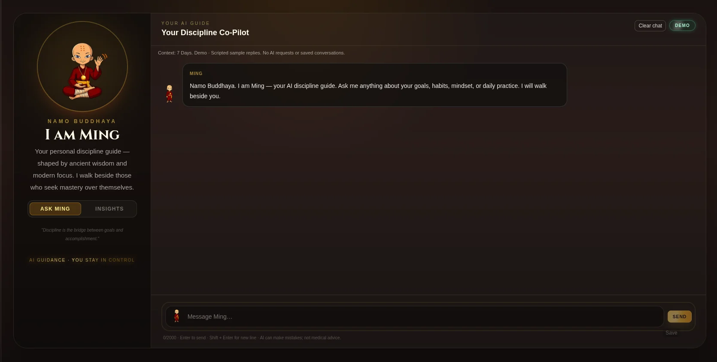  AI Guru (Ming) — focused guidance based on real activity context.
Outcome: a cohesive, secure, and data-informed platform that helps users convert everyday effort into sustainable personal progress.
Live demo: https://monkmode.debarghya.org • Source: https://github.com/debarghya131/MonkMode
MonkMode | Developed by Debarghya Bandyopadhyay

