JQUERY with JAVASCRIPT

The display on the browser for the content

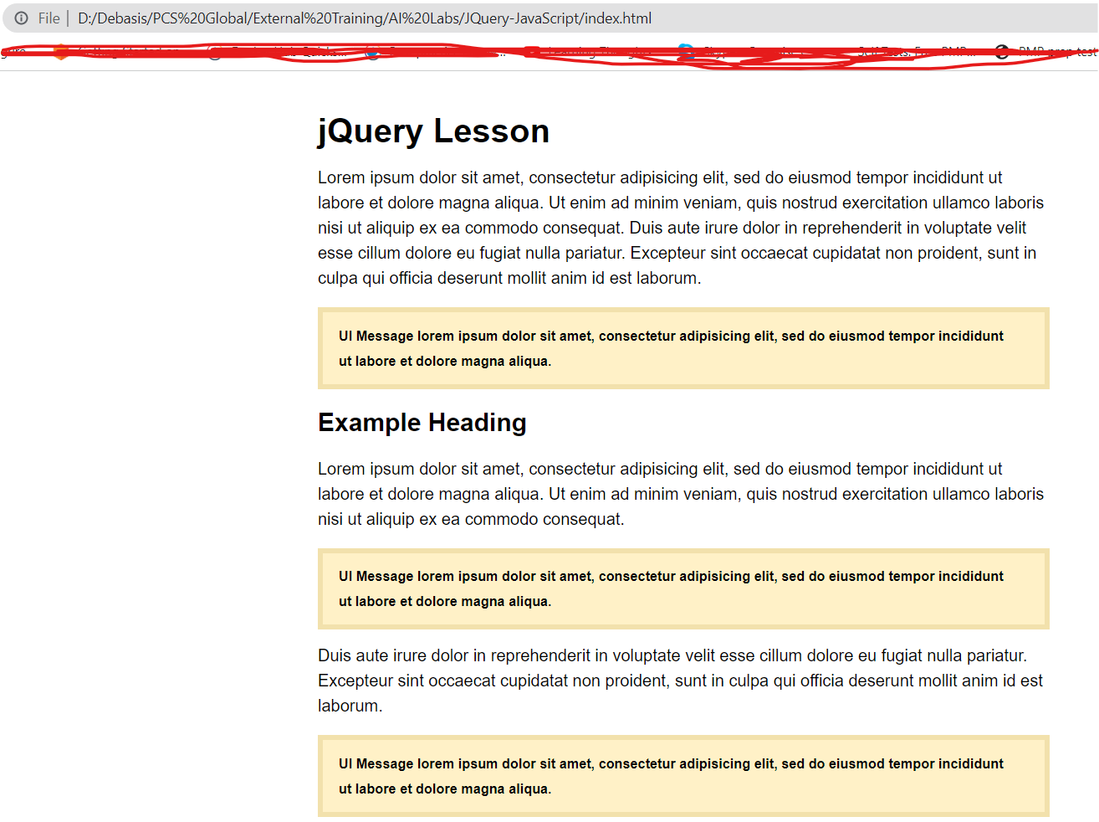

Disecting the above created by different technologies, will lead us to understand **HTML for content**, **CSS for style** and **Javascript for behaviour:**

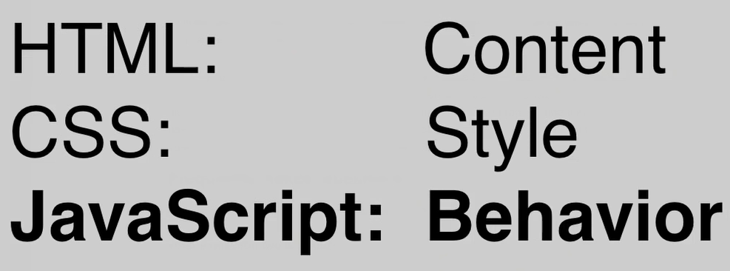 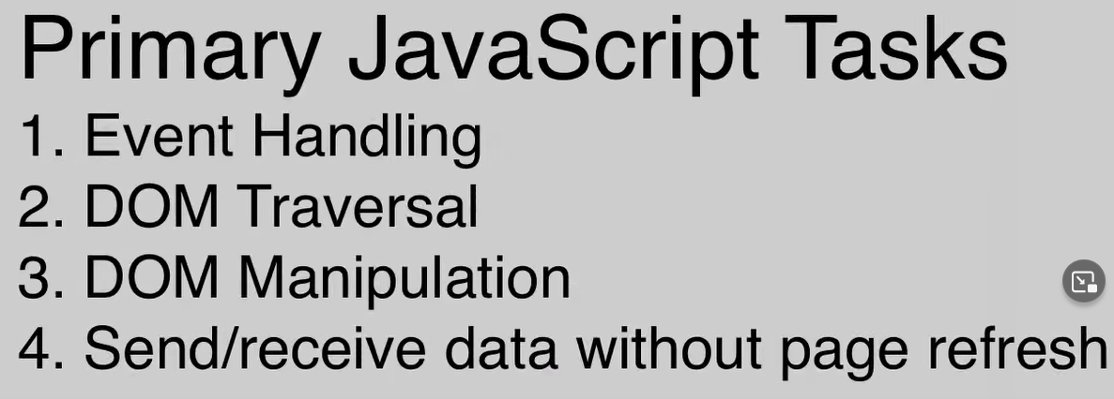 -> AJAX 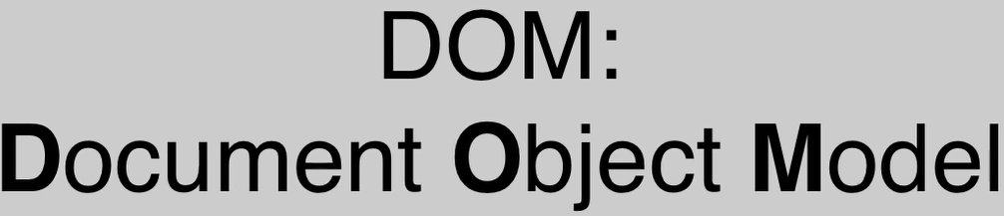

**DOM**

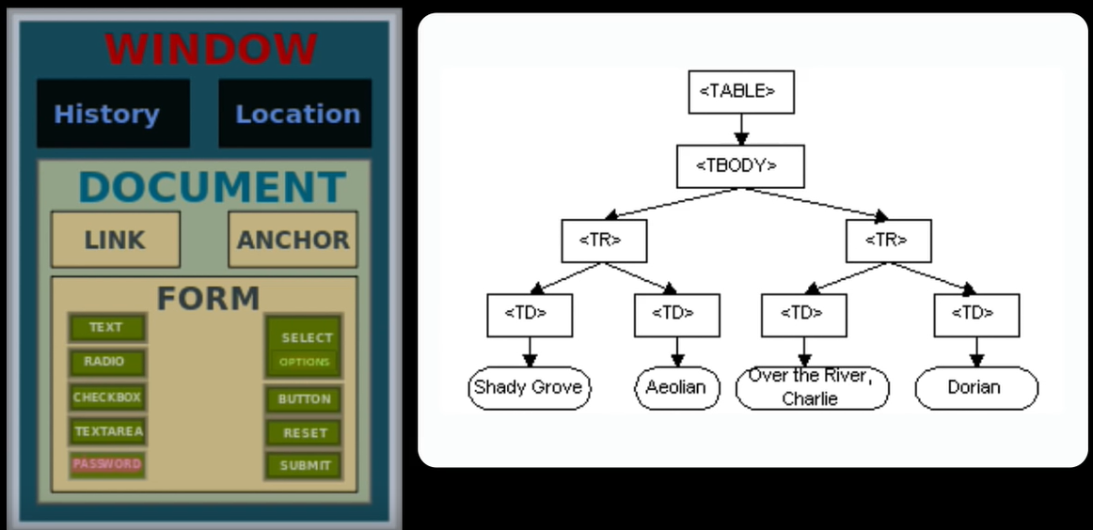

Let's see the HTML file for the content it produces when run:

**screen.css**

**body** {

font-family: Helvetica, sans-serif;

line-height: 1.5em;

padding: 15px;

}

.**container** {

max-width: 700px;

margin: 0 auto;

}

**a**,

**a:link**,

**a:visited** {

color: blue;

}

.**highlight** {

background-color: orange;

}

**p** {margin: 0 0 1em 0;}

.**ui-message** {

background-color: #FFF1C7;

border: 5px solid #F2E1AC;

padding: 10px 30px 10px 15px;

margin: 0 0 1em 0;

font-weight: bold;

font-size: 13px;

position: relative;

}

.**ui-message** **p** {

margin: 0;

}

**.ui-close** {

background-color: #F2E1AC;

color: #8A7A49;

position: absolute;

top: 0;

right: 0;

padding: 1px 6px;

cursor: pointer;

}

**.ui-close:hover** {

background-color: #8A7A49;

color: #F2E1AC;

}

**.faq-question** {

color: blue;

cursor: pointer;

}

**.img-right** {

max-width: 50%;

float: right;

margin: 0 0 1em 15px;

}

**.about-placeholder** {

background-color: #F1FAD2;

padding: 10px 15px;

border: 5px solid #DDE8B7;

margin: 0 0 1em 0;

font-size: 13px;

}

**#about** {

display: block;

text-align: center;

font-size: 15px;

font-weight: bold;

}

**index.html**

<!DOCTYPE html>

<html lang="en">

<head>

<title>jQuery Tutorial</title>

<meta charset="utf-8" />

<meta name="viewport" content="width=device-width, initial-scale=1.0, minimum-scale=1.0" />

<link rel="stylesheet" media="screen, projection" href="**css/screen.css**" />

<script src='https://code.jquery.com/jquery-3.2.1.min.js' type="text/javascript"></script>

<script type="text/javascript" src="**js/script.js**"></script>

</head>

<body>

<!-- container -->

<div class="container">

<h1>jQuery Lesson</h1>

<p> Lorem ipsum dolor sit amet, consectetur adipisicing elit, sed do eiusmod tempor incididunt ut

labore et dolore magna aliqua. Ut enim ad minim veniam, quis nostrud exercitation ullamco

laboris nisi ut aliquip ex ea commodo consequat. Duis aute irure dolor in reprehenderit in voluptate

velit esse cillum dolore eu fugiat nulla pariatur. Excepteur sint occaecat cupidatat non proident,

sunt in culpa qui officia deserunt mollit anim id est laborum.

</p>

<!-- ui-message -->

<div class="**ui-message**">

<!-- Added the following in HTML in order to print the "X" to add as a content to the div class ui-message -->

<!-- this entire action of adding/traversing the DOM and manipulating the DOM with the close functionality with be done by JAVASCRIPT -->

**<span class="ui-close">X</span>**

<p>UI Message lorem ipsum dolor sit amet, consectetur adipisicing elit, sed do eiusmod tempor incididunt

ut labore et dolore magna aliqua.</p>

</div>

<!-- /ui-message -->

<h2>Example Heading</h2>

<p>Lorem ipsum dolor sit amet, consectetur adipisicing elit, sed do eiusmod tempor incididunt ut labore et dolore magna aliqua.

Ut enim ad minim veniam, quis nostrud exercitation ullamco laboris nisi ut aliquip ex ea commodo consequat.

</p>

<!-- ui-message -->

<div class="**ui-message**">

<p>UI Message lorem ipsum dolor sit amet, consectetur adipisicing elit, sed do eiusmod tempor

incididunt ut labore et dolore magna aliqua.

</p>

</div>

<!-- /ui-message -->

<p>Duis aute irure dolor in reprehenderit in voluptate velit esse cillum dolore eu fugiat nulla pariatur.

Excepteur sint occaecat cupidatat non proident, sunt in culpa qui officia deserunt mollit anim id est laborum.

</p>

<!-- ui-message -->

<div class="**ui-message**">

<p>UI Message lorem ipsum dolor sit amet, consectetur adipisicing elit, sed do eiusmod tempor

incididunt ut labore et dolore magna aliqua.

</p>

</div>

<!-- /ui-message -->

<p>Lorem ipsum dolor sit amet, consectetur adipisicing elit, sed do eiusmod tempor incididunt ut labore et dolore magna aliqua.

Ut enim ad minim veniam, quis nostrud exercitation ullamco laboris nisi ut aliquip ex ea commodo consequat.

Duis aute irure dolor in reprehenderit in voluptate velit esse cillum dolore eu fugiat nulla pariatur. Excepteur sint occaecat cupidatat non proident,

sunt in culpa qui officia deserunt mollit anim id est laborum.

</p>

<!-- faq -->

<div class="**faq**">

<h2>Frequently Asked Questions</h2>

<h4>What if the widget does not function correctly?</h4>

<!-- answer -->

<div class="**answer**">

<p>Answer text to question #1 here lorem ipsum dolor sit amet, consectetur adipisicing elit,

sed do eiusmod tempor incididunt ut labor, duis aute irure dolor in reprehenderit ut aliquip ex ea commodo consequat ipsum dolor sit.

</p>

<p>Lorem ipsum dolor sit amet, consectetur adipisicing elit,

sed do eiusmod tempor incididunt ut labore et dolore magna.

</p>

</div>

<!-- /answer -->

<h4>What if question two is asked?</h4>

<!-- answer -->

<div class="**answer**">

<p>Answer text to question #2 here lorem ipsum dolor sit amet, consectetur adipisicing elit, sed do eiusmod tempor incididunt ut labor,

duis aute irure dolor in reprehenderit ut aliquip ex ea commodo consequat ipsum dolor sit.

</p>

<p>Lorem ipsum dolor sit amet, consectetur adipisicing elit, sed do eiusmod tempor

incididunt ut labore et dolore magna.

</p>

</div>

<!-- /answer -->

<h4>What if question three is asked?</h4>

<!-- answer -->

<div class="**answer**">

<p>Answer text to question #3 here lorem ipsum dolor sit amet, consectetur adipisicing elit, sed do eiusmod tempor incididunt ut labor,

duis aute irure dolor in reprehenderit ut aliquip ex ea commodo consequat ipsum dolor sit.

</p>

<p>Lorem ipsum dolor sit amet, consectetur adipisicing elit, sed do eiusmod tempor

incididunt ut labore et dolore magna.

</p>

</div>

<!-- /answer -->

<h4>What if question four is asked?</h4>

<!-- answer -->

<div class="**answer**">

<p>Answer text to question #4 here lorem ipsum dolor sit amet, consectetur adipisicing elit, sed do eiusmod tempor incididunt ut labor,

duis aute irure dolor in reprehenderit ut aliquip ex ea commodo consequat ipsum dolor sit.

</p>

<p>Lorem ipsum dolor sit amet, consectetur adipisicing elit,

sed do eiusmod tempor incididunt ut labore et dolore magna.

</p>

</div>

<!-- /answer -->

</div>

<!-- /faq -->

<!-- about-placeholder -->

<div class="**about-placeholder**">

<a id="**about**" href="**about.html**">Learn More!</a>

</div>

<!-- /about-placeholder -->

</div>

<!-- /container -->

</body>

</html>

Now, we start writing the script.js (JavaScripting) - so far we did not have any java scripting to define the DOM behaviour.

**jQuery** is world's most popular Javascript library, which is a giant set of shortcuts and tools that make writing Javascript a lot easy.

jQuery is a two step process :

1. Select an element or a series of elements (Manipulating the DOM)
2. Action defined on the element selected (Traversing the DOM)

**script.js**

**jQuery**(document).**ready**(function() {

    /*

        We would now manipulate the DOM, by adding the "X" button dynamically to each ui-message box

        We would therefore take out the <span> element from index.html and create this button by JS

    */

        // Adding the "X" button

**jQuery**(".ui-message").**append**('<span class="ui-close">X</span>');

    /*

        We would like to select/access the "X" button on the boxed div and do the following actions:

    */

    // **jQuery**(".ui-close").**hide**();  // just a poc we hide the "X" button when the form loads/refreshes

    // **jQuery**(".ui-close").**fadeOut**();  // just a poc we fade out the "X" button when the form loads/refreshes

    // **jQuery**(".ui-close").**slideUp**();  // just a poc we slide up the "X" button when the form loads/refreshes

    /*

        But, we want to write a code in JS, an eventHandler such that

        when we click on the "X" button, the entire box disappears

    */

        // Handling the Click event

**jQuery**(".ui-close").**click**(function() {

            // **alert**("Hello!!!"); // just a poc

            /*  this hides all the div-boxes with class ui-message. Which is not the intended goal.

                We want to apply hide when clicked on individual boxes */

            // **jQuery**(".ui-message").**hide**();

            /*  To do individual box hide we need to traverse the DOM

                We need to find the immediate nearest parent of the clicked element "X"  */

**jQuery**(this).**parents**(".ui-message").**fadeOut**();

        });

    /*

        Now, let's hide the answers to the questions initially,

        let the questions be highlighted and when clicked it displays the answers

    */

        // Initially hide the annswers for the FAQ section

**jQuery**(".answer").**hide**();

    /*

        Now, let's find the JS to handle the FAQ question click

    */

        // Handling the FAQ question click

**jQuery**(".faq h4").**click**(function() {

            // Onclick we want to move/traverse to the nearest class of div of answer and act on that

            // **jQuery**(this).**next**(".answer").**slideDown**(); // slideDown/expand on the answer div

**jQuery**(this).**next**(".answer").**slideToggle**();  // toggle up on down on click for anser div

        })

        // Make the appearance of the FAQ question as clickable blue (from the .faq-question css)

**jQuery**(".faq h4").**addClass**("faq-question");

    /*

        Dynamically load "about" content - that is we do not load the heavy content into the page automatically

        It is loaded on the fly on demand when the user clicks on "Learn More!" - this is the send/receive function

        of Javascript/jQuery with the help of Ajax/j

    */

        // we target the id "about" for the click event on the link "Learn More!" we create some function for the click

**jQuery**("#about").**click**(function() {

            // we load the about.html only for the body-text class of div within the div of about-placeholder

**jQuery**(".about-placeholder").**load**("./about.html .body-text");

                // Now, when someone clicks on the link we do not want follow the link to open a page of about.html

                // so we return false

**return false**;

                // So, when the link is clicked, it dynamically loads the content into the DOM of the current page

                // from a different source (about.html) without a page refresh or page reload

        });

});

**Programming with jQuery**