**SQL PROJECT – COFFEE STORE ANALYSIS**

**Q.What is the total no. of customers having loyalty card.(Make two column for Yes and No respectively with count of loyalty card in 1st row)**

**SELECT**

**COUNT(CASE WHEN Loyalty_Card='Yes' THEN Customer_ID END) AS YES,**

**COUNT(CASE WHEN Loyalty_Card='No' THEN Customer_ID END) AS NO**

**FROM customers;**

**RESULT:**

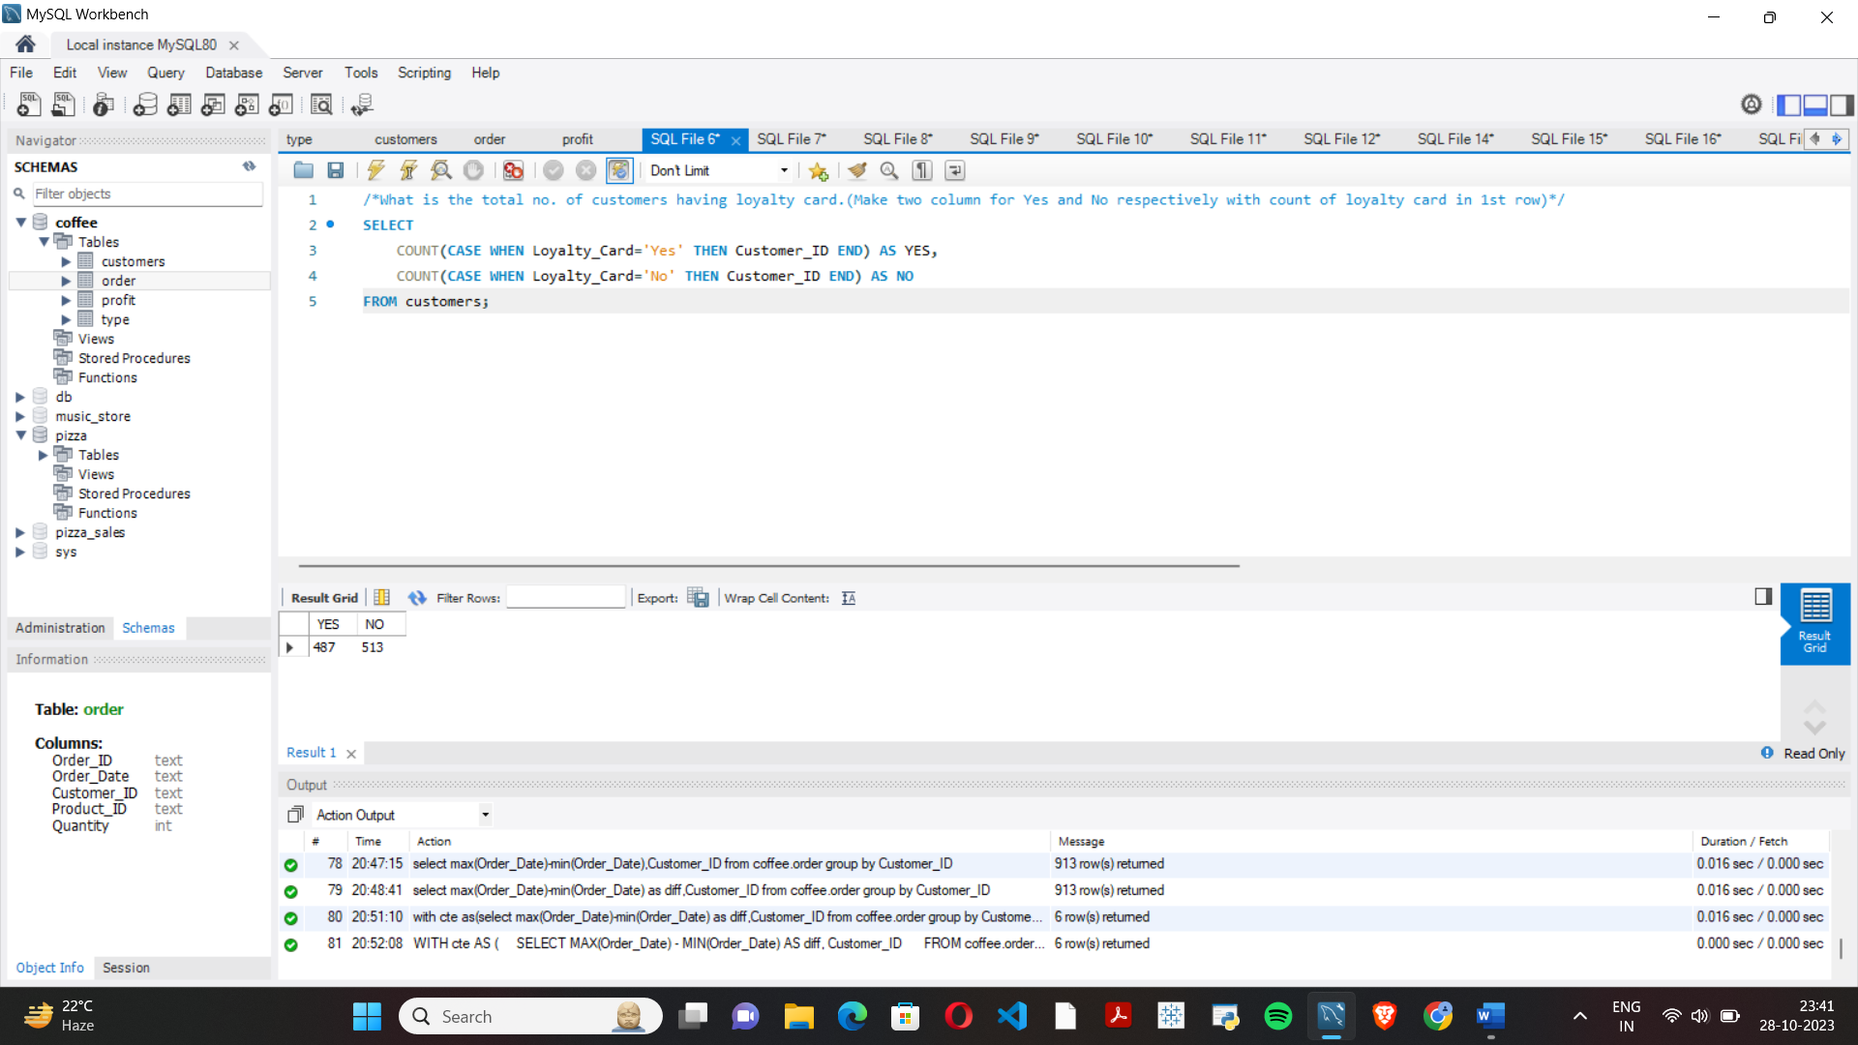

**Q.Change the datatype of Order_Date from char to date.**

**UPDATE coffee.order**

**SET Order_Date = STR_TO_DATE(Order_Date, '%d-%m-%Y');**

**Q.How Many quantity of coffee sold between 14-08-2019 and 25-04-2020?**

**SELECT SUM(quantity) AS Total FROM coffee.order**

**WHERE Order_Date BETWEEN '2019-06-14' AND '2020-01-20'**

**RESULT:**



**Q.Print no. of sales Yearwise.**

**SELECT SUM(quantity) AS Total, YEAR(Order_Date) AS Year**

**FROM coffee.order**

**GROUP BY Year**

**ORDER BY Year;**

**RESULT:**

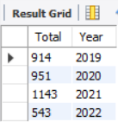

**Q.Which customer ordered the most quantity of products?**

**SELECT SUM(o.quantity) AS Total, c.customer_name AS Name**

**FROM coffee.order o**

**JOIN customers c ON c.customer_id = o.customer_id**

**GROUP BY Name**

**ORDER BY Total DESC LIMIT 1;**

**RESULT:**

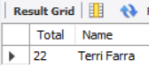

**Q.Print no. of sales monthwise(rowwise) with Years as column.**

**SELECT MONTH(Order_Date) as Month,**

**COUNT(CASE WHEN YEAR(Order_Date) = '2019' THEN MONTH(Order_Date) END) as '2019',**

**COUNT(CASE WHEN YEAR(Order_Date) = '2020' THEN MONTH(Order_Date) END) as '2020',**

**COUNT(CASE WHEN YEAR(Order_Date) = '2021' THEN MONTH(Order_Date) END) as '2021',**

**COUNT(CASE WHEN YEAR(Order_Date) = '2022' THEN MONTH(Order_Date) END) as '2022'**

**FROM coffee.order**

**GROUP BY Month**

**ORDER BY Month;**

**RESULT:**

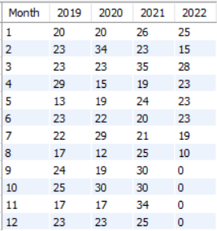

**/*Which Country has the most Loyal customers to total customer by percentage.*/**

**SELECT Country,**

**ROUND(COUNT(CASE WHEN Loyalty_Card='Yes' THEN Customer_ID END)*100/COUNT(Customer_ID), 2) AS LoyalPercentage**

**FROM customers**

**GROUP BY Country;**

**RESULT:**

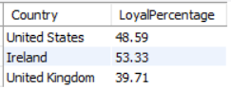

**/*Write profits over month for each year and Average profit over months.*/**

**WITH cte AS (**

**SELECT MONTH(Order_Date) AS Month,**

**SUM(CASE WHEN YEAR(Order_Date) = '2019' THEN o.Quantity * p.Unit_Price END) AS Year2019,**

**SUM(CASE WHEN YEAR(Order_Date) = '2020' THEN o.Quantity * p.Unit_Price END) AS Year2020,**

**SUM(CASE WHEN YEAR(Order_Date) = '2021' THEN o.Quantity * p.Unit_Price END) AS Year2021,**

**SUM(CASE WHEN YEAR(Order_Date) = '2022' THEN o.Quantity * p.Unit_Price END) AS Year2022**

**FROM coffee.order o**

**JOIN profit p ON o.product_id = p.product_id**

**GROUP BY MONTH(Order_Date)**

**)**

**SELECT cte.Month,**

**ROUND(SUM(Year2019) OVER (ORDER BY cte.Month),2) AS Year2019,**

**ROUND(SUM(Year2020) OVER (ORDER BY cte.Month),2) AS Year2020,**

**ROUND(SUM(Year2021) OVER (ORDER BY cte.Month),2) AS Year2021,**

**ROUND(SUM(Year2022) OVER (ORDER BY cte.Month),2) AS Year2022,**

**ROUND((CASE WHEN Year2022=0 THEN (Year2019+Year2020+Year2021+Year2022)/4**

**ELSE (Year2019+Year2020+Year2021)/3 END),2) AS Avg**

**FROM cte;**

**RESULT:**

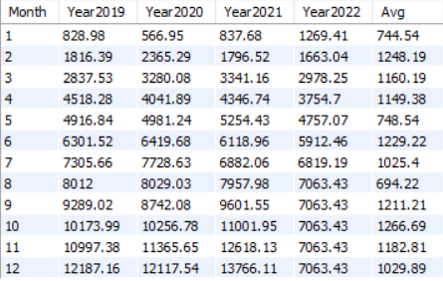

**/*write the name of the top 10 customer who spent the most money?(round off to 2 decimal places)*/**

**SELECT c.Customer_Name, ROUND(SUM(o.Quantity * p.Unit_Price), 2) AS Total**

**FROM customers c**

**JOIN coffee.order o ON c.customer_id = o.customer_id**

**JOIN profit p ON o.product_id = p.product_id**

**GROUP BY c.Customer_Name**

**ORDER BY Total DESC**

**LIMIT 10;**

**RESULT:**

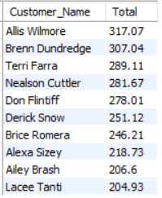

**/*What is name of the top 3 customers with most quantities ordered?(customer with same orders will have same rank)*/**

**SELECT \***

**FROM (**

**SELECT *,**

**DENSE_RANK() OVER (ORDER BY Total DESC) AS rank_no**

**FROM (**

**SELECT SUM(o.quantity) AS Total, c.customer_name AS Name**

**FROM coffee.order o**

**JOIN customers c ON c.customer_id = o.customer_id**

**GROUP BY Name**

**ORDER BY Total DESC**

**) AS t**

**) AS ranked**

**WHERE rank_no <= 3;**

**RESULT:**

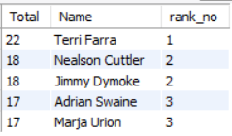

**/*How many customers are there where city name ends with Junction.*/**

**SELECT COUNT(customer_id) AS COUNT**

**FROM customers**

**WHERE RIGHT(Address_Line1, 8) = 'Junction';**

**RESULT:**



**/*Write top 3 product for each coffee type according to profit?*/**

**SELECT \***

**FROM (**

**SELECT *,**

**ROW_NUMBER() OVER (PARTITION BY Coffee_Type ORDER BY Profit DESC) AS rank_no**

**FROM (**

**SELECT t.Product_ID AS Product_ID, t.coffee_type AS Coffee_Type, p.profit AS Profit**

**FROM type t**

**JOIN profit p ON t.Product_ID = p.Product_ID**

**ORDER BY t.Coffee_Type, p.Profit DESC**

**) AS subquery**

**) AS ranked**

**WHERE rank_no < 4;**

**RESULT:**

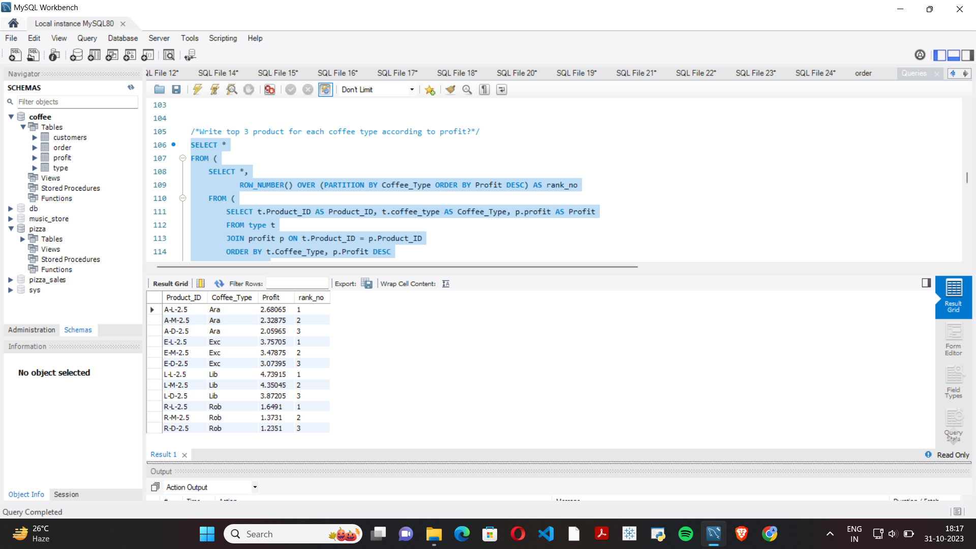

**/*Write cummulative profits over the months for year 2020.*/**

**WITH cte AS (**

**SELECT MONTH(Order_Date) AS Month,**

**SUM(CASE WHEN YEAR(Order_Date) = '2020' THEN o.Quantity * p.Unit_Price END) AS Year2020**

**FROM coffee.order o**

**JOIN profit p ON o.product_id = p.product_id**

**GROUP BY MONTH(Order_Date)**

**)**

**SELECT cte.Month,**

**ROUND(SUM(CTE.Year2020) OVER (ORDER BY cte.Month),2) AS CumulativeProfit**

**FROM cte;**

**RESULT:**

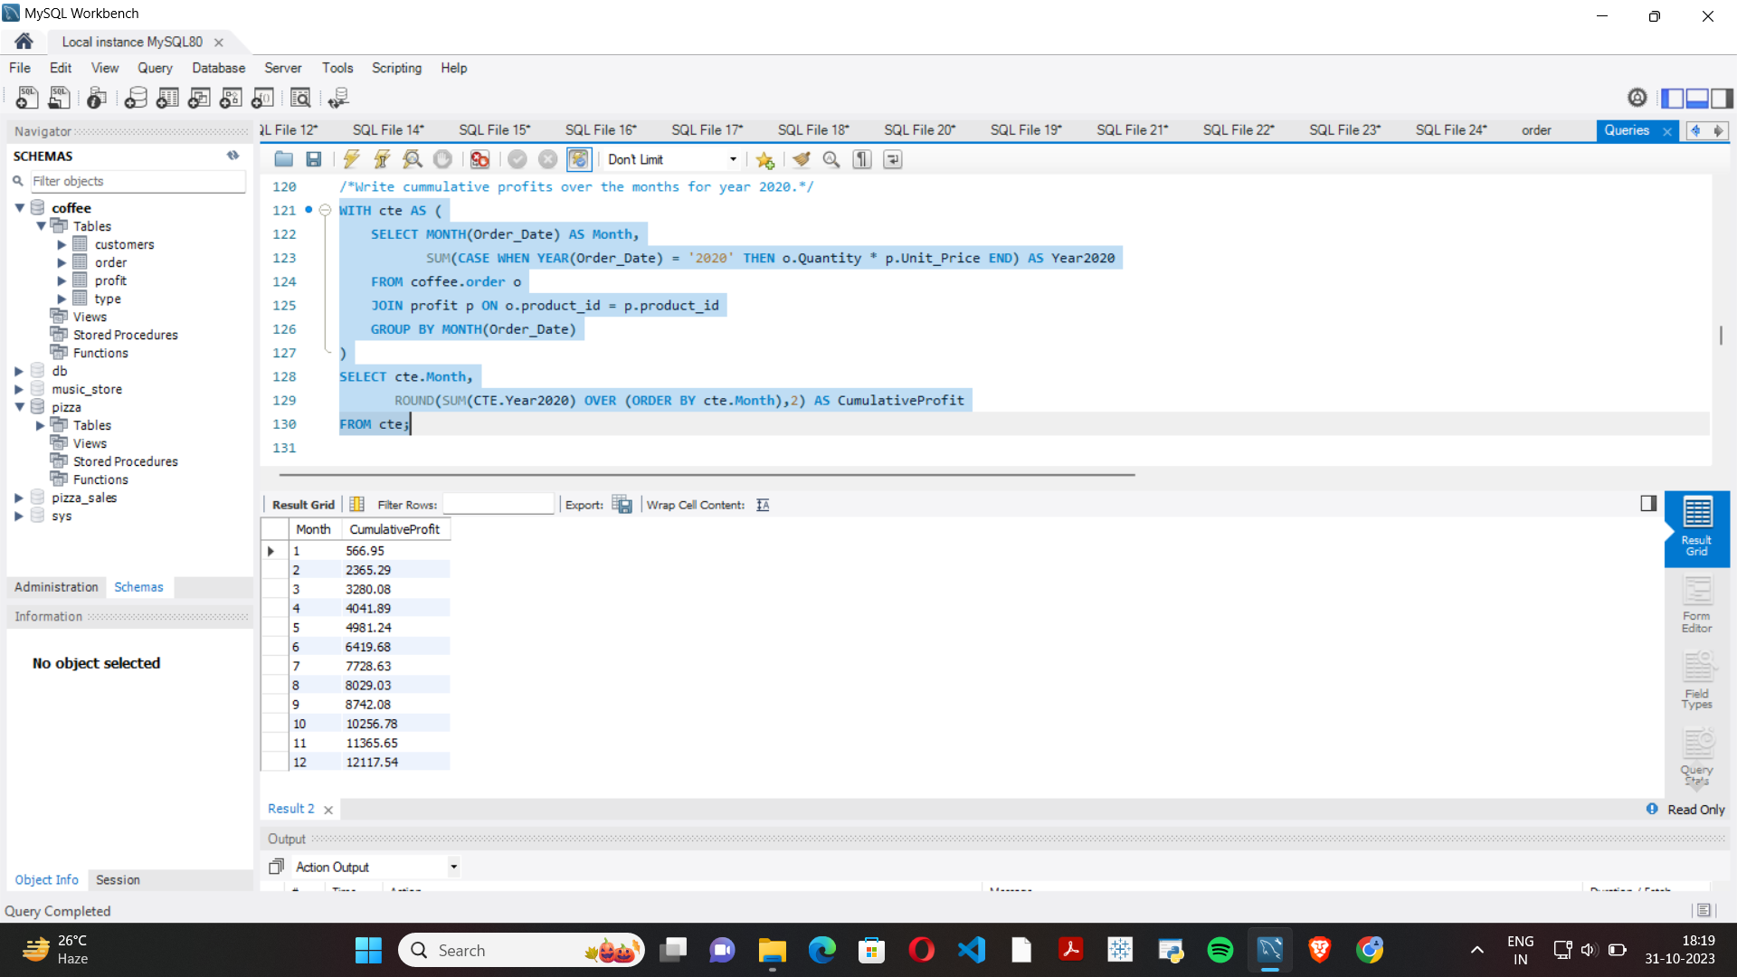

**/*What is the top 3 City giving maximum profit for each country.*/**

**WITH CTE AS (**

**SELECT ROUND(SUM(o.Quantity * p.Unit_Price), 2) AS Total, c.Country, c.City**

**FROM customers c**

**JOIN coffee.order o ON c.customer_id = o.customer_id**

**JOIN profit p ON o.product_id = p.product_id**

**GROUP BY c.Country, c.City),**

**CTE2 AS (**

**SELECT *, ROW_NUMBER() OVER (PARTITION BY Country ORDER BY Total DESC) AS r**

**FROM CTE)**

**SELECT \***

**FROM CTE2**

**WHERE r <= 3;**

**RESULT:**

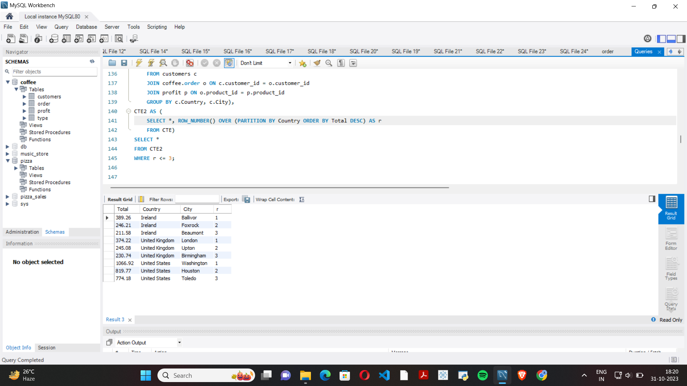

**/*Write the name of the third highest customer who spent the most money?(round off to 2 decimal places)**

**(Query should not include limit and window functions)*/**

**/*METHOD 1 */**

**WITH CTE AS (**

**SELECT c.Customer_Name, ROUND(SUM(o.Quantity * p.Unit_Price), 2) AS Total**

**FROM customers c**

**JOIN coffee.order o ON c.customer_id = o.customer_id**

**JOIN profit p ON o.product_id = p.product_id**

**GROUP BY c.Customer_Name**

**)**

**SELECT Total as Third_Highest, Customer_Name**

**FROM CTE**

**WHERE Total = (**

**SELECT MAX(Total)**

**FROM CTE**

**WHERE Total < (**

**SELECT MAX(Total)**

**FROM CTE**

**WHERE Total < (SELECT MAX(Total)**

**FROM CTE)**

**)**

**);**

**/* METHOD 2 */**

**WITH CTE AS (**

**SELECT c.Customer_Name as Customer_Name, ROUND(SUM(o.Quantity * p.Unit_Price), 2) AS Total**

**FROM customers c**

**JOIN coffee.order o ON c.customer_id = o.customer_id**

**JOIN profit p ON o.product_id = p.product_id**

**GROUP BY c.Customer_Name**

**)**

**SELECT DISTINCT(Total),Customer_Name**

**FROM CTE c1**

**WHERE 3 = (SELECT COUNT(DISTINCT Total)**

**FROM CTE c2**

**WHERE c1.Total <= c2.Total);**

**RESULT:**



**/*Write the name of the customer who order in two consecutive days.*/**

**WITH cte AS (**

**SELECT o1.Customer_id, o2.Order_Date AS Order_Date1, o1.Order_Date AS Order_Date2**

**FROM coffee.order o1**

**JOIN coffee.order o2**

**ON DATEDIFF(o1.Order_Date, o2.Order_Date) = 1 AND o1.Customer_id = o2.Customer_id**

**)**

**SELECT c1.customer_name, c.Order_Date1, c.Order_Date2**

**FROM customers c1**

**JOIN cte c**

**ON c1.Customer_ID = c.Customer_id;**

**RESULT:**



**/*Who are the longest customers of the coffee store?*/**

**WITH cte AS (**

**SELECT MAX(Order_Date) - MIN(Order_Date) AS diff, Customer_ID**

**FROM coffee.order**

**GROUP BY Customer_ID**

**)**

**SELECT c.Customer_Name, c1.diff**

**FROM customers c**

**RIGHT JOIN cte c1**

**ON c.Customer_ID = c1.Customer_ID**

**WHERE c1.diff = (SELECT MAX(diff) FROM cte);**

**RESULT:**

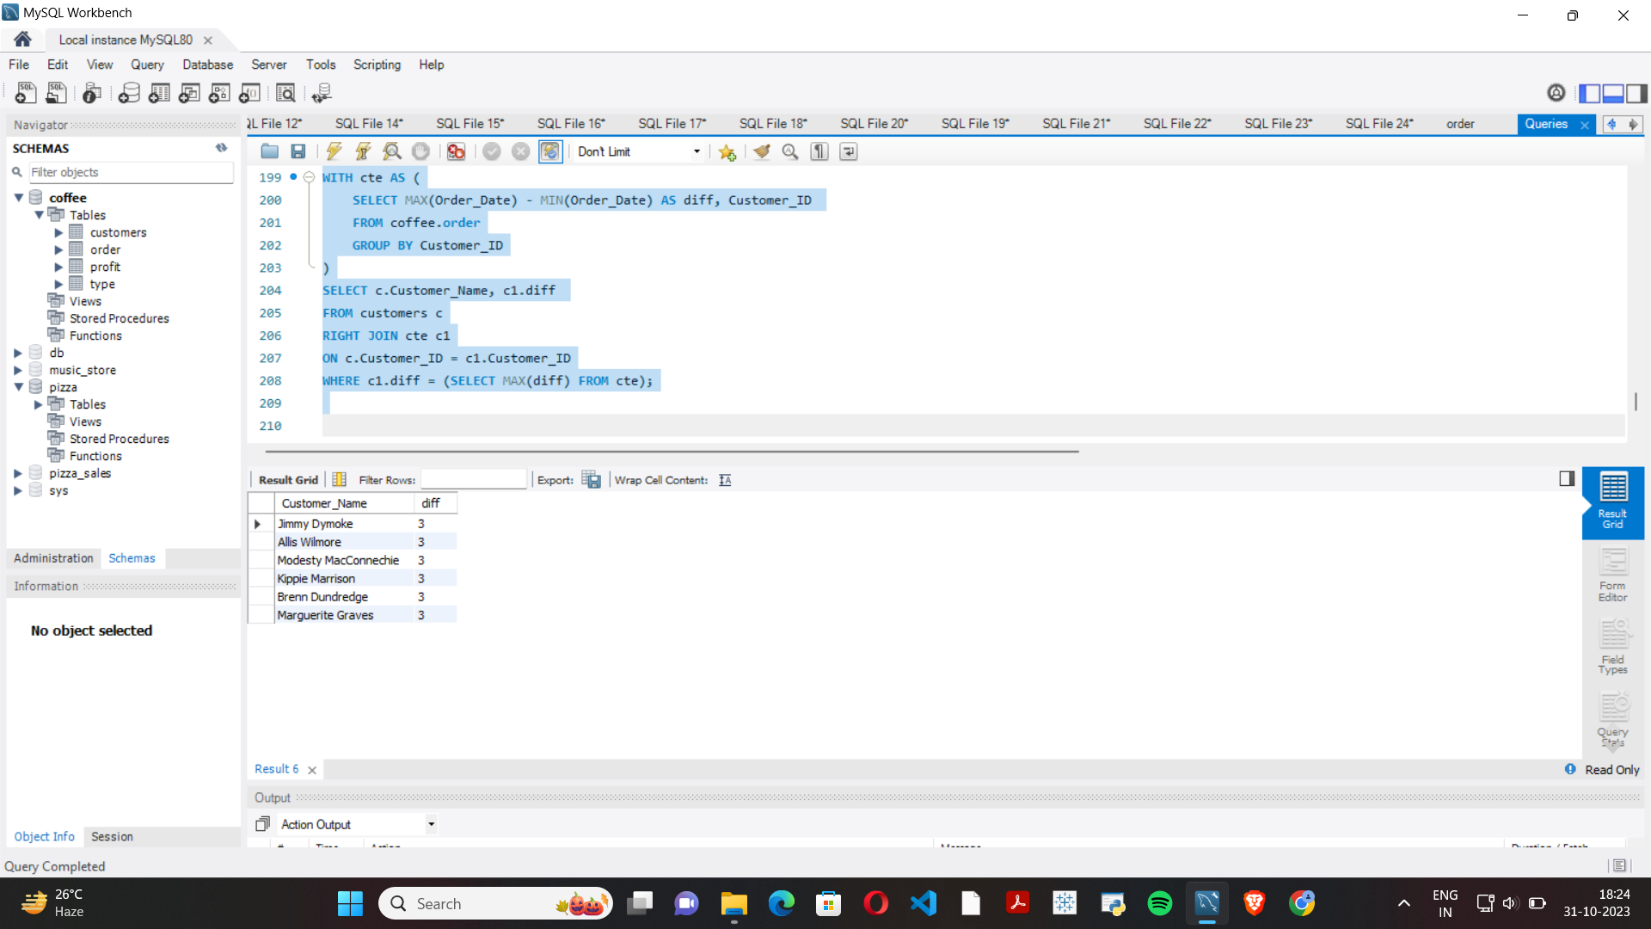

**/*Name an interval of 10 days (difference between start date and end date is 10) in which maximum orders have been received.*/**

**WITH cte AS (**

**SELECT DISTINCT**

**order_date AS start_date, DATE_ADD(order_date, INTERVAL 10 DAY) AS end_date**

**FROM coffee.order**

**)**

**SELECT**

**COUNT(o.order_id) AS MAX, c.start_date, c.end_date**

**FROM coffee.order o**

**LEFT JOIN cte c ON o.order_date BETWEEN c.start_date AND c.end_date**

**GROUP BY c.start_date, c.end_date**

**ORDER BY MAX DESC LIMIT 5;**

**RESULT:**

