
[NAME OF THE COLLEGE / INSTITUTE]
[Affiliated to: Name of the University]
[Address, City, State – PIN]

A PROJECT REPORT ON
DOCBOOK: A DOCTOR APPOINTMENT BOOKING SYSTEM

Submitted in partial fulfilment of the requirements for the award of the degree of
[BACHELOR OF COMPUTER APPLICATION (BCA)]
Submitted by
[STUDENT NAME]
Roll No.: [ROLL NUMBER] Registration No.: [REGISTRATION NUMBER]
Under the guidance of
[NAME OF THE GUIDE]
[Designation, Department]

SESSION: [20XX – 20XX]
BONAFIDE CERTIFICATE

This is to certify that the project report entitled “DocBook: A Doctor Appointment Booking System” is a bonafide record of the project work carried out by [STUDENT NAME], Roll No. [ROLL NUMBER], a student of [Programme], [Name of the College / Institute], affiliated to [Name of the University], during the academic session [20XX – 20XX].
The work has been carried out by the candidate under my supervision and guidance, in partial fulfilment of the requirements for the award of the degree of [Programme]. The matter embodied in this report has not been submitted, either in part or in full, to any other institute or university for the award of any other degree or diploma. To the best of my knowledge and belief, the report is the original work of the candidate.

_____________________________ | _____________________________
Signature of the Guide Signature of the Head of Department

Date: ____________ Signature of the External Examiner
Place: ____________
ACKNOWLEDGEMENT
The completion of this project has been a valuable learning experience, and it would not have been possible without the guidance and support of several people. I take this opportunity to express my sincere gratitude to all of them.
First and foremost, I am deeply thankful to my project guide, [NAME OF THE GUIDE], [Designation], for the constant encouragement, patient review of every module and valuable technical suggestions offered throughout the development of this work. The clarity of the final report owes a great deal to those discussions.
I am sincerely grateful to [NAME], Head of the Department, and to the Principal, [NAME OF THE PRINCIPAL], [Name of the College], for providing the laboratory facilities, the internet access and the academic environment that made this work possible. I also thank all the faculty members of the department for the knowledge shared during the course of the programme.
I would like to thank my classmates and friends who tested the application at various stages, reported errors and suggested improvements to the booking and rescheduling workflow. Their feedback helped to convert an academic prototype into something that behaves like a usable product.
Finally, I am grateful to my family for their unwavering patience, moral support and encouragement during the long hours of coding, debugging and documentation that this report represents.

[STUDENT NAME]
Roll No. [ROLL NUMBER]
ABSTRACT
Access to a doctor usually begins with a telephone call. In most clinics and small hospitals the appointment book is still maintained by hand at the reception desk, and the patient has no way of knowing which doctor is available, at what time, or whether the slot promised on the telephone has already been given to somebody else. The result is double booking, long waiting rooms and a paper record that cannot answer a simple question such as how many appointments were cancelled last month.
DocBook is a web-based doctor appointment booking system developed to remove that gap. It is a three-tier application in which a React single-page front end talks to an Express REST API, which in turn stores its data in MongoDB through the Mongoose object data modelling library. Users register in one of three roles — patient, doctor and administrator — and each role sees only the functions it is entitled to, because every request carries a JSON Web Token that is verified and checked against the role and the active status of the account.
A patient can search the doctor directory by name or specialty, choose a date on a calendar and pick a time slot that the doctor has actually published for that weekday. The server re-validates the date, the weekday, the slot and the existing bookings before saving, so a conflicting appointment can never be created. A doctor can maintain a weekly availability pattern, pause bookings with a stated reason, declare a period of leave, and confirm, complete, cancel or reschedule the appointments that come in. When a new time is proposed, the request appears on the patient dashboard and the original appointment remains valid until the patient accepts or rejects it. Administrators get a private dashboard with statistics, account management and a report generator that exports any date range as CSV or as a printable PDF.
The system was tested module by module and then as an integrated application. It removes double booking, makes availability visible before the patient travels to the clinic, keeps a permanent history of every cancellation and reschedule, and gives the administration a factual basis for reporting.

Keywords: appointment booking, healthcare web application, React, Express, MongoDB, JWT authentication, role-based access control, scheduling.
CONTENTS
CHAPTER 1: INTRODUCTION 1
1.1 Background of the Study 1
1.2 Need for the System 1
1.3 Objectives of the Project 2
1.4 Scope of the Work 2
CHAPTER 2: PROBLEM DEFINITION 3
2.1 The Existing System 3
2.2 Limitations of the Existing System 3
2.3 The Proposed System 3
2.4 Benefits of the Proposed System 4
CHAPTER 3: SYSTEM FLOWCHART 5
3.1 Working of the System 5
3.2 Data Flow Diagram 6
3.3 Database Design 7
CHAPTER 4: SOFTWARE, HARDWARE AND PLATFORM USED 8
4.1 System Architecture 8
4.2 Software Requirements 8
4.3 Hardware Requirements 9
4.4 Platform and Deployment 10
4.5 Module Description 10
4.6 Security Measures 11
CHAPTER 5: SCREEN SHOTS WITH SHORT USER MANUAL 12
5.1 How the Manual is Arranged 12
5.2 Home Page and Doctor Directory 12
5.3 Registration and Login 13
5.4 Choosing a Slot and Confirming the Appointment 13
5.5 Patient Dashboard, Rescheduling and Cancellation 14
5.6 Doctor Dashboard and Availability Controls 15
5.7 Confirming, Completing and Rescheduling an Appointment 15
5.8 Generating and Exporting Reports 16
5.9 Administrator Dashboard 17
CHAPTER 6: FUTURE SCOPE 18
6.1 Online Payment and Fee Collection 18
6.2 Reminders and Notifications 18
6.3 Teleconsultation and Prescriptions 18
6.4 Ratings, Reviews and Verification 18
6.5 Mobile Application and Offline Support 18
6.6 Analytics and Artificial Intelligence 18
6.7 Multi-Clinic Support and Accessibility 19
CHAPTER 7: REFERENCES 20

CHAPTER 1: INTRODUCTION

1.1 Background of the Study
Healthcare delivery in India has changed shape over the last decade. Diagnostic laboratories publish reports online, pharmacies accept orders from a phone and insurance claims are filed without paper, yet the first and most repeated interaction between a patient and a hospital — fixing an appointment — is still handled by a person at a desk or on a telephone. A patient who wishes to consult a specialist must call the reception, describe the problem, be told to come on a particular day, and then queue for a token that may not correspond to any fixed time. If the doctor is on leave, the patient learns about it only after arriving at the clinic.
The problem is not a shortage of software in principle. Large hospital chains run full hospital management systems, but these are expensive, are installed on-premises, require trained operators and are designed around the billing department rather than around the patient. A clinic with three doctors, a diagnostic centre, a polyclinic in a residential area, or a department of a college health centre needs something much smaller: a directory of doctors, a truthful view of their free time, a booking record that cannot be duplicated, and a report for the person in charge.
DocBook was conceived for that middle ground. It is a browser-based application that any patient can open on a mobile phone, in which a doctor publishes the hours he or she actually intends to sit, and in which the appointment record becomes the single source of truth for the patient, the doctor and the administrator. Being built entirely on free and open technologies, it can be hosted at a nominal monthly cost and extended by any developer familiar with JavaScript.

1.2 Need for the System
Three observations shaped the requirement. First, availability is invisible: at present a patient has no way of knowing, before travelling, whether the doctor is sitting, on leave or already fully booked for the day. Second, appointment records are unreliable: the same slot is often promised twice, and a cancellation made on the telephone leaves no trace. Third, there is no supervision: the person responsible for the clinic cannot answer questions such as how many appointments were booked last month, how many patients did not turn up, or which doctor is over-loaded.
A system that publishes availability, prevents conflicting bookings and records every change with a timestamp and a reason answers all three at once, and relieves the reception desk of routine telephone calls.

1.3 Objectives of the Project
- To design and develop a responsive web application through which patients can find doctors and book appointments without any manual intervention.
- To represent each doctor’s real availability through a weekly schedule, a booking pause switch and dated leave periods, and to prevent two patients from booking the same slot.
- To implement a transparent rescheduling workflow in which the doctor proposes a new time with a reason and the patient accepts or rejects it, the original appointment staying valid until the proposal is answered.
- To maintain a complete history of every appointment — confirmation, reschedule, acceptance, rejection and cancellation — with the reason recorded by the person who acted.
- To provide doctors and administrators with date-range reports that can be exported as CSV or printed as a PDF.
- To implement authentication and role-based authorisation so that a patient, a doctor and an administrator can never reach each other’s functions, and to store passwords only as salted hashes.

1.4 Scope of the Work
The present version covers the appointment life-cycle from discovery to closure: registration and login for patients and doctors, an administrator account provisioned from the server, doctor discovery, booking with server-side validation, schedule management, rescheduling, cancellation with a reason, account settings and reporting. Payment collection, teleconsultation, e-prescription and billing lie outside the present scope and are listed in Chapter 6.
The application is intended for a single clinic, polyclinic or hospital department; it stores only the information needed to schedule and administer appointments, not clinical records.

CHAPTER 2: PROBLEM DEFINITION

2.1 The Existing System
In the existing arrangement the reception desk maintains a physical register, or at best a spreadsheet, in which the name of the patient, the doctor, the date and the time are written by hand. Appointments are requested by telephone, by a message on a mobile application, or in person. The doctor informs the reception about leave verbally, and the register is corrected with a pen. When a patient cancels, the entry is struck out and the slot is offered to the next caller.
This workflow has the merit of familiarity and requires no computer, but it depends entirely on the memory and diligence of the person at the desk, and it produces no data that can be analysed later.

2.2 Limitations of the Existing System
- Double booking: because the register is not consulted while a call is in progress, the same date and time are frequently promised to more than one patient.
- Invisible availability: the patient cannot see which days and hours a doctor actually sits, or whether the doctor is on leave, until a telephone call is answered.
- No record of cancellations or changes: a struck-out entry records neither the reason nor the person who authorised the change, so disputes cannot be settled.
- Loss and damage, and no reporting: a paper register can be misplaced or spoiled, there is no backup, and questions about monthly appointments or doctor load cannot be answered without manually counting pages.
- No access control: anybody standing at the desk can read the register, which exposes patient names and appointment times.
- Waiting time and no supervision: patients are given a day rather than an exact slot and therefore arrive together, while the administrator has no independent view of what the reception has booked and confirmed.

2.3 The Proposed System
The proposed system replaces the register with a document database and the telephone call with a web form, as defined by the functional requirements in Table 2.1.
Table 2.1 Functional requirements of DocBook
ID | Requirement | Actor
FR-1 | Register and log in as a patient or a doctor; the administrator account is provisioned by the server | All
FR-2 | Search the doctor directory by name or specialty and view profile, experience and rating | Patient
FR-3 | Display only those dates and slots on which the selected doctor is actually available | Patient
FR-4 | Book an appointment after re-validating the date, weekday, slot and existing bookings on the server | Patient
FR-5 | Accept or reject a proposed new appointment time | Patient
FR-6 | Cancel an appointment by recording a reason and optional details | Patient
FR-7 | Maintain a weekly availability schedule of days and times | Doctor
FR-8 | Pause or resume bookings and declare dated leave periods | Doctor
FR-9 | Confirm, complete, cancel or reschedule an appointment with a reason | Doctor
FR-10 | Generate date-range reports and export them as CSV or printable PDF | Doctor, Admin
FR-11 | View platform statistics, activate, deactivate and delete accounts, and control appointments | Admin

Two non-functional requirements are equally important. The first is integrity: the server, not the browser, is the final authority on whether a slot may be booked, so the application cannot be tricked by replaying a request. The second is least privilege: authorisation is enforced in middleware on the server, so hiding a button in the interface is a convenience and never a security measure.

2.4 Benefits of the Proposed System
- The patient knows before leaving home whether the doctor is available, and books an exact time rather than a day.
- Conflicting bookings are impossible because the check and the insert are performed on the server against the same collection.
- Every change is recorded with the actor, the time and the reason, so the appointment carries its own audit trail.
- A doctor can publish leave in advance, and the booking engine immediately stops offering those dates.
- Reports for any date range can be produced in seconds, and the administrator has a single dashboard for accounts and appointments that is independent of the reception desk.
- Passwords are stored only as bcrypt hashes and sessions are stateless JSON Web Tokens, so no password is recoverable from the database.

CHAPTER 3: SYSTEM FLOWCHART

3.1 Working of the System
The application is a single-page React client served as static files, which communicates with an Express API over HTTP. On the first load the client fetches the doctor directory from GET /api/doctors and renders the search screen. The visitor may browse without an account; the account is required only at the moment of booking. When a doctor is chosen, the calendar is built from the weekly availability of that doctor, and any date that falls inside a declared leave period, or a date on which the doctor has paused bookings, is shown disabled. Selecting a date filters the time slots; selecting a slot fills the visit summary card.
Pressing “Confirm appointment” sends the doctor identifier, date and time to POST /api/appointments. The server reloads the doctor, rejects a past date, rejects a date that lies in an unavailability period, rejects a time that is not part of the published schedule for that weekday, and finally checks whether a non-cancelled appointment already exists for the same doctor, date and time. Only if all four checks pass is the appointment created, with the status pending. The doctor then confirms it, or proposes another time with a reason. A proposal sets the status to reschedule_requested and stores the proposed date, time, reason and the previous status, so that a rejection can restore the original appointment exactly.
Figure 3.1 summarises this sequence, including the three points at which the flow branches: an unauthenticated visitor is diverted to the login screen, an unavailable slot returns the patient to the selection step, and a proposed new time is offered to the patient before the appointment is closed as completed or cancelled.
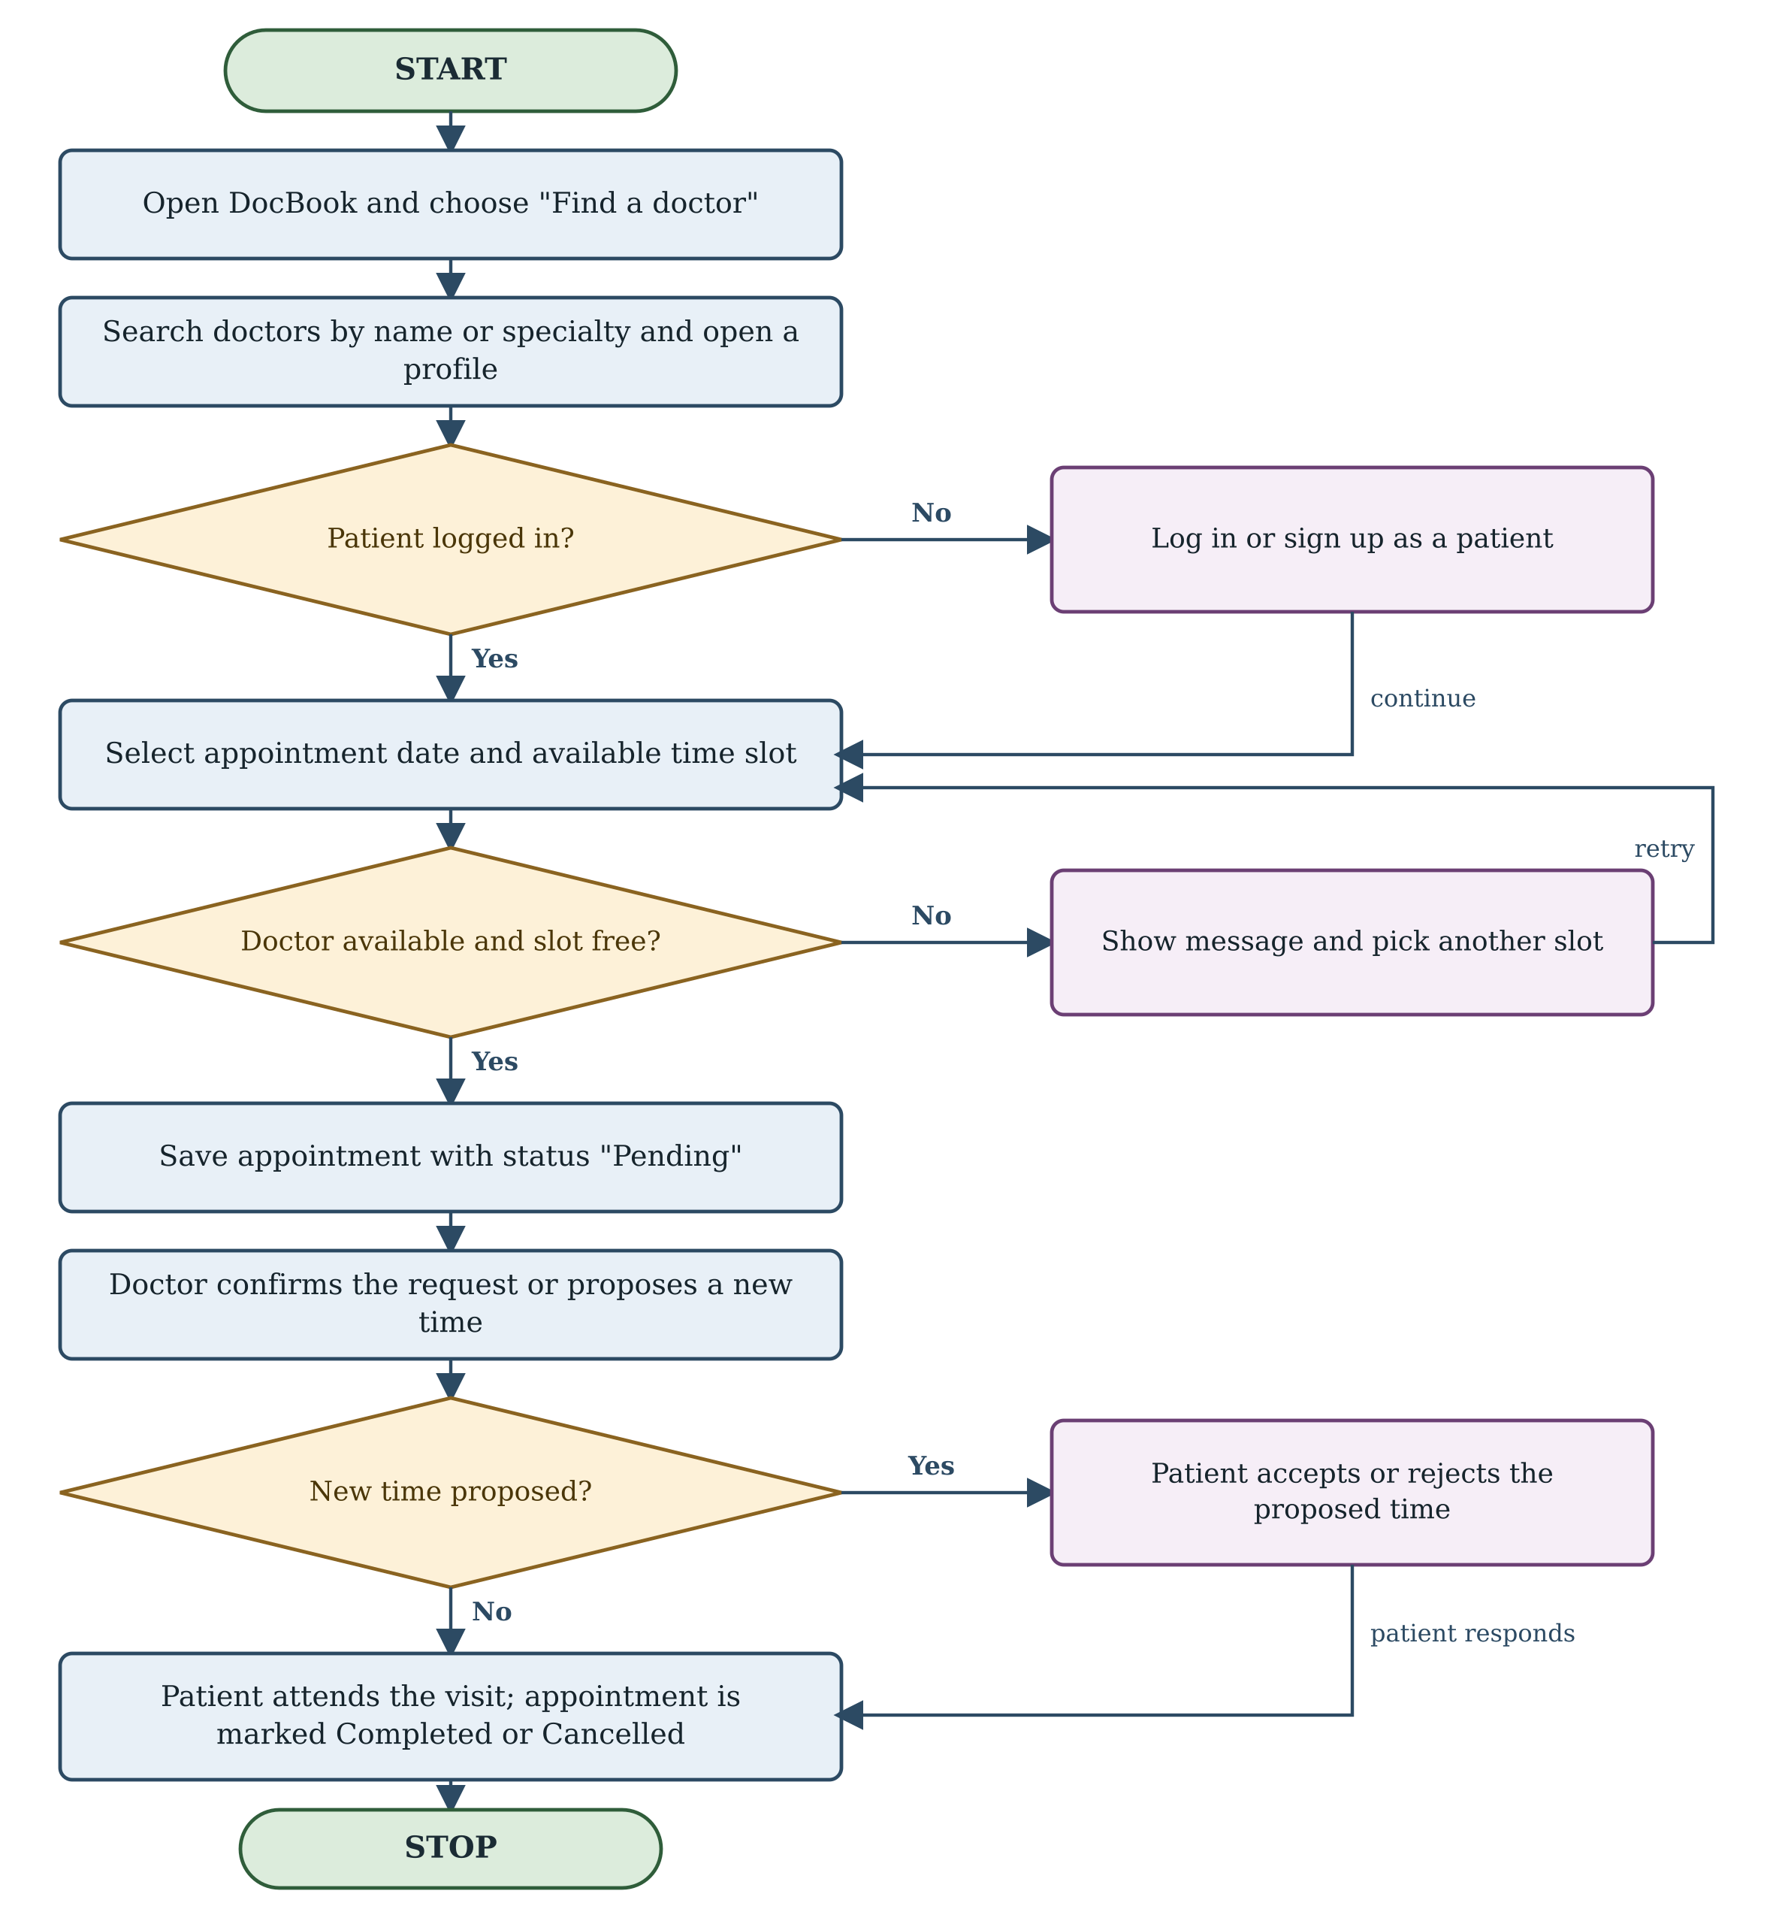
Fig. 3.1 Flowchart of the appointment booking process

3.2 Data Flow Diagram
Figure 3.2 shows the context-level (level 0) data flow diagram. The process “DocBook” receives registration, search, booking and cancellation requests from the patient, schedule and appointment decisions from the doctor, and administrative commands from the administrator. It returns the doctor list with free slots and the status of appointments to the patient, the incoming requests and schedule details to the doctor, and statistics and reports to the administrator. All three flows meet at a single data store, D1, which represents the MongoDB collections for users, doctors and appointments.
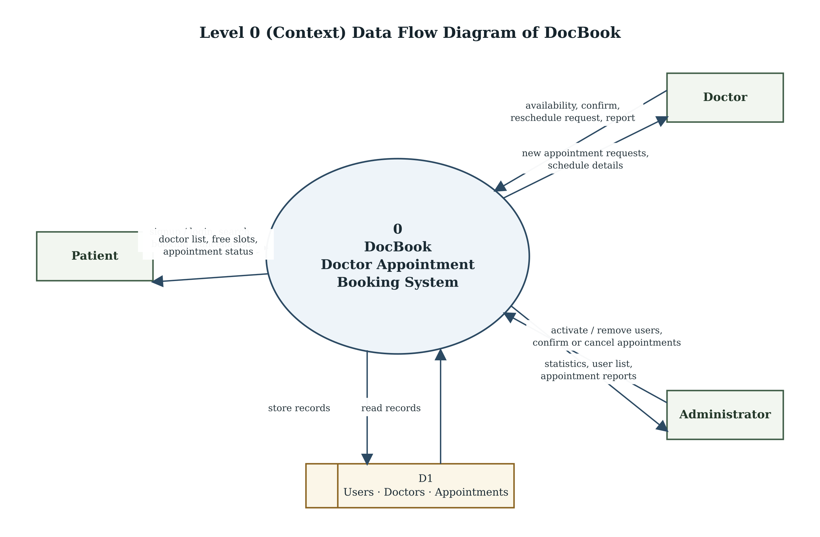
Fig. 3.2 Level 0 (context) data flow diagram of DocBook

3.3 Database Design
The data model is deliberately small. A single users collection stores every account — patient, doctor and administrator — distinguished by the role field, so one authentication path serves all three. A doctor who registers also receives a document in the doctors collection, linked to the user by a one-to-one reference, holding the public profile, the weekly availability, the booking status and the leave periods. Every booking is a document in the appointments collection holding references to the doctor and the patient, denormalised copies of their names so that a list can be rendered without a join, and embedded sub-documents for the pending reschedule request and the history of actions.
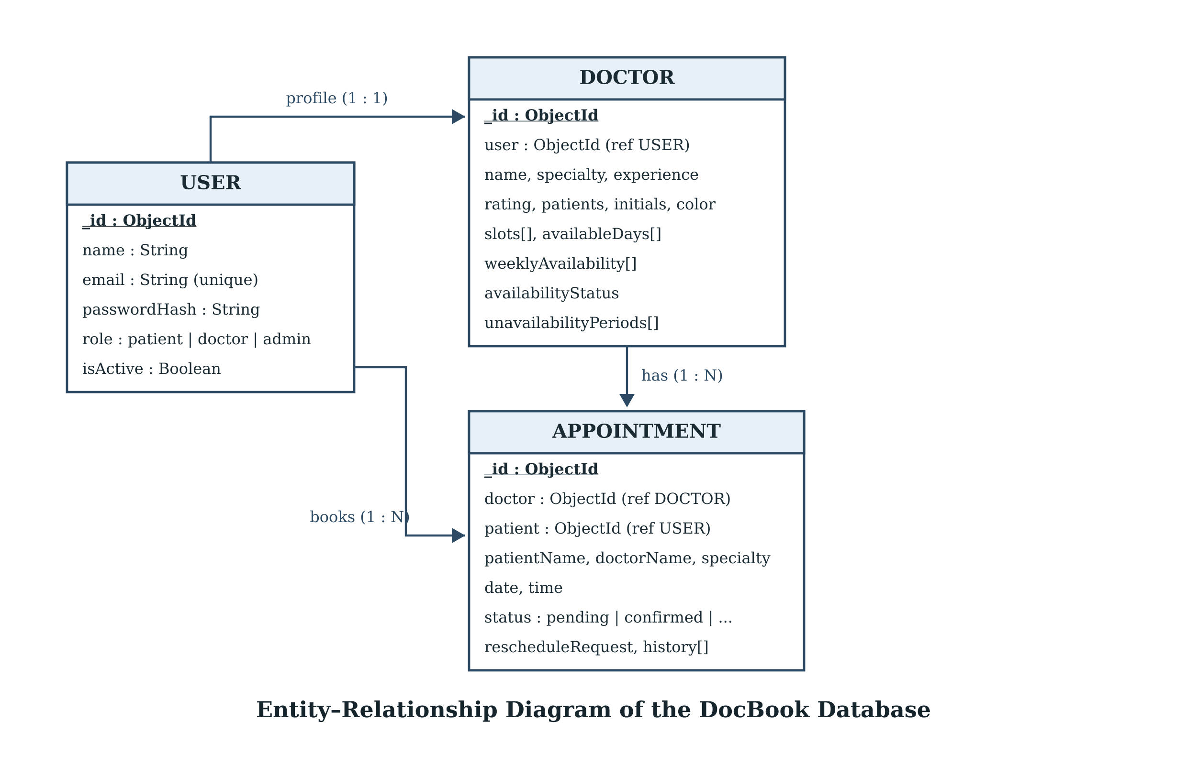
Fig. 3.3 Entity–relationship diagram of the DocBook database
The embedded history array makes the appointment auditable: each entry records the action, the user who acted, the reason, the date and time, and a timestamp, so a cancellation or a rescheduled visit can always be explained.

CHAPTER 4: SOFTWARE, HARDWARE AND PLATFORM USED

4.1 System Architecture
DocBook follows a three-tier architecture. The presentation tier is a React 19 single-page application built with Vite. The application tier is an Express 5 REST API on Node.js, which holds every business rule: validation, conflict detection, authorisation and report aggregation. The data tier is MongoDB, read through Mongoose 8, which supplies schema definition, validation and reference population.
The separation matters for correctness: because every rule lives on the server, the client can be replaced or even bypassed without compromising the data. Vite forwards /api requests to the API on port 5000 during development, and in production the static host rewrites the same prefix to the deployed API, so the browser always speaks to a single origin.

4.2 Software Requirements
Table 4.1 Software used in the development of DocBook
Layer / Category | Software or Library | Version | Purpose in the project
Front-end library | React | 19.x | Component-based user interface
Build tool | Vite with the React plugin | 8.x | Development server, bundling, API proxy
Language | JavaScript (ES2022), JSX, HTML5, CSS3 | — | Application and presentation logic
HTTP client | Fetch API | — | Calls to the REST endpoints
Runtime | Node.js | 22 LTS | Server-side JavaScript execution
Web framework | Express | 5.x | Routing, middleware, JSON parsing
Database | MongoDB (Atlas or local) | 8.x | Store for users, doctors and appointments
ODM | Mongoose | 8.x | Schemas, validation, population, queries
Authentication | jsonwebtoken | 9.x | Signed 7-day session tokens
Password hashing | bcryptjs | 3.x | Salted password hashes (cost 10)
Configuration | dotenv | 16.x | Secrets kept outside the source code
Cross-origin access | cors | 2.x | Controlled API access
Version control | Git and GitHub | — | Source history and collaboration
Development tools | VS Code, Postman, Chrome DevTools, draw.io | — | Coding, API testing, debugging, diagrams

4.3 Hardware Requirements
Table 4.2 states the machine on which DocBook was actually developed, tested and demonstrated, together with the minimum configuration on which the application is expected to run correctly. The figures in the second column were read from the development machine through the Windows System Information panel.
Table 4.2 Hardware used in the development of DocBook and minimum requirement
Component | Configuration used for development and testing | Minimum requirement
Processor | Intel Core i5-10210U, 1.60 GHz base / 2.10 GHz turbo, 4 cores, 8 threads | Intel Core i3, 2.0 GHz or equivalent AMD processor
RAM | 8 GB DDR4 (2666 MHz) | 4 GB
Storage | 512 GB NVMe solid state drive, about 190 GB free during the project | 20 GB free hard disk space
Display | 15.6 inch, 1920 × 1080 pixels | 1366 × 768 pixels
Operating system | Windows 11 Home, 64-bit | Windows 10 / Ubuntu 20.04 or later, 64-bit
Network | Broadband connection, 10 Mbps or above | 2 Mbps broadband connection
Client device | Any laptop, desktop or smartphone with a current browser (Chrome, Edge, Firefox, Safari) | Laptop or desktop with Chrome or Edge
Server | Local Node.js runtime with a local MongoDB instance; equivalent to a MongoDB Atlas M0 free cluster in production | Cloud instance (or MongoDB Atlas M0 free tier) with the Node.js runtime

Four cores suffice because the API, MongoDB, the Vite development server and the browser all run on the same machine, and eight gigabytes of memory keep them resident without swapping. The solid state drive affects only build and start-up times: the application itself, including its dependency folders, occupies under two hundred megabytes.

4.4 Platform and Deployment
The repository is divided into a backend folder containing the Express API and a frontend folder containing the React application. The API reads its configuration from environment variables — PORT, MONGODB_URI, JWT_SECRET and the optional ADMIN_EMAIL and ADMIN_PASSWORD pair used to provision the administrator account. On start-up the server connects to MongoDB, ensures the administrator exists and inserts a small set of starter doctors if the directory is empty, which makes a fresh installation usable immediately. A health endpoint at /api/health reports the state of the database connection.
The front end is built with npm run build into static assets. The included configuration file rewrites /api/:path* to the deployed API and every other path to index.html, so the client-side route for the administrator panel, /admin, works on a static host without a server-side route table. The whole application therefore runs on free or low-cost tiers: a managed MongoDB cluster, a Node host for the API and a static host for the interface.

4.5 Module Description
Table 4.3 Modules of the application
Module | Responsibility
Authentication and session | Sign-up, login, token issue and verification, active-account check on every request
Doctor directory | Search by name or specialty, profile card, public availability summary
Booking engine | Calendar from the weekly schedule, slot filtering, conflict detection, appointment creation
Availability management | Weekly schedule editor, booking pause with reason, dated leave periods with overlap check
Reschedule workflow | Proposal with reason, patient acceptance or rejection, restoration of the previous status
Cancellation | Patient cancellation with a reason and optional details, doctor and admin cancellation
Reporting | Date-range aggregation, monthly counts, CSV export and print or save-as-PDF view
Administration | Statistics, account activation and deletion, appointment control, administrator reports
Account settings | Display-name update and password change after verifying the current password

4.6 Security Measures
- Passwords are never stored in plain text; bcryptjs produces a salted hash with a cost factor of ten, and the hash field is excluded from ordinary queries.
- Authentication uses a signed JSON Web Token that expires after seven days and is sent in the Authorization header; the server verifies the signature before reading any claim.
- Authorisation is enforced by two middleware functions, one that authenticates the token and one that restricts a route to a role, so an endpoint cannot be reached by the wrong actor even if the interface is manipulated.
- Every authenticated request re-reads the account and refuses a deactivated user, which makes account suspension effective immediately rather than at the next login.
- All input is validated on the server: date format and range, weekday, slot membership, string lengths, enumerated reasons and identifier validity.
- Secrets are kept in environment variables, and the repository contains only an example file; the connection string and the token secret never enter version control.

CHAPTER 5: SCREEN SHOTS WITH SHORT USER MANUAL

5.1 How the Manual is Arranged
The screens in this chapter follow the order in which a new user meets them: the public directory, registration, the booking panel, the confirmation, and then the three role-based dashboards. Each screen is followed by its purpose and by the short sequence of steps needed to use it. The frames in this copy are placeholders; each should be replaced with a screen capture of the running application before the report is printed.
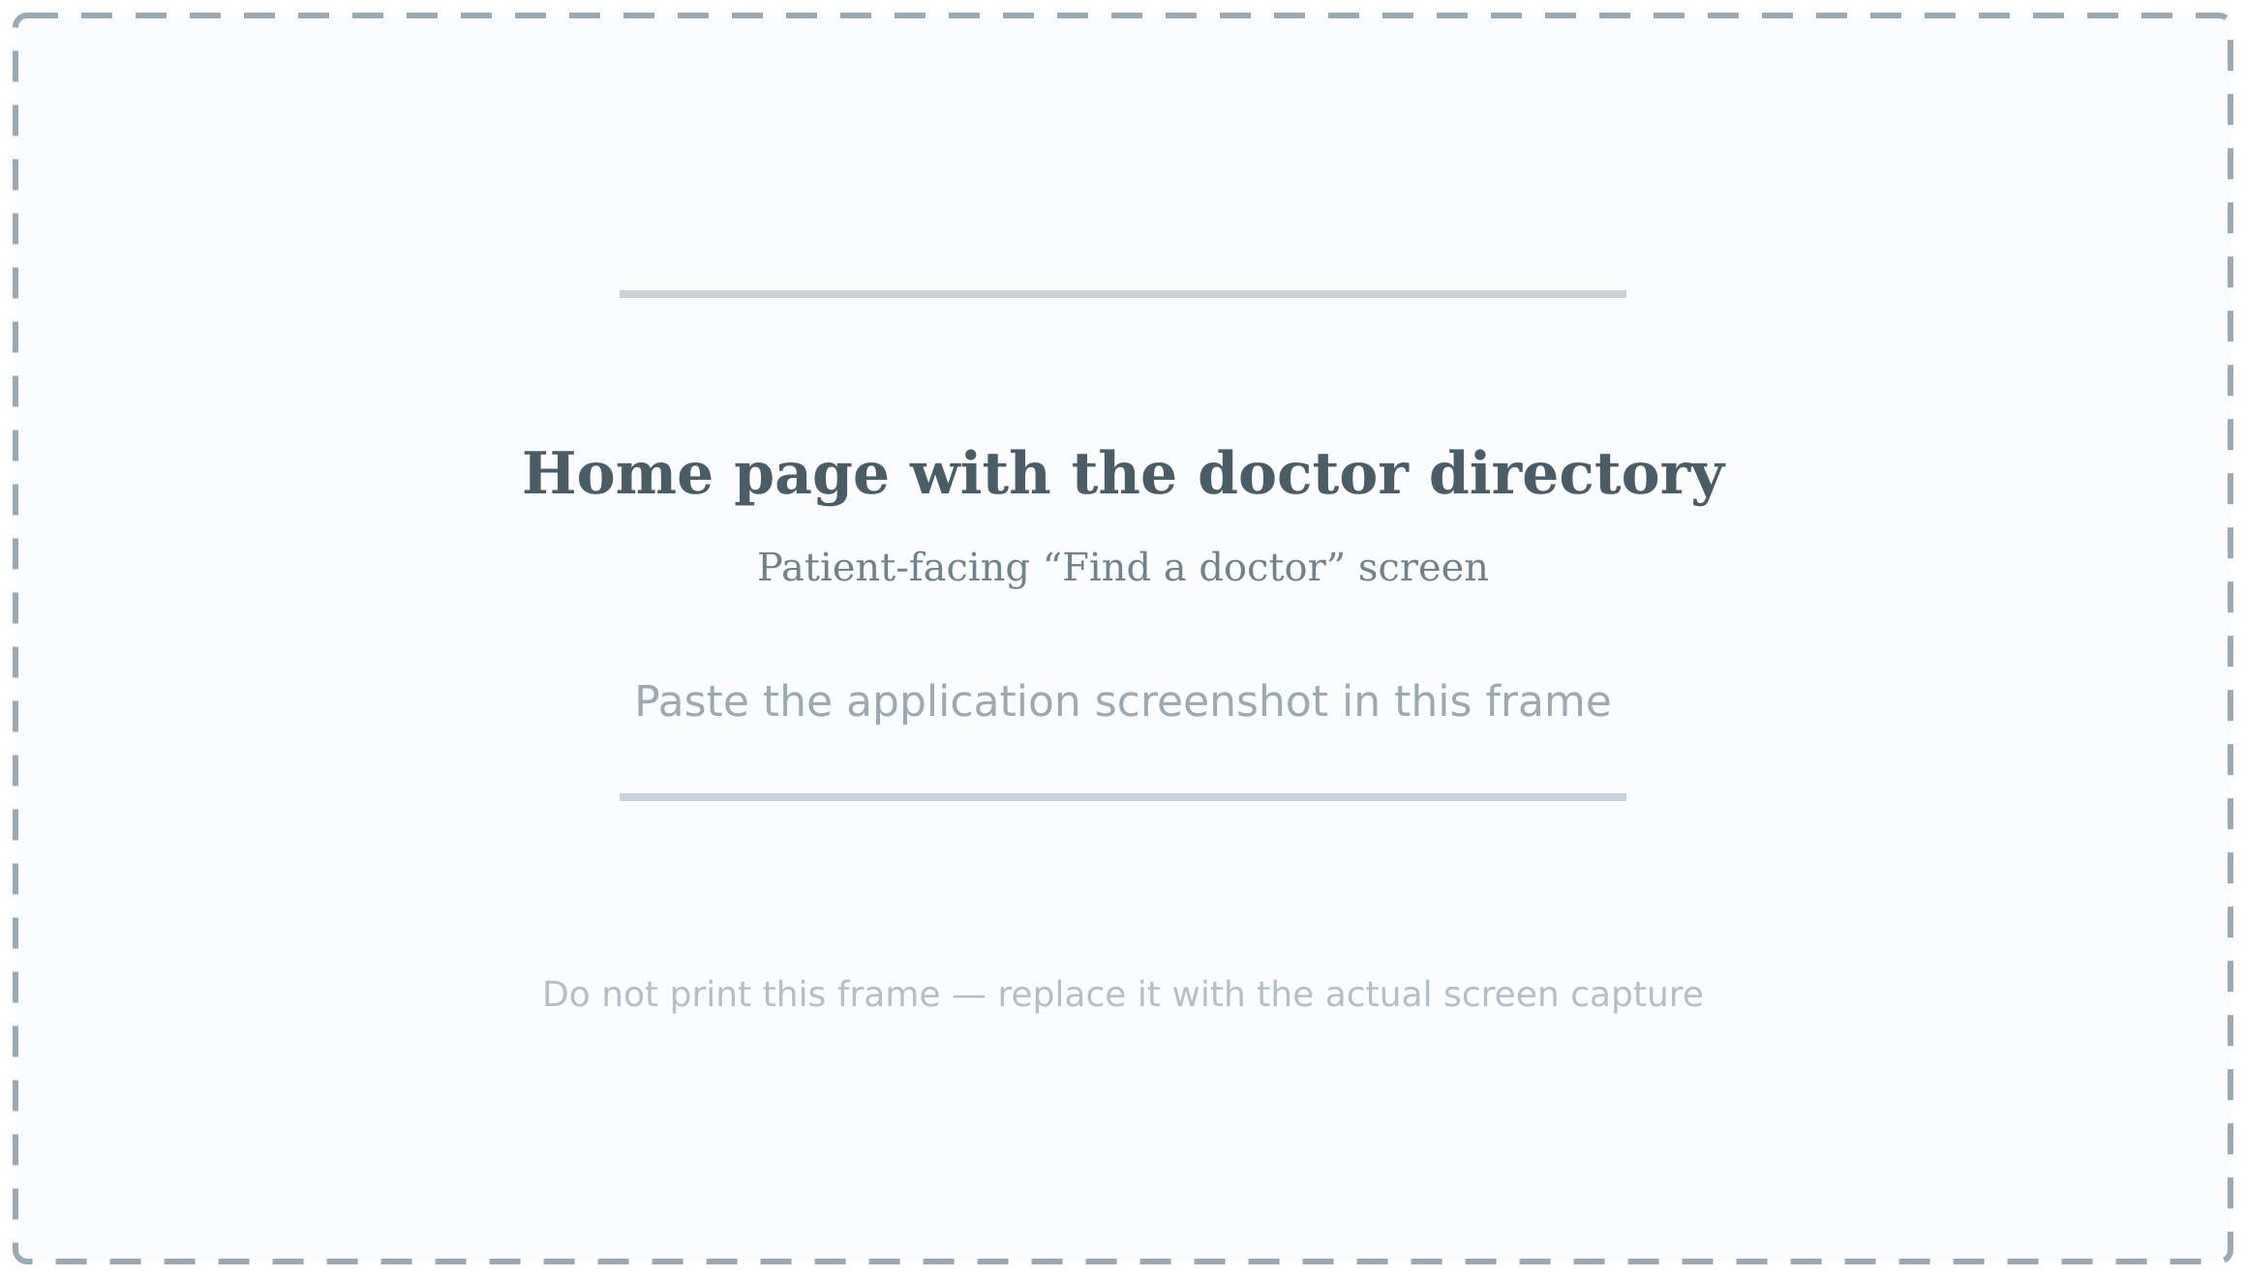
Fig. 5.1 Home page with the doctor directory

5.2 Home Page and Doctor Directory
The landing page greets the visitor, offers a search box for a doctor or a specialty and lists every doctor as a card showing the specialty, rating, experience and the next available day. Three specialty shortcuts below the search box filter the list in one click. The directory is public, so a patient can compare doctors before creating an account.
- Open the application address in any modern browser.
- Type a doctor name or specialty in the search box, or use a shortcut such as “General physician”.
- Read the card details and press “Choose doctor” to move to the booking panel.
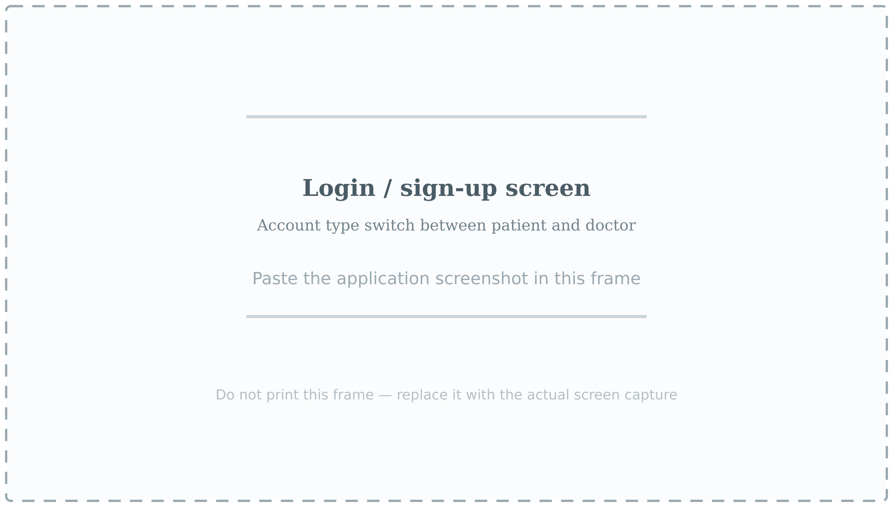
Fig. 5.2 Login and sign-up screen

5.3 Registration and Login
A single screen handles both registration and login, with a switch for the account type. A doctor account asks for the specialty, years of experience and the available appointment times, which become the initial weekly schedule; a patient account needs only a name, an e-mail address and a password of at least eight characters.
- Press “Log in / Sign up” in the top bar.
- Choose Patient or Doctor, then Log in or Sign up.
- On registration, fill in the fields and press “Create account”; on return visits, enter the e-mail address and password and press “Log in”.
- The session is kept in the browser until “Log out” is pressed or the token expires after seven days.
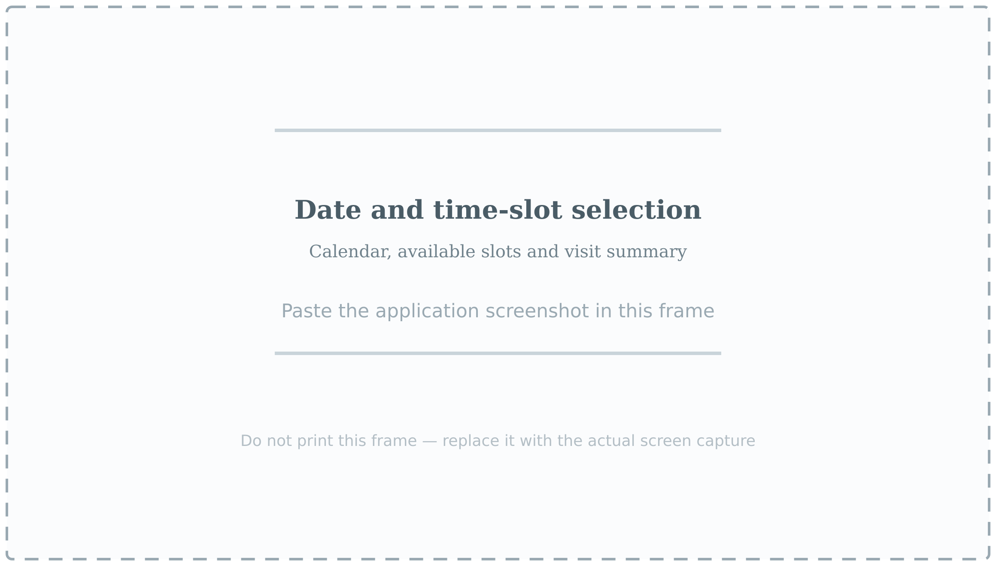
Fig. 5.3 Date and time-slot selection

5.4 Choosing a Slot and Confirming the Appointment
The calendar is generated from the selected doctor’s weekly schedule. Dates in the past, dates on which the doctor does not sit and dates inside a declared leave period are disabled automatically, so only a true opening can be selected. The time list below the calendar shows the slots published for that weekday, and the summary card on the right repeats the doctor, the date and the time before confirmation.
- Move between months with the arrows above the calendar.
- Select a date that is not greyed out; the available times are listed on the right.
- Select a time, check the “Your visit” summary card and press “Confirm appointment”.
- The server re-checks the date, weekday, slot and existing bookings before saving, so an error message — a past date, an unavailable day, a slot already taken or a doctor on leave — means that another slot must be chosen.
- After the success message (Fig. 5.4), open “My appointments” to see the entry with the status Pending, and wait for the doctor to confirm it.
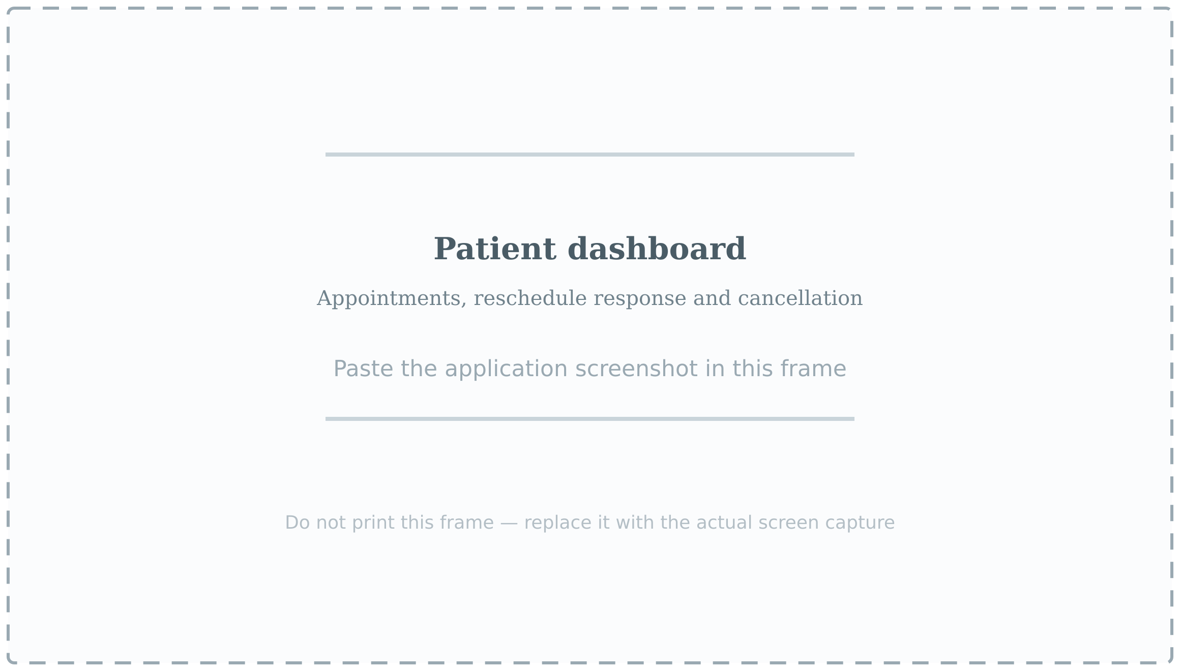
Fig. 5.5 Patient dashboard

5.5 Patient Dashboard, Rescheduling and Cancellation
The dashboard lists every appointment of the patient with its current status. When a doctor proposes a new time, a highlighted panel shows the proposed date, time and reason with two buttons; the original appointment remains valid unless the new time is accepted. Cancellation opens a small form that requires a reason and accepts optional details, and the reason is retained in the appointment history.
- Press “My appointments” in the top bar.
- For a proposed time, press “Accept new time” or “Reject proposal”.
- To cancel, press “Cancel appointment”, choose a reason, add details if required and press “Confirm cancellation”.
- Use the account panel to change the display name or the password.
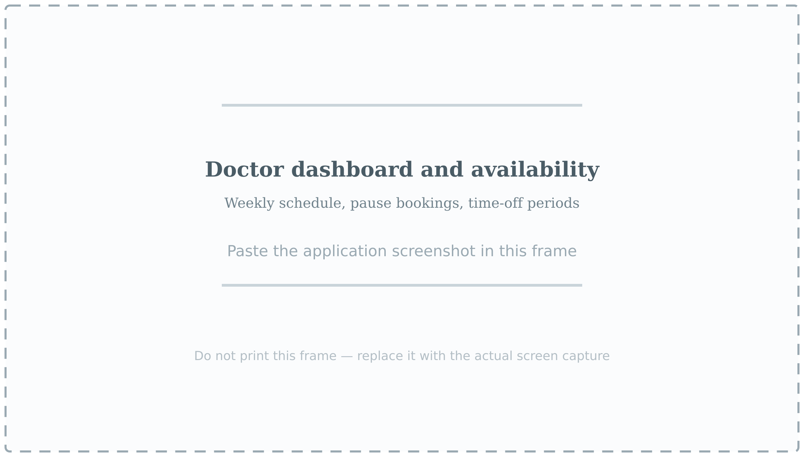
Fig. 5.6 Doctor dashboard and availability controls

5.6 Doctor Dashboard and Availability Controls
The doctor sees the public profile card, an account panel and three availability controls. The weekly schedule sets the days and times that patients may book. The booking status switch pauses all new bookings and demands a reason from a fixed list. The time-off form adds a dated leave period with a reason and an optional explanation, refusing any range that overlaps one already recorded.
- Log in with a doctor account; the dashboard opens automatically.
- Edit the times of each working day and press “Save availability”.
- To stop bookings temporarily, set the status to Unavailable, choose a reason and press “Update booking status”.
- To plan leave, fill in the start date, end date, reason and explanation and press “Add unavailable dates”.
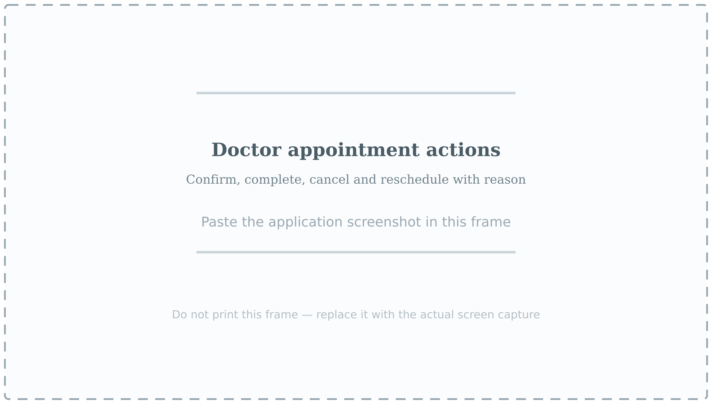
Fig. 5.7 Doctor appointment actions

5.7 Confirming, Completing and Rescheduling an Appointment
Upcoming appointments are listed with their status and the actions permitted at that stage. A pending request can be confirmed or cancelled; a confirmed appointment can be marked completed once its date has arrived. Rescheduling asks for the new date, the new time and a reason, and sends the proposal to the patient rather than moving the appointment silently.
- Open “Upcoming appointments” in the doctor dashboard.
- Press “Confirm” to accept a pending request.
- Press “Reschedule”, choose a new date and time from the doctor’s own schedule, enter a reason and submit.
- After the visit, press “Complete” to close the appointment and move it to history.

Fig. 5.8 Report generation panel

5.8 Generating and Exporting Reports
The report panel is available to doctors for their own appointments and to administrators for the whole platform. A period can be chosen from prepared ranges — today, this week, this month, last month, this year — or supplied as a custom start and end date. The result shows summary counts by status, an appointment table and monthly statistics, and can be downloaded as CSV or printed as a PDF from the browser print dialogue.
- Open the report panel in the doctor or administrator dashboard.
- Choose a period, or select “Custom Date Range” and enter the two dates.
- Press “Generate Report”.
- Press “Download CSV” for a spreadsheet, or “Print / Save PDF” and choose the PDF printer.
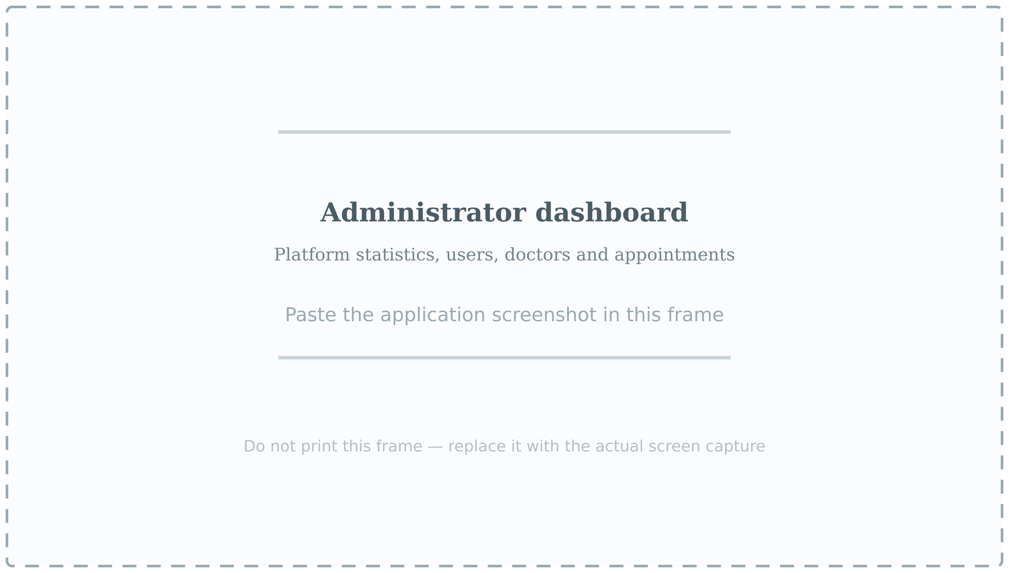
Fig. 5.9 Administrator dashboard

5.9 Administrator Dashboard
The administrator signs in at the private address /admin and reaches a control centre with six sections. Overview shows counts of patients, doctors, appointments and pending requests. Users allows an account to be deactivated or deleted, deletion also removing the related appointments. Doctors lists the directory, Appointments allows a request to be confirmed or cancelled, Generate Report produces the platform-wide report, and My profile manages the account.
- Open /admin and sign in with the administrator account configured on the server.
- Use the sidebar to move between Overview, Users, Doctors, Appointments, Generate Report and My profile.
- Press “Refresh” after any change to reload the statistics.
- Deactivate rather than delete an account when its record must be preserved.

CHAPTER 6: FUTURE SCOPE
DocBook in its present form completes the appointment life-cycle and is ready for use in a single clinic. The following extensions are natural next steps, arranged roughly in the order in which they would add value.

6.1 Online Payment and Fee Collection
A payment gateway such as Razorpay or Stripe would allow the consultation fee to be collected at the time of booking, which also reduces no-shows. A payment identifier, an amount and a payment status could be added to the appointment document without disturbing the existing workflow.

6.2 Reminders and Notifications
A scheduled job could send an e-mail or an SMS a day and an hour before an appointment, and notify the patient whenever a doctor confirms, reschedules or cancels. Since the server already knows every appointment time, the addition is a queue and a template rather than a change of design.

6.3 Teleconsultation and Prescriptions
A video room attached to the appointment would let a doctor consult without travel, and a structured prescription form would turn the appointment record into a clinical one. Neither is attempted here, where the scope is deliberately limited to scheduling.

6.4 Ratings, Reviews and Verification
Patients could rate a completed appointment, the aggregate replacing the seeded rating on the doctor card. A verification workflow, in which the administrator checks a registration number before a profile becomes visible, would strengthen trust in the directory.

6.5 Mobile Application and Offline Support
The interface is already responsive, but a progressive web application would add push notifications, a cached doctor directory and booking over a poor network at little extra cost, since the existing React code can be reused.

6.6 Analytics and Artificial Intelligence
The report module already aggregates appointments by month and status. With more data the same tables could forecast demand by specialty and season and identify patients unlikely to attend, so that reminders could be targeted.

6.7 Multi-Clinic Support and Accessibility
A clinic identifier would let one deployment serve several branches, while translation into Hindi and Bengali with full keyboard navigation would open the application to a much wider group of patients. An append-only audit log, kept outside the appointment document, would record who changed what and when.

CHAPTER 7: REFERENCES
The following books, standards and official documentation were consulted during the design, implementation and documentation of this project.
[1] R. S. Pressman and B. R. Maxim, Software Engineering: A Practitioner’s Approach, 9th ed. New York: McGraw-Hill, 2020.
[2] I. Sommerville, Software Engineering, 10th ed. Boston: Pearson, 2016.
[3] R. Elmasri and S. B. Navathe, Fundamentals of Database Systems, 7th ed. Boston: Pearson, 2016.
[4] A. Silberschatz, H. F. Korth and S. Sudarshan, Database System Concepts, 7th ed. New York: McGraw-Hill, 2019.
[5] React Team, “React – The library for web and native user interfaces,” Meta Open Source. [Online]. Available: https://react.dev
[6] OpenJS Foundation, “Express – Fast, unopinionated, minimalist web framework for Node.js.” [Online]. Available: https://expressjs.com
[7] OpenJS Foundation, “Node.js Documentation,” v22 LTS. [Online]. Available: https://nodejs.org/docs/latest-v22.x/api/
[8] MongoDB Inc., “MongoDB Manual,” MongoDB 8.0. [Online]. Available: https://www.mongodb.com/docs/manual/
[9] Mongoose, “Mongoose ODM Documentation,” v8. [Online]. Available: https://mongoosejs.com/docs/
[10] M. Jones, J. Bradley and N. Sakimura, “JSON Web Token (JWT),” RFC 7519, Internet Engineering Task Force, May 2015.
[11] N. Provos and D. Mazières, “A Future-Adaptable Password Scheme,” in Proceedings of the USENIX Annual Technical Conference, Monterey, 1999, pp. 81–91.
[12] OWASP Foundation, “OWASP Top 10 – 2021: The Ten Most Critical Web Application Security Risks,” 2021. [Online]. Available: https://owasp.org/Top10/

