*.Jenkins is running on java

*.Go to Dashboard

*Go to Manage Jenkins

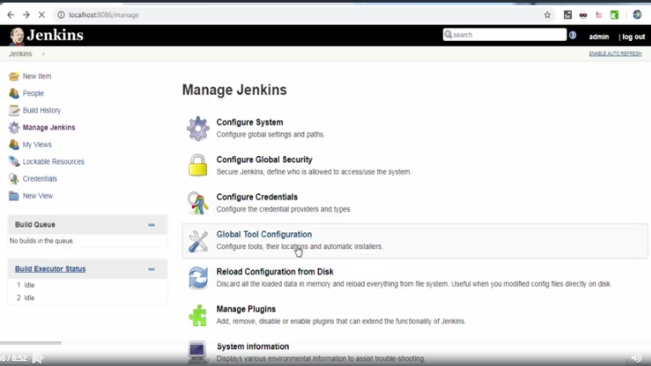

*Give the path of JDK(Set up python)

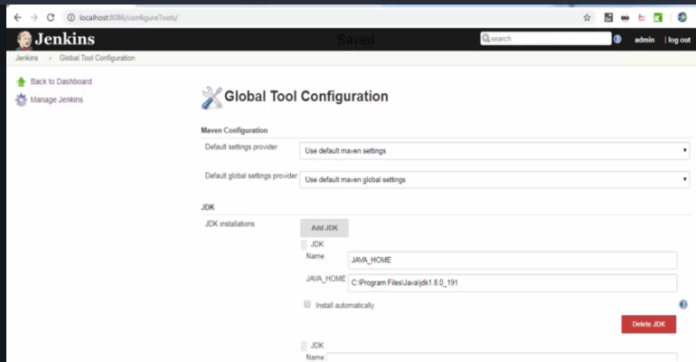

*Get git bash and set it up with Jenkins

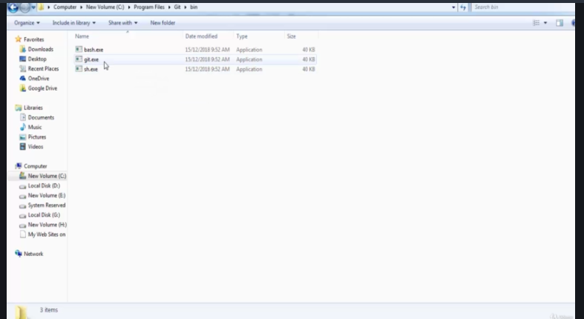

*Go to Global tool configuration

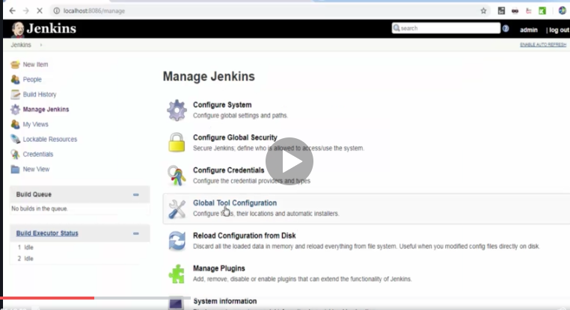

*Set the path of git.exe in Jenkins.

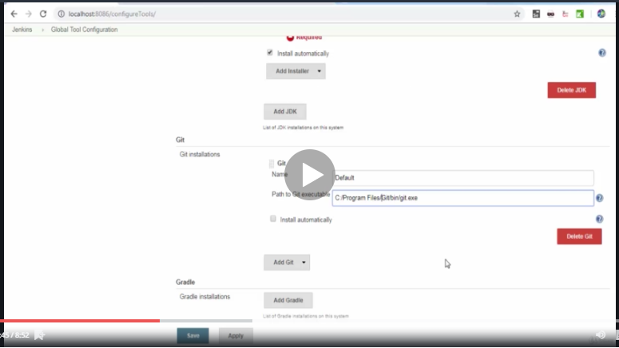

*Set up for python path

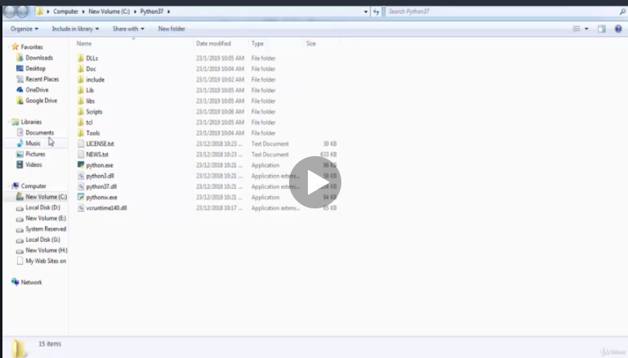

*Give python variables in Jenkins

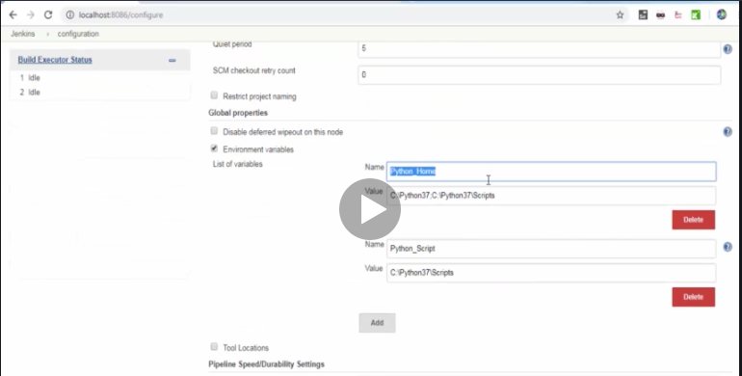

Python_Home and Pyrhon_Script path

*copy external exe files in python folder

*Set up