Part 1

Implemented what is required in a very straight forward fashion. Nothing fancy. Usage as specified i.e.,

./render image.png disparity_map.png

gives you stereogram.

Part 2

Usage is changed a little bit now the command line takes in one more parameter alpha which is a magic number. 200 is what works for most images.
Sample results for nara.png

achyut@achyut-PC:~/git_iu/ddwivedy-achbogga-furzhang-a4$ ./segment part2/nara.png part2/nara-seeds.png 200
beta: 16.9577
r_mean: 127.7
g_mean: 105.774
b_mean: 87.4503
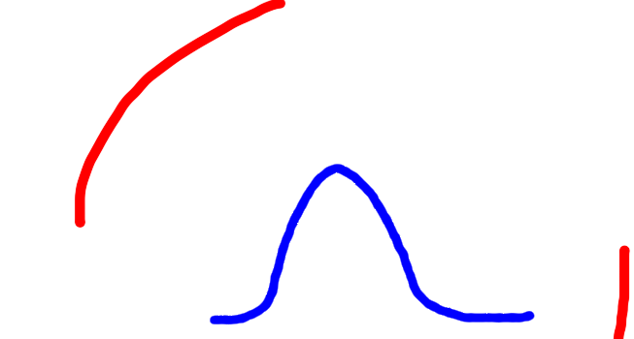
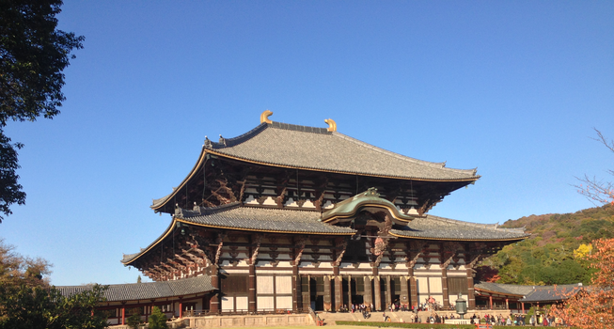
r_variance: 71.8623
g_variance: 65.5493
b_variance: 82.3667
beta in mrf=16.9577
Message Initialized
Message Normalized
Mark Generated
lognormal Generated
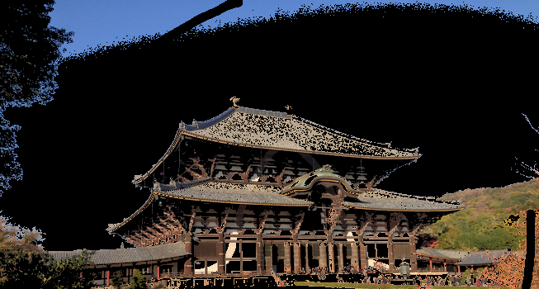
beta: 16.9577
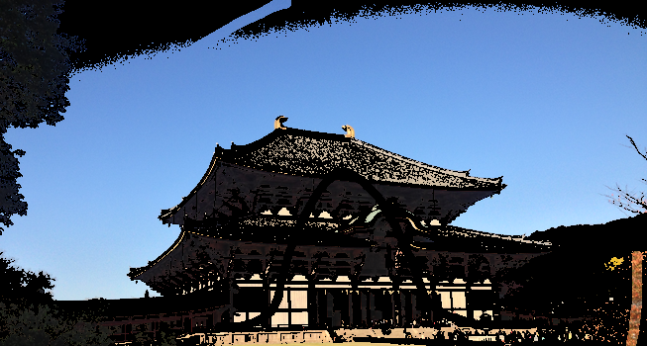
r_mean: 127.7
g_mean: 105.774
b_mean: 87.4503
r_variance: 71.8623
g_variance: 65.5493
b_variance: 82.3667


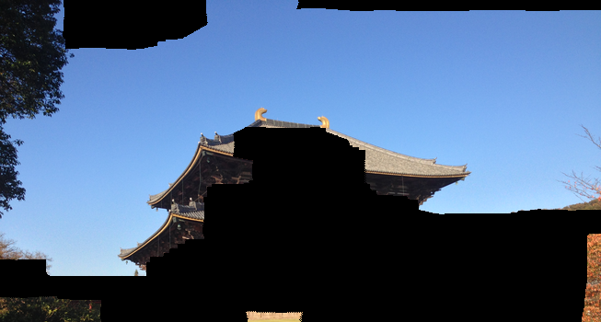
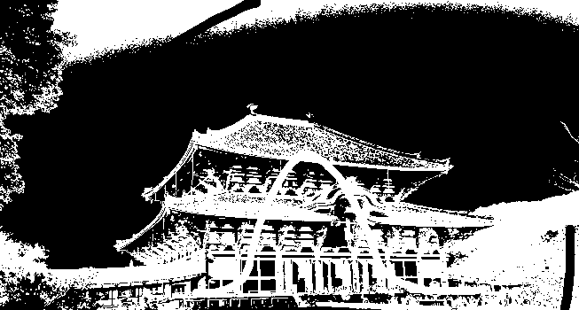
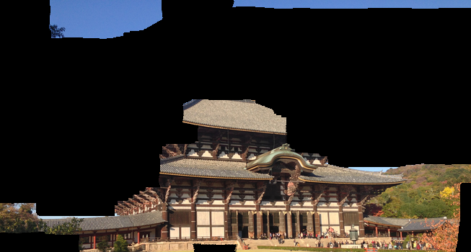

All the other results can be verified from part2 folder.

=> Beta is automated as per the input as it makes more sense. The value is printed if you execute the program.

Instructions for Q3 of part2: first run segment, you will get disparity map in part2 image folder. Use render program on original image and disparity map to generate stereo view.
In segment program, first input is original image, second Is the supervised segment image, third one is magic parameter alpha, 200 is a good number.

Part 3

./stereo part3/Aloe/view1.png part3/Aloe/view5.png part3/Aloe/gt.png 200

The way to run the code has changed. It takes one more parameter called alpha. This is a constant for potts model.
This alpha is very important as it is very sensitive to strike balance between D and V. 200 is a good number to start playing with for unscaled images.

Regarding max_disparity if the ground truth is given the program can estimate max_disp from the gt and take that as the max_disp for the mrf. However any disparity greater than 50 takes many minutes for computation. Please wait for hours if you take values above 200 for MRF.

However not downscaling takes too much time.
These are some of the results of the scanline stereo and MRF

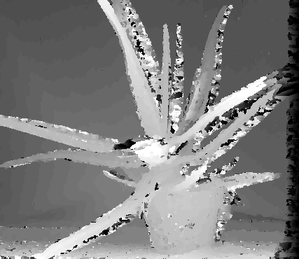
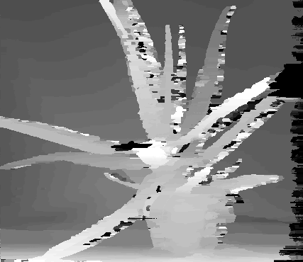
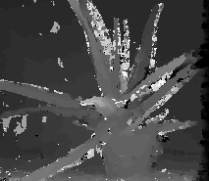
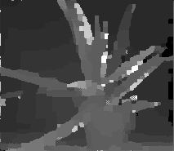
Naive ones : Scanline and MRF ones

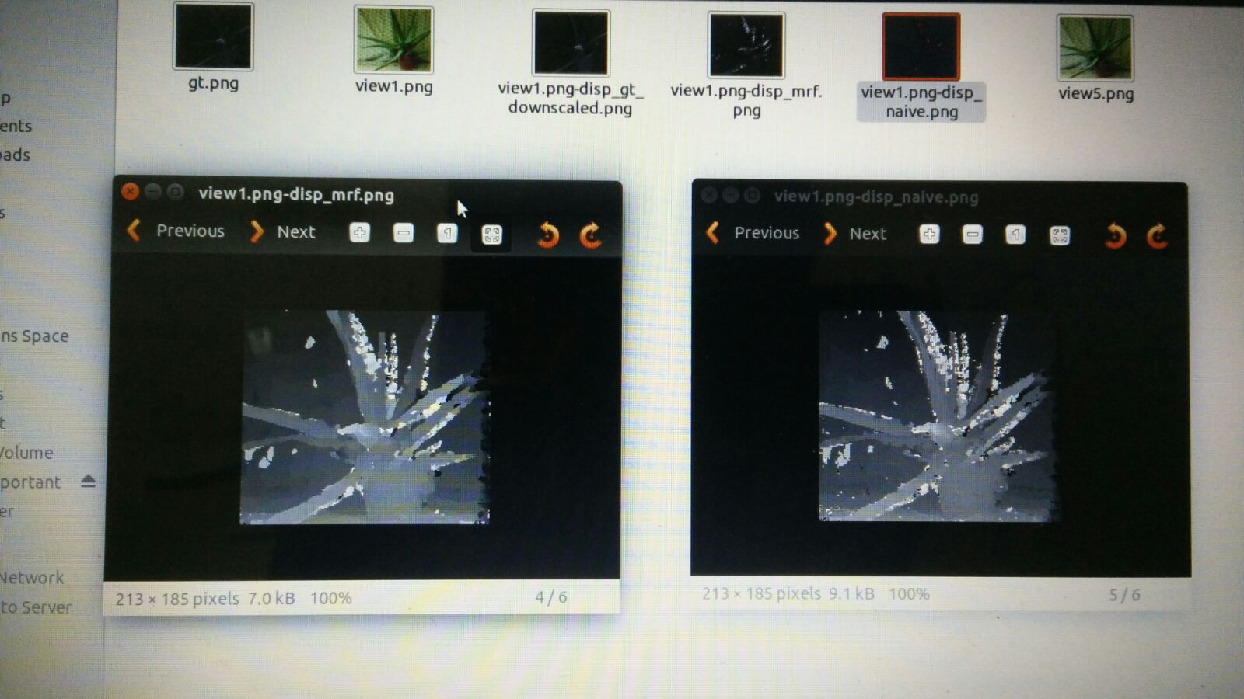
MRF : Naive one

As you can see these are just interim results. Full results are taking hours to compute. So we added the code to produce interim results i.e., stereo energy is loaded into a file as well as displayed on the terminal. Also after each iteration, MRF image is produced which is stored in disp_mrf_last_iter.png

We have also included code to display random messages as images after each iteration to visualize. Here are some of them from left, right, down and up:
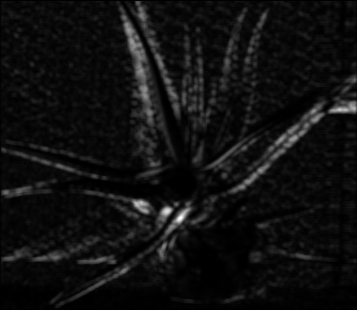
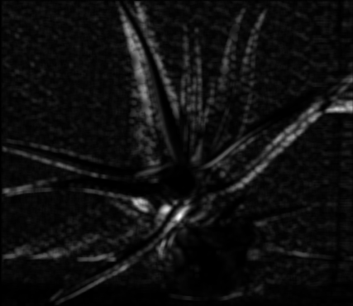
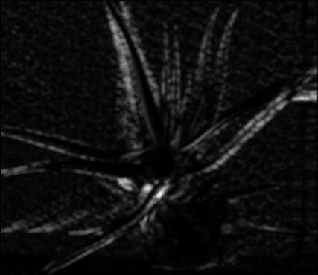
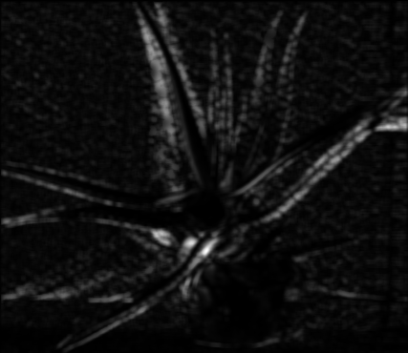

The mathematical error seems to significantly decrease when compared to naïve approach only after a good number of iterations

We have even tried running this as a batch job in bigred 2 as well. But the Bigred2 does not have GLIBC library installed. So given all this effort and time constraints, we could not produce the final results.

However you can visualize the program by downscaling the images by a factor of 4 or so.

Also you have to play with alpha if you do so. Because V is really sensitive to strike balance. We have commented some code in naïve approach to suggest some alpha values analyzing d values.

Quantitatively speaking after 10 iterations the naïve mean error: 3853 where as MRF error: 3562 for unscaled image. Aloe.

As a final note, we are pretty sure that our logic is correct. Please let us know if you have difficulty in understanding the code and we are happy to reply as fast as we can.

Thank you

Achyut, Furu, and Debasis

