**Lesson 3 Demo 1**

**Azure Key Vault**



Steps to be followed:

1. Creating an Azure Key Vault

**Step 1: Creating an Azure Key Vault**

**1.1** Login to the azure portal

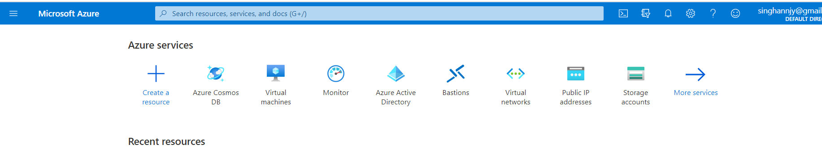

**1.2** Click on **Create a resource** and then search for key vault

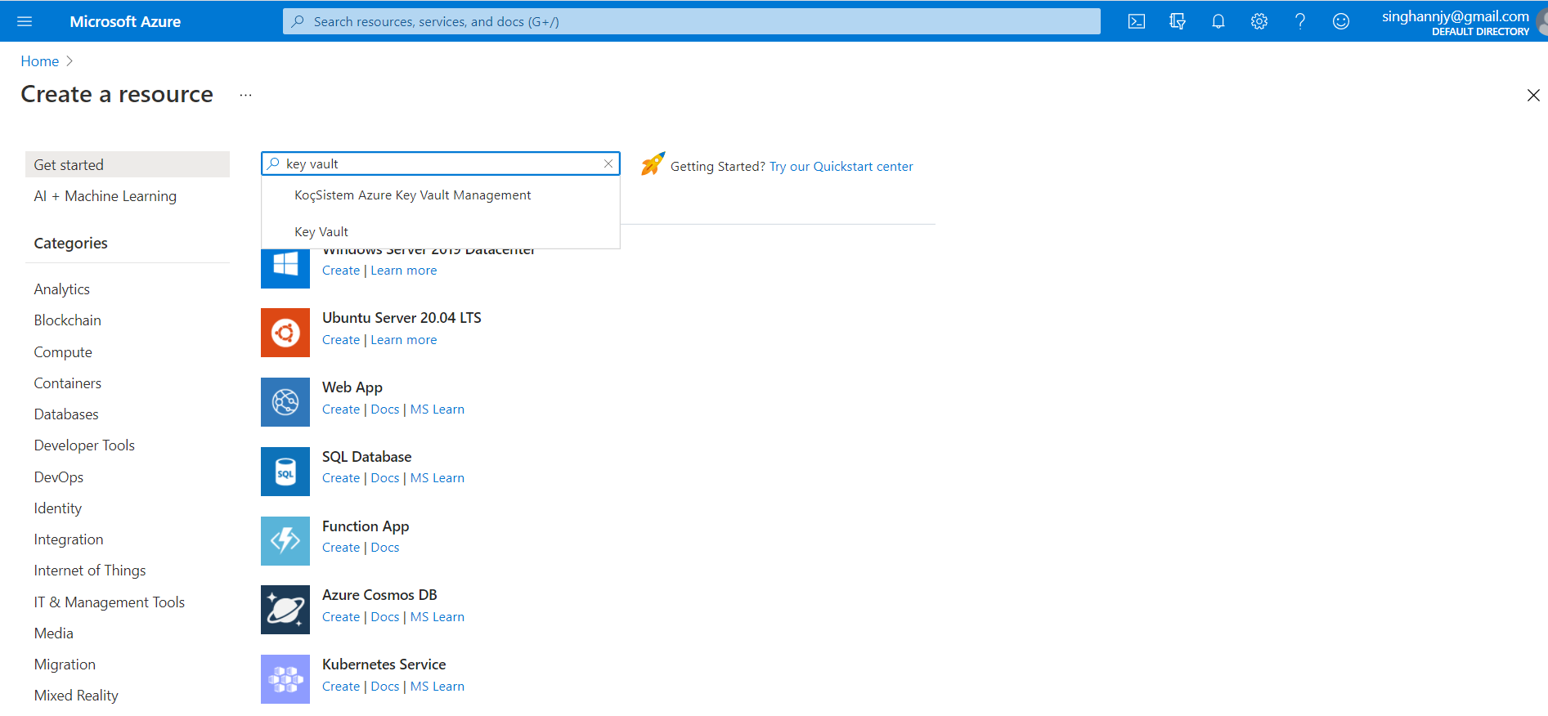

**1.3** On the Key Vault section, choose **Create**

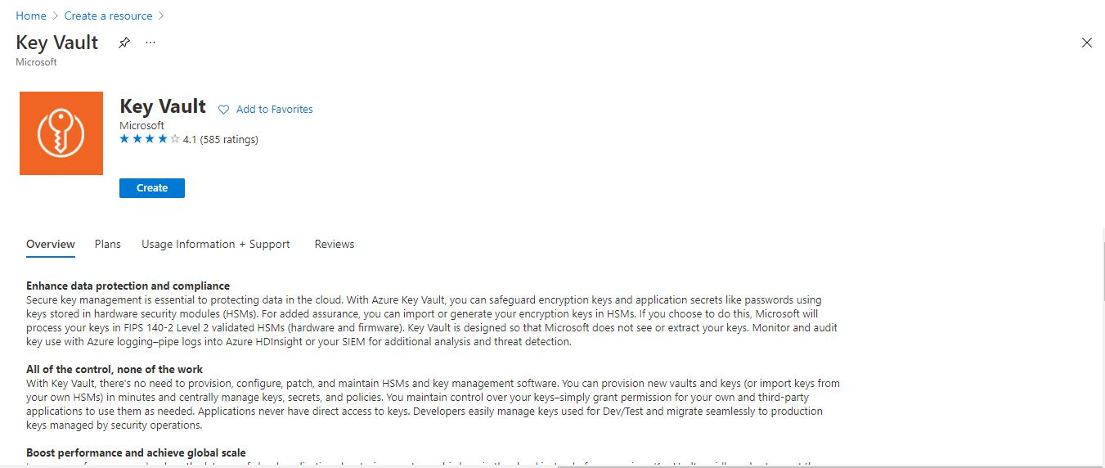

**1.4** In the Azure key vault creation pane, enter the necessary details

**1.5** Select **Review + create** leaving others to default

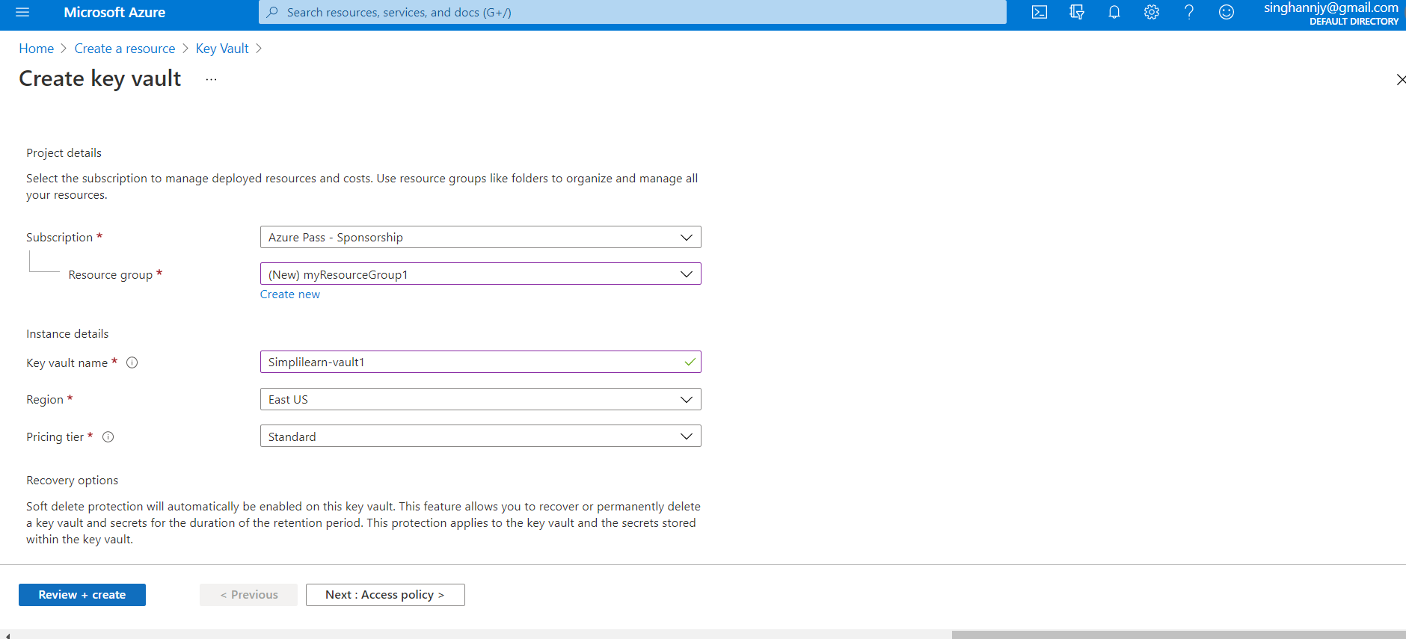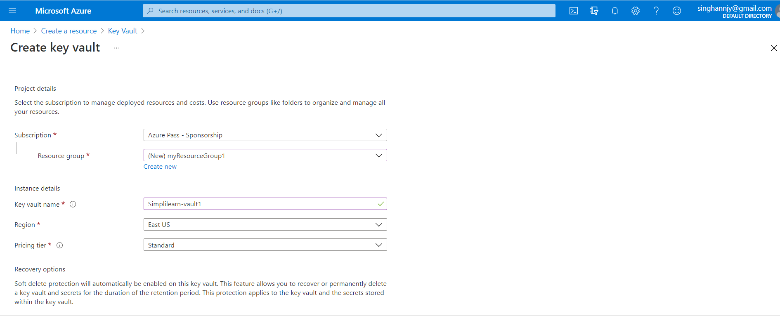

**1.6** Select **Create** after reviewing the account settings

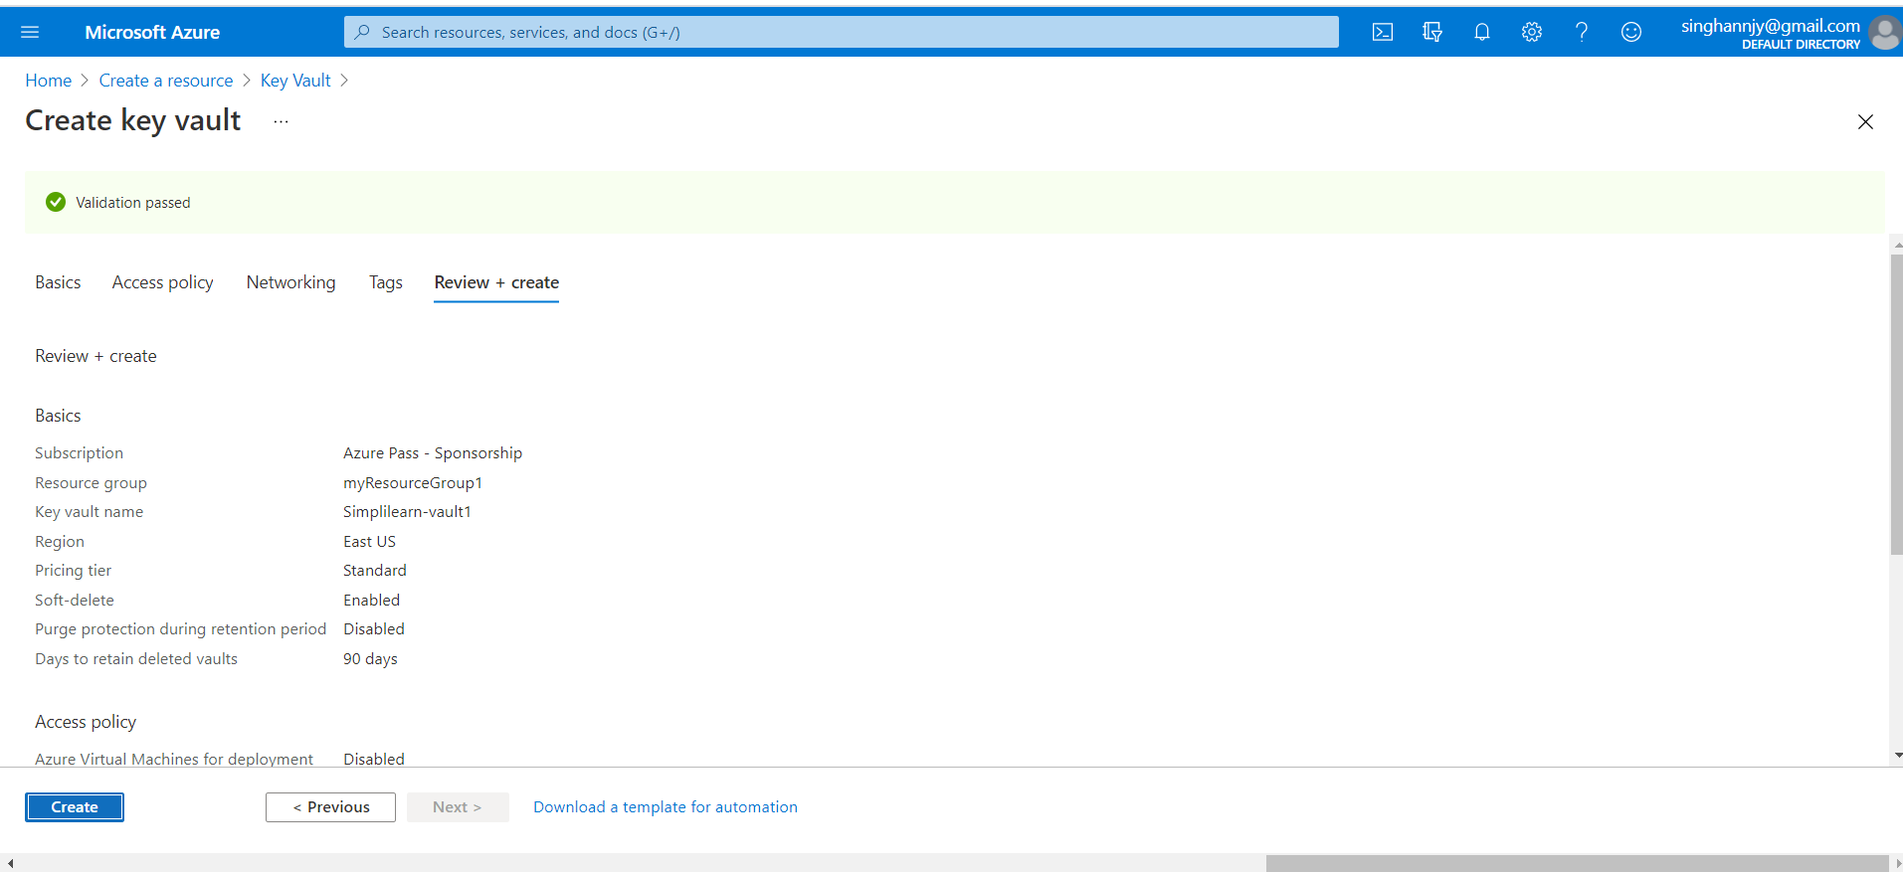

Wait for a few minutes, your Azure key vault will be created

