**Lesson 2 Demo 1**

**Azure Policy Creation**

**Objective**: You have been asked to create an azure policy.

**Tools required**: Azure account with administrator access.

**Prerequisites**: None

**Steps to be followed:**

1. Log into the Azure portal
2. Define a Policy

**Step 1: Log into the Azure portal**

* 1. Log into the Azure portal at <https://portal.azure.com>

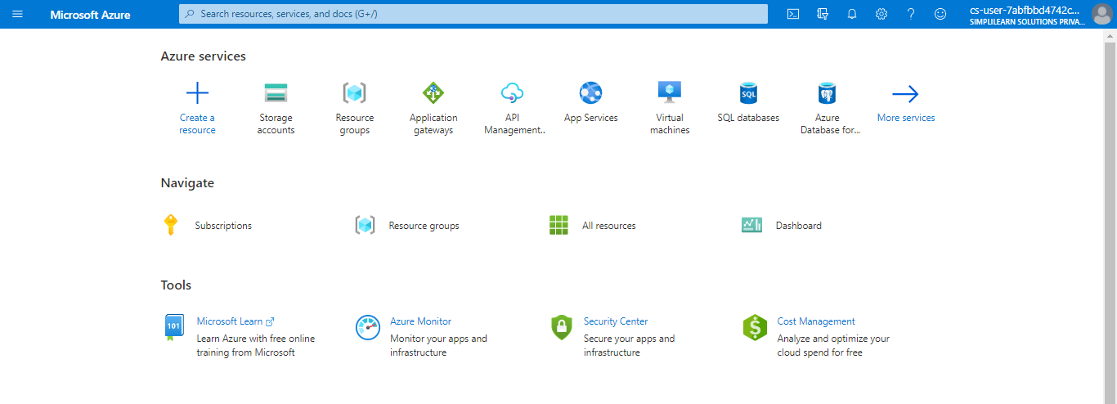

**Step 2: Define a Policy**

2.1 Search for and select **Policy**

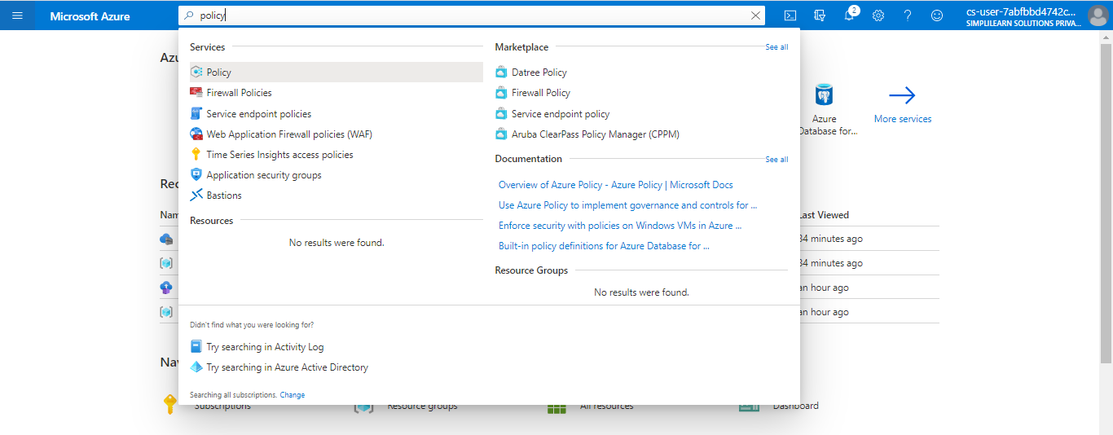

2.2Select **Definitions** under Authoring in the left side of the Azure Policy page

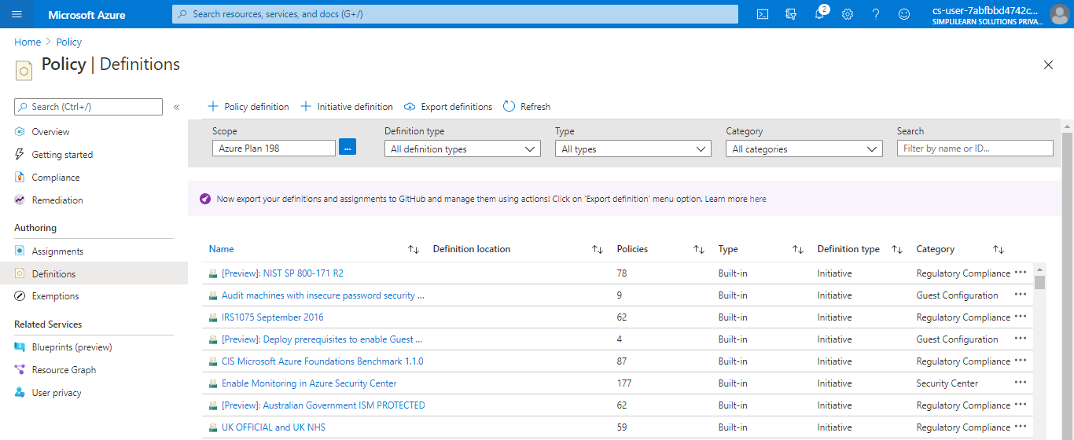

2.3Select **+ Policy** definition at the top of the page. This button opens to the Policy definition page

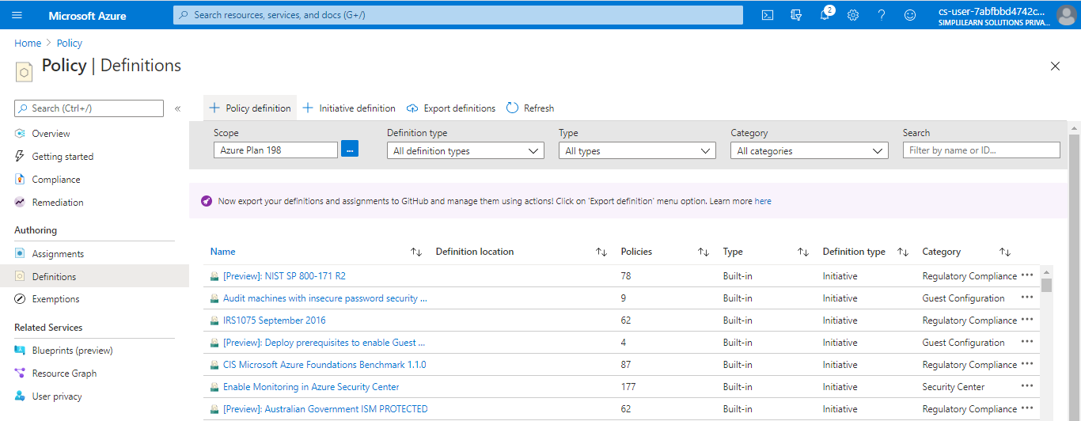

2.4Enter the following information:

a. The management group or subscription in which the policy definition is saved. Select by using the ellipsis on Definition location

b. The name of the policy definition - _*Require VM SKUs smaller than the G series

c. The description of what the policy definition is intended to do: This policy definition enforces that all VMs created in this scope have SKUs smaller than the G series to reduce cost

d. Choose from existing options (such as Compute) or create a new category for this policy definition

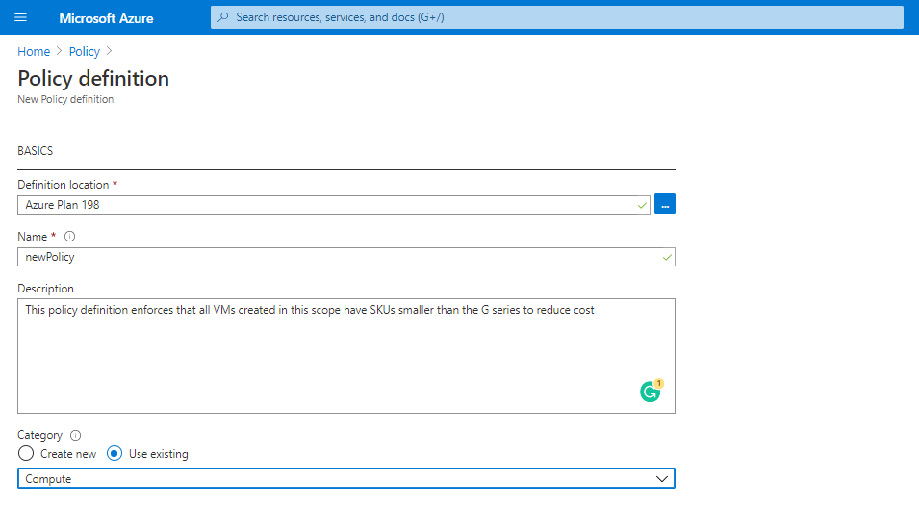

**e.** Copy the following JSON code and then update it for your needs with:

i. The policy parameters

ii. The policy rules/conditions, in this case – VM SKU size equal to G series

iii. The policy effect, in this case: Deny

JSON that you need to copy:

{ "policyRule": { "if": { "allOf": [{ "field": "type", "equals": "Microsoft.Compute/virtualMachines" }, { "field": "Microsoft.Compute/virtualMachines/sku.name", "like": "Standard_G*" } ] }, "then": { "effect": "deny" } } }

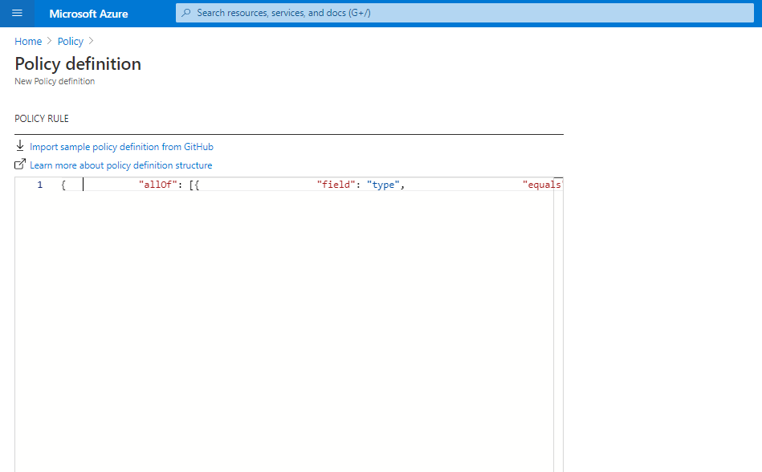

2.5Click on **Save**

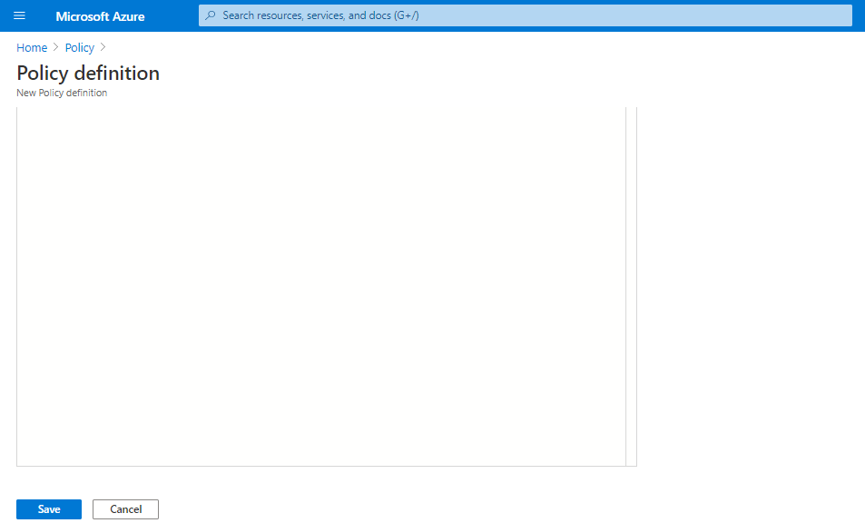

Your new policy will get created

