**Lesson 4 Demo 1**

**Manage Subscriptions and RBAC**

| **Objective:** To implement management group and create custom RBAC roles  **Tools required:** Azure account with administrator credentials  **Prerequisites:** None |
| --- |

**Steps to be followed:**

1. Implementing management groups
2. Creating custom RBAC roles and assigning the RBAC roles

**Step 1: Implementing management groups**

1.1 In the Azure portal, search for and select **Management Groups**

1.2 On the **Management Groups** pane, if you see a message stating: “You are registered as a directory admin but do not have the necessary permissions to access the root management group,” then perform the following steps:

1.2.1 In the Azure portal, search for and select **Azure Active directory**

1.2.2 In the pane displaying properties of your Azure Active directory tenant, in the vertical menu on the left side, in the **Manage** section, select **Properties**

1.2.3In the **Properties** pane of your Azure Active Directory tenant, in the Access management for Azure resources section, select **Yes** and then select **Save**

1.2.4 Navigate back to the **Management groups** blade, and select **Refresh**

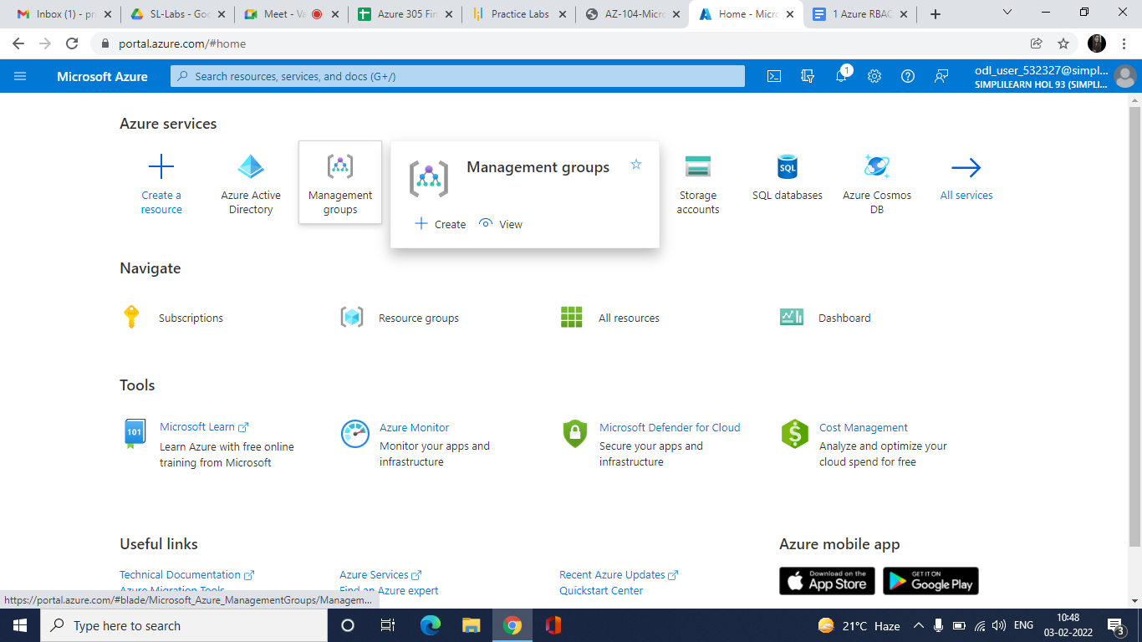

1.3 Click on **+ Create**

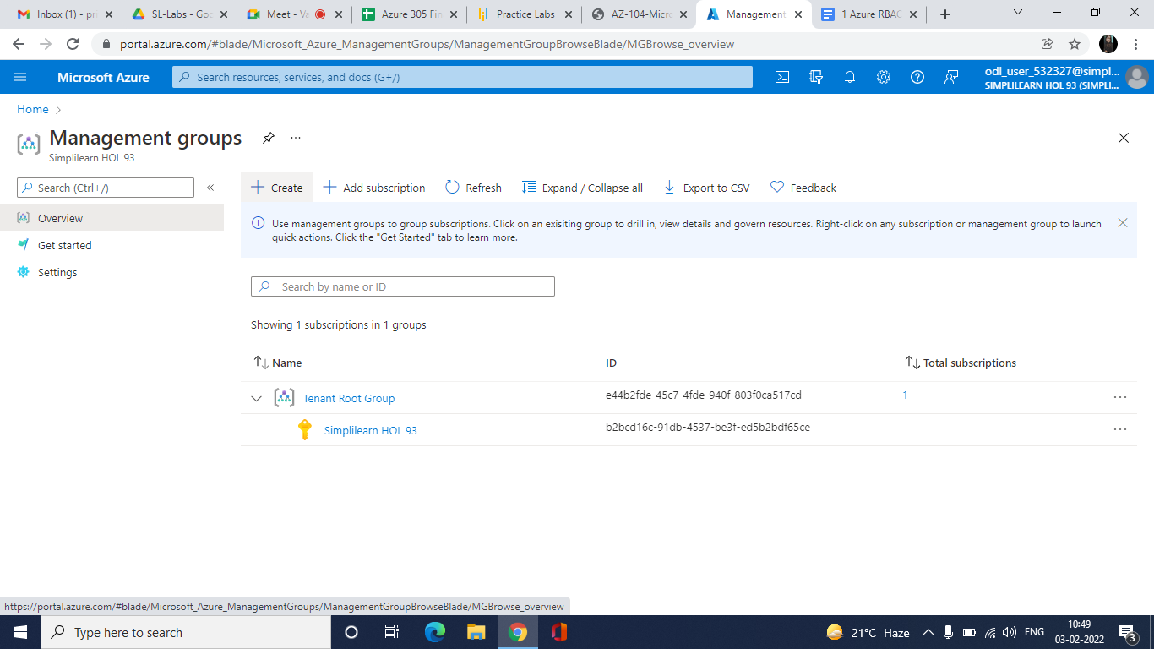

1.4 Create a management group with the following settings and click on **Submit**

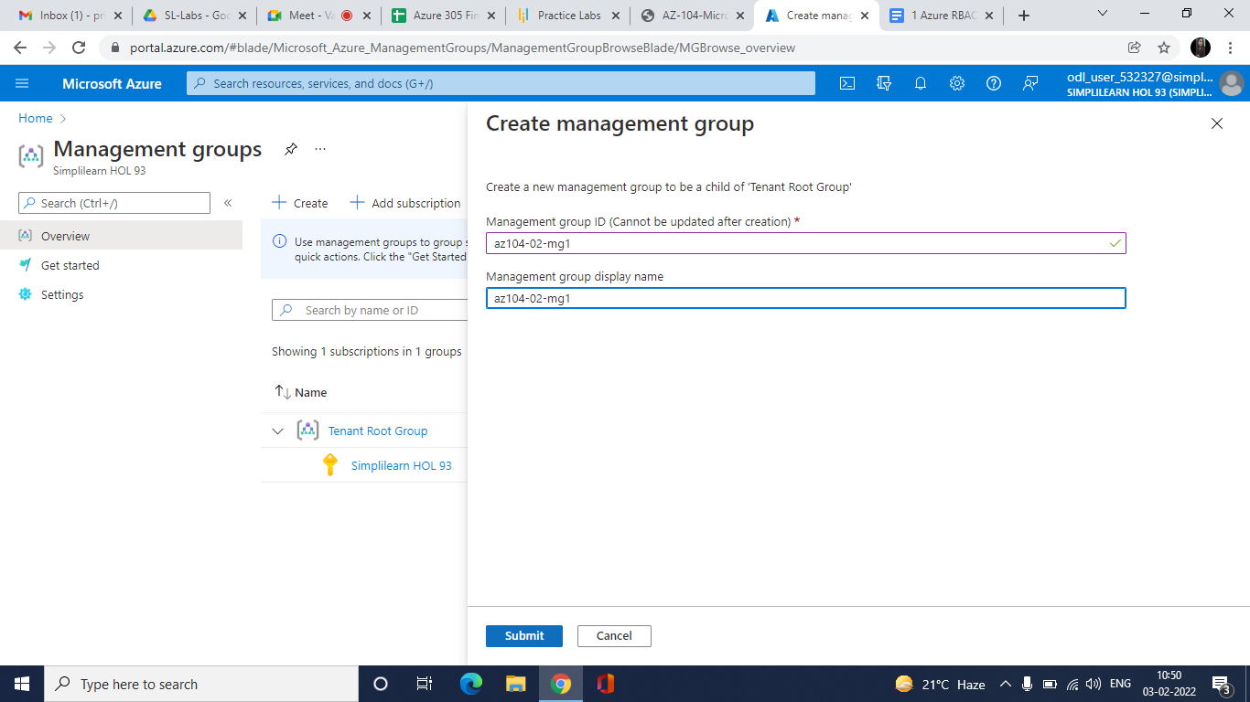

The management group will be created.

1.5 Navigate to the created management group and click on **Subscriptions** from the left menu

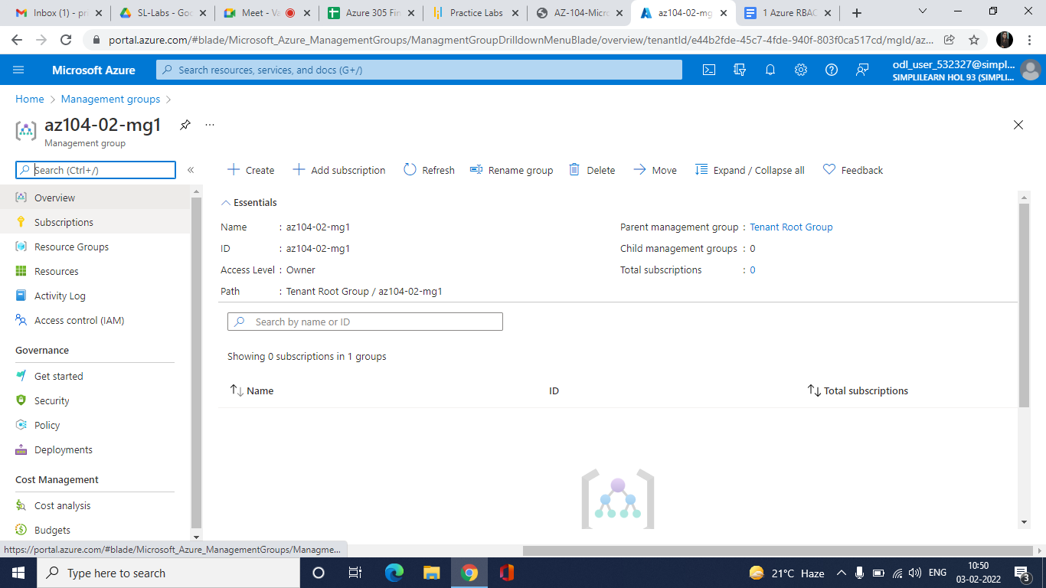

1.6 Click on **+ Add**

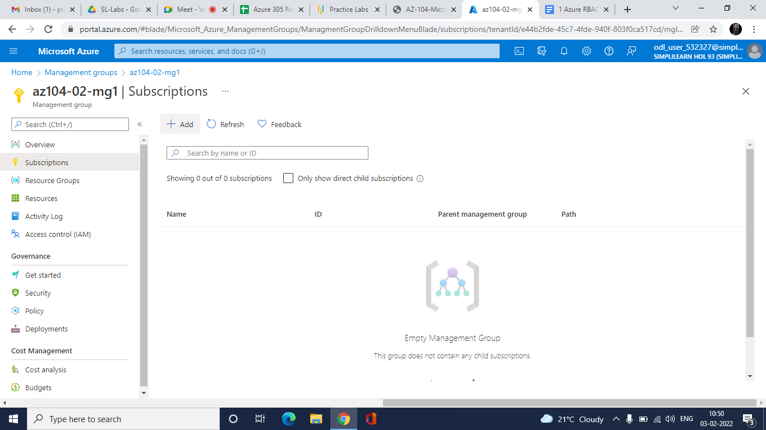

1.7 On the **Add subscription** pane, in the **Subscription** drop-down list, select the subscription you are using in this lab and click **Save**

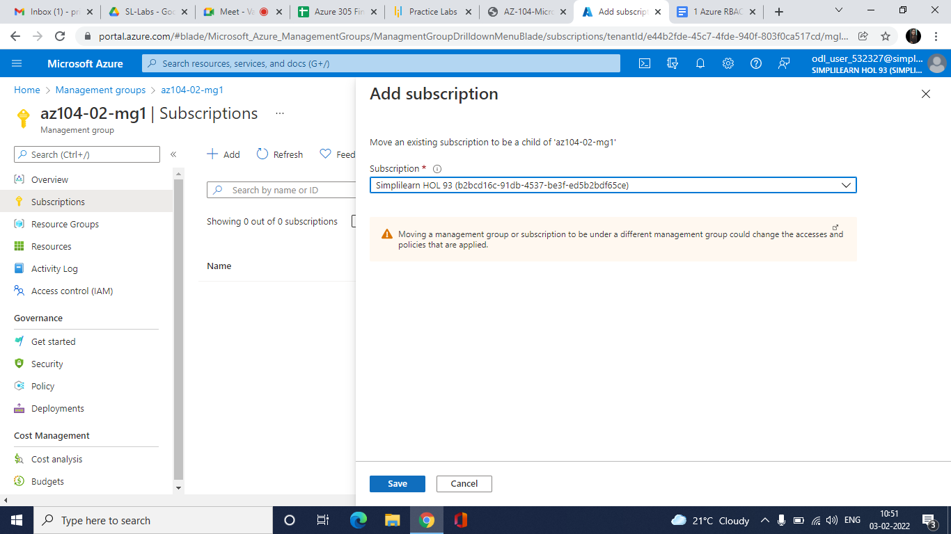

The subscription will be added.

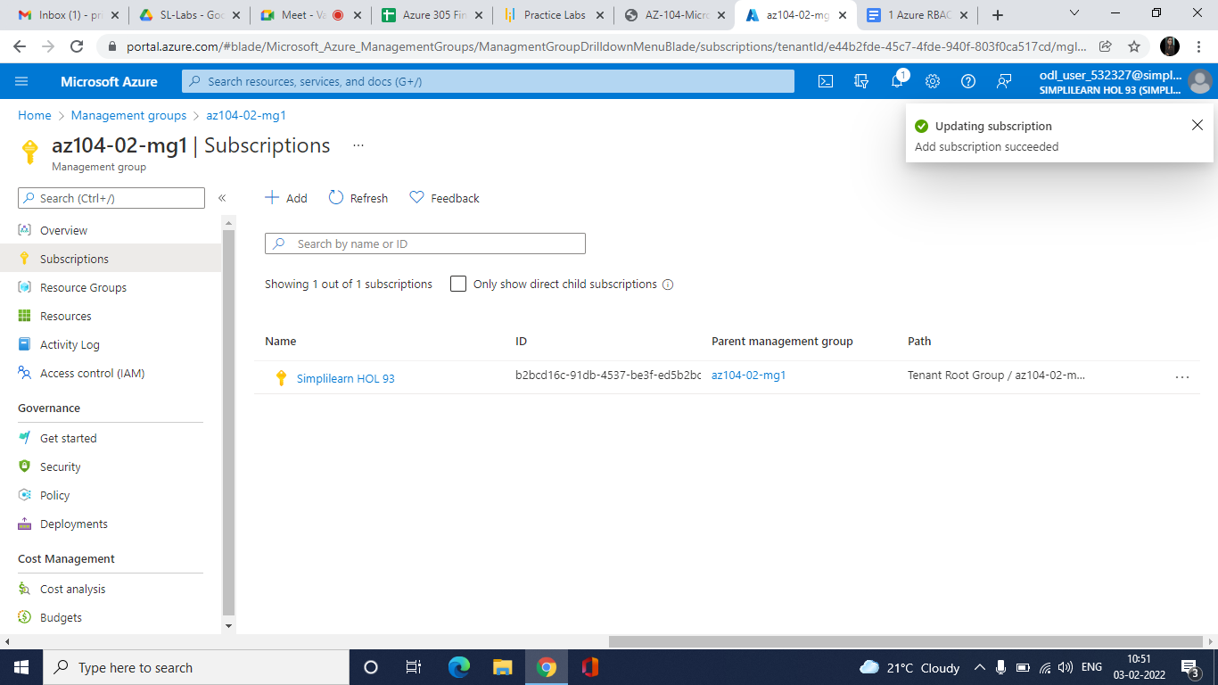

**Step 2: Creating custom RBAC roles and assigning the RBAC roles**

2.1 In the Azure portal, navigate back to the management group that you have created

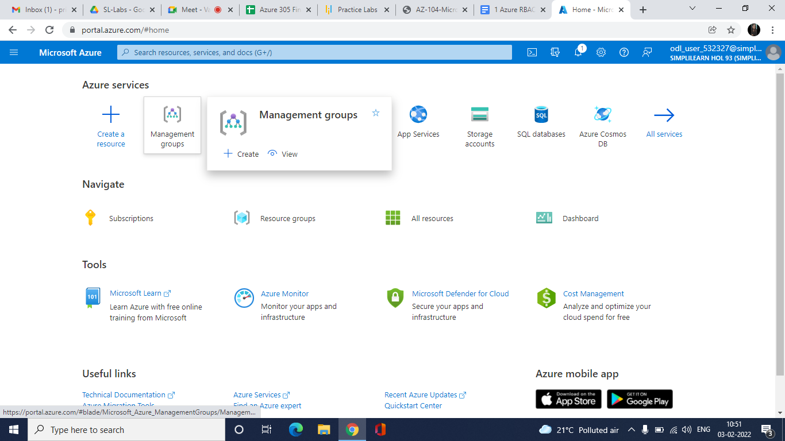

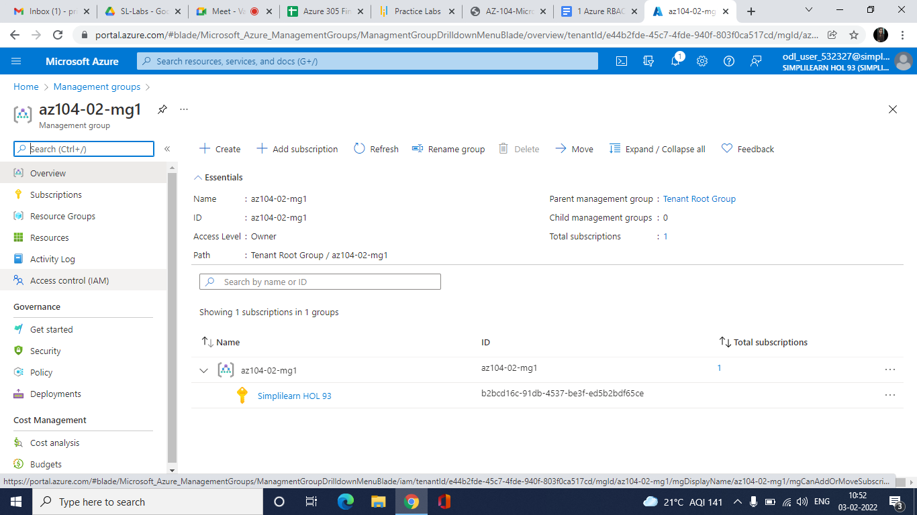

2.2 Click **Access control (IAM)**

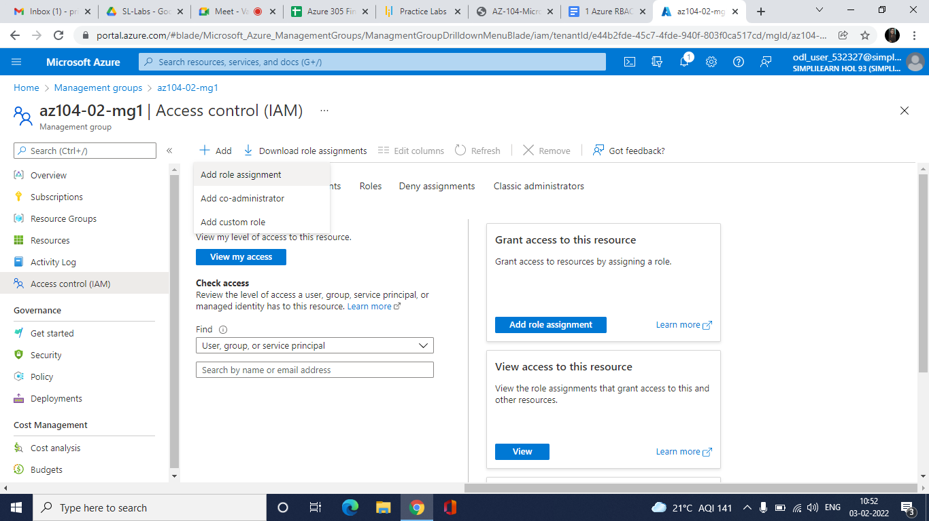

2.3 Click **Add** > **Add role assignment**



2.4 On the Add role assignment pane, select the **Contributor** role from the list of roles and then click on **Next**

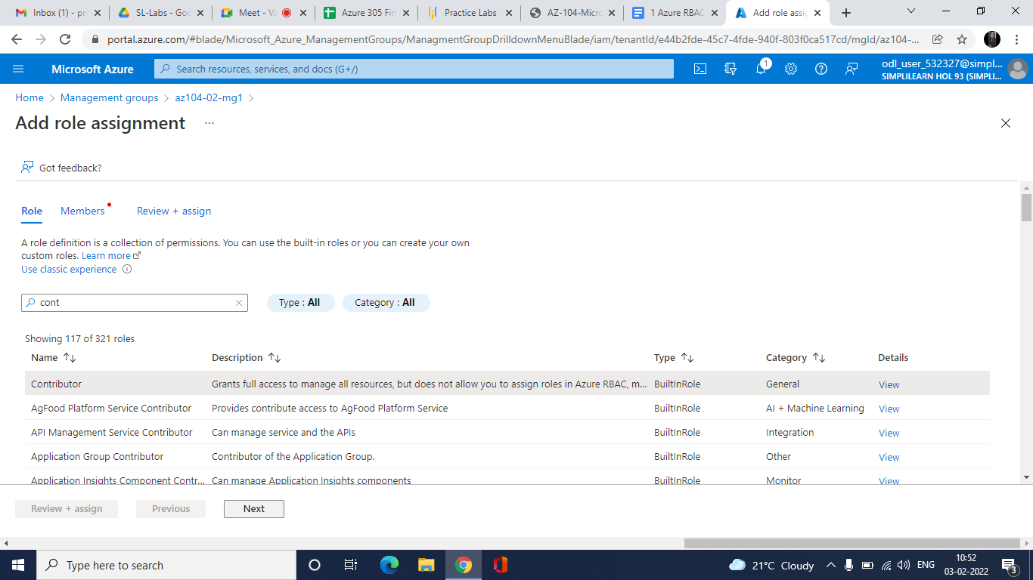

2.5 Under **Members**, click on **Select Members** and then select any member from the list in which you want to assign the role

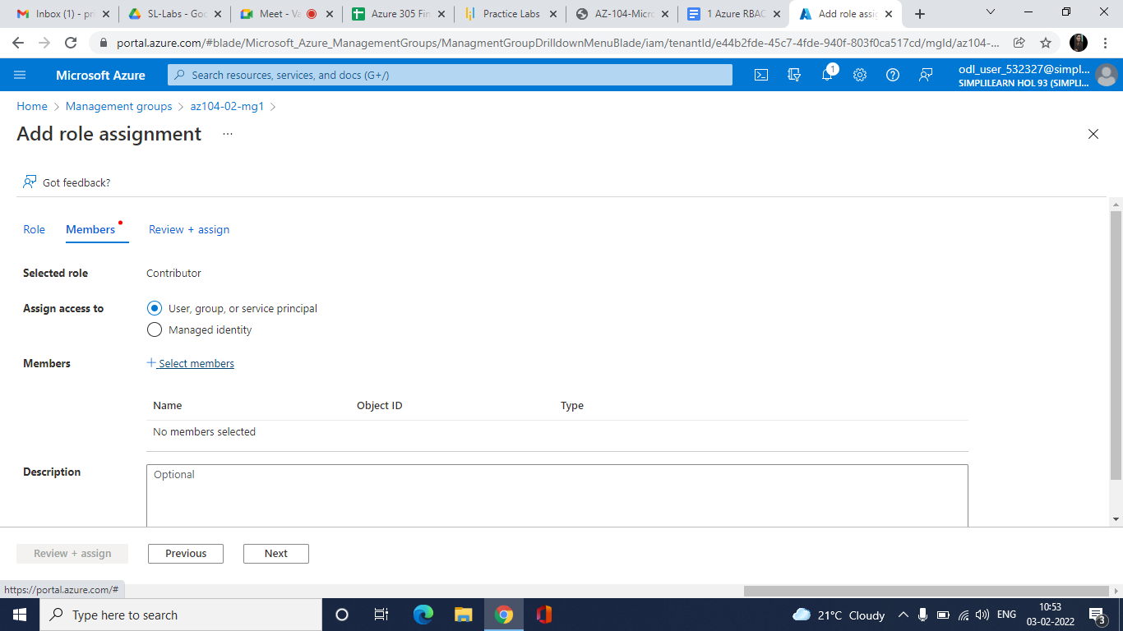

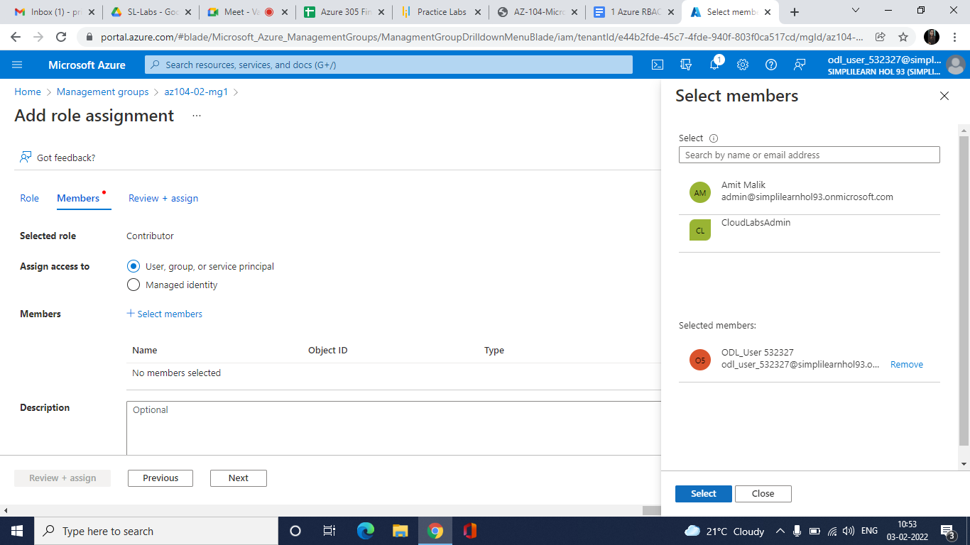

2.6 Click on **Review + assign**

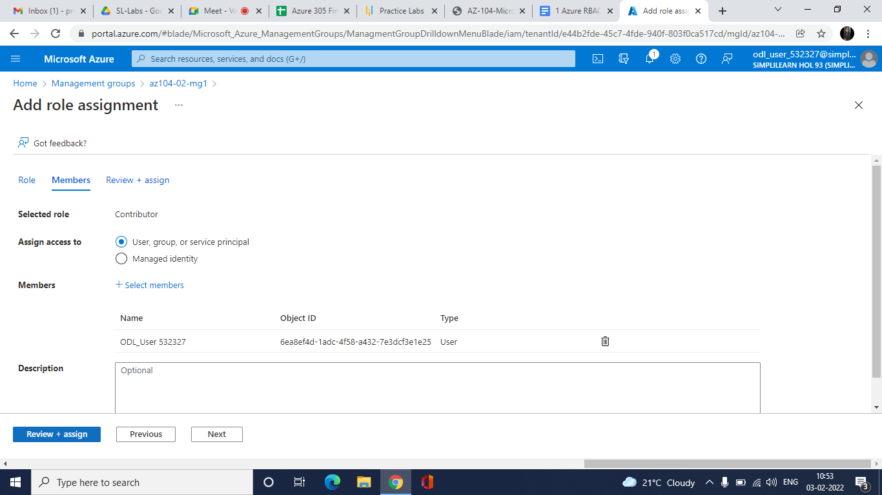

The role assignment will be added.

