**Lesson 3 Demo 3**

**Azure AD: User Creation**



Steps to be followed:

1. Creating a user in Azure AD

**Step 1: Creating a user in Azure AD**

1. Sign in to the Azure portal as an administrator
2. Under Azure services, select **Azure Active Directory**

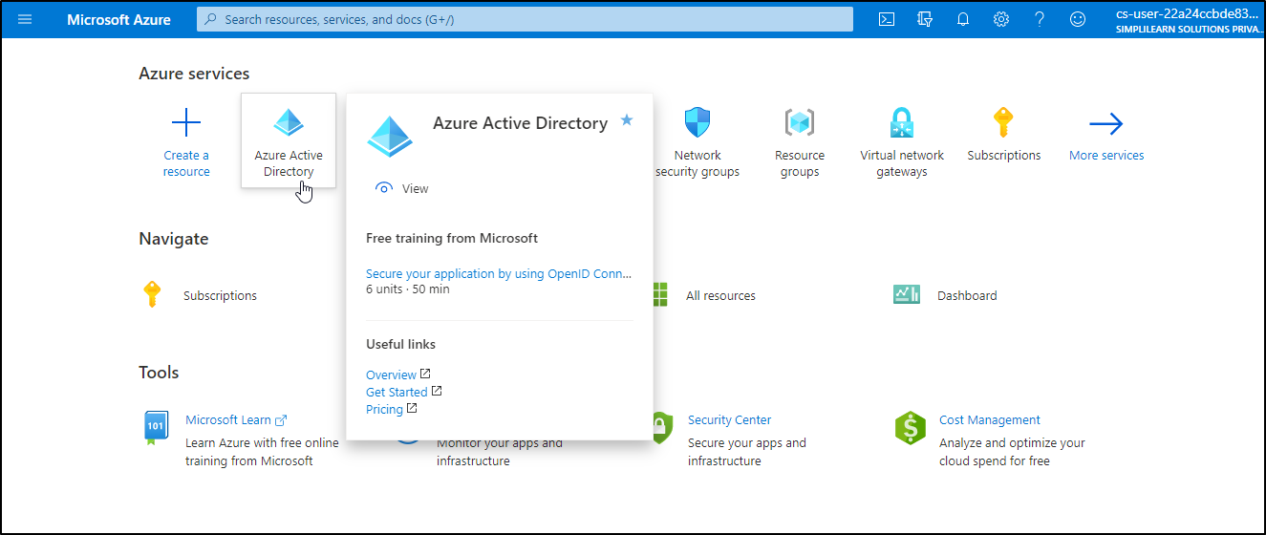

1. Under Manage, select **Users**

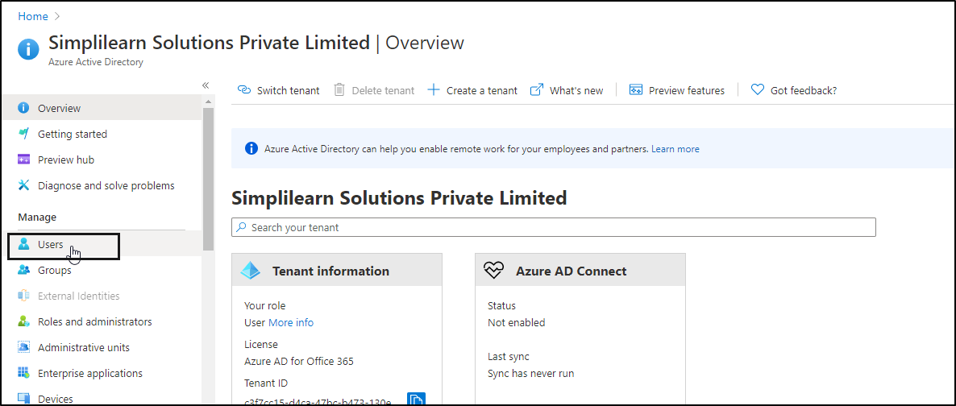

1. Select **New user**

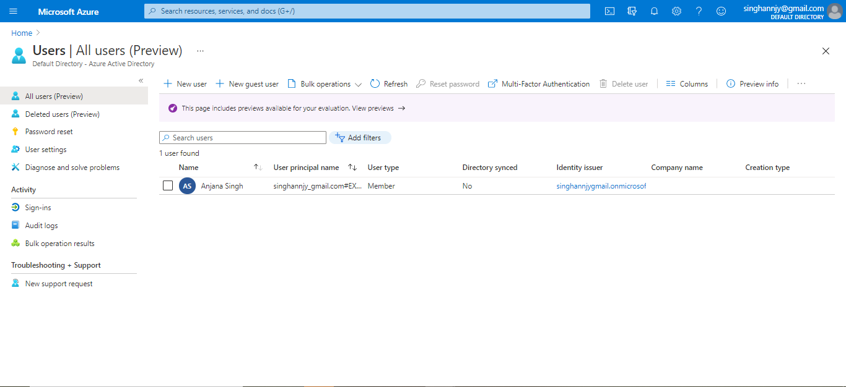

1. On the User page, enter the below information for this user:

Name

Username

Groups

Directory Role

Job Info

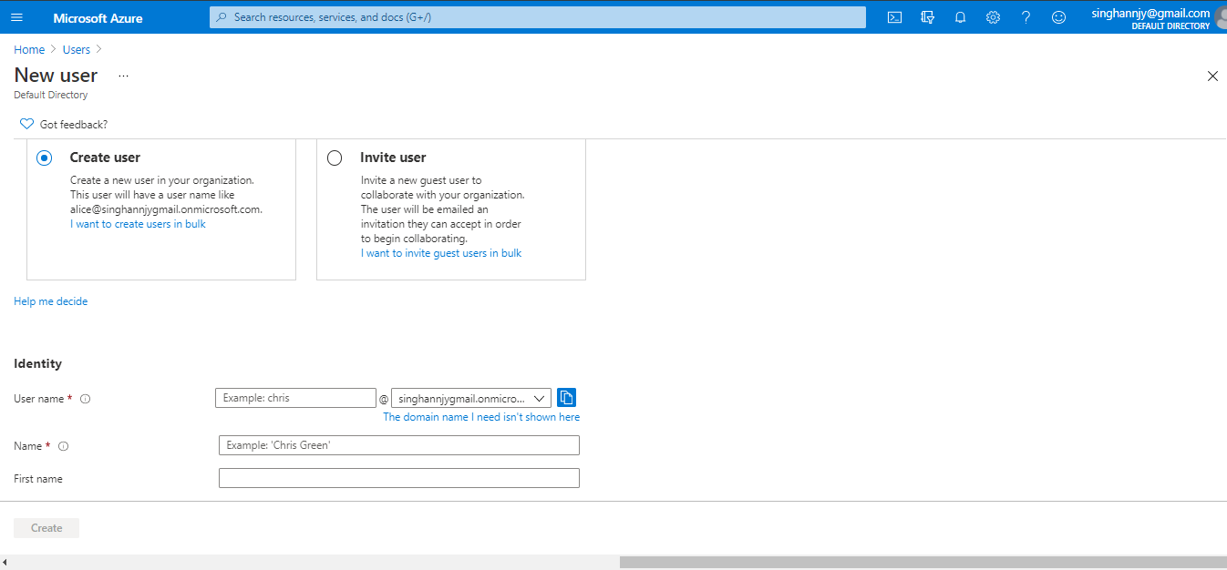

| **Note:** Copy the auto-generated password provided in the Password box. You'll need to give this password to the user to sign in for the first time. |
| --- |

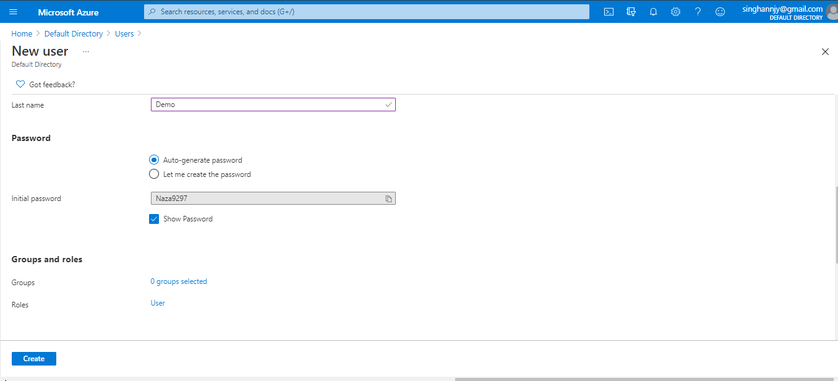

1.6 Once the details are entered, select **Create**

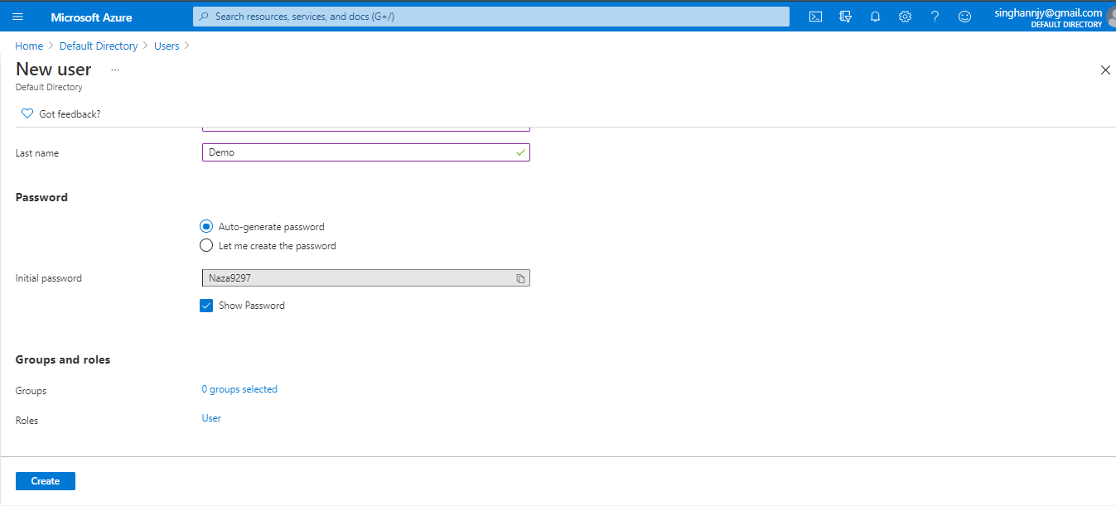

1.7 The user is created and added to your Azure AD organization.

