**Lesson 3 Demo 4**

**Azure AD Guest User Creation**



Steps to be followed:

1. Creating a guest user in Azure AD

**Step 1: Creating a guest user in Azure AD**

1. Sign in to the Azure portal as an administrator
2. Under Azure services, select **Azure Active Directory**

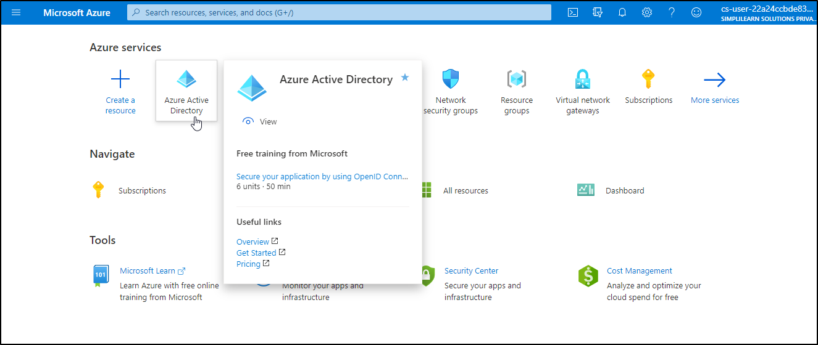

1. Under Manage, select **Users**

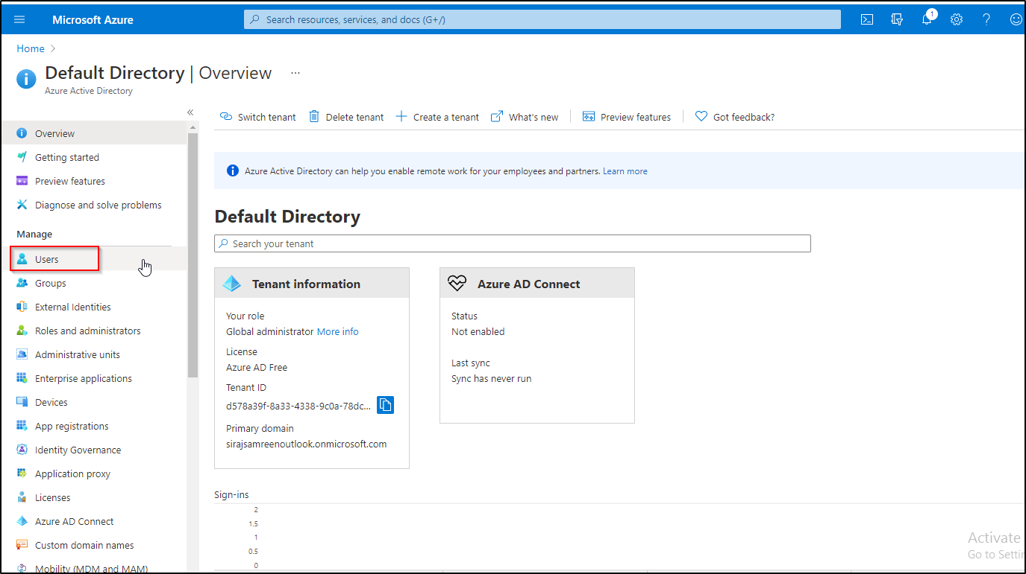

1. Select **New guest user**

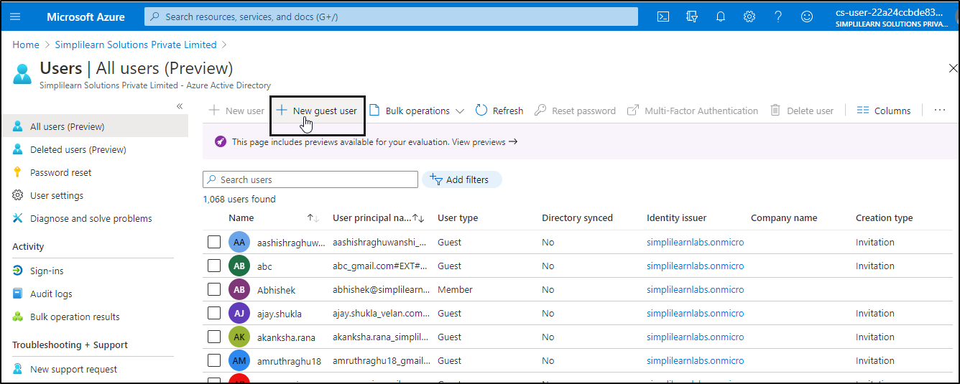

1. On the New user page, select Invite user and then add the guest user's information and then click on the **Invite** button

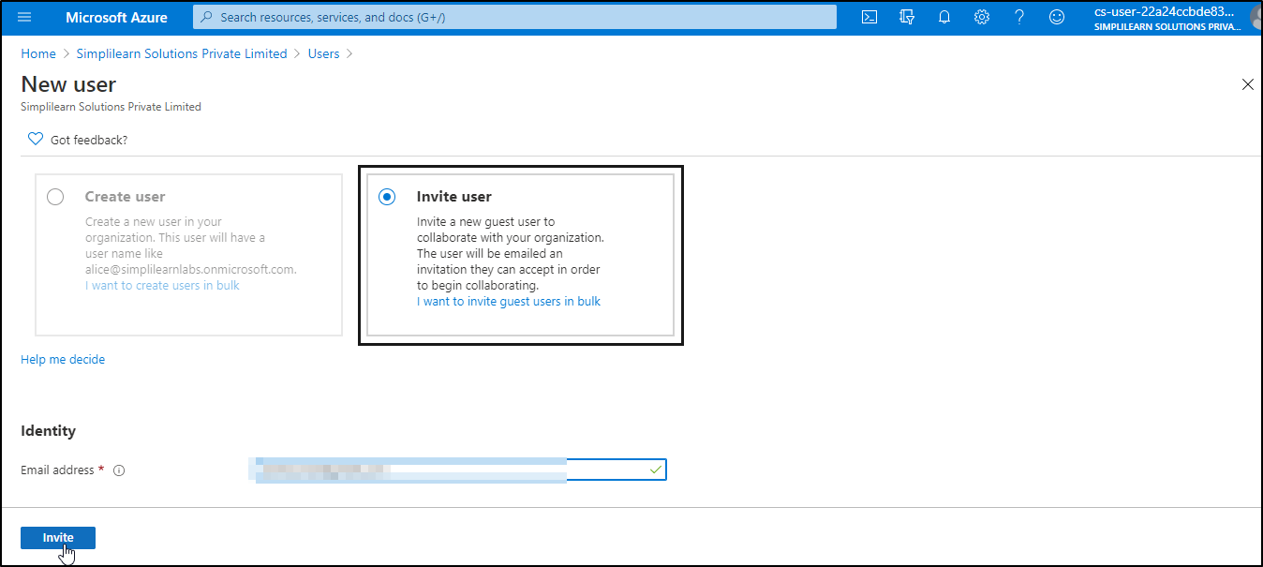

1. After you send the invitation, the user account is automatically added to the directory as a guest.