**Lesson 3 Demo 5**

**Azure AD: Group Creation**



Steps to be followed:

1. Creating a user group in Azure AD

**Step 1: Creating a user group in Azure AD**

1.1 Sign in to the Azure portal as an Azure AD

1.2 Under Azure services, select **Azure Active Directory**

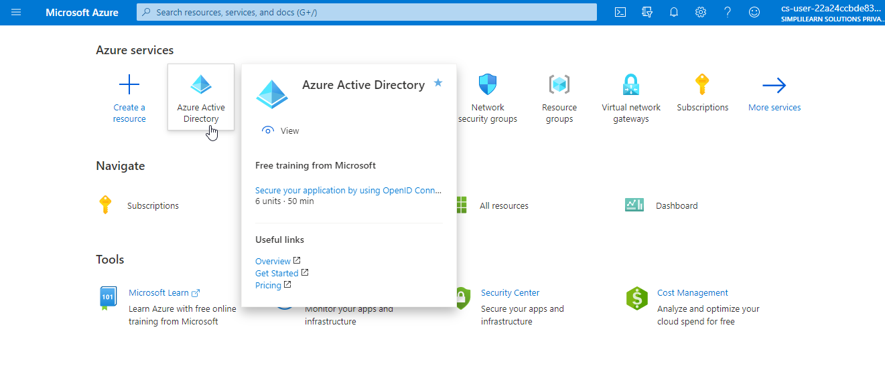

1.3 On the Active Directory page, select Groups and then select **New group**

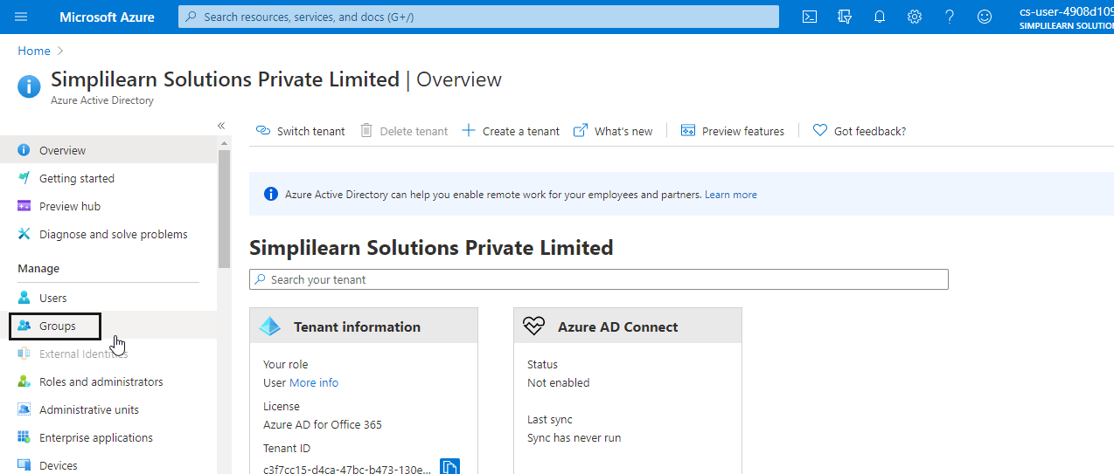

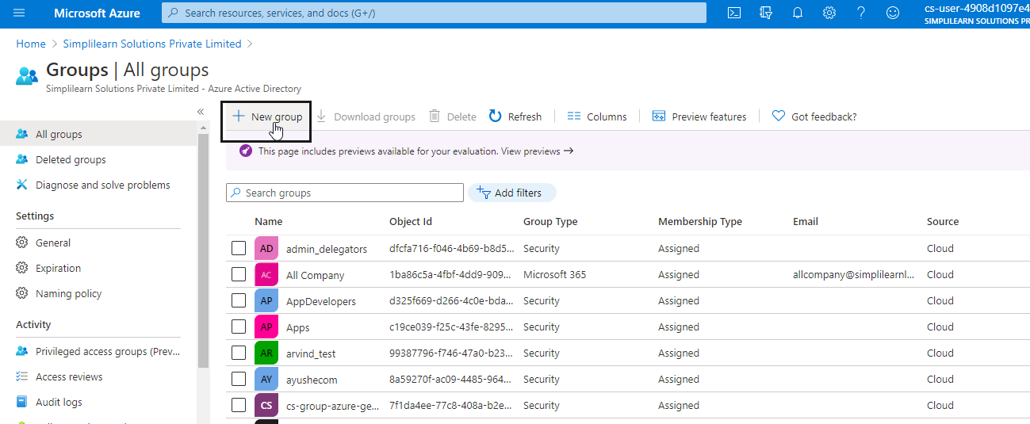

1.4 Select a pre-defined Group type

1.5 Create and add a Group name. Choose a name that you'll remember and that makes

sense for the group. A check will be performed to determine if the name is already in

use by another group. If the name is already in use, to avoid duplicate naming, you'll be

asked to change the name of your group

1.6 Add an optional Group email address for the group under Owners, or keep the email

address that is filled

1.7 Add an optional description to your group

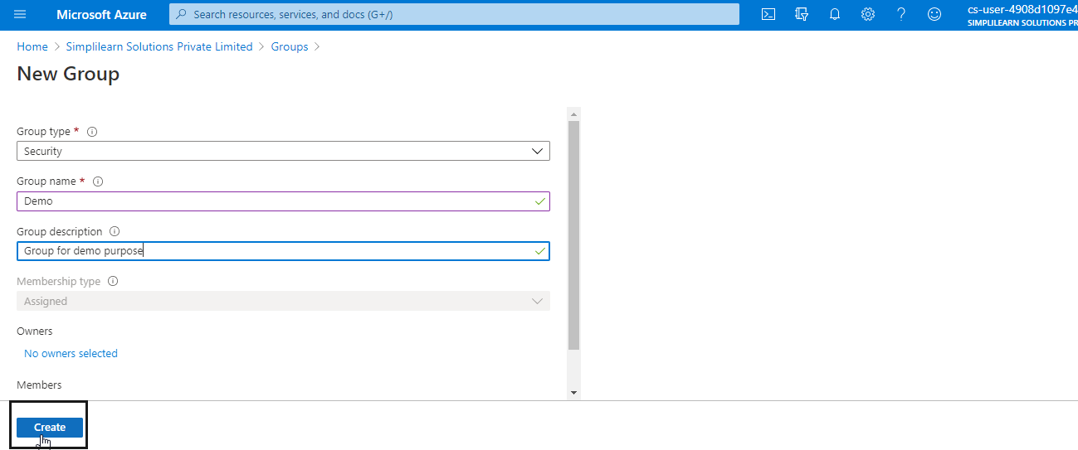

1.8 Click on the **Create** button

1.9 Your group will be created and ready for you to add members.