**ServiceNow Performance Analysis**

**The domain of the Project: Data Analytics**

**Team Mentor (and their designation)**

**Mr P Ravi Shankar – Tata ProEngage volunteer from (TCS)**

**Team Members:**

1. Mr. Debasish Sahu PGDM 2nd year --- Team Coordinator
2. Mr. Sai Akash Lakkakula B.Tech 4th Year --- Team member
3. Ms. Neeti Pandey B.Tech 4th Year --- Team member

**Period of the project**

2 MONTHS

(25 December 2024 to 25 February 2024)

**Declaration**

The project titled “**Service Now Performance Analysis**” has been mentored by Mr. Ravi Shankar, organized by SURE Trust, from December 2024 to February 2025, for the benefit of the educated unemployed rural youth for gaining hands-on experience in working on industry relevant projects that would take them closer to the prospective employer. I declare that to the best of my knowledge the members of the team mentioned below, have worked on it successfully and enhanced their practical knowledge in the domain.

**Team Members Signature**

1. **Sai Akash Lakkakula**



1. **Debasish Sahu**

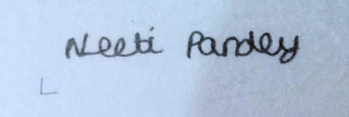

1. **Neeti Pandey**

**Team Mentor**

**Mr. P Ravi Shankar**

**Tata ProEngage volunteer from Tata Consultancy Services**

**Prof. Radhakumari**

**Executive Director & Founder**

**SURE Trust**

**Table of Content**

**INTRODUCTION**………………………………………………………………………………………………………..4

**PROJECT OVERVIEW**…………………………………………………………………………………………………4

**WORK DONE**……………………………………………………………………………………………………………4-7

1.Data Collection and Extraction……………………………………………………………………………….4

2.Data Preprocessing & Cleaning………………………………………………………………………………5

## 3.Exploratory Data Analysis (EDA)…………………………………………………………………………….5

## 4.Data visualization & Dashboard Creation……………………………………………………………….5-7

5.Interpretations and findings………………………………………………………………………………….7-9

6.Key Takeaways and Recommendation…………………………………………………………………..9-10

**LEARNINGS AND REFLECTIONS…………………………………………………………………………….**11-12

1.Team Member’s new learnings and contributions………………………………………………..11

## 2.Challenges Overcome…………………………………………………………………………………………..11

## 3. Lessons Learned………………………………………………………………………………………………….11

4.Conclusion & Future Recommendations……………………………………………………………..12

**ACKNOWLEDGEMENT………………………………………………………………………………………….**12

## 

**Introduction**

As part of our Sure Trust internship, we analyzed ServiceNow data to assess team performance, focusing on **resolution time, trend analysis, and product line-wise insights**. Through collaborative efforts, we identified **a high-resolution rate with minimal SLA breaches** and highlighted areas for process optimization. Trend analysis revealed patterns in ticket reopen rates and resolution variability. Our findings provided actionable recommendations to enhance service efficiency. This project strengthened our **data analysis skills** and emphasized the value of collaboration and analytical decision-making in operational improvement.

## Project Overview

* **Objective:** To analyze and evaluate the effectiveness of the ServiceNow team's performance based on the given data.
* **Scope:** Focused on key performance metrics, issue resolution efficiency, **trend analysis, and product line-wise insights.**
* **Tools & Technologies Used:** Excel, Power BI, ServiceNow reports.
* **Roles & Responsibilities:** Each team member was responsible for different aspects, including data analysis, visualization, trend identification, and reporting. Moreover, each member actively contributed and participated effectively.

## Work Done

The project was executed in multiple phases, each contributing to a comprehensive analysis of ServiceNow's performance. The key stages included Data Collection, Preprocessing, Exploratory Data Analysis (EDA), Visualization, Interpretation, and Final Reporting.

**1. Data Collection & Extraction:**

* The dataset consisted of ServiceNow ticket records, including attributes such as ticket ID, product line, priority level, resolution time, incident state, and SLA breaches.
* We extracted data from ServiceNow reports, formatted in CSV/Excel, and stored it for further processing.
* DAX queries were used to filter, sort, and aggregate data, ensuring only relevant fields were selected.

## 2. Data Preprocessing & Cleaning

* **Duplicate Identification:** Identified duplicate ticket records using DAX queries and Power Query Editor.
* **Data Formatting**: Standardized date formats and converted resolution times into hours for easier interpretation.
* **Outlier Detection:** Identified unusually long resolution times (e.g., tickets unresolved for several months) and flagged them for further review.

## 3. Exploratory Data Analysis (EDA)

We conducted an in-depth analysis of the data to uncover patterns and trends:

* **Ticket Volume Trends**: Analyzed ticket generation over time (daily, weekly, and monthly).
* **Resolution Time Analysis**: Measured resolution time to assess team efficiency.
* **Priority Distribution:** Checked the distribution of Critical, High, Moderate, and Lowpriority tickets.
* **Product Line Comparison:** Identified which product lines had the highest and lowest ticket volumes.

## 4. Data Visualization & Dashboard Creation

We developed interactive dashboards in Power BI to present insights visually.

* **Product line wise tickets:** Displayed ticket count per product line to understand ticket distribution.

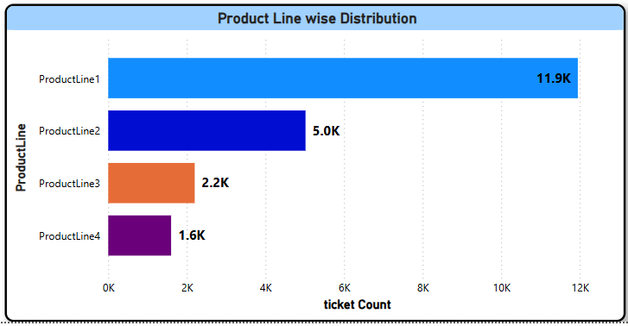

* **Ticket Volume Analysis**
* 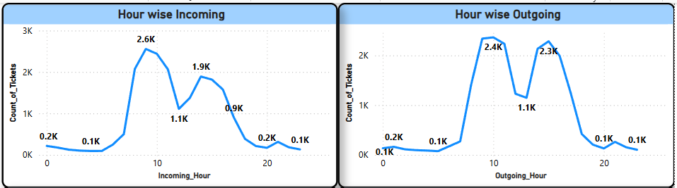**Hourly analysis of logged tickets:** A line chart showing the number of incoming tickets generated per hour and outgoing tickets resolved per hour.

* **Weekly count analysis of ticket:** A line chart showing the number of incoming tickets generated and outgoing tickets resolved by weekly.

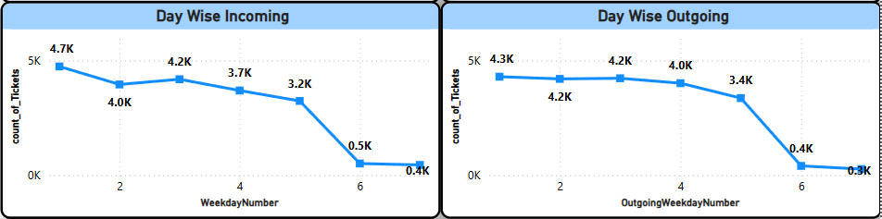

* **Monthly count analysis of ticket:** A line chart showing the number of incoming tickets generated and outgoing tickets resolved month-wise.

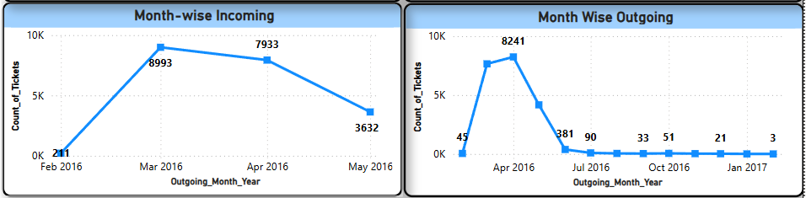

* 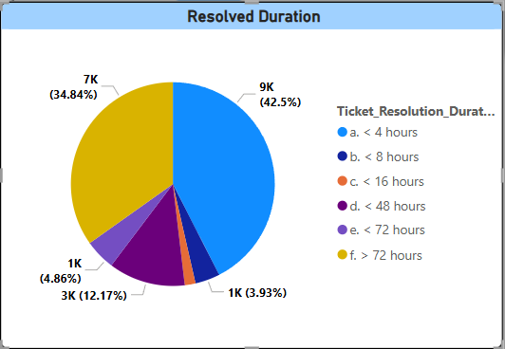**Ticket Age Distribution**: A table showcasing how many tickets were resolved in the different ticket resolution duration bins.

* **Product line and Priority wise ticket analysis:** Created a table showing how many tickets of 4 different product lines belonged to which level of priority.

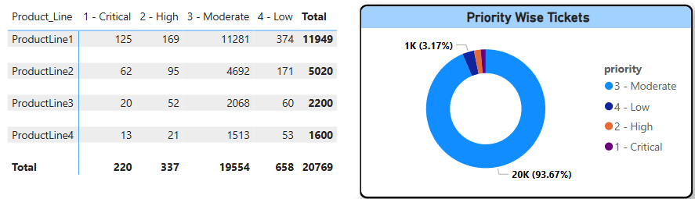

**Interpretation and Findings :**

1. **Total Ticket Count:**
   * **20,769 tickets** in total.
   * **Resolved Tickets: 20,763** (99.97% resolved rate).
   * **Not Resolved Tickets: 6** (nearly negligible).
   * **Reopened Tickets: 234** (around 1.1% of total tickets).
   * **SLA Breached: 9** (very low).
2. **Priority Distribution:**
   * **93.67% of tickets are moderate-priority** (~19,554).
   * High and Critical priority tickets are significantly lower.
3. **Product Line Distribution:**
   * **ProductLine1** has the highest ticket count (**11.9K**).
   * **ProductLine2** follows with **5K tickets**.
   * **ProductLine3 and ProductLine4** have **2.2K and 1.6K tickets**, respectively.

### **Analysis of Ticket Resolution Duration:**

#### **Breakdown of Resolved Tickets by Duration:**

* **< 4 hours**: **8,827 tickets (42.5%)** → A large portion of tickets is resolved within **4 hours**, indicating **high efficiency** in handling most issues.
* **< 8 hours**: **816 tickets (3.93%)** → A **small** percentage of tickets take between **4 to 8 hours**.
* **< 16 hours**: **354 tickets (1.7%)** → Very few tickets require **8 to 16 hours** for resolution.
* **< 48 hours**: **2,527 tickets (12.17%)** → A notable number of tickets extend **beyond a day** but are closed within **48 hours**.
* **< 72 hours**: **1,009 tickets (4.86%)** → A **minor percentage** takes between **48 to 72 hours**.
* **> 72 hours**: **7,236 tickets (34.84%)** → A **substantial** number of tickets take **more than 3 days**, indicating possible **delays, backlog issues, or complexity in resolution**.

### **Analysis of Incoming and Outgoing Ticket Trends**

#### **Hourly Ticket Trends:**

* **Incoming Tickets:**
  + Peaks at **10 AM (2.6K tickets)** and **4 PM (1.9K tickets)**.
  + Drops significantly during non-business hours (midnight to early morning).
* **Outgoing Tickets:**
  + Peaks at **10 AM (2.4K tickets)** and **4 PM (1.1K tickets)**, closely following incoming trends.
  + This suggests that tickets are being resolved at a similar rate as they arrive.

#### **Daily Ticket Trends:**

* **Incoming Tickets:**
  + Highest volume on **Day 1 (4.7K tickets)**.
  + Gradual decline towards **Day 6 (0.5K tickets)**.
* **Outgoing Tickets:**
  + Follows a similar trend with peaks on **Day 1 (4.3K tickets)** and **Day 2 (4.2K tickets)**.
  + Steady drop-off towards **Day 6 (0.4K tickets)**.
  + Suggests that ticket resolution is aligned with incoming demand but decreases towards the weekend.

#### **Monthly Ticket Trends:**

* **Incoming Tickets:**
  + Peaks in **March 2016 (~9,933 tickets)**.
  + Drops significantly from **May 2016 onwards**.
* **Outgoing Tickets:**
  + Peaks in **April 2016 (~8,241 tickets)**.

Gradual decrease over time, with **very low values by October 2016**.

**Key Take Aways & Recommendations:**

**1.Hourly Trends Optimization**

The peaks at 10 AM and 4 PM indicate high activity periods.

To improve response time, allocate more resources during these hours.

**2. Daily Trends Optimization**

A decline in incidents towards Day 6 suggests reduced issue occurrence or slower operations.

Focus on backlog clearance and preventive actions during Days 1-3, when volume is highest.

**3. Monthly Trends Analysis**

The drop after March-April 2016 may be due to process improvements, seasonality, or system changes.

Further analysis is needed to determine if this decline is linked to policy updates, system upgrades, or shifts in ticket management.

**4. High Rate of Resolution but Space for Faster Closure**

99.97% of the tickets are closed (20,763 out of 20,769), which indicates a high success rate of incident closure.

However, 7,236 tickets (34.84%) are closed more than 72 hours, which could indicate backlog issues, lack of resources, or complex problem-solving.

Examine the type of tickets closed more than 72 hours and whether additional resources, automation, or process enhancement can reduce this period.

**5. Fast Resolution for Most Tickets**

42.5% (8,827 tickets) are resolved in less than 4 hours, reflecting excellent response efficiency on typical issues.

Only 3.93% of tickets (816) are resolved in 4-8 hours and 1.7% (354) are resolved in 8-16 hours, indicating that most issues get resolved within the first few hours.

Maintain and enhance the efficiency of low- and moderate-priority ticket resolution through knowledge bases, automation tools, and AI chatbots to promptly resolve recurring problems.

**6. Product Line 1 Needs More Support Resources**

Product Line 1 accounts for 57% of the total tickets (11.9K out of 20.7K).

All other product lines have significantly smaller numbers of tickets (5K, 2.2K, and 1.6K).

Investigate why Product Line 1 is the one that's generating most of the tickets—is complexity in products, defects, poor customer education, or less efficient support processes?

Would investing in more specialist resources, preventative maintenance, or self-service decrease ticket volume on this product?

**7. Issue Prioritization done Nicely**

93.67% are modestly-priority tickets, that is, the most of the issues are not priority.

Tickets with Critical or High-priority represent a marginal proportion, a representation of zero severe service failures.

Continue with faster turnaround of high-priority tickets without settling on efficiency to deal with mediocre and low-priority issues.

**8. SLA Breach is Low, but Reopened Tickets Need to Be Handled**

9 tickets breached SLA, demonstrating excellent compliance with service levels.

234 tickets were reopened, indicating potential quality issues in initial resolutions.

Carry out root-cause analysis of reopened tickets. If they are a result of poor or faulty solutions, conduct quality audits, enhanced support staff training, or more rigorous resolution verification before ticket closure.

**Learnings and reflections**

## Team Member’s new learnings and contributions:

|  |  |  |  |
| --- | --- | --- | --- |
|  | **Debasish Sahu** | **Sai Akash** | **Neeti Pandey** |
| **Experience** | **Gained expertise in business reporting, stakeholder management, EDA, DAX queries, and Power BI, translating data into actionable insights.** | **Strengthened skills in Power BI dashboards, DAX queries, and data processing, learning to interpret large datasets for business decisions.** | **Developed expertise in EDA, DAX queries, and data visualization, aligning analytical insights with business needs for process optimization.** |
| **Contribution** | **Project reporting, documentation, and presentation. Identified ticket patterns, conducted outgoing trend analysis, and managed team coordination.** | **Conducted incoming trend analysis, analyzed product line-wise ticket distribution, and helped find total distinct and resolved tickets.** | **Identified ticket patterns, assisted in categorizing resolution bins, and contributed to trend analysis and workflow efficiency.** |

### **1. Challenges Overcome**

* **Complexity of Analysis:** Understanding the intricacies of ServiceNow data required deep analytical thinking and a structured approach.
* **Trainer’s Guidance:** With continuous support, we aligned our analysis with business objectives and improved data interpretation.
* **Understanding Business Requirements:** Identifying key KPIs and aligning them with the business owner's expectations helped ensure meaningful insights.
* **Addressing Pain Points:** By analyzing resolution trends and product line performance, we provided actionable recommendations to enhance efficiency.

By overcoming these challenges, we successfully delivered a **data-driven report** that contributed to operational improvements.

## Lessons Learned

* **Commitment & Responsibility:** Each team member must actively participate for project success.
* **Better Planning & Coordination:** Regular team meetings and status updates can improve execution.
* **Stronger Communication:** Clear discussions with the trainer (Business Owner) will clarify expectations.
* **Domain Knowledge Improvement:** Understanding ServiceNow’s workflow and key metrics beforehand will be beneficial.

**3.Conclusion & Future Recommendations**

The project successfully delivered valuable insights into **ServiceNow performance, resolution trends, and product line efficiency**. Through data-driven analysis, we identified key areas for optimization and provided actionable recommendations. Moving forward, similar projects can further improve by focusing on:

* **Deeper Business Understanding:** Aligning analysis with specific business goals and pain points.
* **Structured Progress Tracking:** Implementing regular check-ins to ensure smooth execution.
* **Advanced Knowledge of Metrics:** Gaining familiarity with industry tools for more precise analysis.
* **Collaborative Approach:** Encouraging effective teamwork and clear responsibility-sharing.

This experience reinforced the importance of **data analytics, structured execution, and business-driven insights** for operational success.

**Acknowledgment:**

We would like to thank our trainer **Mr P Ravi Shankar** and the **Director of Sure Trust** - **Prof. Dr. Radha Kumari** for providing us with this learning opportunity and for guiding us throughout the project.

**Submitted by:**

1. Sai Akash Lakkakula
2. Debasish Sahu
3. Neeti Pandey

**Date:** 4th Mar,2025