Assignment-2: CSS
Time: 2 weeks
(Visual appeal of your design matters)

Part-I (Deadline: Week-1)
1. Using external, internal and inline CSS, write few paragraphs about yourself such that each paragraph is formatted differently. Use multiple attributes (background-color, text color, text-align, font-family, font-size etc.) for paragraph formatting.
2. Consider page setup window of a word processor looks like as shown below. On a HTML page, design the window and keep an option for user to select various themes.
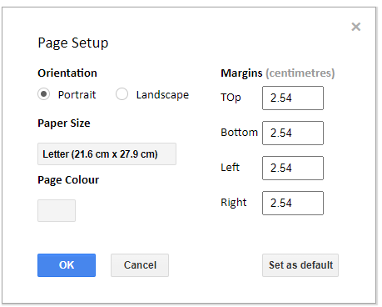

Part-II (Deadline: Week-2)
keep an option for user to select various themes for the problem given in Assignment-1.

Bonus Assignment (Optional – carries extra credit)
Make the theme selector of Part-I, Question-2 (the page-setup window) actually work using CSS only – no JavaScript is allowed. When the user picks a theme, the whole window (background, text colour, borders and the accent/button colour) must change live on the page.
Requirements:
(a) Provide at least three themes (for example Light, Dark and High-contrast) that the user can pick through radio buttons.
(b) Do the switching with the :checked pseudo-class together with the sibling combinators (~ or +). Instead of rewriting every rule for each theme, drive all colours through CSS custom properties (variables).
(c) Add a smooth colour change with the transition property so the themes fade rather than jump.
(d) The window must remain usable on a small screen – make it responsive using flexbox or grid and at least one media query.
Hint: place the radio inputs before the window in the HTML, then write rules such as #dark:checked ~ .window { --bg:#222; --fg:#eee; }. Keep everything in a single HTML file with an internal <style> block. Expected effort: about 1–2 hours.

