

Course Code: INT 315
Course Title: Cluster Computing
Continuous Assessment: 02
Date Of Submission: 09-April-2026
Topic: Water Quality Classification using Decision Tree

Name: Debasmita Chatterjee
Registration No.: 12219423
Roll No.: REM301A63
Section: EM301
TABLE OF CONTENT
TITLE 1
ABSTRACT 1
INTRODUCTION 1
PROBLEM STATEMENT 1
OBJECTIVES 1
DATASET DESCRIPTION 2
DATA PREPROCESSING 2
MODEL BUILDING 3
EVALUATION METRICS 4
RESULTS 4
VISUALIZATION 4
DISCUSSION 5
CONCLUSION 5
FUTURE WORK 5
IMPLEMENTATION 5
LINKS 12

TITLE
Water Quality Classification using Decision Tree (PySpark)

ABSTRACT
This project focuses on classifying water samples as safe or unsafe for human consumption using chemical and physical water quality parameters. A Decision Tree classifier was implemented using Apache Spark to efficiently process the dataset. Missing values were handled using median imputation, and class imbalance was reduced through upsampling. The model was trained using cross-validation for better performance and achieved an accuracy of 72.57%. Visualization techniques such as confusion matrix heatmap and feature importance bar chart were used to analyze model performance and identify the most influential water contaminants.

INTRODUCTION
Water quality assessment is essential for public health and environmental sustainability. Contaminated water can cause severe health issues, making water safety prediction an important problem.
Machine learning techniques can help classify water samples based on physical and chemical characteristics. This project uses a Decision Tree classifier in PySpark to predict whether water is potable or not.

PROBLEM STATEMENT
The objective of this project is to classify water samples as safe or unsafe for drinking based on water quality attributes such as pH, hardness, solids, chloramines, sulfate, conductivity, and turbidity.
The challenge lies in handling missing values, class imbalance, and identifying the most important contaminants affecting water quality.

OBJECTIVES
- To load and preprocess the water quality dataset using PySpark
- To handle missing values effectively
- To balance the dataset using upsampling
- To perform feature engineering
- To build a Decision Tree classification model
- To evaluate model performance using accuracy and F1-score
- To visualize confusion matrix and feature importance

DATASET DESCRIPTION
The dataset contains water quality parameters and a target variable indicating water potability.
Key features used:
- pH
- Hardness
- Solids
- Chloramines
- Sulfate
- Conductivity
- Organic Carbon
- Trihalomethanes
- Turbidity
Target:
- Potability (Safe / Unsafe)
The dataset consists of 3276 water samples.

DATA PREPROCESSING
Data preprocessing was performed to improve model quality.
- Handling Missing Values
Missing values in pH, Sulfate, and Trihalomethanes were replaced using median values.
- Label Preparation
The Potability column was renamed to label for classification.
- Class Balancing
The minority class was upsampled to reduce dataset imbalance.
- Feature Assembly
Selected features were combined into a single feature vector using VectorAssembler.
FEATURE ENGINEERING
The following water quality parameters were selected as input features:
- pH
- Hardness
- Solids
- Chloramines
- Sulfate
- Conductivity
- Organic Carbon
- Trihalomethanes
- Turbidity
These parameters significantly influence water potability and help the model learn classification patterns.

MODEL BUILDING
A Decision Tree classifier was implemented using PySpark MLlib.
Steps followed:
- Feature vector creation
- Train-test split (80:20)
- Hyperparameter tuning using CrossValidator
- Model training on training dataset
- Predictions on test dataset
Cross-validation helped improve model generalization and reduce overfitting.

EVALUATION METRICS
The following metrics were used:
1. Accuracy
Measures overall classification correctness.
2. Confusion Matrix
Shows true positives, true negatives, false positives, and false negatives.
3. F1-Score
Measures balanced classification performance.
These metrics provide a complete view of model effectiveness.

RESULTS
The model achieved:
- Accuracy ≈ 72.57%
- F1-score ≈ 0.724
The model showed balanced performance for both safe and unsafe water samples.
This indicates that the Decision Tree classifier can effectively predict water potability.

VISUALIZATION
1. Confusion Matrix Heatmap
The confusion matrix heatmap was used to visualize model predictions and classification errors.
2. Feature Importance Bar Chart
Feature importance was used to identify the most influential water quality parameters.
Key important features included:
- Chloramines
- pH
- Sulfate
These factors had the highest impact on prediction.

DISCUSSION
The Decision Tree model performed well in classifying water quality, achieving realistic accuracy.
The confusion matrix showed balanced prediction performance, though some overlap between safe and unsafe classes still existed.
Feature importance analysis revealed that chemical disinfectants and acidity levels significantly influence water safety

CONCLUSION
This project successfully implemented a water quality classification system using Apache Spark.
The model achieved good performance with an accuracy of 72.57%, and feature importance analysis identified key contaminants affecting water safety.
The project demonstrates how machine learning can support water quality monitoring and public health decisions.

FUTURE WORK
Future improvements may include:
- Using ensemble models such as Random Forest
- Applying advanced feature engineering
- Increasing dataset size
- Integrating IoT sensor data for real-time prediction

IMPLEMENTATION
Step 1: Starting Spark Session
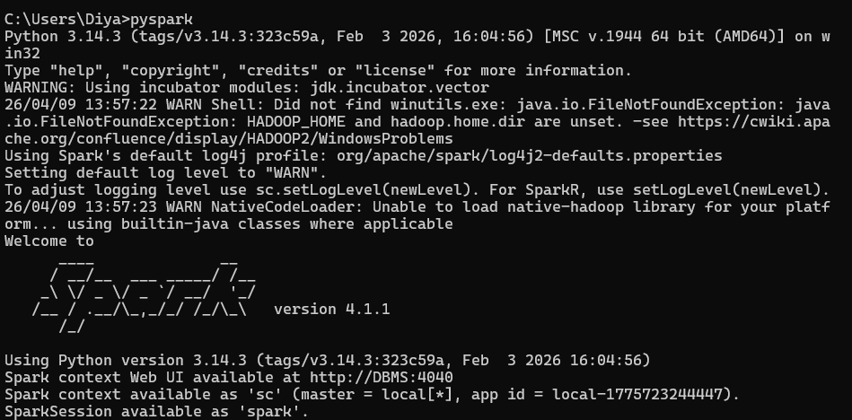
Output: Spark Session Started
Step 2: Loading Dataset and Handling Missing Values
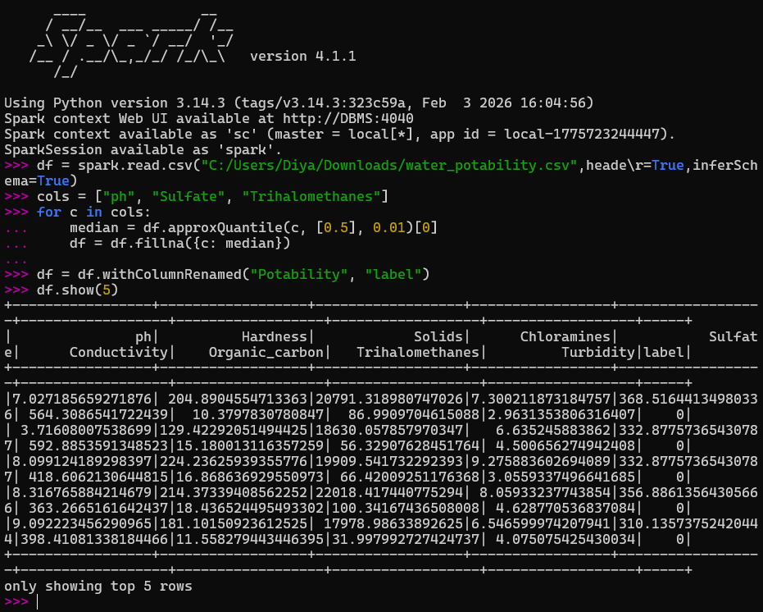
Output: Dataset loaded successfully, missing values handled, and target column prepared for classification.

Step 3: Class Balance Check
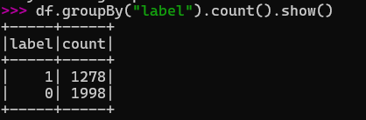
Output: Displayed class distribution, showing imbalance between safe and unsafe water samples.
Step 4: Balanced Dataset
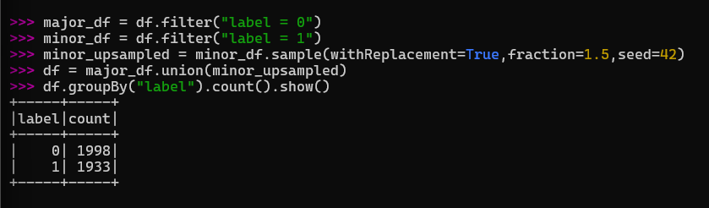
Output: Balanced the dataset by upsampling the minority class to reduce class imbalance.
Step 5: Feature Engineering
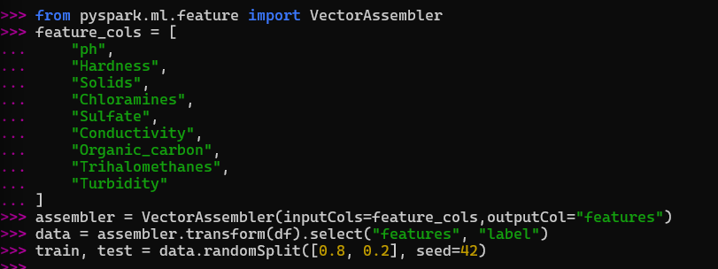
Output: Features were combined into a single vector, and the dataset was split into training and testing sets.

Step 6: Train Decision Tree + Hyperparameter Tuning
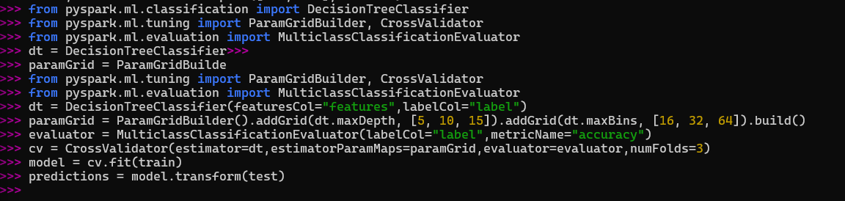
Output: Trained the Decision Tree model using cross-validation and generated predictions on the test dataset.
Step 7: Accuracy
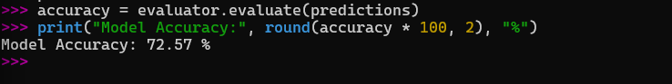
Output: The Decision Tree model achieved an accuracy of 72.57% on the test dataset.
Step 8: Confusion Matrix
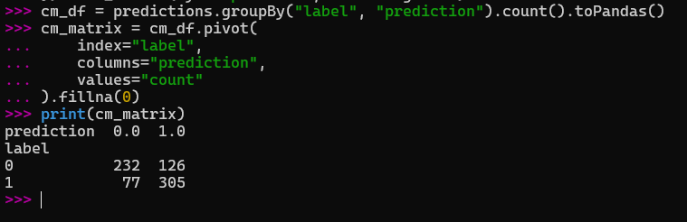
Output: Generated the confusion matrix, showing correct and incorrect classifications for both safe and unsafe water samples.

Step 9: Confusion Matrix Heatmap
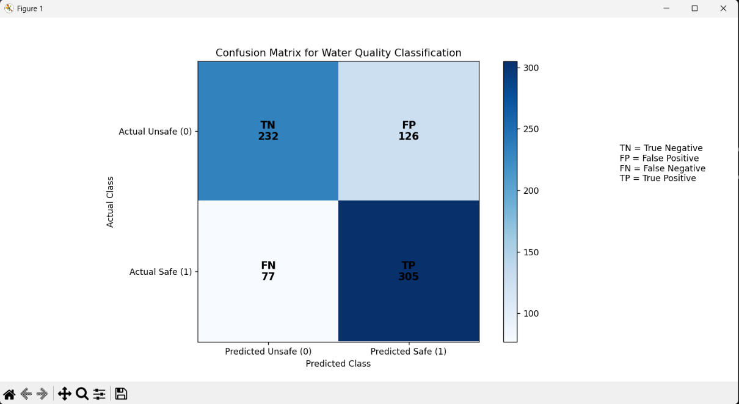
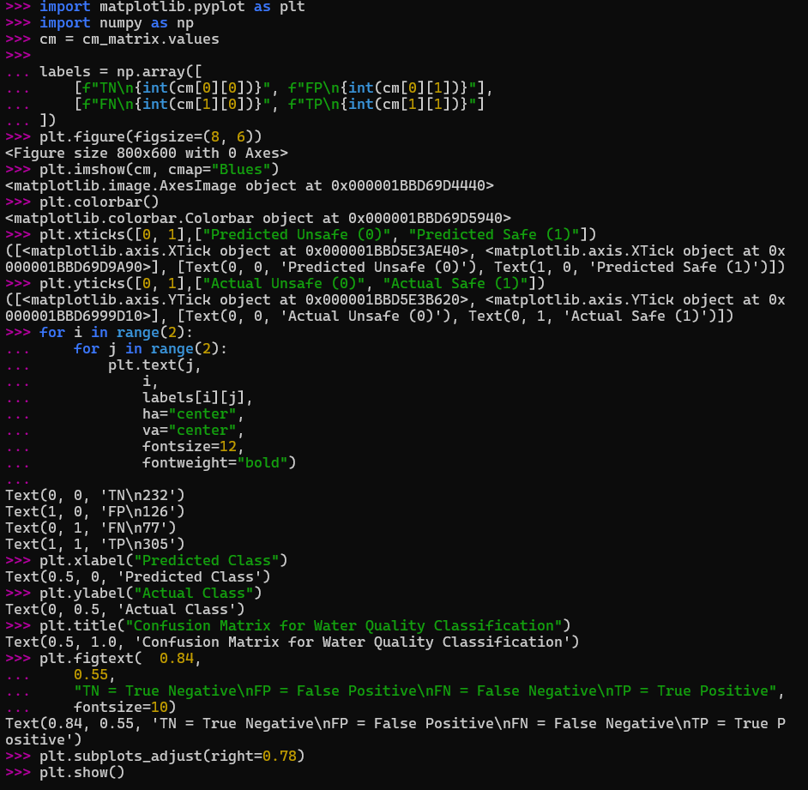
Output: Visualized the confusion matrix as a heatmap to clearly show true positives, true negatives, false positives, and false negatives.

Step 10: Feature Importance
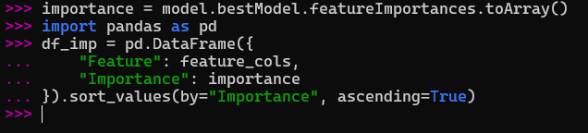
Output: Visualized feature importance to identify the most influential water quality parameters affecting classification.
Step 11: Feature Importance Graph
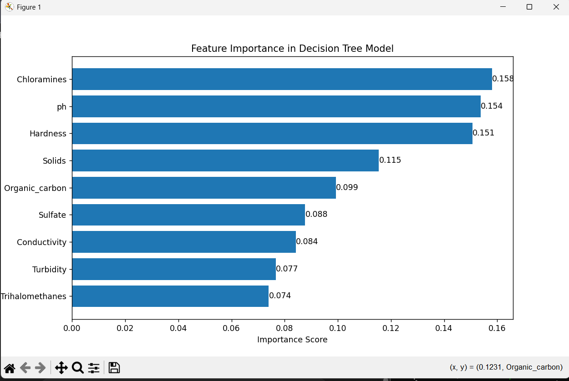
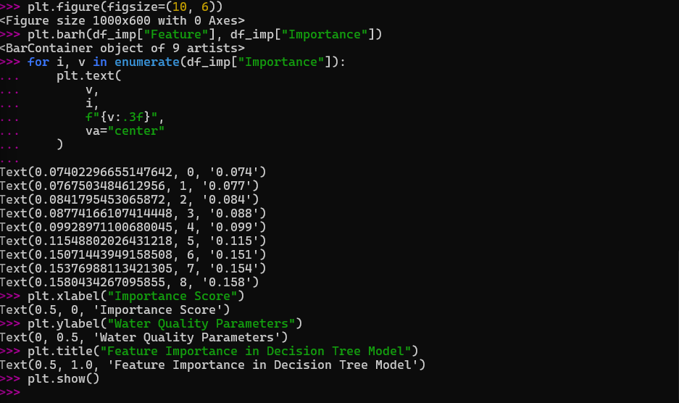
Output: Displayed the contribution of each water quality parameter to the Decision Tree model's prediction.
Step 12: F1-Score Evaluation
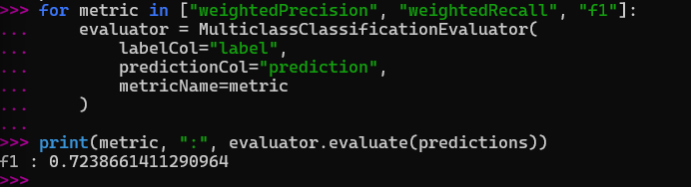
Output: Evaluated model performance using F1-score, showing balanced classification performance with a score of 0.72.
Step 16: Class Distribution
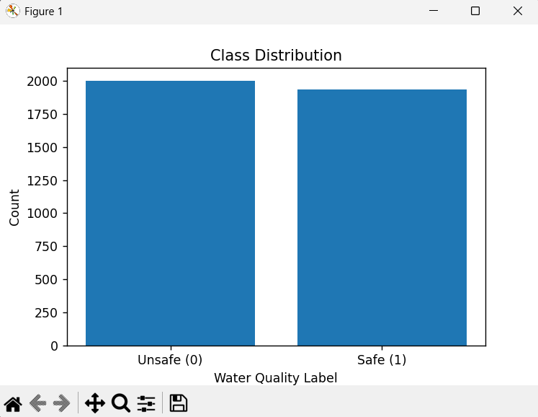
Output: Visualized the distribution of safe and unsafe water samples in the dataset.

LINKS

GITHUB LINK: https://github.com/debasmita30/Water-Quality-Classification-
WORD LINK: https://github.com/debasmita30/Water-Quality-Classification-/blob/main/Report.docx
PDF LINK: https://github.com/debasmita30/Water-Quality-Classification-/blob/main/Report.pdf
PPT LINK: https://github.com/debasmita30/Water-Quality-Classification-/blob/main/ Water-Quality-Classification-.pptx

