Problem: Unexpected motor failures hault production.
Goal: Predict failures using sensor data (vibration,temp,current)
Task:
1.Clean and label sensor screens.
2.Train a model to flag abnormal patterns.
3.Build a dashboard for maintenance alerts.
Outcome Metrics:
Unplanned Downtime, Maintenance Cost.
(Time Series Anomaly Detection , Classification of all types)

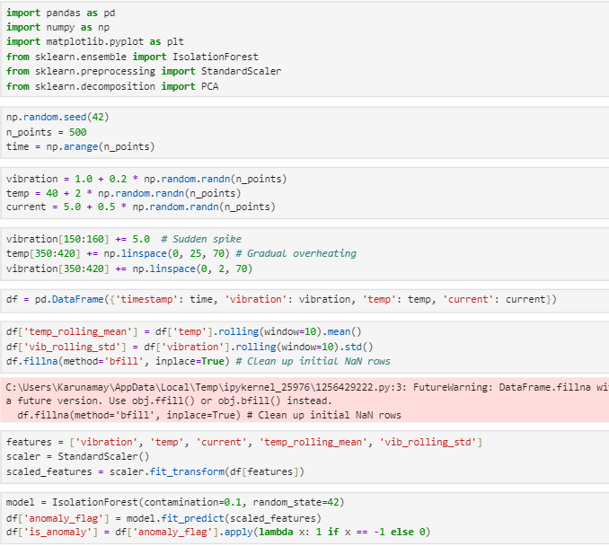

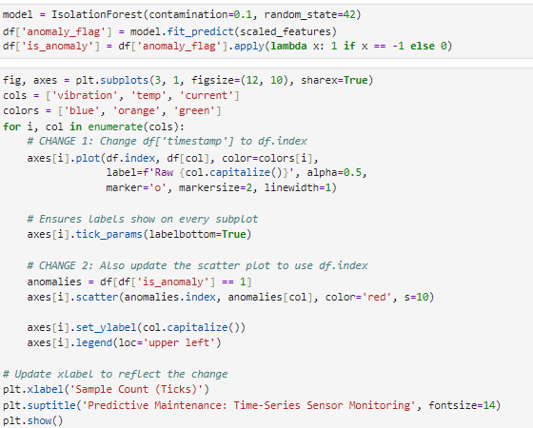
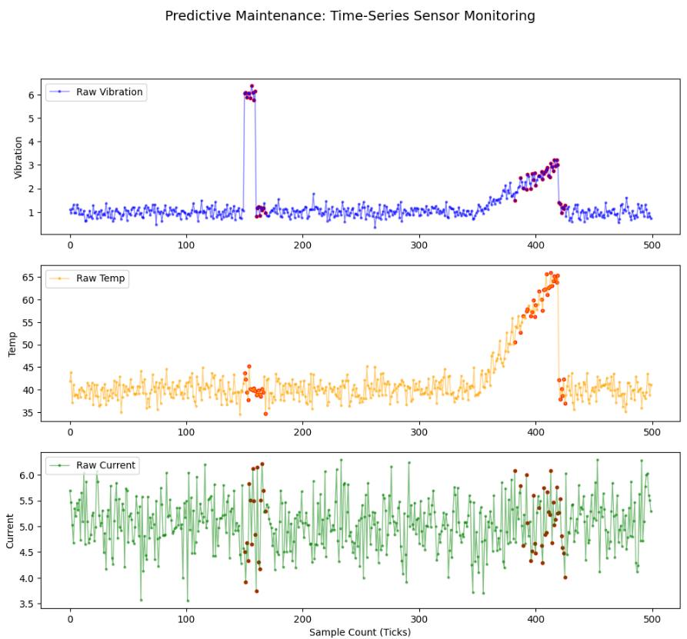
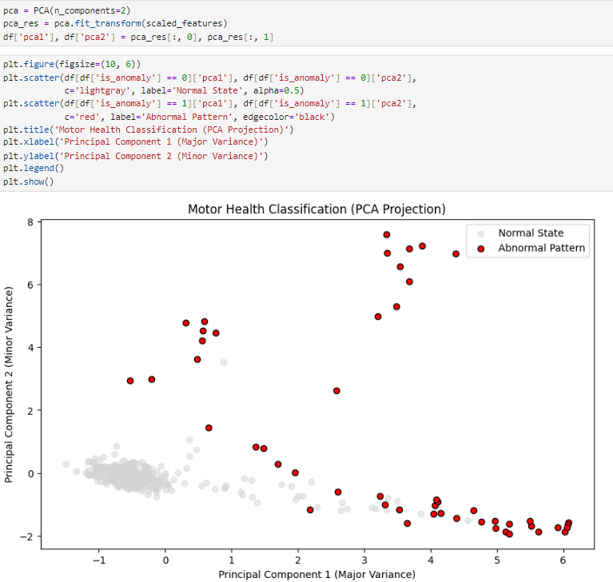
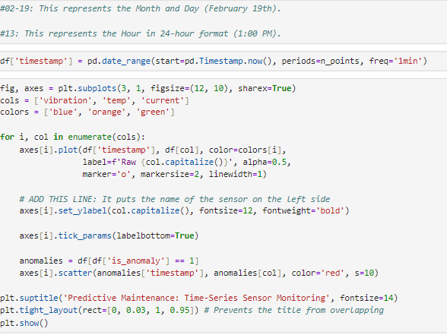

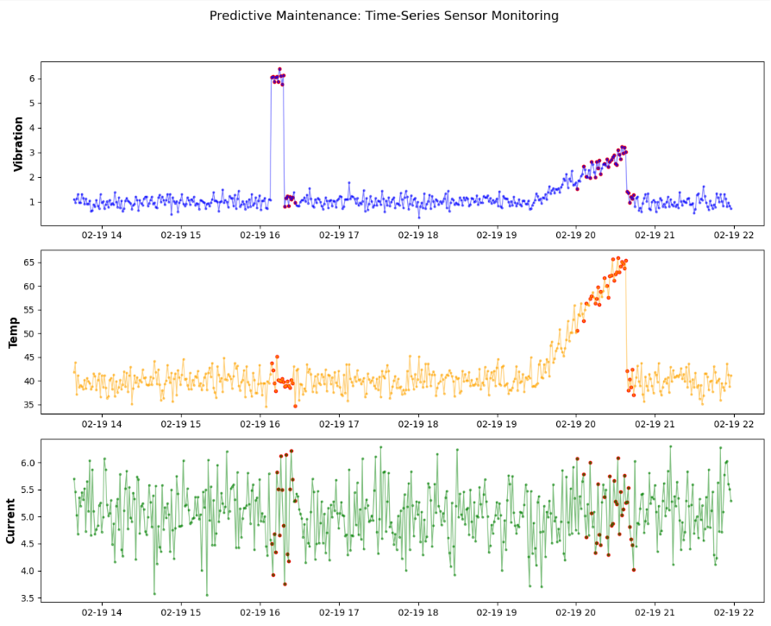
#ROI=(Financial Gains(Savings)-Cost Of Investment) * 100/Cost of Investment
#Financial Gains: The "Loss Avoided." This is the cost of the unplanned downtime you prevented (Production value * hours saved).
#Cost of Investment: This includes your time developing the model, the cost of the sensors (vibration, temp, current), and the labor for the maintenance team to perform the predicted repairs.
