(UG/02/BTCSEAIML/2023/065)
LAB ASSIGNMENT 3:
1.Write a python program to compute • Central Tendency Measures: Mean, Median,Mode • Measure of Dispersion: Variance, Standard Deviation 2. Measures of different errors 3.Confusion Matrix, Classification Report, 4. Plotting ROC AUC Curve (breast_cancer.zip and Heart.csv files separately)
1.(Using breast_cancer.zip file)
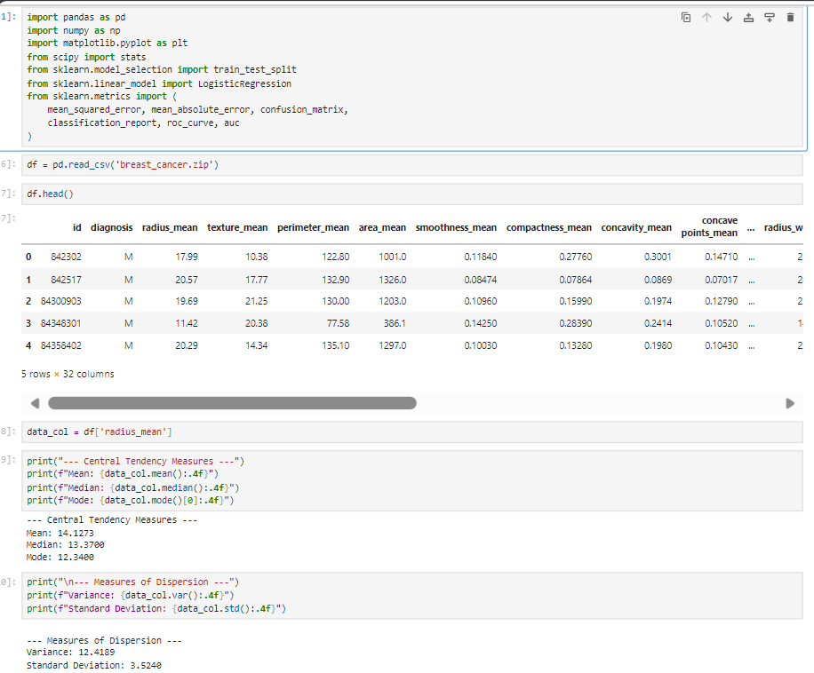
2. and 3.
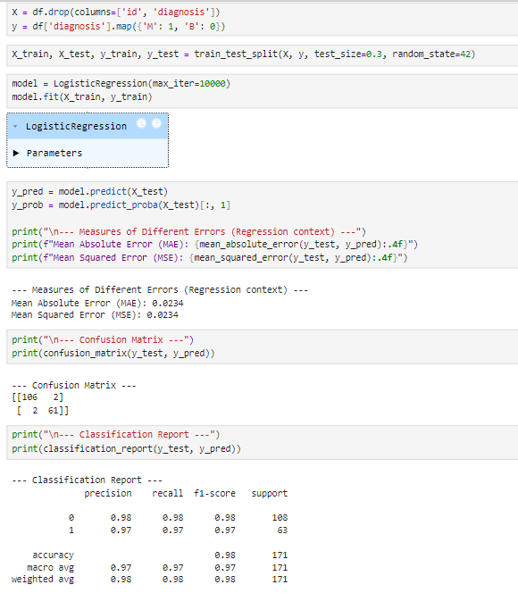

4.
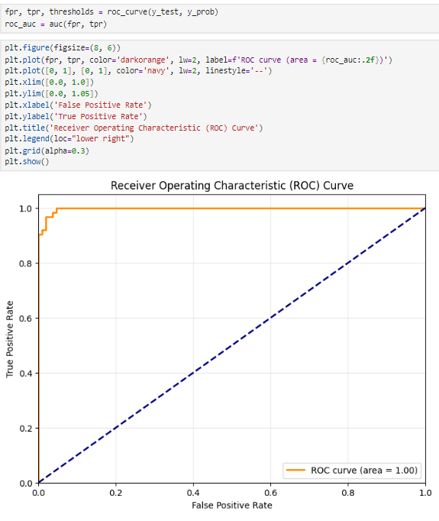

1.(Using Heart.csv file)
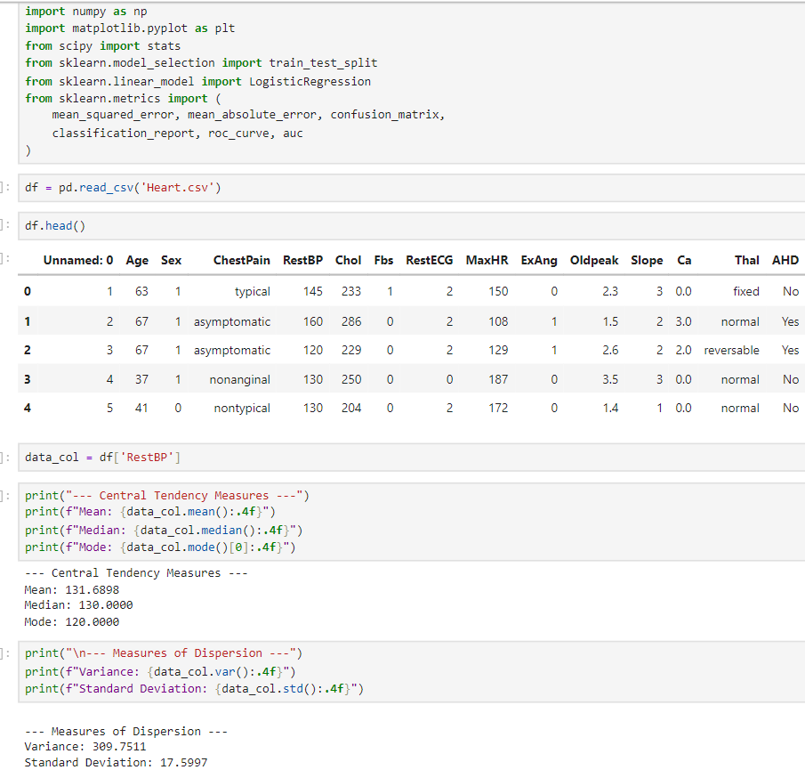

2.
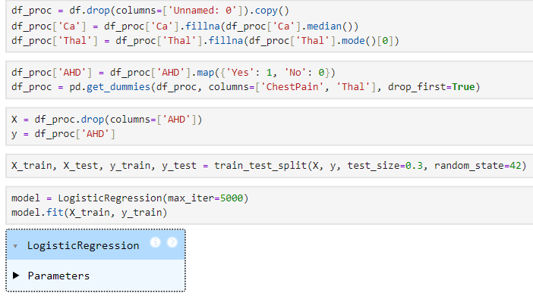
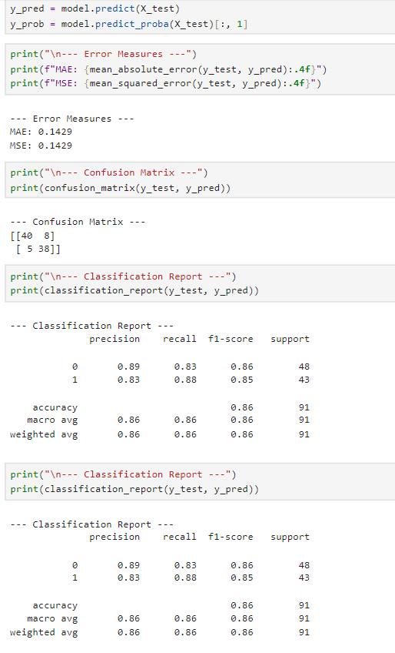

4. 