Healthcare Readmission Risk Prediction
Predicting 30-Day Hospital Readmission in Diabetic Patients

Executive Summary
This project builds a machine learning model to predict whether a diabetic patient's hospital encounter will result in readmission within 30 days, using the UCI Diabetes 130-US Hospitals dataset (101,766 encounters, 50 variables, 1999-2008). The goal is to flag high-risk patients at discharge so care teams can prioritize follow-up and reduce preventable readmissions.
After data cleaning, feature engineering, and testing three model families (Logistic Regression, Random Forest, and CatBoost), the final tuned CatBoost model achieves a ROC-AUC of 0.670 and PR-AUC of 0.228 on a held-out, patient-level test set. This is a modest but genuine improvement over a random-guess baseline (ROC-AUC 0.50) and is consistent with published benchmarks on this dataset, which is known to be a hard prediction problem given the information available.
The model correctly flags 47% of true 30-day readmissions (recall) at the cost of a 20% precision rate, meaning roughly 4 in 5 flagged patients will not actually be readmitted within 30 days. This trade-off, and the reasoning behind it, is discussed in the Results and Limitations sections below.

1. Problem Statement
Hospital readmissions are costly and, in many cases, preventable. For diabetic patients specifically, readmission within 30 days can indicate inadequate discharge planning, medication management issues, or unresolved complications. The objective of this project is:
- Predict, at the point of discharge, the probability that a given encounter will result in readmission within 30 days.
- Identify the clinical, administrative, and demographic factors most associated with early readmission.
- Produce a risk-tiered patient list (Low / Medium / High) that could plausibly support discharge-planning prioritization.

2. Data

2.1 Source and Structure
Two files were used: diabetic_data.csv (101,766 rows, 50 columns) containing encounter-level clinical and administrative data, and IDS_mapping.csv, a lookup table translating three coded ID fields (admission_type_id, discharge_disposition_id, admission_source_id) into human-readable categories.

2.2 Data Quality Issues Found
Missing values in the raw file are encoded as the character '?' rather than a blank cell — this was not obvious on first inspection and had to be handled explicitly (na_values='?') to get accurate missingness statistics. After correcting for this:
- weight: 96.9% missing — dropped.
- max_glu_serum: 94.7% missing — dropped.
- A1Cresult: 83.3% missing — retained, missingness recoded as 'Not Tested' (clinically meaningful — the test simply wasn't ordered).
- medical_specialty: 49.1% missing — recoded as 'Unknown'.
- payer_code: 39.6% missing — recoded as 'Unknown'.
- race, diag_1, diag_2, diag_3: under 2.3% missing each — recoded as 'Unknown'.
2,423 encounters with a discharge disposition of 'Expired' or 'Hospice' were removed (6 discharge codes total), since a deceased or hospice patient cannot be meaningfully readmitted and including them would distort the target definition. This reduced the working dataset from 101,766 to 99,343 encounters.
No duplicate rows or duplicate encounter IDs were found. The dataset contains 99,343 encounters across roughly 70,000 unique patients, confirming that some patients have multiple hospital visits — a key consideration for the train/test split (Section 5).

3. Target Variable
The target, early_readmission, was defined as 1 if the 'readmitted' field equals '<30' (readmitted within 30 days), and 0 otherwise (readmitted after 30 days, or not readmitted at all). This is a binary classification problem with meaningful class imbalance: roughly 11% of encounters are positive.
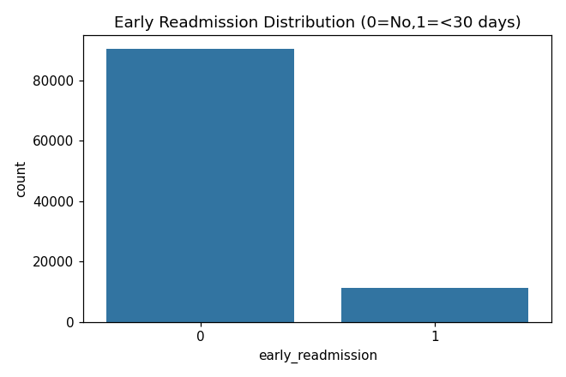

4. Exploratory Data Analysis
Readmission rate was examined against demographic factors (age, gender, race), hospitalization factors (admission type, admission source, discharge disposition), and numeric utilization variables (time in hospital, number of medications, number of prior inpatient/outpatient/emergency visits, number of diagnoses). Key patterns:
- Readmission risk increases with age, but the relationship flattens in the oldest age bands.
- Patients with more prior inpatient visits, more prior emergency visits, and more diagnoses show consistently higher readmission rates — prior utilization is a strong signal.
- Admission source and discharge disposition both show meaningful variation in readmission rate across categories, motivating their inclusion as engineered categorical features rather than being dropped.
Chi-square tests confirmed statistically significant associations (p < 0.001) between early_readmission and each of gender, race, age, admission type, admission source, discharge disposition, A1C test result, insulin status, diabetes medication status, and medication change status. Mann-Whitney U tests on the numeric utilization variables were likewise significant, confirming their distributions genuinely differ between readmitted and non-readmitted encounters — though statistical significance at this sample size does not by itself imply strong predictive power, which is why formal modeling was still necessary.
A variance inflation factor (VIF) check on the core numeric features found no severe multicollinearity (all VIF values well under the common threshold of 10), so no numeric features were dropped on that basis.

5. Feature Engineering and Leakage Control

5.1 Leakage-Excluded Columns
The following columns were explicitly excluded from modeling: readmitted and early_readmission (these define the target itself), encounter_id and patient_nbr (identifiers with no predictive meaning), and the raw *_id columns once their human-readable mapped versions were created, to avoid duplicate encoding of the same information.

5.2 Engineered Features
- num_med_changes — count of medications marked 'Up' or 'Down' during the encounter, capturing active dose adjustment.
- num_meds_active — count of medications not marked 'No', capturing total medication burden.
- total_prior_visits — sum of prior outpatient, emergency, and inpatient visits, capturing overall prior healthcare utilization.
- diag_1_group — the primary diagnosis code (diag_1) grouped into clinically coherent ICD-9 chapter groups (Circulatory, Respiratory, Digestive, Diabetes, Injury, Musculoskeletal, Genitourinary, Neoplasms, Other), rather than used as a near-unique raw code.
- Rare-category collapsing — categories with fewer than 1,000 encounters in medical_specialty, discharge_disposition, and admission_source were grouped into 'Other', reducing noise from sparsely populated categories.
The final modeling feature set spans 12 categorical and 11 numeric features (23 total before feature selection; see Section 8.4 for the reduced 19-feature final set).

6. Train / Test Split
A patient-level split was used (GroupShuffleSplit, 80/20, random_state=42), grouping by patient_nbr, to guarantee that no patient's encounters appear in both the training and test sets. This is essential given that the dataset contains repeated encounters for the same patient — a random row-level split would leak patient-specific information across the split and produce an overly optimistic performance estimate. The resulting split was 79,541 training encounters and 19,802 test encounters.

7. Baseline and Initial Model Comparison
Four models were trained and evaluated on the held-out test set: a majority-class baseline, Logistic Regression (class-balanced), Random Forest (class-balanced, 300 trees), and CatBoost (native categorical handling, scale_pos_weight for imbalance).
Model | Accuracy | Precision | Recall | F1 | ROC-AUC | PR-AUC
Baseline (majority class) | 0.888 | 0.000 | 0.000 | 0.000 | 0.500 | 0.112
Logistic Regression | 0.673 | 0.178 | 0.532 | 0.267 | 0.661 | 0.212
Random Forest | 0.689 | 0.186 | 0.527 | 0.275 | 0.665 | 0.219
CatBoost | 0.656 | 0.178 | 0.575 | 0.272 | 0.668 | 0.229

PR-AUC (area under the precision-recall curve) was prioritized over accuracy as the primary comparison metric, because with an 11% positive class rate, accuracy is dominated by correctly predicting the majority (non-readmitted) class and can be misleadingly high — the baseline's 88.8% accuracy despite zero predictive value illustrates this directly. CatBoost had the best PR-AUC and was carried forward for improvement.
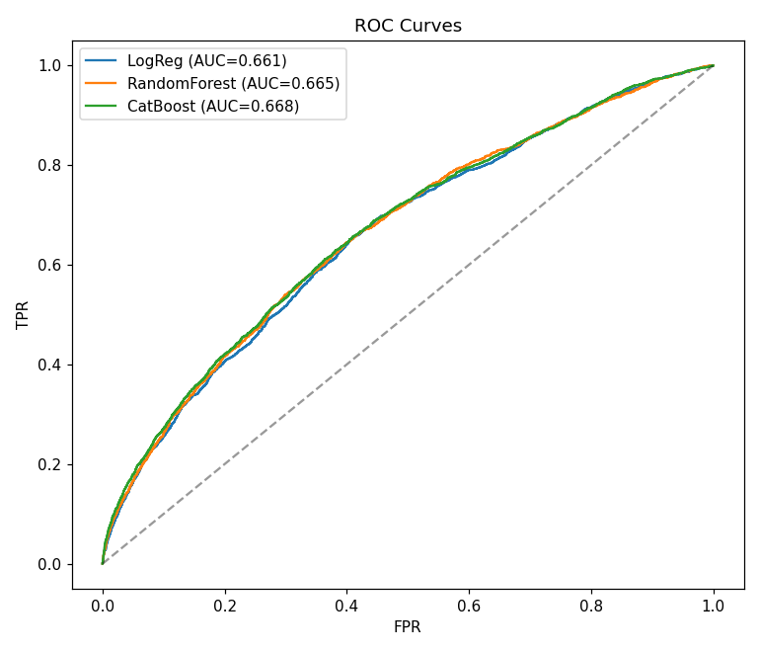

8. Model Improvement

8.1 Cross-Validation
The single train/test split was validated against 3-fold, patient-grouped, stratified cross-validation to check that the initial results were not an artifact of one particular split.
Model | ROC-AUC (mean ± std) | PR-AUC (mean ± std)
Logistic Regression | 0.660 ± 0.013 | 0.211 ± 0.010
Random Forest | 0.667 ± 0.013 | 0.214 ± 0.011
CatBoost | 0.669 ± 0.011 | 0.220 ± 0.009

CatBoost remained the strongest and most stable performer across folds, confirming the model choice.

8.2 Threshold Optimization
The default 0.5 probability cutoff is arbitrary and was not tuned for this problem's cost structure. Using out-of-fold CatBoost predictions from the cross-validation step, precision, recall, and F1 were computed across thresholds from 0.15 to 0.90. A threshold of 0.54 maximized F1 (precision 0.202, recall 0.460, F1 0.281). An alternative threshold of 0.42 was also identified for use cases prioritizing recall over precision (recall 0.753 at precision 0.155) — for example, if the cost of missing a true readmission is judged to significantly outweigh the cost of an unnecessary follow-up call.
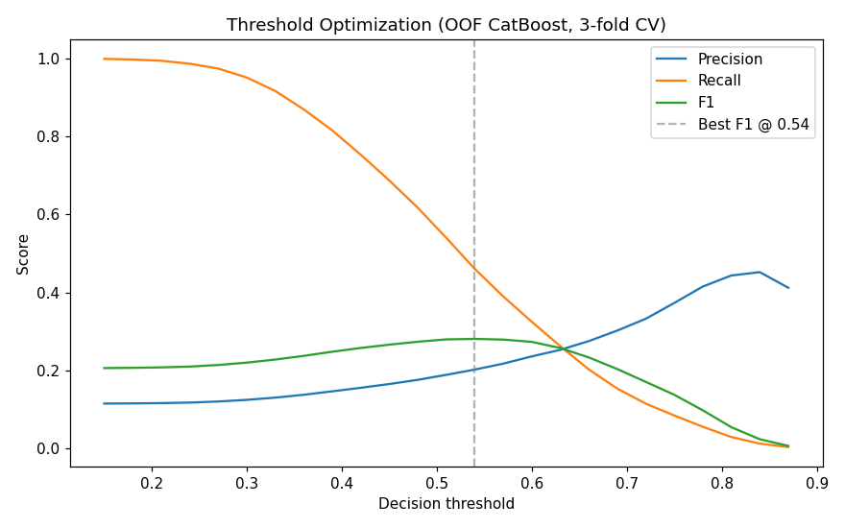

8.3 Hyperparameter Tuning
A randomized search over CatBoost's depth, learning_rate, l2_leaf_reg, and iterations parameters was run using 2-fold, patient-grouped cross-validation, scored on PR-AUC. The best configuration found was depth=8, learning_rate=0.05, l2_leaf_reg=5, iterations=200, achieving a mean PR-AUC of 0.220 in the search (comparable to the untuned default, indicating the model was already reasonably well-specified and the ceiling here is closer to a data-availability limit than a tuning limit).

8.4 Feature Re-Selection
Using the tuned model, the four lowest-importance features (number_outpatient, num_procedures, num_med_changes, change) were dropped and performance was compared via 2-fold cross-validation. The reduced 19-feature set achieved a PR-AUC of 0.2207 versus 0.2198 for the full 23-feature set — a negligible difference — so the reduced set was kept as the simpler, equally performant final feature set.
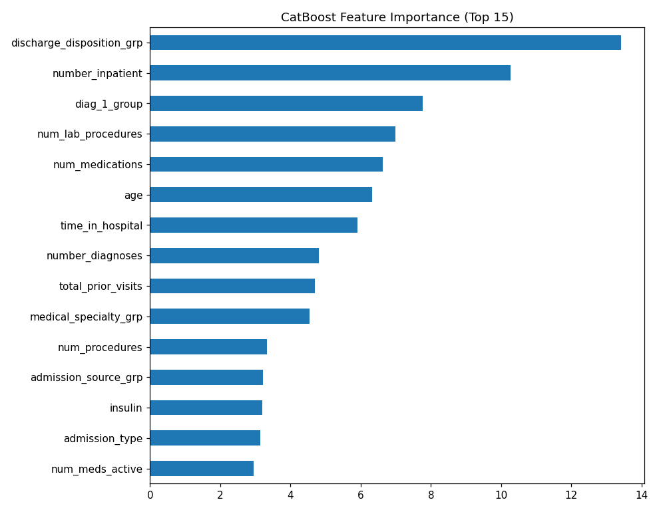
The strongest predictors were the primary diagnosis group (diag_1_group), total prior healthcare utilization (total_prior_visits), age, number of diagnoses, and A1C test result — broadly consistent with clinical intuition: patients with more diagnoses, more prior utilization, and more complex diabetes management are at higher readmission risk.

9. Final Model and Results
The final locked model is CatBoost with the tuned hyperparameters and reduced feature set above, evaluated once on the held-out test set (not touched again after this evaluation, to avoid overfitting the reported metric to repeated test-set peeking):
Metric | Value
ROC-AUC | 0.670
PR-AUC | 0.228
Precision (readmit class) | 0.196
Recall (readmit class) | 0.474
F1 (readmit class) | 0.277
Operating threshold | 0.54

At this operating point, the model correctly identifies 1,051 of the 2,216 true 30-day readmissions in the test set (47.4% recall), while flagging 4,315 encounters that were not actually readmitted within 30 days (false positives). In a real deployment, this means the model is best used as a triage aid — narrowing a large population down to a smaller, higher-risk subset for human review — rather than as an autonomous decision-maker.

Risk Tiers
Every encounter was scored and assigned to a risk tier based on predicted probability quantiles: Low (below the 50th percentile), Medium (50th-85th percentile), and High (above the 85th percentile). Across the full dataset (99,343 encounters): 49,671 Low, 34,770 Medium, and 14,902 High risk.

10. Limitations
- Overall predictive power is modest (ROC-AUC ~0.67). This is consistent with published results on this dataset and reflects a genuine ceiling: the available fields (largely administrative and coarse clinical codes) do not capture many of the clinical nuances that actually drive readmission, such as detailed lab trends, social determinants of health, or care-transition quality.
- Precision at the chosen threshold is low (0.196) — roughly 4 out of 5 flagged patients will not be readmitted within 30 days. This is an inherent consequence of the low base rate (~11%) combined with the model's discriminative power, not a bug.
- The dataset spans 1999-2008 and reflects the clinical practice patterns and coding conventions of that era; predictions may not generalize to current clinical settings without revalidation.
- The model was tuned and evaluated with reduced cross-validation fold counts (2-3 folds) and a small hyperparameter search space to fit compute constraints; a more exhaustive search might yield marginal further gains but is unlikely to fundamentally change the conclusions above.

11. Recommendations and Next Steps
- Deploy as a triage/prioritization tool for discharge planning, not as an automated denial or intervention trigger — the false-positive rate is too high for autonomous use.
- Pair the High-risk tier with a human-reviewed discharge checklist (medication reconciliation, follow-up appointment scheduling, patient education) rather than an automated action.
- If richer data becomes available (lab result trends over time, social determinants, post-discharge follow-up compliance), retrain — this is the most likely path to a meaningfully higher ceiling.
- Periodically re-validate the model against current-era data before any production use, given the age of the training data.
- Build a Power BI dashboard on the exported predictions (readmission_predictions_final.csv) to make risk tiers, demographic breakdowns, and driver features accessible to non-technical stakeholders.

Appendix A: Final Feature List
race, gender, age, admission_type, admission_source_grp, discharge_disposition_grp, medical_specialty_grp, A1Cresult, diag_1_group, insulin, diabetesMed, time_in_hospital, num_lab_procedures, num_medications, number_emergency, number_inpatient, number_diagnoses, num_meds_active, total_prior_visits

Appendix B: Files Delivered
- Healthcare_Readmission_FULL.ipynb — complete, executed analysis notebook (data understanding through final predictions).
- data/ — source data files (diabetic_data.csv, IDS_mapping.csv).
- outputs/ — all generated plots, model_comparison.csv, cv_results.csv, hyperparam_search.csv, final_model_summary.json, readmission_predictions_final.csv (the Power BI-ready export).

