Resolved: US public K-12 schools should be allowed to regulate students’ off-campus electronic speech.

Definitions

Regulation (Black’s Law): The act of regulating; a rule or order prescribed for management or government; a regulating principle; a precept.

* (Merriam-Webster): to bring (something) under the control of authority.

Monitor (thelawdictionary.org): To keep track of, to check, to supervise, or to watch.

Control (Merriam-Webster): to direct the behavior of a person: to cause a person to do what you want.

Public School (Merriam-Webster): a school that gets money from and is controlled by a local government.

Chilling effect (uslegal.com): Term in law and communication that describes a situation where a speech or conduct is suppressed by fear of penalization at the interests of an individual or group. It can affect one’s free speech. Since many attacks rely on libel law, the term libel chill is also often used. The term chilling effect has been in use in the U.S since 1950.

Law of large numbers: poll size must be 1/10 total population

Potential warrants

Pro:

* Drug/alcohol use

Students are exposed to drug/alcohol use on social media and off. According to teendrugrehabs.com, who received a poll from the government about drug use, nearly 50% of high school students admit to doing drugs. More than 60% say that drugs are regularly used and marketed in their school. Personally, I’ve seen seniors at my school doing drugs. Everybody knows about the drug problem - why must social media be regulated?

* Cheating

While they are cheating, regulation of electronic speech would not solve the problem of cheating. Students can easily print out papers and give them to their friends. If they’re truly worried about being tracked, they could easily download a free VPN or hide their IPs. The bottom line is, regulating social media will not fix the cheating problem.

* Students need to know how to act when adults

The best way to learn is through experience. By staying on the internet, students are

getting real-world experience of the real world.

* Tinker vs Des Moines

On campus and without internet. Had Tinker posted a blog advocating for a truce in the Vietnam war, would they have been suspended?

* Cyberbullying/suicide - 4500 kids commit suicide every year according to cyberbullyhotline.com

Stephanie Pappas, a specialist in psychology and neuroscience, said that “cyberbullying on social media is linked to depression in teenagers.” According to Kevin Caruso, a suicide survivor and founder of suicide.org, a website devoted to research and prevention of suicide, “over 90 percent of people who die by suicide have a mental illness at the time of their death.” Why is this relevant? Rather than focusing our efforts on limiting the rights of children, we should be looking for psychiatrists to talk to our youth.

* A study conducted in October 2015 proved that “some state laws have helped significantly reduce instances of bullying and cyberbullying among teens.” There is no need to create more regulation laws when this has been proven.
* I know from past experience that when teachers watch or monitor students, they feel inclined to show off their wits. You say that students will be too scared of authority to express their opinions, but why wouldn’t they feel inclined to show off their wits like they have been for generations?

Con:

* KiVa is a bullying prevention program. According to their website, “in Finland KiVa has been evaluated in a large randomized controlled trial including 117 intervention schools and 117 control schools. The program has been shown to reduce both self- and peer-reported bullying and victimization significantly. It influences multiple form of victimization, including verbal, relational, physical, and cyberbullying. In addition, positive effects on school liking, academic motivation and achievement have been reported. KiVa also reduces anxiety and depression and has a positive impact on students' perception of their peer climate. A remarkable 98% of victims involved in discussions with the schools' KiVa teams felt that their situation improved. Finally, Finnish data from more than 1000 schools that started the implementation of KiVa in fall 2009 showed that after the first year of implementation, both victimization and bullying had reduced significantly. KiVa is now being evaluated in several countries: the first international studies from the Netherlands, Estonia, Italy, and Wales are emerging, showing that KiVa is effective outside of Finland as well.” (Prevention, intervention, and monitoring)
* Limits free speech

The majority of students are minors who don’t know how to exercise their rights or live as adults. According to findlaw.com, “children have a limited right to free speech.” While yes, their access to free speech helps them learn how to utilize the first amendment, their denial teaches them self-control. Given permission, schools would not prevent students from expressing themselves, only regulate and act upon abusive behavior.

* Students need to exercise their rights in order to become successful adults

See above.

* Students need to learn about the “real world”

For the same reasons that children are kept from watching rated R movies or from seeing other disturbing videos, they do not need to learn about the “real world.” Take a step back from arguing about the guaranteed rights of students and think about the innocence of students. By not limiting free speech, we are leaving kids exposed to many worldly problems.

* Many students are legally adults (counter to minor argument)

After 16, students are choosing to go to school, and thus are even more under school laws than minors are. Furthermore, should an adult commit an online crime, s/he would be tried as an adult, not a minor.

* Vague phrasing in many laws

We are looking at a moral question about whether or not schools have the right to regulate students’ speech on the internet - past students’ experiences are irrelevant.

* Violation of privacy

Safety comes before privacy.

* Mixed messages of free speech

Yes, schools are denying their students free speech, but this “mixed message” won’t interfere with their learning of the topic. In fact, my partner and I would argue that this limitation teaches students the boundaries between their legal rights and social norms. We don’t want a generation of adults who abuse others while staying just inside legal parameters.

* Authorities always in control

The fact of the matter is that authorities always are in control. When students grow up, they become adults and must learn to listen to their bosses.

* Gives students responsibilities to learn from

Yes, giving students would help them learn how to utilize their rights, but is the risk of bullying and potential suicide really worth the experience of a potentially slightly advantageous learning experience?

* No need for any *more* free speech laws - students get punished for anything incriminating

That’s assuming people find out. Many targeted students are too afraid of admitting to being bullied online or not and bullies get off scot-free.

* Learning how to utilize free speech is part of “learning” and schools definitely should not have the right to prohibit that

Once again, safety is more important than learning. Schools also have an obligation to keep their students physically and emotionally safe.

* Anti-bullying laws/school intervention don’t help

According to Rachel C. Vreeman and Aaron E. Carroll, both American pediatricians, “Many school-based interventions directly reduce bullying, with better results for interventions that involve multiple disciplines.”

* Reid Sagehorn-suspended for 7 weeks and threatened with expulsion after sarcastically “jokingly tweeted ‘actually yeah’ in response to a question about whether he had made out with one of his high school teachers,” according to Scholar in Mass Communication, Clay Calvert. If schools were given permission to regulate students’ off-campus electronic speech, who

Clay Calvert is a specialist in the First Amendment. While this can be used to vet your point, isn’t it possible that he’s biased?

* Schools are innately racist and attack students of color more often.

Stephen T. Russell, PhD, Katerina O. Sinclair, PhD, and Paul Poteat, PhD conducted a study regarding bullying minorities. In a survey, conducted on “2 large population-based studies of adolescents,” more than ⅓ of students admitted to being bullied in a biased way. Some schools may be racist, but the racism prevented with regulation is more important. Furthermore, “girls are about twice as likely as boys to be victims and perpetrators of cyberbullying,” according to dosomething.org. You state that children of color are twice as likely to be persecuted as offenders, yet I have proof that girls are twice as likely as boys to be victims and perpetrators. How can you be sure that this is bias and not just children of color committing more crimes?

* According to dosomething.org, only 1 in 10 victims of cyberbullying will report their abuse to a parent or trusted adult.

Web sites

Case Law

[Tinker vs. Des Moines](https://www.law.cornell.edu/supremecourt/text/393/503)

[Bethel vs. Fraser](https://www.law.cornell.edu/supremecourt/text/478/675)

[Hazelwood vs. Khulmier](https://www.law.cornell.edu/supremecourt/text/433/347)

[Frederick vs. Morse](https://www.law.cornell.edu/supct/cert/06-278)

[Cyber-bullying](http://cyberbullying.org/cyberbullying-legal-issues.pdf)

[Sameer Hinduja](http://www.hinduja.org/)

[Justin W. Patchin](http://people.uwec.edu/patchinj/)

[Safety and cyber-bullying](http://heinonline.org/HOL/Page?handle=hein.journals/vanlr63&div=24&g_sent=1&collection=journals)

[First Amendment](http://www.firstamendmentcenter.org/cyberspeech)

<http://theconversation.com/can-schools-punish-students-for-off-campus-online-speech-52466>

<http://www.splc.org/article/2015/12/student-suspended-for-two-word-sarcastic-tweet-to-receive-425000-in-settlement>

<http://www.meganmeierfoundation.org/statistics.html>

<http://family.findlaw.com/emancipation-of-minors/what-are-the-legal-rights-of-children.html>

<http://news.jrn.msu.edu/bullying/2012/04/01/bullies-as-adults/>

<http://www.npr.org/sections/health-shots/2013/08/19/213502228/kids-involved-in-bullying-grow-up-to-be-poorer-sicker-adults>

<http://archpedi.jamanetwork.com/article.aspx?articleid=569481&resultclick=1>

<http://www.teendrugrehabs.com/facts-and-stats/>

<http://turningpointcenters.com/blog/socialmediateendruguse/>

<http://www.pacer.org/bullying/about/media-kit/stats.asp>

<http://www.governing.com/news/headlines/49-States-Now-Have-Anti-Bullying-Laws-Hows-that-Working-Out.html>

<http://www.governing.com/news/headlines/are-anti-bullying-efforts-making-things-worse.html>

<http://www.bullyingstatistics.org/content/bullying-and-suicide.html>

<https://www.dosomething.org/us/facts/11-facts-about-cyber-bullying>

<http://www.kivaprogram.net/is-kiva-effective>

<http://www.cbsnews.com/news/how-well-are-state-anti-bullying-laws-working/>

Victims

[Ryan Halligan](http://www.ryanpatrickhalligan.org/)

[Megan Meier](http://www.meganmeierfoundation.org/megans-story.html)

[Amanda Todd](http://www.newyorker.com/culture/culture-desk/the-story-of-amanda-todd)

[Jessica Logan](http://www.cbsnews.com/pictures/victims-of-bullying/11/)

[Hope Witsell](http://www.cnn.com/2010/LIVING/10/07/hope.witsells.story/)

[Tyler Clementi](http://tylerclementi.org/tylers-story/#)

Regulations of 1st amendment

[Center for Public Education](http://www.centerforpubliceducation.org/Main-Menu/Public-education/The-law-and-its-influence-on-public-school-districts-An-overview/Free-speech-and-public-schools.html)

[Tinker vs. Des Moines](https://www.law.cornell.edu/supremecourt/text/393/503)

[Internet](http://www.history.com/news/ask-history/who-invented-the-internet)

[Social Media](http://historycooperative.org/the-history-of-social-media/)

Dictionary:

[Public Schools](http://www.merriam-webster.com/dictionary/public%20school)

[K-](http://www.macmillandictionary.com/us/dictionary/american/k-12)12

Dark Web

This depends on what you're using it for.

Using the deep web in general has many legal complications. That being said, if you're using Tor for *any reason*, it's probably because you value a sense of anonymity.

I've spent hours on the deep web without absolutely any security steps taken prior. I knew what I would be doing and where I would end up. I knew which links I'd be visiting and I knew for certain that they weren't questionable or illegal in any way. Usually when exploring this way,

In contrast, a VPN isn't even remotely all you need in order to securely explore Tor. I will copy and paste an answer to a question that will further detail what exactly I'm referring to in that regard. There are aspects of the deep web that could get you in serious trouble- by that, I mean you'd be lucky to suffer legal consequences as a result.

There are a multitude of required steps that must be taken in order to ensure the most amount of potential anonymity while browsing the deep web. Quickly "Googling" it wouldn't really do you justice. You need a fairly solid understanding of how Tor works and the implications involved with things such as downloads, using Java while on Tor, etc.

Here's the link to that question: [Jordan Hölzel's answer to Is it illegal to surf/browse the deep web?](https://www.quora.com/Is-it-illegal-to-surf-browse-the-deep-web/answer/Jordan-H%C3%B6lzel)

Cheers.

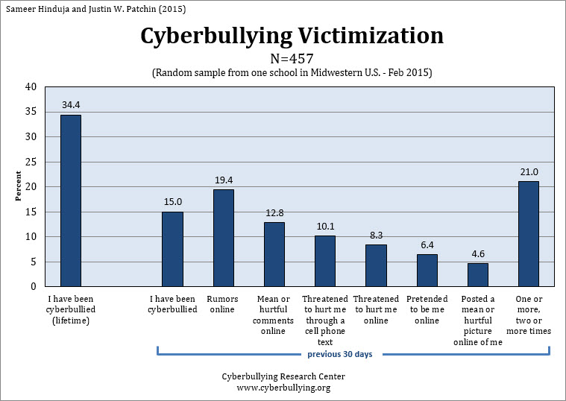

http://www.stopbullying.gov/laws/federal/index.html