**PONDICHERRY UNIVERSITY**

**(A CENTRAL UNIVERSITY)**



**SCHOOL OF ENGINEERING AND TECHNOLOGY**

**DEPARTMENT OF COMPUTER SCIENCE**

**M.SC. COMPUTER SCIENCE**

**PONDICHERRY UNIVERSITY**

NAME : DEBAYAN PAL

REGISTER NO : 23370016

SEMESTER : 3rd SEMESTER

SUBJECT : ISM

**SMART BOARD**

**What is a Smart Board?**

A Smart Board is an interactive whiteboard. It lets you control a computer using touch, a stylus, or gestures. Unlike traditional whiteboards, Smart Boards allow you to interact with digital content in real-time. You can write, draw, click, drag, and drop items just like you would on a tablet or smartphone. These boards come with various software options, allowing users to run presentations, draw diagrams, and even connect to the internet.

Smart Boards first emerged in the early 1990s. The technology was quickly adopted in educational settings with smart classrooms, where it provided new ways to engage students. Today, Smart Boards are found in schools, businesses, and even homes. They serve as a central hub for collaborative work and learning and come with a variety of features.

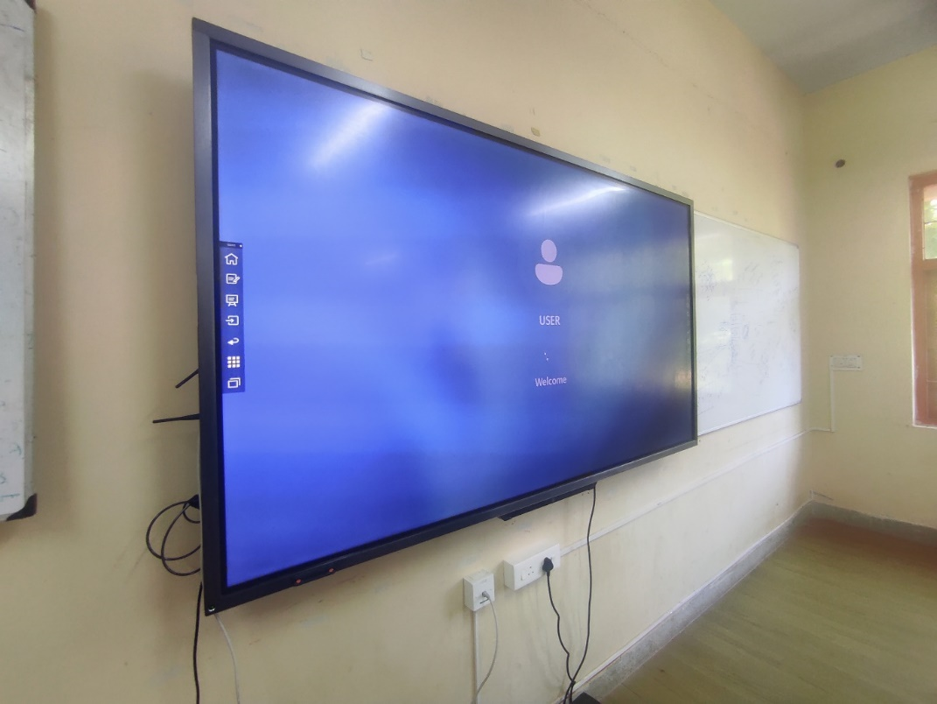

**Features of a Smart Board:**

Touchscreen Interface

Multi-touch Capability

Digital Ink

Screen Sharing

Interactive Software

Connectivity

Audio and Video Integration

Customizable Interface

Cloud Integration

White board

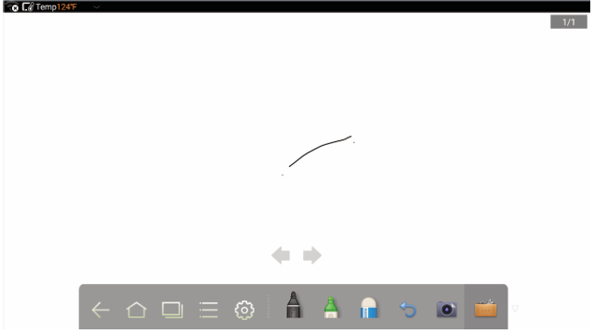

**Uses of Smart Boards:**

**1. Education**

Interactive Lessons

Collaborative Learning

Instant Feedback

**2. Corporate Settings**

Interactive Presentations

Brainstorming Sessions

Remote Collaboration

**3. Healthcare**

Medical Training

Patient Education

Team Collaboration

**4. Retail**

Interactive Displays

Training

Operations Management

**Benefits of Using a Smart Board**

1. Enhanced Engagement

2. Improved Collaboration

3. Versatility

4. Increased Productivity

5. Accessibility

6. Cost-Effective

7. Environmental Benefits

8. Real-Time Feedback

9. Long-Term Durability

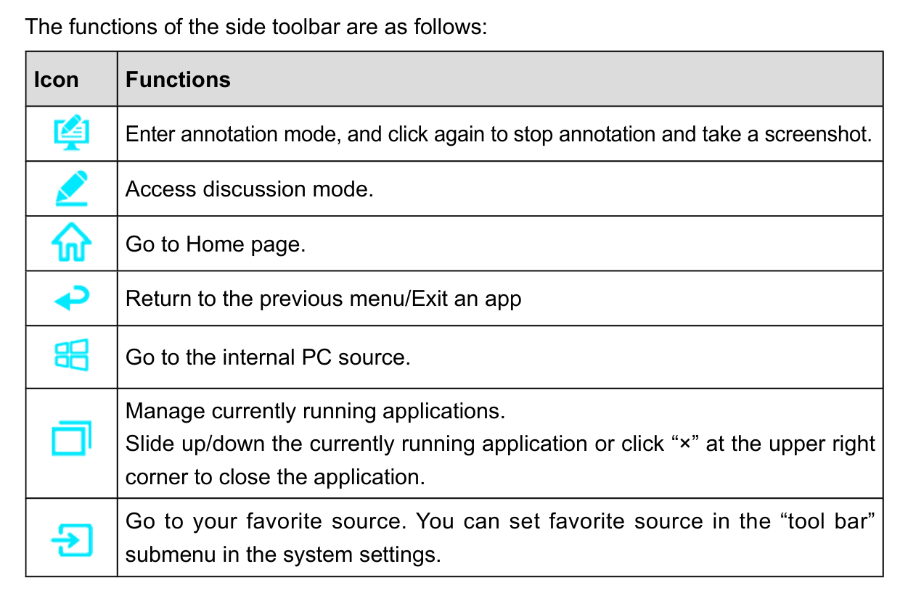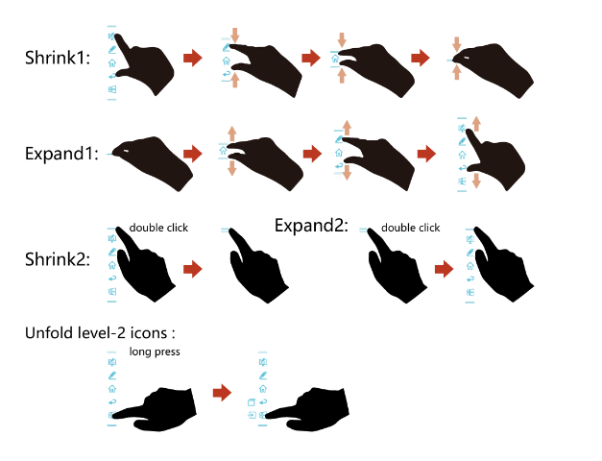

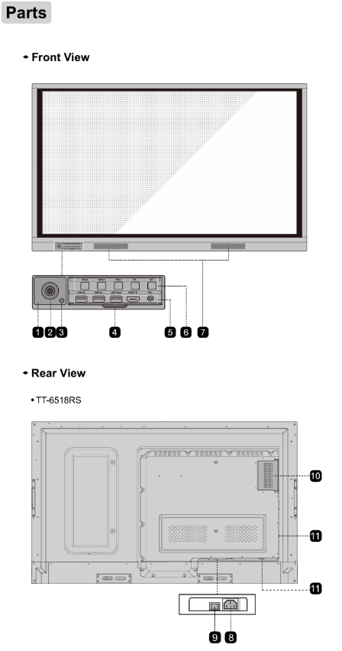

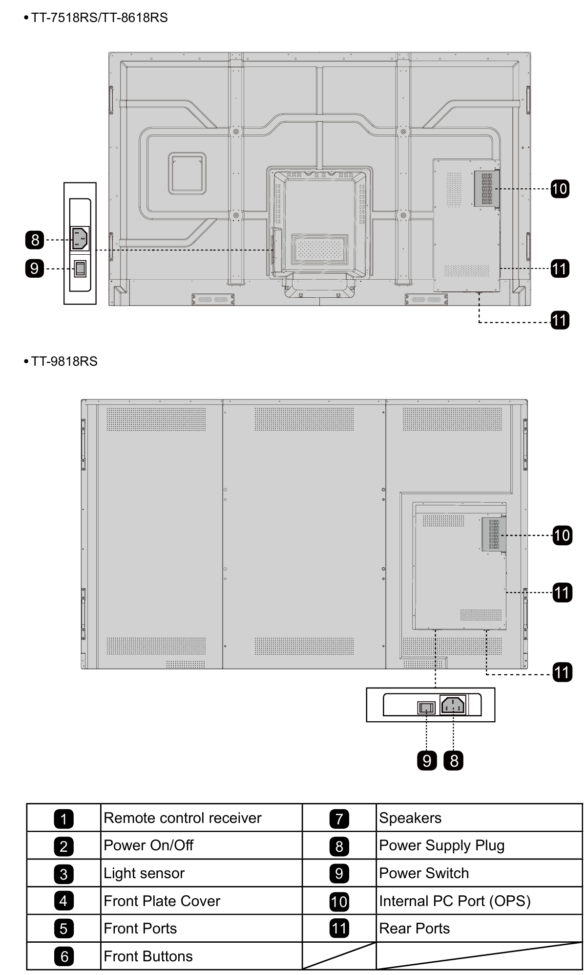

**Specifications:**

|  |  |
| --- | --- |
| **Model** | **TT-6518RS** |
| Display  Backlight | LED |
| Display Area | 56.24 x 31.63 in 1428.5 x 803.5 mm |
| Active Screen Size | 65.00 inch |
| Display Ratio | 16:9 |
| Resolution | 3840 x 2160 Pixel |
| Display Colors | 8 bit, 1.07 billion colors |
| Brightness | ≥ 350 cd/m² |
| Contrast | 4000:1 |
| Response Time | ≤ 8 ms |
| Life Time | 30000 h (Min.) |
| Speaker Position | Forward |
| Max. Power Output | 2 x 15 W |
| Microphone Type | 3.5 mm interface |
| Electrical:  Power Consumption | Maximum ≤ 220  W  Standby Mode ≤  0.5 W |
| Working Voltage | AC 100 V – 240 V, 50 Hz / 60 Hz |
| Touch Surface | Anti-glare tempered glass |
| Transparency | 88% |
| Surface Hardness | 7H |
| HID support | YES |
| Touch Points | 10 Points in Smart system 20 Points in Windows |
| Writing Tools | Eraser, Stylus or Finger |
| Scan Speed | 10 ms |
| Positioning Accuracy | Center area 1.0 – 1.5 mm / Edge area 1.2 – 2.0 mm |
| Communication Interface | USB-A |
| Storage  Temperature/  Humidity | -14 °F – 122 °F / 20% – 70% |
| Working Temperature/ Humidity | 32 °F – 104 °F / 20% – 70% |
| Outline Dimension | 60.87 x 37.1 x  3.74 in  1546 x 943 x  95 mm |
| Packing Dimension | 67.91 x 42.72 x  11.02 in  1695 x 1075 x  275 mm |
| Front Interface Inputs | HDMI In x 1, USB (Touch) x 1, USB (Public) x 2, Microphone In x 1 |
| Rear Interface Inputs | HDMI In x 2, DP x 1, USB (Touch) x 4, HDMI Out x 1, Line Out x 1, DC Out (5V, 2A), SPDIF out x 1, USB 2.0 (Public) x 1, USB 2.0 (Embedded) x 1, RS-232 x 1, USB 3.0 (Public) x 1, Audio In x 1, VGA x 1, LAN In x 1, LAN Out x 1, OPS Slots (4K@60 Hz) |
| Chip | ARM A53 x 4, 1.4 GHz |
| RAM | 2 GB |
| Flash | 8 GB |
| Net Weight | approx. 44 kg |
| Installation Method | Wall-mounted / Floor Stand |

**CCTV**

**System Overview**: The Dahua 4 MP Starlight+ ePoE camera offers Analytics+ functions at the edge – performing complex real-time face capture, people counting, and perimeter protection surveillance. The Dahua Analytics+ algorithms significantly improve accuracy and reliability as compared to standard intelligent features. The camera is ideal for a host of diverse applications — Starlight+, True Wide Dynamic Range, and Smart IR technologies allow the camera to operate in any lighting condition and the IP67 and IK10 rating make the camera suitable for the harshest environments.

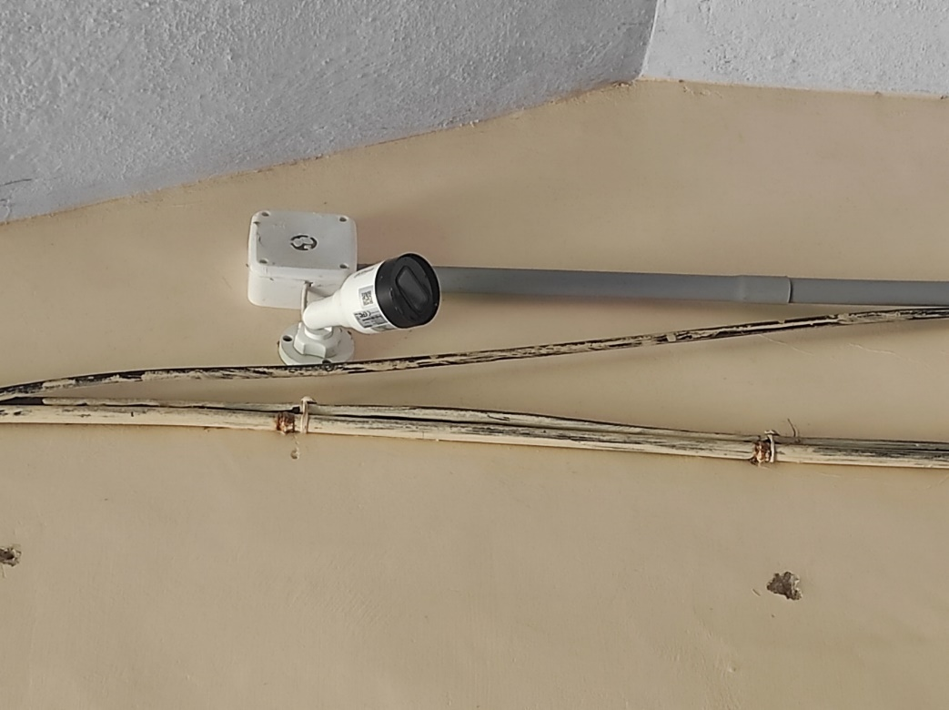

**Functions**

**Face Capture:**

Dahua Analytics+ with Face Capture technology automatically captures

faces from a digital image or from a video frame. The camera employs

advanced algorithms to locate faces quickly and accurately from the

source video and then captures the facial image.

**Facial Attributes:**

Once the camera captures a facial image, it analyzes the face and

extracts six attributes — age, gender, expression, and whether the target

face wears glasses, wears a mask, or sports facial hair.

**People Counting:**

The camera uses complex real-time people counting algorithms to

deliver accurate flow statistics from two distinct people counting

functions, Line Crossing and Regional. The line crossing function counts

the number of people crossing a defined line, and the regional function

counts the number of people in a distinct, user-defined area. People

counting is ideal for measuring the number of customers entering or

exiting a location and to monitor groups of people in a distinct location.

**Perimeter Protection:**

Dahua Analytics+ includes Tripwire and Intrusion functions that offer

custom tripwires based on object type for automation in limited access

areas. Perimeter Protection requires less pixels to detect an object to

deliver improved accuracy and decreased false alarms due to lights, weather, trees, or animals.

• 1/1.8-in. 4 MP Progressive-scan CMOS Sensor

• Triple-stream Encoding

• Smart H.265+ and Smart H.264+ Dual Codec

• 4 MP (2688 x 1520) at 30 fps, 2.7 mm to 12 mm Motorized Lens

• Enhanced Power and Data Transmission Distances (ePoE)

• Starlight+ Technology for Low-light Applications

• Analytics+ Functions — Face Capture, Facial Attribute Extraction,

People Counting, and Perimeter Protection

• ArcticPro Series Camera - Operational down to –40° C (–40° F)

• IP67 Ingress Protection and IK10 Vandal Resistance

• True Wide Dynamic Range (120 dB) and Day/Night IR Cut Filter

• Maximum IR LED Distance 50 m (164.04 ft)

• Intelligent Video System

**Technical Specification**

|  |  |
| --- | --- |
| Camera  Image Sensor | 1/1.8-in. 4 MP CMOS |
| Effective Pixels | 2688(H) x 1520(V) |
| RAM/ROM | 1 GB / 128 MB |
| Scanning System | Progressive |
| Electronic Shutter Speed | Auto, Manual, 1/3 s to 1/100,000 s |
| Minimum Illumination Color: | 0.0024 lux at F1.8 (1/3 s, 30 IRE) Color: 0.029 lux at F1.8 (1/30 s, 30 IRE) 0 lux at F1.8 (with IR on) |
| S/N Ratio | Greater than 56 dB |
| IR Distance | Distance up to 50.0 m (164.04 ft) |
| IR On/Off Control | Auto, Manual |
| IR LEDs | Three (3) |
| Lens  Lens Type | Motorized |
| Mount Type | Board-in |
| Focal Length | 2.7 mm to 12 mm |
| Max. Aperture | F1.8 |
| Angle of View | Horizontal: 114° to 47°  Vertical: 62° to 26° |
| Optical Zoom | 4.4x |
| Aperture Control | Auto |
| Close Focus Distance | 1.20 m (3.94 ft) |
| DORI  Distance¹   |  | | --- | | Lens | | Wide | | Telephoto | | |  |  |  |  | | --- | --- | --- | --- | | Detect (8 ppf) | Observe (19 ppf) | Recognize (38 ppf) | Identify (76ppf) | | 58 m (190ft) | 23 m (75 ft) | 12 m (39 ft) | 6 m (20 ft) | | 131 m (430ft) | 52 m (171 ft) | 26 m  (85 ft) | 13 m (43 ft) | |
| Video  Compression | Smart H.265+, H.265, Smart H.264+, H.264, H.264B, H.264H, MJPEG (sub stream only) |
| Streaming Capability | Three (3) Streams |
| Resolution | 4 MP (2688 x 1520),2560 x 1440, 2304 x 1296, 1080p (1920 x 1080), 1.3 MP (1280 x 960), 720p (1280 x 720), D1 (704 x 480), VGA (640 x 480), CIF (352 x 240) |
| Frame Rate | Main Stream:4 MP(2688 x 1520)at 30fps  Sub Stream 1: D1 at 30 fps  Sub Stream 2: 1080p at 11 fps |
| Bit Rate Control | CBR/VBR |
| Bit Rate | H.264: 32 Kbps to 8192 Kbps  H.265: 19 Kbps to 8192 Kbps |
| Day/Night | Auto (ICR), Color, B/W |
| BLC Mode | BLC, HLC, True WDR (120 dB), SSA |
| White Balance | Auto, Natural, Street Lamp, Outdoor, Manual, Regional Custom |
| Gain Control | Auto, Manual, Gain Priority, Shutter Priority |
| Noise Reduction | 3D DNR |
| Motion Detection | Off, On (4 Zones, Rectangular) |
| Region of Interest | Off, On (4 Zones) |
| Advanced Features | Electronic Image Stabilization (EIS), Smart IR, Defog |
| Flip | 0°, 90°, 180°, 270° |
| Audio  Compression | G.711a, G.711Mu, AAC, G.726, G.723 |
| Network  Ethernet | RJ-45 (10/100 Base-T) |
| Protocol | HTTP, HTTPS, TCP, ARP, RTSP, RTP, UDP, SMTP, FTP, DHCP, DNS, DDNS, PPPOE, IPv4/v6, QoS, UPnP, NTP, ICMP, IGMP, 802.1x |
| Interoperability | ONVIF Profile S and G, CGI, Milestone, Genetec, P2P |
| Streaming Method | Unicast / Multicast |
| Maximum User Access | 20 Users |
| Edge Storage | Network Attached Storage (NAS) FTP Micro SD Slot, maximum 256 GB |
| Web Viewer | IE (Version 8 and higher), Chrome, Firefox, Safari (Version 12 and higher) |
| Management Software | SmartPSS, DSS, P2P |
| Smart Phone | IOS, Android |
| Certifications  Safety | UL60950-1 CAN/CSA C22.2 No.60950-1-07 EN60950-1 |
| Electromagnetic Compatibility (EMC) | FCC CFR 47 Part 15 Subpart B Electromagnetic Compatibility Directive 2014/30/EU |
| Audio | Input: One (1) Channel Output: One (1) Channel |
| Alarm | Input: Two (2) Channels (5 mA, 5 VDC) Output: One (1) Channel (300 mA, 12 VDC) |
| Electrical  Power Supply | 12 VDC or PoE+ (IEEE 802.3at, Class 4) |
| Power Consumption  12 VDC | Standard: 3 W with IR ON: 12.1 W with heater ON: 10.3 W |
| Power Consumption  PoE+ | Standard: 3.7 W with IR ON: 15.2 W with heater ON: 12.5 W |
| Operating Conditions | –40° C to +60° C (–40° F to +140° F), 10% to 95% RH |
| Storage Conditions | –40° C to +60° C (–40° F to +140° F), 10% to 95% RH (daily temperature difference within 15° C/59° F ) |
| Ingress Protection | IP67 |
| Vandal Resistance | IK10 |
| Casing | Metal and Plastic |
| Dimensions | 273.20 mm x 95.0 mm x 95.0 mm (10.76 in. x 3.74 in. x 3.74 in.) |
| Net Weight | 1.11 kg (2.44 lb) |
| Gross Weight | 1.51 kg (3.33 lb) |

