Linux Programming: Assignment-1: 20-09-2025

Name: Debayan Nath
USN: ENG24CY0097
Batch: Cyber 3C
Roll: 48

- What is Linux Operating System (OS)? List three pros and cons of it. (CO1) .
Linux is a free and open-source operating system. It is based on the Unix architecture. It is built around the linux kernel, which manages hardware resources like memory, CPU, I/O devices. Linux is known for its stability, security, and flexibility.

Pros of LINUX OS:
-OPEN Source OS & FREE to use for users all over the world.
-HIGH SECURITY compared to other OS.
-LIGHTWEIGHT as it can run on low end Hardware.

Cons of LINUX OS:
-Limited Compatibilty as some commercial apps and games are not available for LINUX.
-DRIVER ISSUES as certain hardware components may not have linux drivers.
-DIFFICULT for new users changing from Windows or macOS.

- Differentiate between Linux, Mac, Android, and Windows OS with at least six unique features. (CO1)
LINUX
-Open source.
-Highly customisable.
-Runs on PCs, embedded systems.
-Strong security
-Limited apps and games.
-Full control over OS.
macOS
-Closed source
-Sleek UI.
-Exclusive for Apple devices.
-Strong apple ecosystem security.
-Optimzed for productivity.
-Limited customization.

Android
-Open Source
-Touch optimized
-Used in smartphones, tablets, smart TVs.
-Frequent security patches and updates
-Millions of apps are available.
-Moderate customization

Windows
-Closed Source
-Easy to understand UI
-Used in PCs, laptops
-Regular updates
-MALWARE prone
-Limited system level customization

- Why is Linux preferred for Mainframe Servers for legacy applications? Give three out-of-the-box technical reasons. (CO1)
Linux is preferred for Mainframe Servers for legacy applications due to several technical advantages viz. preferences like cost or community support.
Three out-of-the-box technical reasons are:
-Binary compatibility can run legacy apps without rewriting.
-Massive I/O native throughput and parellisms high performance for batch or transaction-heavy apps.
-Vizualization- First Design secure scalable environments for legacy apps.
- Explain the structure of the Linux File System with proper diagram. Note: you can use the tree command to find it out. (CO2)
The Linux File System Structure is organized as a hierarchical tree. The tree starts from the root directory /. Where every file and directory stems from this root, and the file system structure is designed to separate system files ,user data and and app files efficiently.
A simplified diagram using the tree command format:
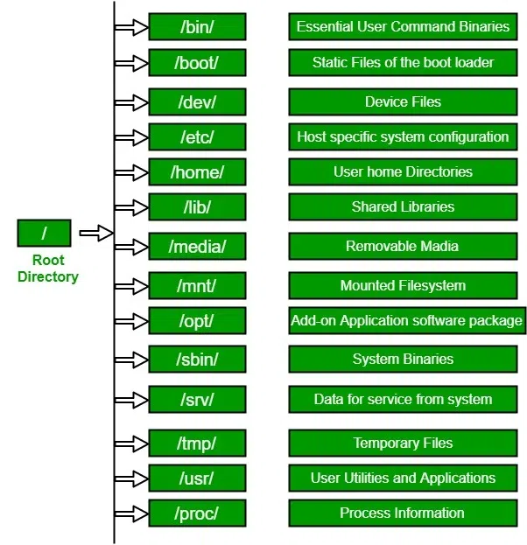
- If Linux OS is open-source, how do companies like Red Hat still
making money from it? Do a market study and answer properly.(CO2)
Despite Linux OS being open source, companies like Red Hat Enterprise of Linux (RHEL) monetize it through a subscription based model enterprise.

- Red Hat offers Red Hat Enterprise Linux (RHEL), a version of LINUX that is certified and well renowned all over the world.
- Big businesses pay for technical support, security patches and performance tuning which is provided by Red Hat 24/7.
- Red Hat offers a wide range of products like OpenShift, Ansible, Red Hat Satellite, Cloud services and many more.
- They provide certification courses, training programs for users, and consultation.
- They offer users subscription based models, creating recurring revenue streams.
- Write the command to display today’s date and time (i.e., current System time). (CO1)
The date command in Linux allows us to display today’s date and time (i.e, current System time). It is an essential command for system for system configuration and scripting. The uses of data command are:
- 1)To set system date and time.
2)Customize output format.
3)Perform data calculations
4)Display time in different time zones.
Format of date command:
date [OPTION]... [+FORMAT]
date [-u]--utc|--universal] [MMDDhhmm[[CC]YY][.ss]

- Which command is used to check how long the system has been running? (CO1)
uptime command is used to find out how long the system has been running. This command returns a set of values that involve, the current time and the amount of time system is in running state, number of users currently logged into and the load time for the last 1,5, or even 15 minutes .
Format:
uptime [-options]

Uptime options:
uptime -p, –pretty shows uptime in pretty format
uptime -h, –help display this help and exit
uptime -s, –since system up since
uptime -V, –versions output version info and exit.

- What is the difference between shutdown -h now and halt? (CO1)
Both shutdown -h now and halt are used to stop a Linux system, but they behave differently and serve differently purposes.

-shutdown -h now:
Shuts down the system and powers it off.
Behaviour:
1)notifies all logged in users
2)cleanly stops all running processes
3)unmouths file systems safely
4)powers off the machine
5)sends proper warnings and process termination.

-halt:
Immediately stops all CPU functions.
Behaviour:
1)does not notify logged in users unlike -h now
2)may or may not power off the system as it depends on the hardware configuration.
3)skips few shutdown routine steps
4) always a risk of data loss.

- Compare init 0 and shutdown -h. Which is safer? Why? (CO1)
Both init 0 and shutdown -h is used for hafting a system. But of the two, shutdown -h is a more preferred and safer command for hafting a system.
init 0 : This command prompts the init process, which is the parent of all other processes, to change the system’s runlevel to 0 (runnlevel 0 is the “halt state”). While this command will ultimately shut down the system, its a more direct, less managed approach. It immediately kills all running processes. This sudden termination can be problematic as it creates a high risk of data corruption or data loss.

shutdown -h: This command is specifically designed for a graceful shutdown. The -h flag stands for "halt." When you execute shutdown -h, the command first sends a warning message to all logged-in users, as it gives the user a chances to save their work and then log off for the system to turn off. These scripts are responsible for a controlled shutdown: they garacefully stop services, unmount fielsystems and synchronise data to the disk.

- A system administrator accidentally powers off a Server machine without shutting it down properly. What problems can occur to the said Server? (CO2)
When a server is powered off without a proper shutdown,it is like pulling the plug on a computer, which can lead to a variety of issues, primarily related to data integrity and system stability, and in some cases, hardware damage.

Data Corruption & File System Inconsistencies
This is the most common issue/risk. During normal operation, servers constantly write and cache data to improve performance. During abrupt shutdown, the system ignores/ bypasses crucial processes. Any data that was in the process of being written or was buffered in memory will be lost.

File system’s internal data structure can be damaged. This may lead to the whole drive being unreadable.

Application & Service Failures
Applications and internal services have there own internal processes and task before a clean shutdown such as closing transactions and terminiting background tasks.
These may lead to error causes in applications internal databases which may destroy it.

“Service start-up issues: When the server is powered back on, services may fail to start because they can't find the expected files or their configuration has been damaged. This can cause significant downtime.”

—------------x—-----------------

