VIT Bhopal University
VITyarthi

CSE0001 - Digital Literacy
Project Report

Name | Debayan Mitra
Registration No. | 25BCE10801
Branch | B. Tech CSE Core (SCOPE)
Year / Semester | Winter Semester (2026)
Course Code | CSE0001
Course Title | Digital Literacy
Faculty / Mentor | Kanan
Submission Date | 31/03/2026
GitHub Repository | https://github.com/debayan888/Digital-Literacy-Project-Sem-2

Introduction
So I am a first year student at VIT Bhopal Uni and this whole semester semester (2nd) has honestly been quite a learning experience for me when it comes to the digital side of things. This project is part of the CSE0001 Digital Literacy course and the idea is that I am basically acting as a Student Digital Ambassador. The whole point of that role is to help other students around me understand and actually use the digital skills that are necessary nowadays not just for academics but for real life as well.
The project is split into five tasks. Each one covers something different — like how to design properly, how to build your professional presence online, how to practice coding, how to write professional emails, and how to stay safe from cybercrimes. To keep everything organized and also to get some actual GitHub experience, I have uploaded all my work there. So the submission itself became a learning exercise, which I think is a pretty smart way of doing it.

Task 1 - Digital Literacy Awareness Presentation

Tool Used
Canva (canva.com)

About this work
For this task I made a one-page informational poster kind of thing using Canva. The title I gave it is 'Digital Literacy' and it is basically meant for fellow first year students who may not know much about this topic yet. I tried to keep it simple and not too text-heavy because honestly if a poster has too much writing nobody reads it.

I covered three main things in the poster. First, what digital literacy actually means because a lot of people think it just means knowing how to use a phone or laptop, but it is actually much more than that. Second, I listed out some useful digital tools for students like Notion for notes, Canva for design, Zotero for managing references, and Zoom for online meetings. Third, I wrote about safe internet practices things like using strong passwords and not falling for phishing emails. I also added a small section on email etiquette with a Do's and Don'ts format, and some guidance on building a professional online presence using LinkedIn, GitHub, and a personal portfolio.

For the design I chose a clean colour-coded layout. Each section has a different colour so that even at a glance you can tell which topic is being discussed. I used icons and short bullet points instead of paragraphs because that makes it much easier to read quickly.

Tool Used | Canva (canva.com)
Topics Covered | Digital Literacy Overview, Student Digital Tools, Safe Internet Practices
File Location | task-1-presentation/ (exported image in repository)

Task 2 - Student Digital Portfolio

Platforms Set Up
- GitHub (github.com)
- LinkedIn (linkedin.com)
- Stack Overflow (stackoverflow.com)

Write-up:
This task was about creating or updating accounts on three important platforms which are GitHub, LinkedIn, and Stack Overflow. Each of these serves a completely different purpose and I think every CSE student should have all three set up before even finishing first year.

Starting with GitHub it is basically where all your code lives. I created a public repository called “Digital-Literacy-Project-Sem-2” which is where I am uploading everything for this project. I also made a profile README which is that special file that shows up when someone visits your GitHub profile. I wrote a short intro about myself, my branch, and what I am hoping to learn. I plan to keep adding projects here as I go through my degree it will be like a portfolio of my actual work.

For LinkedIn, I filled in my education details B. Tech degree, VIT Bhopal University, and my expected graduation year. LinkedIn is basically a necessity if you want to apply for internships or connect with people in the industry. I have already started following some companies and connecting with seniors from my branch which I think will be useful when placement season comes.

Stack Overflow was new for me. I knew the website existed I had landed on it many times while searching for coding errors but I never had an actual account. I created one for this task and the plan is to start by asking questions when I get stuck and eventually, as my knowledge grows, to start answering questions too. It is a good platform for building a technical reputation over time.

GitHub Profile | https://github.com/debayan888/
LinkedIn Profile | https://www.linkedin.com/in/debayan-mitra-076140388/
Stack Overflow Profile | https://stackoverflow.com/users/32556938/debayan-mitra?tab=profile
Screenshots Location | task-2-portfolio/ (in repository)

Task 3 – Coding & Collaboration Platforms

Part A: Coding Practice: HackerRank
For Part A, I chose HackerRank because it is actually one of the platforms that companies use for recruitment tests. So practicing here from first year itself makes sense by the time I am in 3rd or 4th year and applying for internships, I will already be familiar with the format and the interface.

I created an account and completed the 'Solve me First' challenge which is the beginner level starting problem. I know it is a very basic one but the point was to get set up and understand how the platform works. I earned 31 points in Problem Solving which is obviously just a start the plan is to keep solving more problems, especially as we start learning data structures and algorithms in later semesters.

Platform | HackerRank (hackerrank.com)
Challenge Completed | Solve me First
Score / Badge | Problem Solving (31 points secured)
Screenshot Location | task-3-platforms/ (in repository)

Part B: Google Workspace: Digital Literacy form.
For Part B I made a Google Form titled 'Digital Literacy Awareness Quiz'. The form has five questions a mix of MCQs and one short answer question designed to test whether a student actually understands the digital literacy concepts from this course. I tried to make the questions practical rather than just theoretical, so it covers things like what to do when you receive a suspicious email, why two-factor authentication is important, and what UPI fraud looks like.

Making the quiz actually helped me revise the course content myself because I had to think carefully about what the correct answer is and why, and also what makes a good wrong option for an MCQ. It is harder than it looks.

Form Title | Digital Literacy Awareness Quiz
No. of Questions | 5 (Mix of MCQ and Short Answer)
Google Form Link | https://forms.gle/8bfuvh7s39eo9XzA7
Screenshot Location | task-3-platforms/ (in repository)

Reflection
Both platforms turned out to be more useful than I expected. HackerRank is something I will keep using regularly because coding practice is not something you can leave for the last moment it needs to be consistent. Google Forms I had used before but mostly just to fill in forms, not to create them. While I have been building the quiz from scratch this made me realize that how much thought goes into the designing any type of form based surveys. Overall, this task was quite practical and hands-on which I appreciated.

Task 4 – Professional Email & Etiquette Guide

Part A: Email 1: Extension Request to Professor
The first email is about sending it to a professor to request for a deadline extension on an assignment. I wanted to write it the way a student would genuinely write it not stiff or robotic, but polite and thoughtful, with a clear reason behind the request.
A lot of students, when they sit down to email a professor, either go too casual almost like texting a friend or they go to the other extreme and sound like they copied a template off the internet. Neither really works. What a professor actually wants to see is that you respect their time, you have a legitimate reason, and you're being upfront about it rather than just disappearing and submitting late without a word.
Small things matter more than most students realise. Starting with "Respected Sir/Ma'am" sets the right tone immediately it's a simple gesture, but it signals that you understand the professional dynamic. You have to have a particular and specific subject line means which the professor comes to know what the email is about before they even open it. The Closing is to be done with "Warm Regards" instead of just your name, or worse, nothing at all, leaves a good final impression.
The body of the email matters just as, introducing yourself with your name, roll number, and course right at the beginning saves the professor with the trouble of figuring who is it from. Mentioning the assignment by name along with the original deadline, shows you're organised and aware. And when stating your reason, being honest and specific without over-explaining or making it sound like an excuse strikes the right balance between being human and being professional.
These aren't big or complicated things. But they're exactly the kind of details that students skip when they're in a hurry, and they're also the details that quietly shape how a professor perceives you not just in that one email, but throughout the semester.
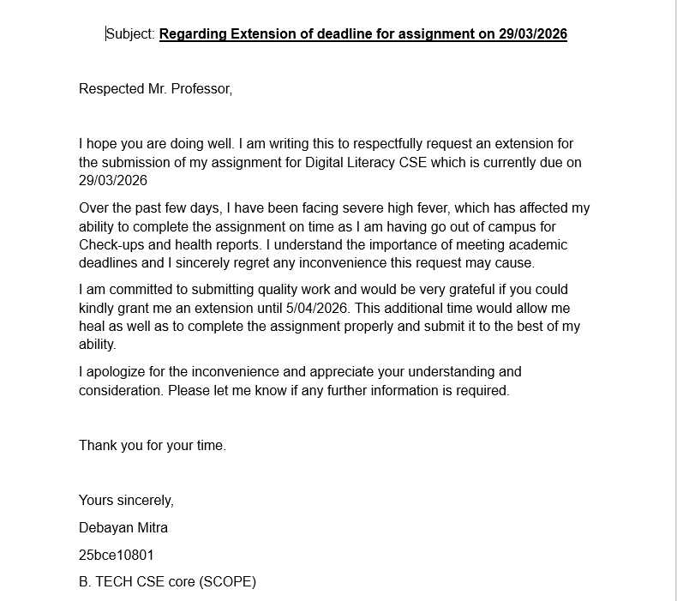

Part A – Email 2: Internship Interest to Company
The second email is about writ cold email to a company expressing interest in an internship. This type of email is something every CSE student will eventually have to write and most of the people have no idea how to structure about it. I have kept it short and precise up to three short paragraphs because recruiters do not have time to read long emails from unknown students. The focus was about introducing myself, mentioning what I can offer, and making a clear ask so that to present which you want to present to the coordinator becomes clear.

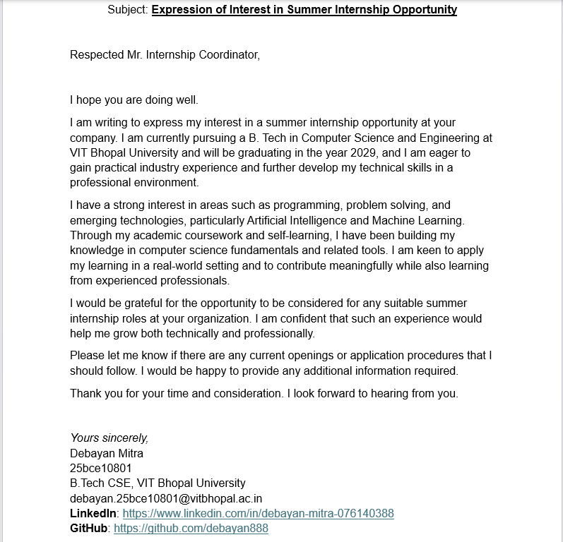

Part B – Social Media Do's and Don'ts
✓ DO's | ✗ DON'Ts
Use respectful and polite language in posts, comments, and messages. | Do not share passwords, OTPs, or any personal confidential information online.
Verify information before sharing it — fake news spreads very fast on social media. | Do not post offensive, abusive, or hateful content directed at anyone.
Check your privacy settings regularly and limit what personal information is publicly visible. | Do not spread rumours or unverified information, even if it seems harmless.
Think before you post, especially if the content could affect your academic or professional reputation. | Do not upload photos, videos, or posts that invade someone else's privacy without consent.
Use social media for learning, networking, and professional growth — it can be genuinely useful. | Do not copy content or captions from others without giving proper credit.
Share original content or properly credit the original creator or source. | Do not engage in cyberbullying, trolling, or any form of online harassment.
Keep your profile professional if it is visible to teachers, recruiters, or organizations. | Do not post impulsively when you are angry, frustrated, or emotional — always give it a moment.
Report fake accounts, scams, cyberbullying, or harmful content when you come across it. | Do not accept friend requests or messages from unknown or suspicious accounts without verifying.
Use strong passwords and enable two-factor authentication for all important accounts. | Do not overshare details about your location, daily routine, or personal life publicly.
Be mindful of your digital footprint — what you post online can stay there for a very long time. | Do not use social media in ways that negatively affect your studies, productivity, or reputation.

Communication Scenario & Reflection
One real example that I think most college students can relate to is the case of a student who posted an angry, informal message about a faculty member on the college WhatsApp group. The message was written in frustration, had some inappropriate language in it, and within minutes it was screenshotted and forwarded reaching faculty members and even the college administration. The student had to face a formal disciplinary hearing and their examination appearance was temporarily withheld.

The thing is, the frustration the student felt might have been completely valid but the way of expressing it was the problem. If they had approached the faculty directly during office hours, or had raised the issue through the college grievance system, the same concern could have been addressed without any of the fallout. Even venting to a close friend privately would have been far better than a group message.

The main lesson here is simple: digital communication is permanent and traceable. Once you send something, you cannot unsend it from everyone's memory or their screenshots. Online behaviour needs to be treated with the same level of care and professionalism as face-to-face interactions maybe even more so.

Task 5 – Professional Email & Etiquette Guide

Cybercrime Type: UPI / Online Payment Fraud
Crime Type | UPI / Online Payment Fraud
Case Study File | task-5-cybercrime/casestudy.md (in repository)
Prevention Checklist | task-5-cybercrime/prevention-checklist.md (in repository)

Case study Summary
UPI fraud is probably the most common cybercrime targeting college students and young adults in India right now. The way it typically works is like this a victim gets a phone call from someone pretending to be a customer care executive from a bank or an e-commerce platform. The caller tells them there is some problem with their account, or that they are eligible for a cashback or refund, and then asks them to either share their UPI PIN or to 'approve' a collect request that has been sent to their phone.

What the victim does not realize is that in UPI, approving a collect request means you are sending money not receiving it. The fraudster creates urgency and confusion deliberately so that the victim does not have time to think it through. The moment the victim approves the request or shares their PIN, the money is gone and because UPI transactions are near-instant, it is almost impossible to recover.

The people who fall for this are usually young and relatively new to UPI, or they are in a panicked state because the call sounds very official and urgent. The financial loss is bad enough but the psychological distress the guilt, the embarrassment is sometimes worse, especially when it affects the family financially.

Prevention Checklist: Stay Safe Online

Prevention Checklist: Stay Safe Online
Never share your UPI PIN, OTP, or bank password with anyone no legitimate bank or app will ever ask for this.
Understand one key rule about UPI: you enter your PIN only to SEND money. If someone tells you to enter your PIN to 'receive' money, it is a fraud, 100%.
Do not approve any UPI collect or pay request that you did not initiate yourself always read the request carefully before tapping approve.
Enable two-factor authentication (2FA) on all important accounts email, social media, college portals, and banking apps.
Use strong and unique passwords for every platform. If remembering them is hard, use a password manager.
Always verify who you are talking to before sharing any information if in doubt, hang up and call the official helpline number directly.
Do not click on links received via SMS, WhatsApp, or email claiming to be from your bank or any government body without checking the source first.
If you think you have been a victim of cybercrime, report it immediately at cybercrime.gov.in or call the National Cyber Crime Helpline 1930 it is available 24x7.

Reflection
Before I started researching for this task I genuinely thought cybercrime was mostly about hackers breaking into systems the kind of thing you see in movies. So it was actually quite eye-opening to learn that UPI fraud works almost entirely through psychology, not technology. There is no actual hacking happening the fraudster just creates panic and urgency and waits for the victim to make a mistake. That kind of manipulation is honestly scarier than technical attacks because it can target anyone regardless of how tech-savvy they are.

Conclusion
One personal habit I am going to change because of this task is to never act under pressure during any financial transaction. If someone on a call is rushing me or creating panic, that itself is a red flag. I will pause, end the call, and verify independently. I have also saved 1930 (the cybercrime helpline) in my phone as a contact something I would recommend every student to do.

Looking back at all five tasks, this project has been one of the more practically useful things I have done in my first year so far. It was not just about reading or writing I actually had to create things: design a poster, set up professional profiles, practice coding, write formal emails, and research real cybercrime cases. Each task pushed me to learn something new that I can actually use going forward.

What I realized while doing this is that all these skills are connected to each other. Having a professional GitHub profile means nothing if you do not know how to communicate via email. Knowing coding platforms is helpful but being aware of cybercrime is equally important when you are applying for jobs online. It all ties back to the same core idea being a responsible, capable, and well-rounded person in the digital world.

My GitHub repository now has all the work from this project and I plan to keep updating it as I go through my degree. The habits I have started building here regular commits, professional communication, and staying safe online are going to stay relevant long after this course is done.

