Debayan Roy 11000125039
Computer Organization Assignment 1

Objectives
- Study and verify the truth tables of AND, OR, NAND, NOR, NOT, XOR and XNOR gates.
- Design and implement a Half Adder using basic logic gates (XOR + AND).
- Design and implement a Half Adder using NAND gates only.
- Design and implement a Full Adder using basic logic gates.
- Design and implement a Full Adder using NAND gates only.

Part (a): Basic Logic Gates — Study and Verification

A logic gate is the fundamental building block of digital circuits. It performs a specific Boolean logic operation on one or more binary inputs (0 = LOW, 1 = HIGH) and produces a single binary output. Seven fundamental gates were simulated with all possible input combinations, and the input/output logic levels were recorded to verify their truth tables. Two sample simulation states are shown below: all inputs LOW (0,0) and all inputs HIGH (1,1) / input HIGH for NOT.
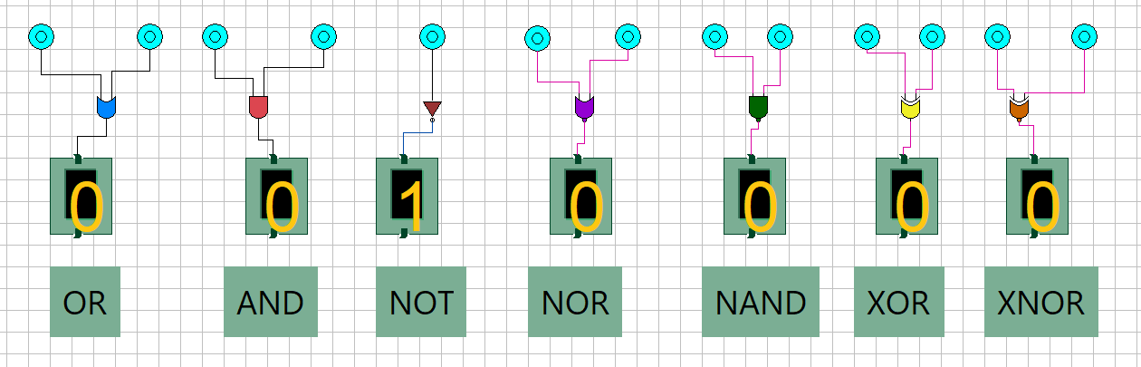
Fig. A1 — All seven gates simulated with inputs A = 0, B = 0 (NOT gate input = 0).
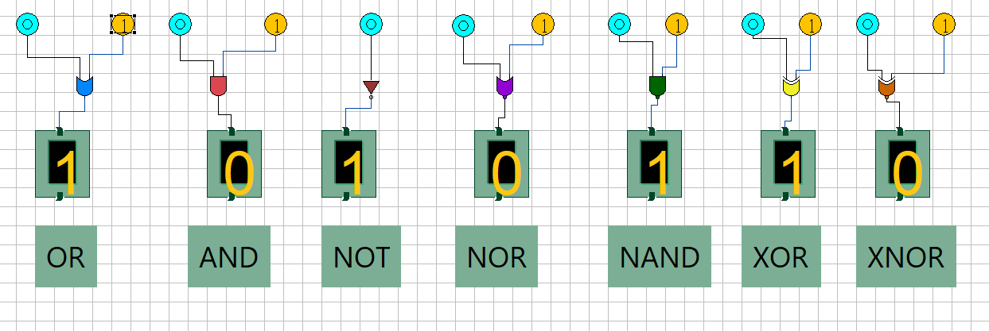
Fig. A2 — All seven gates simulated with inputs A = 0, B = 1 (NOT gate input = 1), verifying the switching behaviour of each gate.

AND Boolean Expression: Y = A · B
Output is HIGH only when *all* inputs are HIGH. Symbol: D-shaped block.

A | B | Y
0 | 0 | 0
0 | 1 | 0
1 | 0 | 0
1 | 1 | 1

OR Boolean Expression: Y = A + B
Output is HIGH when *at least one* input is HIGH. Symbol: curved-back shield shape.

A | B | Y

0 | 0 | 0
0 | 1 | 1
1 | 0 | 1
1 | 1 | 1

NOT (Inverter) Boolean Expression: Y = A'
Single-input gate; output is the complement (inverse) of the input. Symbol: triangle with a bubble at the output.

A | Y
0 | 1
1 | 0

NOR Boolean Expression: Y = (A + B)'
Complement of OR — output is HIGH only when *all* inputs are LOW. Equivalent to OR gate followed by a NOT gate.

A | B | Y
0 | 0 | 1
0 | 1 | 0
1 | 0 | 0
1 | 1 | 0

NAND Boolean Expression: Y = (A · B)'
Complement of AND — output is LOW only when *all* inputs are HIGH. Called a 'universal gate' since any Boolean function can be built using NAND gates alone.

A | B | Y
0 | 0 | 1
0 | 1 | 1
1 | 0 | 1
1 | 1 | 0

XOR (Exclusive-OR) Boolean Expression: Y = A ⊕ B
Output is HIGH only when the inputs are *different* (odd number of 1's). Central to adder design since it implements the 'sum without carry' logic.

A | B | Y

0 | 0 | 0
0 | 1 | 1
1 | 0 | 1
1 | 1 | 0

XNOR (Exclusive-NOR) Boolean Expression: Y = (A ⊕ B)'
Complement of XOR — output is HIGH only when both inputs are *equal*. Used as an 'equality detector'.

A | B | Y
0 | 0 | 1
0 | 1 | 0
1 | 0 | 0
1 | 1 | 1
Observation: The simulated outputs for every gate, at every combination of input logic levels, matched exactly with the theoretical truth table values shown above (confirmed by the 0/1 display indicators in Fig. A1 and Fig. A2). This confirms correct gate behaviour and validates the simulation environment used for the subsequent adder designs.

Part (b): Half Adder using Basic Logic Gates
A Half Adder is a combinational circuit that adds two single binary digits, A and B, and produces two outputs: SUM and CARRY. It is called a 'half' adder because it does not account for a carry input from a previous addition stage — it only handles the addition of two bits.

Logic Design
From the addition of two bits A and B, the SUM is 1 whenever exactly one of the inputs is 1 (i.e. the outputs differ) — this is precisely the behaviour of an XOR gate. The CARRY is 1 only when both A and B are 1 — this is precisely the behaviour of an AND gate. Hence the half adder is realised directly with just two gates:
Intuitively, from the truth table, sum = A ⊕ B and carry = (A · B)
A | B | SUM | CARRY
0 | 0 | 0 | 0
0 | 1 | 1 | 0
1 | 0 | 1 | 0
1 | 1 | 0 | 1
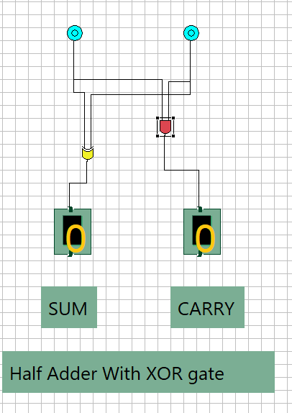
Fig. B1 — Half Adder; inputs A = 0, B = 0.

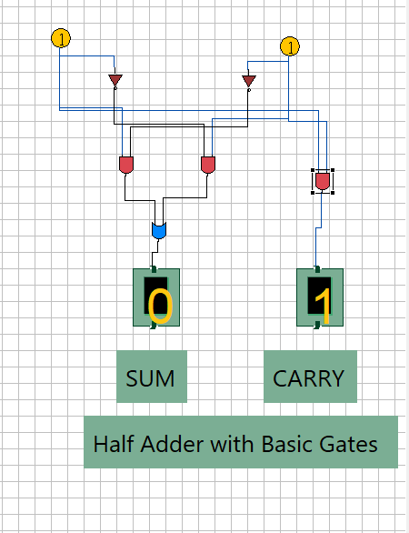
Fig. B2 — Half Adder with inputs A = 1, B = 1

Part (c): Half Adder using NAND Gates Only
The NAND gate is a universal gate — any Boolean function, including AND, OR, NOT and XOR, can be constructed using only NAND gates. This is useful in real IC design since fabricating a circuit from a single gate type reduces manufacturing complexity and cost.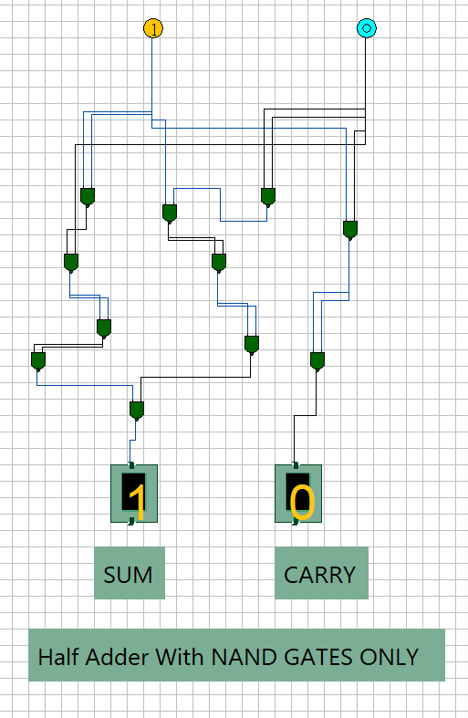
Fig. C1 — Half Adder implemented entirely with NAND gates, tested for inputs A = 1, B = 0.

Part (d): Full Adder using Basic Logic Gates
A Full Adder extends the half adder by also accepting a Carry-IN (Cin) bit from a previous addition stage, in addition to the two operand bits A and B. It produces a SUM output and a Carry-OUT (Cout) output, and is the basic building block used to chain together multi-bit binary adders (ripple-carry adders).

Logic Design
The SUM is HIGH when an odd number of the three inputs are HIGH, which is realised by cascading two XOR gates. The Carry-OUT is HIGH whenever two or more of the three inputs are HIGH, which is realised by OR-ing the carries generated by combining the inputs pairwise:

A | B | Cin | SUM | Cout
0 | 0 | 0 | 0 | 0
0 | 0 | 1 | 1 | 0
0 | 1 | 0 | 1 | 0
0 | 1 | 1 | 0 | 1
1 | 0 | 0 | 1 | 0
1 | 0 | 1 | 0 | 1
1 | 1 | 0 | 0 | 1
1 | 1 | 1 | 1 | 1
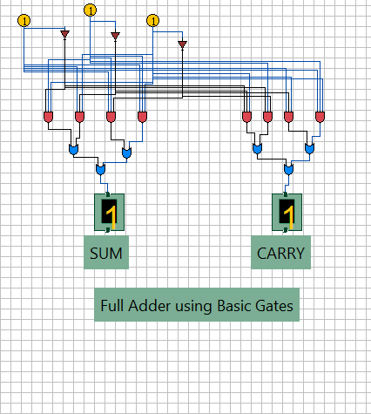
Fig. D1 — Full Adder built from basic gates; INPUTS : A = 1, B = 1, Cin = 1.

Alternative structural view — Two Half Adders
A full adder can equivalently be constructed by cascading two half-adder blocks with their carry outputs combined through an OR gate: the first half adder adds A and B to give an intermediate sum and carry; the second half adder adds this intermediate sum to Cin to give the final SUM; and Cout is the OR of the two half-adder carry outputs. This structural equivalence was also verified in simulation, shown below for reference.
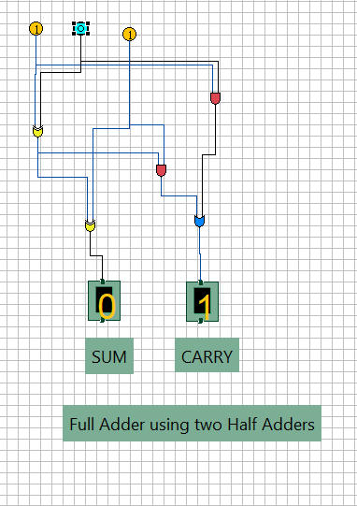
Fig. D2 — Full Adder as two cascaded Half Adders, inputs A = 1, B = 1, Cin = 0

Part (e): Full Adder using NAND Gates Only

Following the same universal-gate principle used in Part (c), the full adder is re-designed using NAND gates exclusively. The most efficient standard realisation uses nine 2-input NAND gates, built by cascading two NAND-only half adders (each requiring five NAND gates, but sharing one gate between stages) and combining the two carry terms with a NAND-based OR construction.

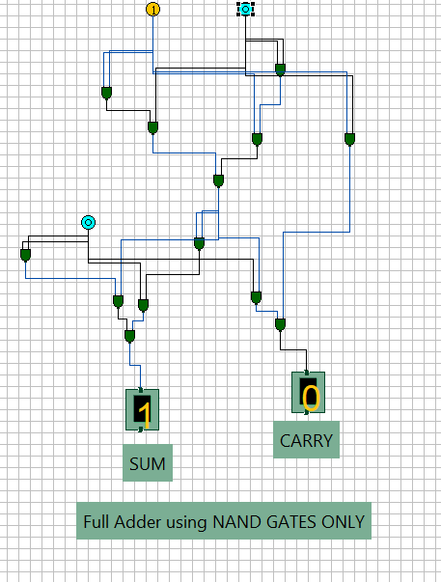
Fig. E1 — Full Adder implemented entirely with NAND gates, tested for inputs A = 1, B = 1, Cin = 0

Result / Conclusion

The truth tables of all seven basic logic gates (AND, OR, NOT, NOR, NAND, XOR, XNOR) were successfully studied and verified through simulation. Half Adder and Full Adder circuits were then designed and implemented using two different approaches — basic gates and NAND-gates-only — and in every case the simulated SUM and CARRY/Cout outputs matched the expected truth-table values for all possible input combinations. This confirms both the correctness of the adder designs and the validity of NAND as a universal logic gate capable of realising any combinational function, including AND, OR, NOT and XOR operations required for binary addition.

