Debayan Roy, 11000125039
Assignment 3

Contents
- a) 4:1 Multiplexer using only NAND gates
- b) 1:4 Demultiplexer using only NAND gates
- c) 8:1 Multiplexer using two 4:1 MUX and one 2:1 MUX
- d) 4-bit Binary Parallel Adder
- e) 4-bit Binary Parallel Subtractor

Part (a): 4:1 Multiplexer using only NAND Gates

Theory
A 4:1 multiplexer selects one of four input lines (I0, I1, I2, I3) and routes it to a single output Y, based on two select lines S1 and S0. The standard sum-of-products expression for the output is:
$$Y = S1'.S0'.I0 + S1'.S0.I1 + S1.S0'.I2 + S1.S0.I3$$
Since any SOP (AND-OR) expression can be realized using only NAND gates (AND-OR-Invert followed by an inversion, which cancels out through double NAND application), the circuit can be built entirely from two-input and multi-input NAND gates plus NAND-based inverters (a NAND gate with both inputs tied together acts as an inverter).

Design Steps
- Generate the complements S0' and S1' using NAND gates connected as inverters.
- Form the four minterm AND products ($S1^{'}.S0^{'}, S1^{'}.S0, S1.S0^{'}, S1.S0$) using NAND gates followed by inverting NAND gates (a NAND followed by a NAND-inverter realizes an AND).
- AND each minterm term with its corresponding data input using the same NAND + inverter technique.
- Combine the four resulting product terms with a 4-input OR, realized as a NAND of inverted terms (De Morgan's theorem: $A+B+C+D = (A'.B'.C'.D')'$).
- The Enable/output NAND stage produces the final output Y.

Truth Table

S1 | S0 | Output Y
0 | 0 | I0
0 | 1 | I1
1 | 0 | I2
1 | 1 | I3

Implemented Circuit

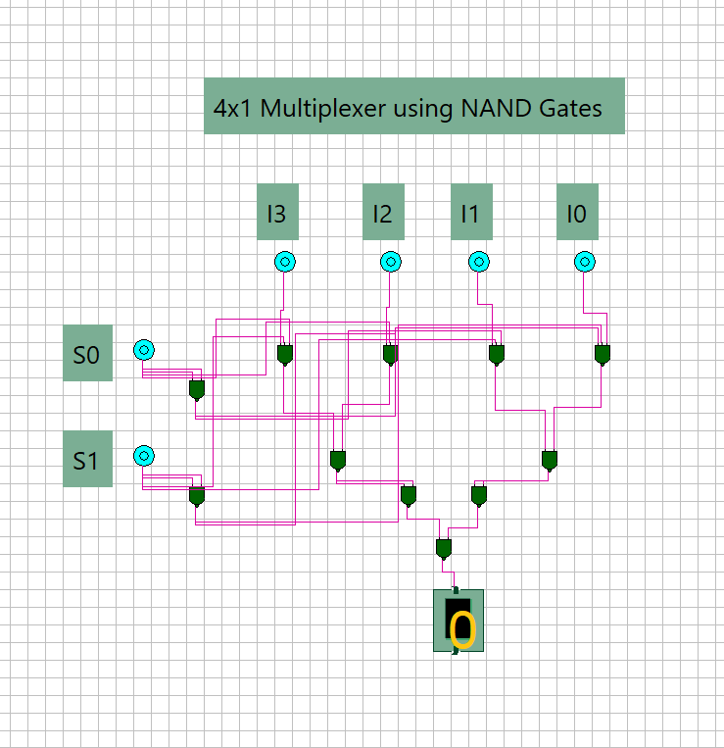

Figure 1: 4x1 Multiplexer implemented entirely with NAND gates.

Part (b): 1:4 Demultiplexer using only NAND Gates

Theory
A 1:4 demultiplexer routes a single input data/enable line E to one of four output lines (D0-D3), depending on the select lines S1 and S0. Each output is active (follows E) only when the select lines match its corresponding binary address; otherwise it stays low. The Boolean expressions for the four outputs are:
$D0 = S1'.S0'.E$ $D1 = S1'.S0.E$ $D2 = S1.S0'.E$ $D3 = S1.S0.E$
Each of these is a 3-input AND function, which is implemented using a NAND gate followed by a NAND-connected inverter (double negation restores the AND function while using only NAND gates).

Design Steps
- Generate S0' and S1' using NAND gates wired as inverters.
- For each output Dn, feed the appropriate combination of S1/S1', S0/S0', and E into a NAND gate.
- Pass the NAND output through a second NAND-inverter stage to recover the correct AND (active-high) logic at each output line.
- Only the output whose select combination matches S1S0 will follow the enable input E; all others remain at logic 0.

Truth Table

S1 | S0 | E | D3 | D2 | D1 | D0
0 | 0 | 1 | 0 | 0 | 0 | E
0 | 1 | 1 | 0 | 0 | E | 0
1 | 0 | 1 | 0 | E | 0 | 0
1 | 1 | 1 | E | 0 | 0 | 0

Implemented Circuit

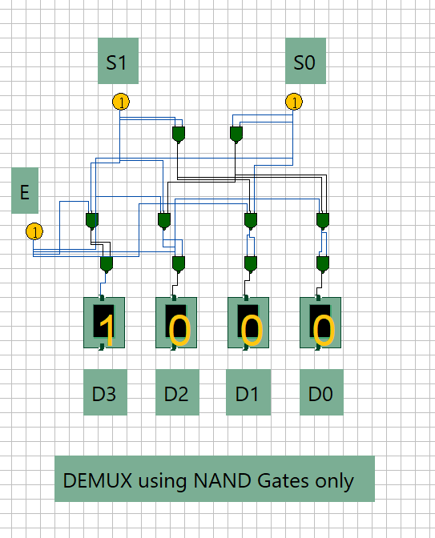
Figure 2: 1x4 Demultiplexer implemented entirely with NAND gates.

Part (c): 8:1 Multiplexer using 4:1 Multiplexers

Theory
An 8:1 multiplexer selects one of eight inputs (I0-I7) using three select lines (S2, S1, S0). It can be built hierarchically from smaller multiplexers: two 4:1 MUXes handle the lower-order selection, and a 2:1 MUX combines their outputs using the most-significant select line.

Design Steps
- Apply inputs I0-I3 to the first 4:1 MUX, and I4-I7 to the second 4:1 MUX.
- Connect select lines S1 and S0 in common to both 4:1 MUXes - these choose one line from each group of four.
- The output of the first MUX (from I0-I3) represents the selected line when S2 = 0; the output of the second MUX (from I4-I7) represents the selected line when S2 = 1.
- Feed both 4:1 MUX outputs into a 2:1 MUX, using S2 as its select line, to produce the final 8:1 output Y.

Governing Equation
Y = S2'.(4:1 MUX output for I0-I3, selected by S1S0) + S2.(4:1 MUX output for I4-I7, selected by S1S0)

Truth Table (Select Logic)

S2 | S1 | S0 | Output Y
0 | 0 | 0 | I0
0 | 0 | 1 | I1
0 | 1 | 0 | I2
0 | 1 | 1 | I3
1 | 0 | 0 | I4
1 | 0 | 1 | I5
1 | 1 | 0 | I6
1 | 1 | 1 | I7

Implemented Circuit

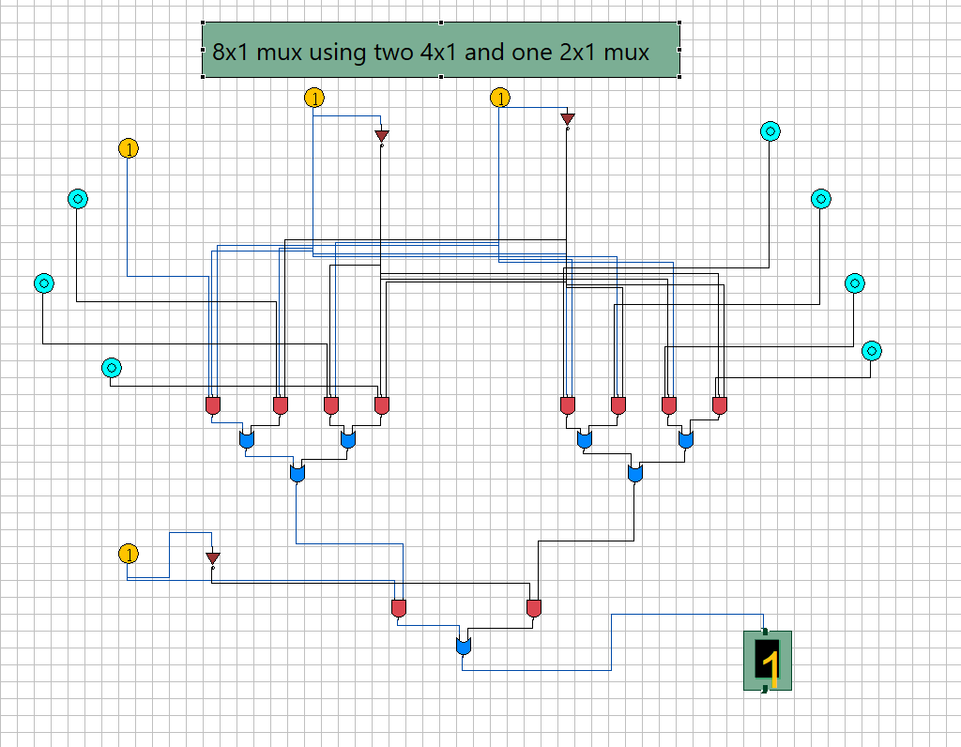

Figure 3: 8x1 Multiplexer built from two 4x1 and one 2x1 MUX

Part (d): 4-bit Binary Parallel Adder

Theory
A 4-bit parallel adder adds two 4-bit binary numbers A (A3A2A1A0) and B (B3B2B1B0) simultaneously, producing a 4-bit sum (S3S2S1S0) and a carry-out (C4). It is built by cascading four full adders, where the carry-out of each stage feeds the carry-in of the next more-significant stage (ripple-carry architecture).

Full Adder Equations
Sum = A XOR B XOR Cin Cout = A.B + Cin.(A XOR B)

Design Steps
- Stage 0 (LSB): Full adder takes A0, B0, and Cin = 0 (no carry into the least significant bit), producing S0 and C1.
- Stage 1: Full adder takes A1, B1, and carry C1 from stage 0, producing S1 and C2.
- Stage 2: Full adder takes A2, B2, and carry C2 from stage 1, producing S2 and C3.
- Stage 3 (MSB): Full adder takes A3, B3, and carry C3 from stage 2, producing S3 and the final carry-out C4.
- The final result is the 4-bit sum S3S2S1S0 together with the overflow/carry bit C4.

Example Verification
From the implemented circuit, all four A and B input bits are set to 1 (A = 1111 = 15, B = 1111 = 15). The circuit produces Sum = 1110 (14) with Carry = 1, which represents 11110 in binary = 30 = 15 + 15. This confirms correct operation.

Implemented Circuit

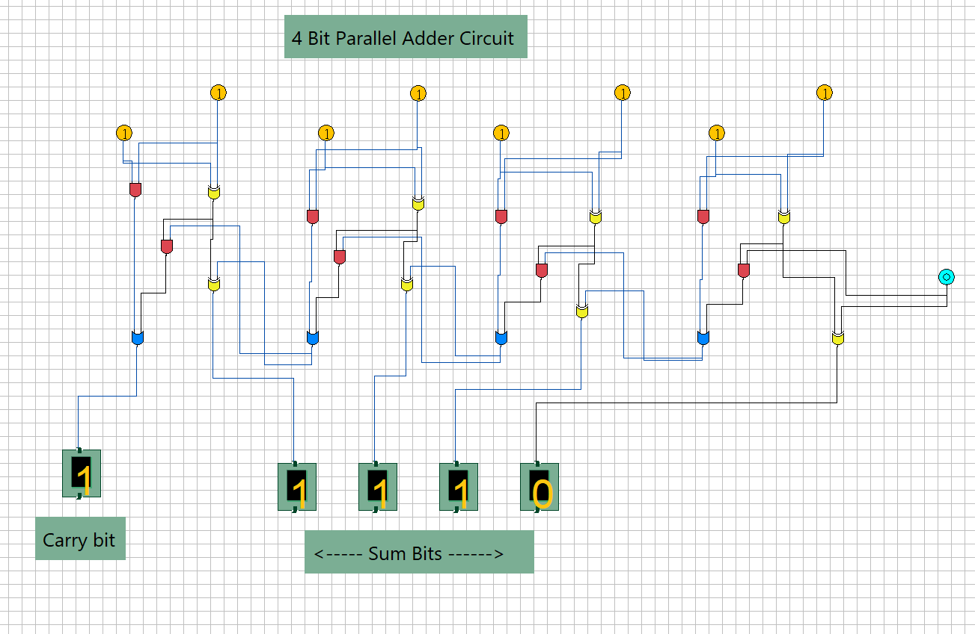
Figure 4: 4-bit Parallel Adder built from four cascaded full adder

Part (e): 4-bit Binary Parallel Subtractor

Theory
A 4-bit parallel subtractor computes A - B for two 4-bit binary numbers using the 2's complement method, which allows subtraction to be performed with the same full-adder hardware used for addition. Each bit of B is first XORed with a common control line M: when M = 1, B is bitwise complemented (1's complement); adding this to A together with an initial carry-in of M = 1 completes the 2's complement subtraction A + B' + 1 = A - B.

Governing Equations
Bi' = Bi XOR M (M = 1 for subtraction)
Difference = A XOR Bi' XOR Cin Cout = A.Bi' + Cin.(A XOR Bi')

Design Steps
- XOR each bit of B (B0-B3) with the mode control line M = 1, which produces the 1's complement of B at every stage (shown by the inverter/XOR gates in the circuit).
- Set the carry-in of the least significant full adder to M = 1, which adds the '+1' required to convert the 1's complement into a 2's complement.
- Cascade four full adders exactly as in the adder circuit, using A_i and the complemented B_i' as the two data inputs to each stage, with the carry rippling from stage 0 to stage 3.
- The four full-adder sum outputs give the difference bits (D3D2D1D0).
- The final carry-out represents the sign bit: 1 indicates a non-negative result (A >= B), 0 indicates a negative result represented in 2's complement form.

Example Verification
From the implemented circuit, all four A and B input bits are set to 1 (A = 1111 = 15, B = 1111 = 15) with M =
1. The circuit produces Difference = 0000 and Sign/Carry bit = 0, correctly representing A - B = 15 - 15 = 0.

Implemented Circuit

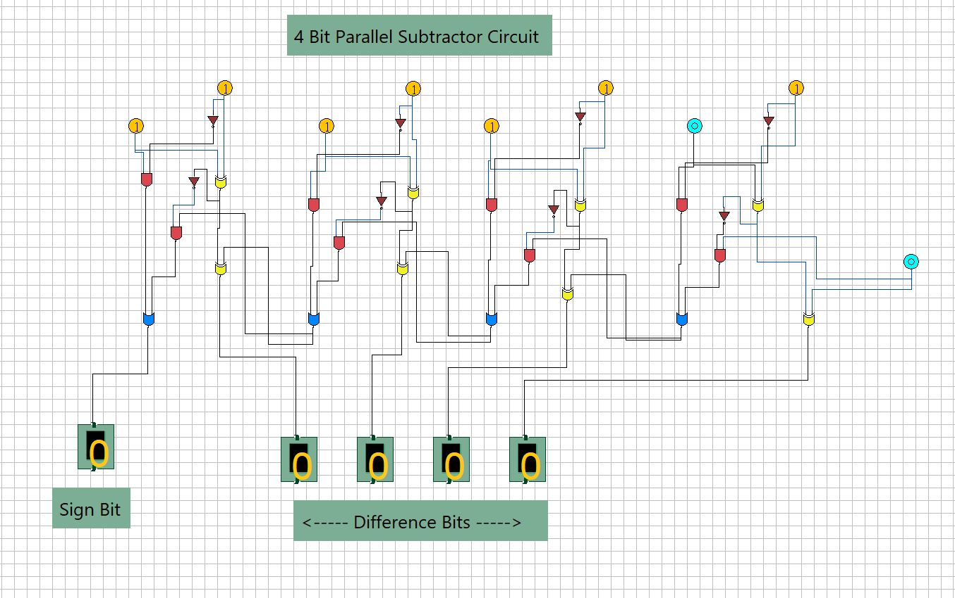
Figure 5: 4-bit Parallel Subtractor built from four cascaded full subtractors

