Debayan Roy, 11000125039
Assignment 4

Contents
- Binary to Octal Decoder
- Octal to Binary Encoder
- Half Subtractor using Multiplexer
- Full Subtractor using Multiplexer

Part (a): 3-to-8 Line Decoder (Binary to Octal)
A decoder is a combinational circuit that converts binary information from n coded input lines to a maximum of 2ⁿ unique output lines. The 3:8 decoder studied here takes a 3-bit binary code on inputs I2, I1, I0 (with I2 as the most significant bit) and activates exactly one of eight outputs, D0 through D7, corresponding to the decimal value of that code — hence "Binary to Octal". An Enable/Activation input is also provided: when it is LOW, all outputs remain LOW regardless of I2 I1 I0, and the decoder only produces a valid output when it is HIGH.
Each output Dk is simply the AND of the Enable line with the minterm of I2 I1 I0 that equals k. For example:
D4 = EN · I2 · I1′ · I0′ D0 = EN · I2′ · I1′ · I0′
In the circuit, each of the eight outputs is generated by a pair of cascaded AND gates (realising the 3-input AND of Enable and the two/three literals of the corresponding minterm), so the decoder uses 16 two-input AND gates in total along with three inverters to generate I2′, I1′ and I0′.

Truth Table
EN | I2 | I1 | I0 | Active Output
0 | X | X | X | None (all D = 0)
1 | 0 | 0 | 0 | D0 = 1
1 | 0 | 0 | 1 | D1 = 1
1 | 0 | 1 | 0 | D2 = 1
1 | 0 | 1 | 1 | D3 = 1
1 | 1 | 0 | 0 | D4 = 1
1 | 1 | 0 | 1 | D5 = 1
1 | 1 | 1 | 0 | D6 = 1
1 | 1 | 1 | 1 | D7 = 1

Simulation
The circuit below was tested with the Enable line HIGH and the select code I2 I1 I0 = 1 0 0, i.e. binary 4. As expected, only output D4 goes HIGH while every other output (D0–D3, D5–D7) remains LOW, confirming correct one-hot decoding.
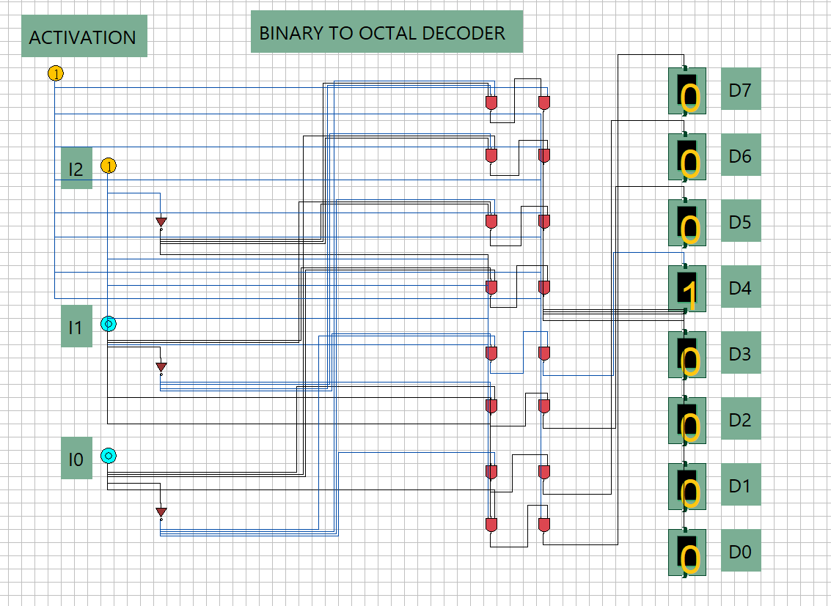
Fig. 4.1 — 3-to-8 Binary-to-Octal Decoder. With Enable = 1 and I2 I1 I0 = 100 (decimal 4), only output D4 is HIGH; all other outputs are LOW.

Part (b): 8-to-3 Line Encoder (Octal to Binary)
An encoder performs the inverse operation of a decoder: it accepts 2ⁿ input lines, of which at most one is active at a time, and produces the n-bit binary code corresponding to the active input. The 8:3 encoder studied here takes eight inputs D0–D7 and produces a 3-bit output E2 E1 E0 equal to the binary value of the index of whichever input is HIGH.
Each output bit Ek is the OR of every input line Dm whose index m has a 1 in bit position k. For a simple (non-priority) encoder this gives:
E2 = D4+D5+D6+D7 E1 = D2+D3+D6+D7 E0 = D1+D3+D5+D7
This is realised with three OR gates, each combining the four input lines whose binary index has a 1 in the corresponding bit position. A basic (non-priority) encoder assumes that only one input is asserted at any given time — if more than one input were HIGH simultaneously, the output would correspond to the OR of their codes rather than a single valid code, which is why priority encoders are used in practice when this assumption cannot be guaranteed.

Truth Table
Active Input | E2 | E1 | E0
D0 | 0 | 0 | 0
D1 | 0 | 0 | 1
D2 | 0 | 1 | 0
D3 | 0 | 1 | 1
D4 | 1 | 0 | 0
D5 | 1 | 0 | 1
D6 | 1 | 1 | 0
D7 | 1 | 1 | 1

Simulation
In the tested circuit, input D4 alone is driven HIGH while all other inputs are held LOW. The OR-gate network correctly produces E2 E1 E0 = 1 0 0, which is the binary equivalent of 4 — exactly the input line that was active.
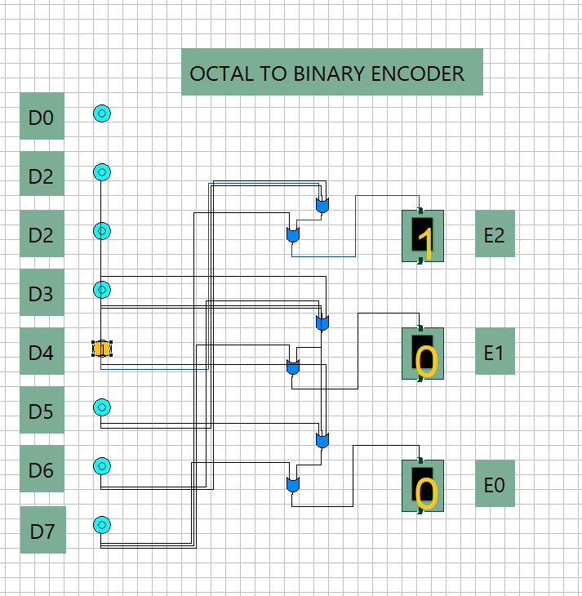
Fig. 4.2 — 8-to-3 Octal-to-Binary Encoder. With input D4 = 1 (all others LOW), the outputs read E2 = 1, E1 = 0, E0 = 0, i.e. binary 100 = decimal 4. (Note: the second input row is labelled "D2" in the simulator instead of "D1" — a labelling slip in the original file; the wiring itself follows the standard D0–D7 order used in the truth table above.)

Part (c): Half Subtractor Using a Multiplexer
A multiplexer can implement any Boolean function of n variables by placing (n−1) of the variables on its select lines and hard-wiring each data input to the constant (0 or 1) that the function takes for that combination of select values. Here, each half-subtractor output — DIFFERENCE and BORROW — is generated by its own 4:1 multiplexer, with inputs A and B connected to the select lines S1 and S0, and the four data lines tied to fixed logic levels drawn straight from the truth table row for that select combination.
DIFFERENCE = A ⊕ B BORROW = A′ · B

Truth Table
A (S1) | B (S0) | DIFFERENCE | BORROW
0 | 0 | 0 | 0
0 | 1 | 1 | 1
1 | 0 | 1 | 0
1 | 1 | 0 | 0
Reading down the DIFFERENCE column gives the four data-line values (0, 1, 1, 0) that must be wired into the DIFFERENCE multiplexer for select combinations A B = 00, 01, 10, 11 respectively; likewise the BORROW column (0, 1, 0, 0) gives the data-line pattern for the BORROW multiplexer. No extra gating logic is required beyond the multiplexers themselves and the inverters that generate A′ and B′ used internally by each 4:1 MUX.

Simulation
With A = 0 and B = 1 applied to the select lines of both multiplexers, the DIFFERENCE multiplexer correctly selects its data line for select code 01, giving DIFFERENCE = 1, and the BORROW multiplexer likewise gives BORROW = 1 — matching the second row of the truth table.
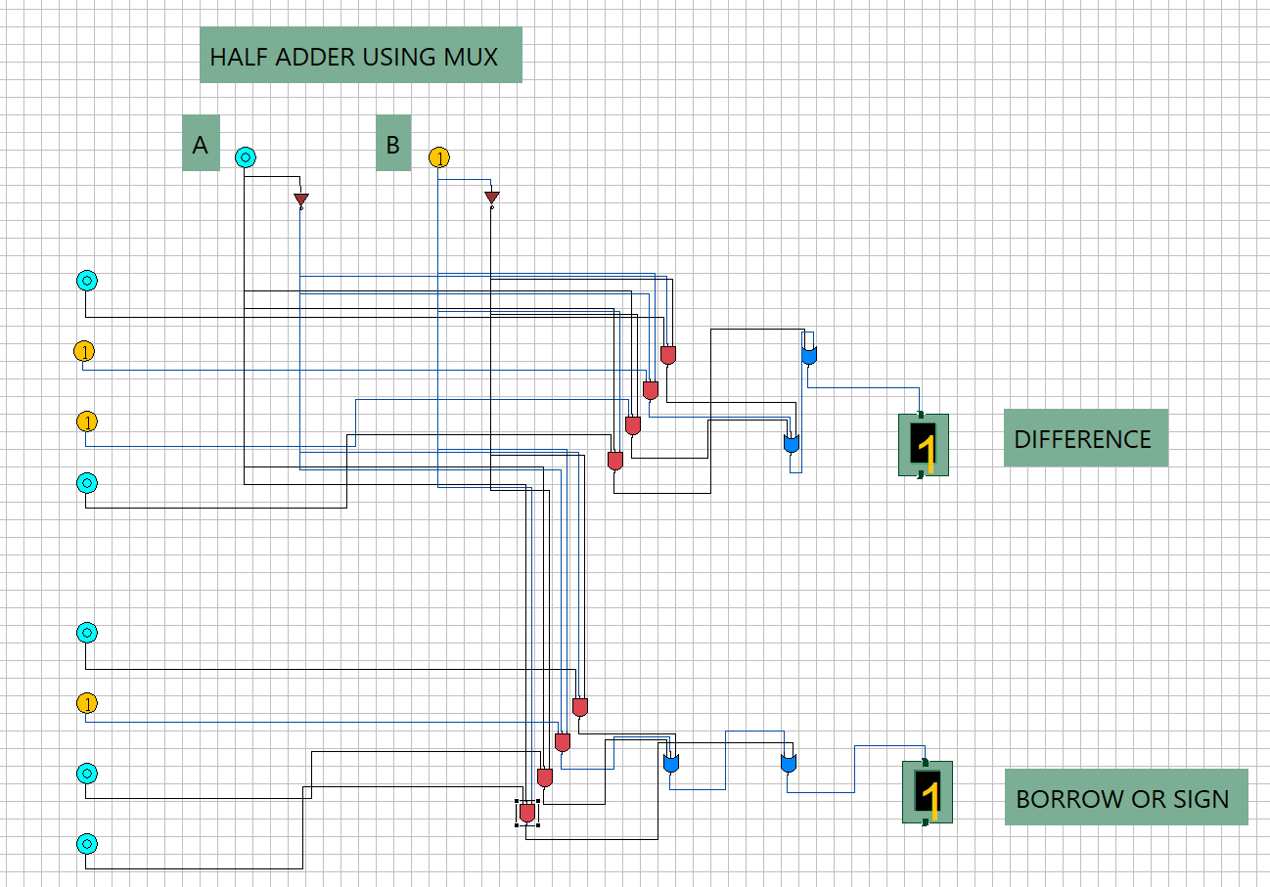
Fig. 4.3 — Half Subtractor implemented using two 4:1 multiplexers (one for DIFFERENCE, one for BORROW), with A, B driving the select lines. Inputs A = 0, B = 1 give DIFFERENCE = 1 and BORROW = 1. (Note: the on-canvas title in the simulator was left over from an earlier copy of the file as "Half Adder using MUX" — the wiring and output labels confirm this is the half-subtractor circuit.)

Part (d): Full Subtractor Using an 8:1 Multiplexer
The same data-selection principle extends directly to the full subtractor, which has three inputs — the minuend A, the subtrahend B, and the borrow-in C — and therefore eight possible input combinations. Each output (DIFFERENCE and SIGN/BORROW) is realised with a single 8:1 multiplexer: A, B and C drive the three select lines, and the eight data inputs of each MUX are hard-wired to the corresponding column of the truth table below, read off row by row.
DIFFERENCE = A ⊕ B ⊕ C BORROW = A′B + A′C + BC = A’B + C (A ⊕ B)’

Truth Table
A | B | C (Bin) | DIFFERENCE | BORROW
0 | 0 | 0 | 0 | 0
0 | 0 | 1 | 1 | 1
0 | 1 | 0 | 1 | 1
0 | 1 | 1 | 0 | 1
1 | 0 | 0 | 1 | 0
1 | 0 | 1 | 0 | 0
1 | 1 | 0 | 0 | 0
1 | 1 | 1 | 1 | 1
The DIFFERENCE multiplexer therefore has its eight data lines wired, in select order ABC = 000…111, to the pattern 0,1,1,0,1,0,0,1 (the parity/XOR pattern), while the BORROW multiplexer's data lines are wired to 0,1,1,1,0,0,0,1, taken directly from the BORROW column. This approach needs no explicit AND/OR reduction — the truth table becomes the wiring diagram — at the cost of using a larger, 8-input multiplexer for each output.

Simulation
The tested circuit applies A = 0, B = 1, C = 1 to the three select lines. This corresponds to the fourth row of the truth table above, where DIFFERENCE = 0 and BORROW = 1 — exactly the values produced by the two 8:1 multiplexers in the simulation.
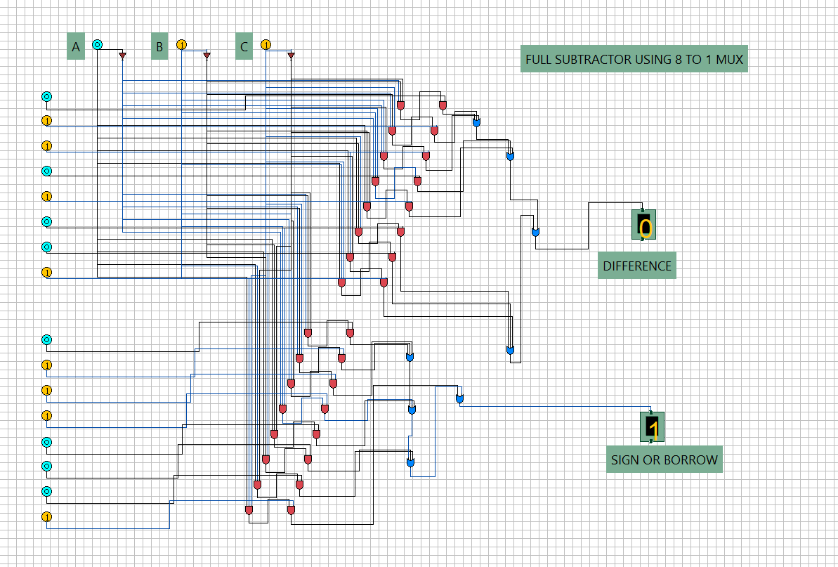
Fig. 4.4 — Full Subtractor implemented using two 8:1 multiplexers, with A, B, C (borrow-in) driving the select lines of both. Inputs A = 0, B = 1, C = 1 give DIFFERENCE = 0 and SIGN/BORROW = 1, matching the truth table.

