ASSIGNMENT 5
Design and Implementation of a
4-Bit Ripple Carry Adder

DEBAYAN ROY, B. TECH in CSE (2nd year SEM III), ROLL: 11000125039
A ripple carry adder is built by cascading n full adders. The carry-out of each stage is connected to the carry-in of the next more significant stage, so the carry "ripples" from the least significant bit (LSB) to the most significant bit (MSB). With four full adders the circuit adds two 4-bit numbers A₃A₂A₁A₀ and B₃B₂B₁B₀ (plus an optional carry-in) and produces a 4-bit sum S₃S₂S₁S₀ along with a final carry-out, C4.

Four full adders (stages 0 to 3) are connected so that the carry-out of one stage feeds the carry-in of the next. For stage i (i = 0, 1, 2, 3):
C₀ = Cin
S_{i} = A_{i} ⊕ B_{i} ⊕ C_{i}
C_{i+1} = A_{i}·B_{i} + C_{i}·(A_{i} ⊕ B_{i})
Cout = C₄
The circuit was built in provided logic simulator as shown in Figure 1.

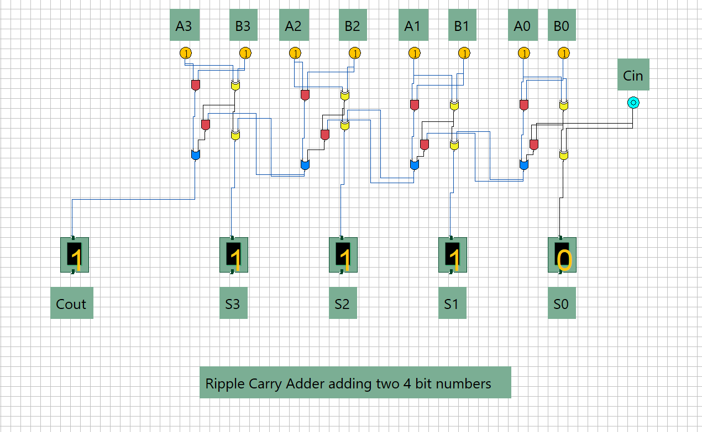
Figure 1: 4-bit ripple carry adder

